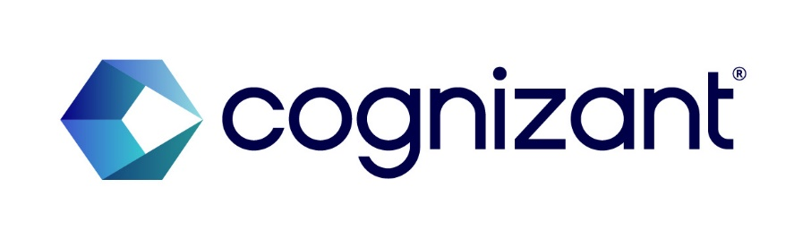
INVENTION DISCLOSURE FORM
General Note
All information submitted within this disclosure shall be treated as confidential. Cognizant reserves the right to release information in the disclosure for the purpose of generating statistics and other corporate, legal or audit purposes, as long as such disclosure shall not adversely affect the scope of protection available to the Intellectual Property (IP) in the disclosure.
The purpose of this Invention Disclosure Form is to record that a new technology/invention has been developed and assess if it may be entitled for a patent protection according to Cognizant policies, and the circumstances under which this occurred. It is an important document. Please prepare it carefully.
In order to be patentable, an invention must be new, useful and “unobvious” to one “having ordinary skill in the art.” Prior use, sale or publication of the invention by you or others will affect the ability to get a valid patent. For these reasons, it is essential to furnish all information that you are aware of concerning prior art methods, devices, publications and technology related to the invention.
Please be aware that any public disclosure (written or oral) of an invention prior to filing a patent application may jeopardize your chances of obtaining patent protection.
Please state the date of each sale or public use of the invention in the United States or in any foreign country and describe the circumstances of these transactions. The description should specify whether the use was for testing or trial purposes, and if there was an effort or intention to maintain the secrecy of the invention after the use commenced. If the invention is going to be offered for sale, publicly exhibited, or used commercially in the near or foreseeable future, please provide details and dates of such anticipated use. If a description of the invention is to be published in the near or foreseeable future, give details and dates of such anticipated publication.
A U.S. patent application for an invention must be filed within one year of any sales, offers for sale, or public disclosures of the invention. Failure to do so will result in the invention being time-barred from patent protection. If foreign patent protection is desired, note that most foreign countries require that a patent application be filed BEFORE any sales, offers for sale, or public disclosures of the invention. Delay in the completion of this form could jeopardize your ability to obtain patent protection for the invention.
Please note that the personal information is collected for the purpose of filing a patent application or other IP Assets or for business continuity purposes. The personal information would be shared with the external attorneys who would be helping us in the preparation and filing of the IP Assets. This personal information is going to be stored in this tool according to the Global Record Retention Schedule.
If you have added any co-inventor(s), you guarantee that you have obtained the consent of that co-inventor’s willingness to be named in the application, along with the inclusion of their personal information.
☒ I hereby acknowledge that I have read and understood the General Note
Please do not hesitate to contact the IP team (IPLegalGroup@cognizant.com) for assistance in completing this Invention Disclosure Form.
Date of submission to the IP Team:

CONCEPTION:
Invention conceived on: [date] ____________________, ______
First written record: [date] ____________________, ______
Reduced to practice: [date] ____________________, ______

FIRST DISCLOSURE TO OTHERS:
Has the invention ever been disclosed orally or in writing to any person other than fellow employees?
Such disclosures may include any instances of confidential or public offers to sell the invention or products embodying the development or made by the development, as well as requests for financing, grant applications, demonstrations, theses, abstracts, oral presentations, trade shows, catalogs, etc.

Inventorship
Identify full name(s) of all inventors. An inventor is that person or persons who conceived the invention or made a substantial contribution to it. Merely having helped build the inventive device and/or tested it at the request of, or under instructions from the inventor(s) does not qualify that person as an inventor. In a similar vein, no potential "inventor" should be omitted, since the non-joinder of an inventor will cause any resultant patent to be invalid.

- Lead Inventor’s Details:
  - Full Name (including middle name (if any)) Rajhasekarun, Ganapathy Damodaran
  - Associate ID: 203356
  - Business Unit: QE&A
  - Current Location 9013 Slverdollar Trail, Irving TX 75063
  - Permanent Address: Plot No 220, Kurunchi Street, JCK Nagar, Chengalpattu 603 002
  - Mobile Number: 267-288-3573
  - Personal Email ID: rajhasekarun.g.d@gmail.com

Background of the Invention
Mainframe Test automation is currently performed using a p-COM-based automation library (Jacob DLL) that interfaces with the mainframe terminal emulator installed on the user’s own local workstation. Because the automation runs directly on the user’s machine, the user’s system resources (CPU, terminal emulator session, keyboard/mouse focus) are occupied for the full duration of the automated execution. This creates a hard dependency between the automation job and the availability of that specific local machine and prevents the user from performing any other task on that workstation while the automation is running. As automation workloads scale, this local-execution model becomes a significant operational bottleneck: jobs cannot be queued, parallelized, or run unattended, and they consume a dedicated physical/virtual desktop per concurrent execution. The underlying technical problem is the tight coupling between the automation logic, the COM-based emulator-control mechanism, and the specific local user endpoint on which it is installed, with no mechanism to decouple execution from a particular user’s machine or to centrally orchestrate and verify multiple such jobs.
AdvantageS and BRIEF DESCRIPTION of the invention
The invention is a system and method for remote, centrally orchestrated execution of mainframe automation, which removes the dependency on the requesting user’s local workstation. Instead of running the Jacob DLL-based automation on the user’s own machine, the automation is executed against a named mainframe emulator instance hosted on a shared pool of remote desktops, under the control of a software agent, with instance lifecycle and job admission centrally managed by a Central Hub. The agent communicates with the central hub over a REST API, receives instance-addressed execution commands, performs the requested mainframe actions locally using the existing COM-based (Jacob-style) automation interface, and then reports results back to the hub — including data retrieved from the emulator and validated against expected values, plus supporting screenshots and execution references — for verification that each step executed correctly. The key advantages, in approximate order of importance, are as follows:
      - the user’s local workstation is freed up entirely during execution, since the automation runs on a remote desktop rather than the user’s machine, allowing the user to continue other work in parallel;
      - a state-based job queue with bounded concurrency (currently capping execution at five parallel emulator instances) lets the Central Hub centrally control and predictably scale resource consumption across the shared pool, rather than provisioning a dedicated machine per user or per job;
      - the emulator-instance registry, keyed by job state, avoids redundantly launching a new emulator instance for every command by reusing an already-registered instance for the same session/state, while still allowing commands to be explicitly routed to the correct named instance;
      - the existing Jacob/COM-based automation logic is preserved and reused (it now runs locally on the remote desktop, against a centrally tracked instance, rather than being re-engineered), which lowers migration cost and risk;
      - the use of a REST API as the command-and-control channel between the central hub and the agent allows the architecture to scale across a distributed pool of remote desktops using standard, firewall-friendly web protocols;
      - validating data retrieved directly from the emulator instance against expected values, supplemented by screenshot/log capture, gives the hub (and the requesting user) an automated, verifiable record that each step of the mainframe automation actually executed and produced the correct result, rather than relying solely on an unverified return code or a screenshot alone;
      - the Client SDK exposes a defined, reusable set of mainframe interaction commands that the user composes into workflows, abstracting the user away from the underlying Jacob/COM mechanics and the remote-execution plumbing entirely, so that workflow authors only need to think in terms of the available commands rather than the distributed architecture executing them.

DETAILED DESCRIPTION AND TECHNICAL IMPLEMENTATION DETAILS OF THE INVENTION including future work:
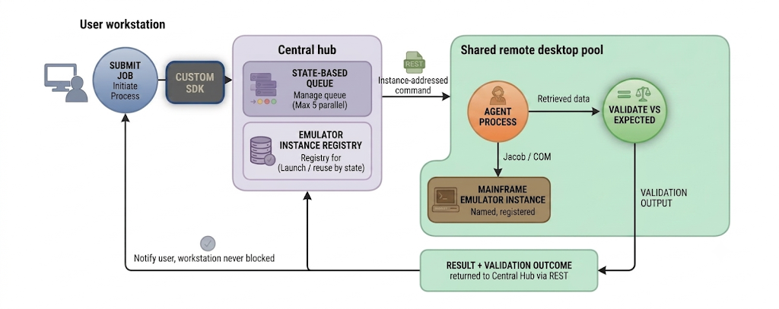
Figure 1: Remote mainframe automation architecture – user workstation, central hub (state-based queue and emulator instance registry), agent process, mainframe emulator instance, and data validation/alerting path.
The invention is a process/system for remote, agent-mediated execution of mainframe automation. The architecture consists of six cooperating components: (a) a Client SDK, installed on or accessible from the requesting user’s local workstation, which exposes the defined set of commands that can be issued to the Central Hub to interact with the mainframe (e.g., navigation, data entry, screen-read commands), and which the user composes into a workflow (an ordered sequence of such commands) and triggers as a single automation job; (b) a Central Hub, which receives automation job requests submitted via the Client SDK, maintains a state-based job queue that admits jobs for execution up to a bounded concurrency limit (currently a maximum of five emulator instances running in parallel), decides which remote desktop/emulator instance should service each job, and exposes a REST API as its command interface; (c) a pool of shared Remote Desktops, each capable of hosting one or more mainframe terminal emulator instances, and each also capable of establishing a connection back to the requesting user’s local environment when needed; (d) an Emulator Instance Registry maintained by the Central Hub, which tracks, for each job “state” (i.e., logical job/session context), whether a live emulator instance already exists and is registered against that state, or whether a new instance must first be launched and registered before any command can be routed to it; (e) an Agent process running on each remote desktop, which exposes/consumes REST endpoints to receive execution commands — each addressed to a specific, named emulator instance — and which drives that emulator instance locally using the existing Jacob/COM-style automation interface; and (f) the requesting User’s local workstation, which submits the automation request (via the Client SDK) and receives results, but is not used to run the automation itself.
The critical process steps are as follows.
- Job submission: the user, via the Client SDK, composes the desired sequence of mainframe interaction commands into a workflow and triggers it; the Client SDK submits this as an automation job, tied to a particular job “state” (logical session/context), to the Central Hub via its REST API.
- Queueing and admission control: the Central Hub places the job into a state-based queue; jobs are admitted for execution according to the current queue state and a bounded concurrency limit, such that at any point in time at most a fixed number of emulator instances (currently five) are running in parallel across the remote desktop pool, while additional jobs wait in queue until capacity frees up.
- Instance resolution: for the job’s state, the Central Hub consults its emulator instance registry; if no emulator instance is yet registered for that state, the Central Hub causes a new mainframe emulator instance to be launched on an available remote desktop and registers that instance against the state, naming/identifying the instance; if an instance is already registered for that state, the existing instance is reused.
- Command delivery: the Central Hub delivers the execution command(s) to the Agent on the relevant remote desktop over REST, with each command explicitly carrying the registered emulator instance name so the Agent can route the command to the correct, already-running instance rather than launching a new one.
- Local execution on the remote desktop: the Agent, running on the assigned remote desktop, uses the Jacob/COM-style automation interface, exactly as it previously ran on the user’s own machine, to drive the named mainframe terminal emulator instance and perform the requested actions (navigation, data entry, screen reads, etc.).
- Data retrieval and validation: the Agent retrieves the resulting data directly from the emulator instance (e.g., screen field values, returned records) and the automation code validates this retrieved data against the expected values defined for that automation step, in addition to capturing supporting screenshots and execution logs/references.
- Result return: the Agent sends the validation outcome, screenshots, and logs back to the Central Hub (and/or the requesting user) over REST, so the result of the automation, and confirmation that each step executed correctly against the expected data, can be verified without the user’s own machine ever having run the automation.
- Resource release: once execution completes and no further commands are pending for that state, the emulator instance and/or remote desktop capacity is released back to the pool, allowing a queued job to be admitted, and the user’s local workstation — which was never blocked during execution — receives the final result.
This directly addresses the technical problem identified in the Background section: rather than tying the automation logic to the user’s own workstation via a locally installed COM/Jacob interface, the same COM/Jacob interface is relocated onto a pool of purpose-built remote desktops, and a thin REST-connected agent, a stateful emulator-instance registry, and a bounded-concurrency queue in the central hub are introduced to decouple job submission, instance provisioning, job assignment, and job execution from any single user endpoint, while still bounding resource consumption to a controlled number of concurrent emulator instances (currently five). The best way to use the invention is for the user to submit the automation job, tagged with its state, to the Central Hub and continue working locally on other tasks while the job is queued, an emulator instance is resolved or launched, and the job executes remotely against that named instance; the user is notified, and can review the validated results, screenshots, and logs, once execution completes.

TECHNICAL Implementation DETAILS:
A working prototype has been built. The Central Hub exposes a REST API over which job requests are submitted, each tagged with a job “state” identifying the logical session/context the job belongs to. The Central Hub maintains a state-based queue and admission-control mechanism: jobs are held in the queue and released for execution such that, at any given time, at most a fixed maximum number of mainframe emulator instances (currently five) are running in parallel across the remote desktop pool, while additional jobs wait in queue until capacity frees up. The Central Hub also maintains an emulator instance registry keyed by job state: when a job for a given state is admitted from the queue and no emulator instance is yet registered for that state, the Central Hub triggers the launch of a new mainframe emulator instance on an available remote desktop and registers that instance (by name) against the state; if an instance is already registered for the state, it is reused rather than launching a duplicate. Once an instance is registered, all subsequent REST commands for that state explicitly include the registered emulator instance name, so the Agent on the corresponding remote desktop can route each command to the correct, already-running instance. Each remote desktop in the pool is capable of hosting one or more such emulator instances. On each remote desktop, the Agent process is installed as a local service/application exposing/consuming REST endpoints to receive its assigned, instance-addressed command(s). Upon receiving a command, the Agent invokes the existing Jacob DLL (a Java-COM bridge) to drive the named mainframe emulator instance’s COM automation interface exactly as the legacy local automation did — the difference is that this COM interaction now happens locally on the remote desktop, against a centrally tracked, named instance, rather than on the requesting user’s own workstation against an ad hoc local session. After each automated step (or set of steps), the Agent retrieves the resulting data directly from the emulator instance (e.g., screen field values, returned records); this retrieved data is validated by the automation code against the expected values defined for that step (today, and unchanged going forward), and the Agent additionally captures a screenshot of the emulator window/session state and compiles execution references/logs. The validation outcome, screenshots, and logs are transmitted back to the Central Hub via further REST calls, allowing both the hub and the end user to verify that the automation executed as expected. Because emulator instances are tracked per state and bounded in number, the Central Hub can safely admit and run up to five jobs concurrently across the pool while queueing the rest, and can route a specific job’s commands to the specific, already-registered instance for its state where session continuity is required.

Future Work
Yes, further work is contemplated. Planned next steps include:
      - making the bounded concurrency limit (currently a fixed maximum of five parallel emulator instances) dynamically configurable based on observed load and available remote desktop capacity, rather than a fixed constant;
      - extending the emulator instance registry with automated idle-instance detection and teardown, so that registered instances for a state are released proactively rather than only at the end of an explicit job;
      - extending the agent to support additional mainframe emulator types/configurations beyond the current implementation;
      - productionizing security and access controls around the REST command channel between the Central Hub and the agents, including authentication of instance-addressed commands. This work is expected to take place over the coming months as the prototype is matured toward production deployment.
(Please provide detailed write up involving a couple of pages to the least. Feel free to provide additional annexures, documents and presentations explaining requested details.)

General Information

- Is your invention a part of some project conducted for any of your clients? If so, provide details of the same.
Yes. This invention was developed in the course of a client engagement involving mainframe automation.

- Has a patent application or any other form of intellectual property protection been sought for all or any element of the Invention anywhere in the world? If yes, please attach a copy of the filing notice(s) and the patent application(s). (NOTE: other forms of intellectual property protection include trademark application, copyright registration, plant breeders registration, integrated circuit topography filing, confidentiality agreements, or trade secret agreements)
No patent application or other form of intellectual property protection has been sought, anywhere in the world, for this invention or any element of it.

- Could a third party raise claims towards the technology / invention? For example,
  - a) …have you received any of the materials used to develop the technology/invention from a third party, - No
  - b) …have you developed the technology/invention as part of a collaboration with a third party? - No

