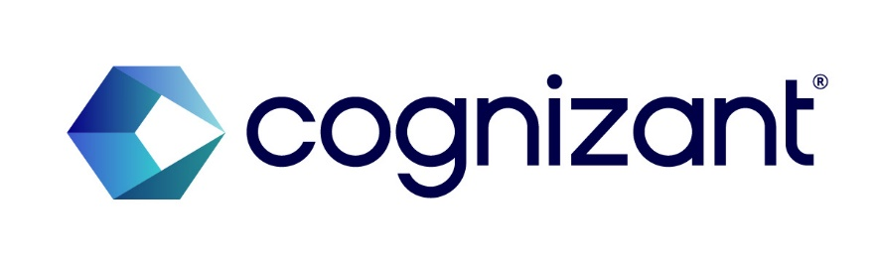
INVENTION DISCLOSURE FORM
General Note
All information submitted within this disclosure shall be treated as confidential. Cognizant reserves the right to release information in the disclosure for the purpose of generating statistics and other corporate, legal or audit purposes, as long as such disclosure shall not adversely affect the scope of protection available to the Intellectual Property (IP) in the disclosure.
The purpose of this Invention Disclosure Form is to record that a new technology/invention has been developed and assess if it may be entitled for a patent protection according to Cognizant policies, and the circumstances under which this occurred. It is an important document. Please prepare it carefully.
In order to be patentable, an invention must be new, useful and “unobvious” to one “having ordinary skill in the art.” Prior use, sale or publication of the invention by you or others will affect the ability to get a valid patent. For these reasons, it is essential to furnish all information that you are aware of concerning prior art methods, devices, publications and technology related to the invention.
Please be aware that any public disclosure (written or oral) of an invention prior to filing a patent application may jeopardize your chances of obtaining patent protection.
Please state the date of each sale or public use of the invention in the United States or in any foreign country and describe the circumstances of these transactions. The description should specify whether the use was for testing or trial purposes, and if there was an effort or intention to maintain the secrecy of the invention after the use commenced. If the invention is going to be offered for sale, publicly exhibited, or used commercially in the near or foreseeable future, please provide details and dates of such anticipated use. If a description of the invention is to be published in the near or foreseeable future, give details and dates of such anticipated publication.
A U.S. patent application for an invention must be filed within one year of any sales, offers for sale, or public disclosures of the invention. Failure to do so will result in the invention being time-barred from patent protection. If foreign patent protection is desired, note that most foreign countries require that a patent application be filed BEFORE any sales, offers for sale, or public disclosures of the invention. Delay in the completion of this form could jeopardize your ability to obtain patent protection for the invention.
Please note that the personal information is collected for the purpose of filing a patent application or other IP Assets or for business continuity purposes. The personal information would be shared with the external attorneys who would be helping us in the preparation and filing of the IP Assets. This personal information is going to be stored in this tool according to the Global Record Retention Schedule.
If you have added any co-inventor(s), you guarantee that you have obtained the consent of that co-inventor’s willingness to be named in the application, along with the inclusion of their personal information.
☒ I hereby acknowledge that I have read and understood the General Note
Please do not hesitate to contact the IP team (IPLegalGroup@cognizant.com) for assistance in completing this Invention Disclosure Form.
Date of submission to the IP Team: [To be completed upon submission – insert date]

CONCEPTION:
Invention conceived on: [date] ____________________, ______
First written record: [date] ____________________, ______
Reduced to practice: [date] ____________________, ______

FIRST DISCLOSURE TO OTHERS:
Has the invention ever been disclosed orally or in writing to any person other than fellow employees?
Answer: No. This invention has not been disclosed orally or in writing to any person outside the company, and has not been offered for sale, publicly demonstrated, published, or otherwise made public in any form.
Such disclosures may include any instances of confidential or public offers to sell the invention or products embodying the development or made by the development, as well as requests for financing, grant applications, demonstrations, theses, abstracts, oral presentations, trade shows, catalogs, etc.

Inventorship

Identify full name(s) of all inventors. An inventor is that person or persons who conceived the invention or made a substantial contribution to it. Merely having helped build the inventive device and/or tested it at the request of, or under instructions from the inventor(s) does not qualify that person as an inventor. In a similar vein, no potential "inventor" should be omitted, since the non-joinder of an inventor will cause any resultant patent to be invalid.

- Lead Inventor’s Details:
  - Full Name (including middle name (if any)): Rajhasekarun, Ganapathy Damodaran
  - Associate ID: 203356
  - Business Unit: QE&A
  - Current Location: 9013 Silverdollar Trail, Irving TX 75063
  - Permanent Address: Plot No 220, Kurunchi Street, JCK Nagar, Chengalpattu 603 002
  - Mobile Number: 267-288-3573
  - Personal Email ID: rajhasekarun.g.d@gmail.com

Background of the Invention
UI test automation has four interconnected technical problems, all rooted in the absence of any automated mechanism to discover and model a web application’s interaction topology.
1. Existing web crawlers and test tools operate on pre-authored, developer-specified selectors or scripts. The traversal logic is hard-coded: the tool only visits paths a human has explicitly anticipated and cannot reason about a previously unseen page to decide what a user would plausibly do next.
2. Multi-step wizards and single-page applications (SPAs) that present different UI states under the same URL are invisible to URL-based crawlers, which collapse all wizard steps into one node and miss intermediate states entirely.
3. Field value resolution in existing test tools is static: developers hard-code input values per field. There is no mechanism to infer sensible values for unseen fields, re-use previously resolved values across runs, or fall back to AI inference only when structured data is unavailable.
4. Page object models and test scripts must be authored and maintained manually per supported language (Java, JavaScript, TypeScript, etc.); there is no mechanism to generate them automatically from a discovered application model, or to update them incrementally when the application changes.
The underlying technical problem is the absence of a system that can:
(a) use a large language model (LLM) to interpret a live, captured DOM state in real time and decide which action a user would plausibly take next, without pre-scripted instructions;
(b) exhaustively enumerate all reachable UI states and branching paths — including every radio-button variant and every wizard step — without combinatorial explosion of browser sessions, by deterministically replaying already-known decision sequences to previously-found branch points and applying LLM inference only at genuinely novel divergence points;
(c) disambiguate same-URL application states using content fingerprinting of the captured element set rather than URL alone; and
(d) emit the discovered topology as a structured, annotated graph of nodes (pages/wizard states) and edges (transitions with triggering element and value) that downstream tooling can consume to auto-generate functional UI test cases without human authoring.

AdvantageS and BRIEF DESCRIPTION of the invention
The invention is an autonomous, AI-driven web crawler and test artefact generator. An LLM interprets each page’s live DOM state in real time to decide which action a user would plausibly take next, without pre-scripted instructions; explores all reachable flows and branching paths using a deterministic branch-replay mechanism; disambiguates same-URL wizard states using content fingerprinting; and outputs a structured, annotated graph of the application’s navigation and interaction model for downstream test artefact generation. At a high level: a real browser (Chromium via Playwright) is launched and loads the target application. The crawler identifies every visible, interactive element across all major UI frameworks (Material, Bootstrap, Ant Design, Ionic, shadcn, and others) using DOM inspection and element visibility checks, including shadow DOM traversal. For fields requiring input, values are resolved through a tiered chain: spreadsheet mappings, human-authored hints, a prior-run cache, and live LLM inference as a last resort, minimising paid model calls. The LLM then selects the next action by semantic reasoning over the captured element set — not hard-coded rules. In guided mode the crawler filters to elements relevant to a specified business intent and completes that flow, including multi-step wizards on the same URL. In open-exploration mode it performs breadth-first traversal and, when it reaches a choice point (e.g., a radio group), records the prior decision sequence as a content-addressed path ID, queues the alternate branch with a divergeNodeId, and later re-navigates to that divergence point deterministically before taking the alternate path — exhaustively enumerating all reachable UI variants without combinatorial explosion. Each visited page state becomes a graph node; each action becomes an edge. States are identified by URL plus a content fingerprint of the captured element set, so wizard steps on a single SPA route are distinct nodes rather than collapsed into one. The graph carries LLM-generated semantic names and descriptions, and is persisted to JSON or a graph database as the cumulative Knowledge Base. The Code Generator reads the graph and produces POM classes and methods (Java, JavaScript, TypeScript, Cypress, and others) without human authoring. When new user stories arrive, the system expands them to interaction-level steps matched to existing Knowledge Base nodes, presents the proposed steps and POM method signatures for user review, and on confirmation generates a complete test class saved back into the framework. During execution, the platform runs the generated tests via standard test runners (TestNG, JUnit, etc.). The key advantages, in priority order, are:
      - LLM-mediated action selection replaces all hard-coded traversal logic, so the system navigates any web application without developer preparation;
      - deterministic branch-replay exhaustively enumerates all branching paths without re-running the LLM for already-known decisions, reducing cost and ensuring reproducibility;
      - content-fingerprint node disambiguation correctly represents SPA wizard flows that URL-only systems collapse into a single node;
      - tiered field-value resolution minimises paid LLM calls while retaining full AI fallback for novel fields;
      - the Knowledge Base is cumulative — delta re-crawls on subsequent deployments only persist changed nodes/edges; and
      - a single graph traversal produces POM classes and test artefacts for all target languages simultaneously, eliminating per-language manual authoring.

DETAILED DESCRIPTION AND TECHNICAL IMPLEMENTATION DETAILS OF THE INVENTION including future work:
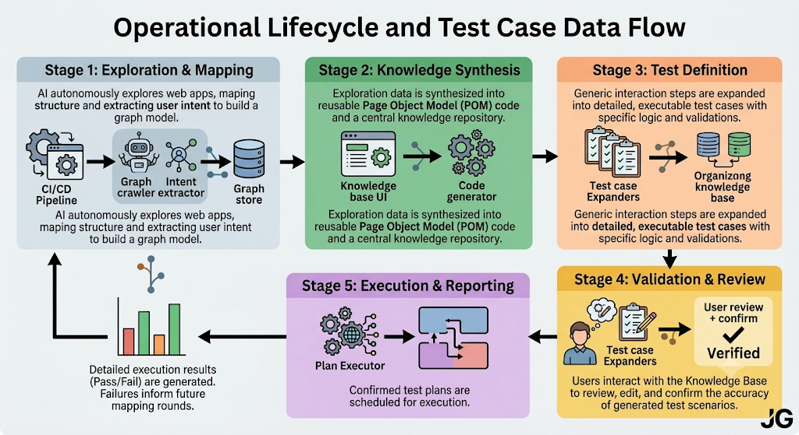
Figure 1: End-to-end workflow – CI/CD curl trigger, intent extraction (Python/LLM), graph crawling (TypeScript/Playwright), graph store (JSON/Neo4j), code generation (Python), knowledge base UI (React), test case expansion and user review, test class generation, and plan execution (TestNG/JUnit).
The invention is a process/system for automated, intent-driven UI test artefact generation. The architecture consists of six cooperating components:
(a) Intent Extractor: receives the text of a user story (plain English acceptance criteria, Gherkin scenarios, or any structured story format) and applies NLP/LLM-based analysis to derive a structured intent object describing the user’s goal and the sequence of high-level actions expected to fulfil it (e.g., “navigate to login, enter credentials, submit, land on dashboard”).
(b) Graph Crawler: a Playwright-driven browser automation component that receives the structured intent and the application URL, launches the application in a headless or headed browser, and navigates the application in pursuit of fulfilling the intent. At each step, the crawler evaluates the current page’s DOM element tree combined with element visibility (i.e., only elements that are both present in the DOM and visible on screen are candidates for interaction) to identify which element best matches the next action implied by the intent. The crawler records each interaction (element locator, action type, data used) and each resulting page transition. When the crawler successfully fulfils the intent, the recorded path constitutes the discovered flow.
(c) Graph Store: the discovered flow is persisted as a directed graph of nodes and edges. Each node represents either a page (with URL, title, and page-level metadata) or a UI element on that page (with locator, label, element type, and interaction type). Each edge represents a navigation transition triggered by an interaction on a source node, pointing to the resulting destination node. The graph is stored in JSON or a graph database, forming the application’s Knowledge Base. The Knowledge Base is cumulative — flows discovered from multiple user stories are merged into a single growing graph.
(d) Code Generator: reads the node-edge graph and produces Page Object Model classes and interaction methods in any target language (Java, JavaScript, TypeScript, and others). Each page node becomes a POM class; each element node within that page becomes a method (or a locator definition plus a method) for interacting with that element. The generated code follows standard POM conventions for the target language and framework.
(e) Test Case Expander and Review UI: when a new user story is submitted, the system expands it to a sequence of interaction-level test steps — each step mapped to an existing node or edge in the Knowledge Base — and presents these steps together with the corresponding generated page object method signatures to the user via a UI. The user reviews and confirms (or adjusts) the proposed test steps. Upon confirmation, the system generates a complete test class containing those steps, wired to the appropriate page object methods, and saves it back into the test framework repository.
(f) Plan Executor: accepts test inputs and executes the confirmed test classes as a plan through standard test runners (TestNG, JUnit, or equivalent), producing pass/fail results and execution logs in the same way as any hand-authored test suite.
The critical process steps are:
Step 1 – Story submission: a user story is submitted to the Intent Extractor, which produces a structured intent object.
Step 2 – Crawl initiation: the intent object and the application URL are passed to the Graph Crawler; Playwright launches the application. Alternatively, the crawler can be triggered automatically via a curl call (HTTP POST) at the end of the UI deployment stage in the CI/CD pipeline, without requiring manual invocation.
Step 3 – Intent-driven navigation: the crawler iteratively evaluates visible DOM elements at each page state, selects the element most consistent with the next action in the intent, interacts with it (click, type, select, etc.), and records the interaction and resulting transition.
Step 4 – Flow completion: when the crawler has fulfilled the intent (i.e., reached the expected terminal state), the recorded interaction path is the discovered flow.
Step 5 – Graph persistence: the flow is written to the Graph Store as a delta update — new nodes and edges are added and changed ones are updated, while unchanged structure is preserved — so re-crawling the same application after a new story or deployment only persists what has actually changed.
Step 6 – Code generation: the Code Generator reads the updated graph and produces or updates POM classes and methods for all target languages.
Step 7 – Test case expansion: for a new user story, the Test Case Expander maps its intent to existing graph nodes, generates interaction-level steps and matching method signatures, and presents them in the Review UI.
Step 8 – Confirmation and class generation: the user confirms the proposed steps; the system generates a test class and commits it to the framework.
Step 9 – Execution: the Plan Executor runs the generated test class via the configured test runner.

TECHNICAL Implementation DETAILS:
A prototype is currently in development. The system is implemented across three technology layers: (i) the Graph Crawler is written in TypeScript using Playwright’s Node.js/TypeScript binding; (ii) all backend components — intent extraction, graph storage, code generation, test case expansion, and plan execution — are implemented in Python; and (iii) the Knowledge Base UI and review interface are implemented in React (TypeScript), communicating with the Python backend over a REST API. The crawler posts its interaction records as JSON to a Python endpoint after each run; the backend persists them to the graph store. The key implementation details for each component are as follows. Intent Extractor: implemented in Python as an LLM-based component. Receives user story text and returns a structured JSON intent object containing: the overall user goal, an ordered list of action steps (each with action type, target description, and input data), and an expected terminal condition. Graph Crawler (TypeScript / Playwright): launches Chromium with settings to suppress bot-detection signals. At each page state, queries the live DOM via Playwright to retrieve all interactive elements and filters to those both present in the DOM and currently visible (Playwright’s isVisible check). Applies a two-stage element filter: first a relevancy filter pruning candidates by attribute similarity to the current intent step (label text, ARIA label, placeholder, name, id, type); then an LLM-based filter that re-ranks remaining candidates by semantic reasoning over the full element context and selects the best match. Supports all major UI component frameworks (Material, Bootstrap, Ant Design, Ionic, Chakra, shadcn, Vuetify, and unrecognised ones) through framework-agnostic attribute inspection, including DOM-piercing shadow DOM traversal for element grouping (e.g., radio groups). Uses a multi-strategy click handler: Playwright locator click with fallback to native JS property setter plus event dispatch, to defeat anti-automation obfuscation. Field value resolution uses a deterministic priority chain: (i) Excel/spreadsheet mapping, (ii) LLM-parsed free-text hint notes (evaluated once at startup), (iii) CrawlDataCache of values resolved in prior runs, (iv) live LLM inference as last resort — minimising paid model calls. In guided mode, filters elements to those relevant to the specified business intent and steers the LLM toward completing that flow. In open-exploration mode, performs breadth-first traversal. On encountering a choice point (e.g., a radio group with N options), records the exact prior decision sequence as a content-addressed path ID (SHA-1 hash of node+element+value tuples, pathManager.ts) and queues each untaken alternative as a Branch entry with a divergeNodeId (branchQueue.ts). A later run re-navigates from the seed URL, deterministically replays the recorded decision sequence to the recorded divergence point (re-using cached LLM decisions, not re-calling the model), and takes the alternate branch — exhaustively enumerating all reachable UI variants without combinatorial browser sessions. Each visited page state is identified by URL combined with a content fingerprint of the captured element set; when a multi-step SPA wizard remains on the same URL across steps, each step receives a distinct node ID, preventing the graph from collapsing wizard states into one. The crawler emits interaction records (source node, element locator, action type, data, destination node) plus LLM-generated semantic names and descriptions (namePageRef, spec.intent, spec.description) as JSON. class template is instantiated for the target language (Java, JavaScript, TypeScript, etc.). For each element node belonging to that page, a locator field and an interaction method are generated from the element’s stored attributes and action type. Templates follow established POM conventions for each language/framework (e.g., WebDriver-style Java, Playwright-style TypeScript). A single graph traversal produces POM files for all configured target languages simultaneously. Test Case Expander: implemented in Python (with the review interface rendered in the React UI). When a new user story arrives, its intent object is matched against existing nodes in the Knowledge Base using the same element-scoring logic as the crawler. Each action step in the intent is mapped to an existing element node and its corresponding generated POM method. The resulting sequence of (step description, POM method call) pairs is presented in the Review UI. After user confirmation, the system instantiates a test class template (TestNG, JUnit, or other) populated with the confirmed steps, saves the file to the configured framework path, and updates the Knowledge Base with any new nodes discovered during the expansion.

Future Work
Further work is contemplated. Planned next steps include:
(1) extending branch-replay coverage to handle dynamically injected DOM elements, iframes, and deeply nested shadow DOM structures that require additional wait/polling strategies before the element set can be fingerprinted;
(2) extending the intent extractor to ingest structured user story formats directly from issue trackers (Jira, Azure DevOps) via API, removing the manual copy-paste step;
(3) the graph already supports delta-based re-writes on every crawl run (new/changed nodes update; unchanged nodes preserved); planned work is to make the concurrency limit and crawl depth configurable per deployment trigger;
(4) the code generator currently supports Java, JavaScript, TypeScript, and Cypress; planned expansion covers Robot Framework and Serenity/BDD;
(5) the crawler is already designed to be triggered via a curl call (HTTP POST) at the end of the CI/CD deployment stage; planned work is surfacing diff-highlighted changed nodes in the Knowledge Base UI after each post-deployment crawl;
(6) making the branch-path ID scheme content-addressable at the cross-run level so that a path already fully explored in a prior crawl is skipped entirely in subsequent runs, further reducing LLM call volume on large applications. This work is expected to take place over the next six to twelve months.

(Please provide detailed write up involving a couple of pages to the least. Feel free to provide additional annexures, documents and presentations explaining requested details.)

General Information

- Is your invention a part of some project conducted for any of your clients? If so, provide details of the same. No. This is a personal invention, not developed as part of any client engagement. It was conceived and developed independently by the inventor.

- Has a patent application or any other form of intellectual property protection been sought for all or any element of the Invention anywhere in the world? If yes, please attach a copy of the filing notice(s) and the patent application(s). (NOTE: other forms of intellectual property protection include trademark application, copyright registration, plant breeders registration, integrated circuit topography filing, confidentiality agreements, or trade secret agreements) No patent application or any other form of intellectual property protection has been sought, anywhere in the world, for this invention or any element of it.

- Could a third party raise claims towards the technology / invention? For example,
  - a) …have you received any of the materials used to develop the technology/invention from a third party, No
  - b) …have you developed the technology/invention as part of a collaboration with a third party? No

