ADDITIONS TO PROTTO UFSC MOTORSPORT VEHICLE DYNAMICS SIMULATION SOFTWARE 1.0

LIST OF FIGURES

Figure 1 – Generic representation of a constant velocity YMD 25
Figure 2– Generic representation of a constant cornering radius YMD 26
Figure 3 – Constant velocity YMD for $V=100 km/h$, $alon=0 g$, open differential 30
Figure 4– Constant velocity YMD for $V=100 km/h$, $alon=-1 g$, open differential 30
Figure 5 – Constant velocity YMD for $V=100 km/h$, $alon=0.5 g$, open differential 31
Figure 6 – Constant velocity YMD for $V=100 km/h$, $alon=0.5 g$, geared differential 31
Figure 7 – Constant cornering radius YMD for $R=30 m$, $alon=0 g$, open differential 32
Figure 8 – Constant cornering radius YMD for $R=30 m$, $alon=-1 g$, open differential 32
Figure 9 – Constant cornering radius YMD for $R=30 m$, $alon=0.5 g$, open differential 33
Figure 10 – Constant cornering radius YMD for $R=30 m$, $alon=0.5 g$, geared differential 33

LIST OF SYMBOLS
$$F_{down}$$ | Aerodynamic downforce [N]
$$F_{down,x}$$ | Aerodynamic downforce longitudinal distribution [%]
$$F_{down,y}$$ | Aerodynamic downforce lateral distribution [%]
$$F_{drag}$$ | Aerodynamic drag force [N]
$$M_{roll}^{aero}$$ | Aerodynamic roll moment [Nm]
$$M_{pitch}^{aero}$$ | Aerodynamic pitch moment [Nm]
$$M_{yaw}^{aero}$$ | Aerodynamic yaw moment [Nm]
$$C_{down}$$ | Aerodynamic downforce coefficient [-]
$$C_{drag}$$ | Aerodynamic drag coefficient [-]
$$C_{roll}$$ | Aerodynamic roll moment coefficient [-]
$$C_{pitch}$$ | Aerodynamic pitch moment coefficient [-]
$$C_{yaw}$$ | Aerodynamic yaw moment coefficient [-]
$$ρ$$ | Air density [kg/m³]
$$A$$ | Vehicle frontal area [m²]
$$V$$ | Vehicle longitudinal velocity [m/s]
$$T_{fl}$$ | Front left tire torque [Nm]
$$T_{fr}$$ | Front right tire torque [Nm]
$$T_{rl}$$ | Rear left tire torque [Nm]
$$T_{rr}$$ | Rear right tire torque [Nm]
$$ω_{fi}$$ | Front inner tire angular speed [rad/s]
$$ω_{fo}$$ | Front outer tire angular speed [rad/s]
$$ω_{ri}$$ | Rear inner tire angular speed [rad/s]
$$ω_{ro}$$ | Rear outer tire angular speed [rad/s]
$$κ_{fi}$$ | Front inner tire slip ratio [%]
$$κ_{fo}$$ | Front outer tire slip ratio [%]
$$κ_{ri}$$ | Rear inner tire slip ratio [%]
$$κ_{ro}$$ | Rear outer tire slip ratio [%]
$$V_{x, fi}$$ | Front inner longitudinal velocity [m/s]
$$V_{x, fo}$$ | Front outer longitudinal velocity [m/s]
$$V_{x, ri}$$ | Rear inner longitudinal velocity [m/s]
$$V_{x, ro}$$ | Rear outer longitudinal velocity [m/s]
$$r_{fi}$$ | Front inner tire radius [m]
$$r_{fo}$$ | Front outer tire radius [m]
$$r_{ri}$$ | Rear inner tire radius [m]
$$r_{ro}$$ | Rear outer tire radius [m]
$${TBR}_{f}^{drive}$$ | Front differential drive torque bias ratio [-]
$${TBR}_{r}^{drive}$$ | Rear differential drive torque bias ratio [-]
$${TBR}_{f}^{brake}$$ | Front differential brake torque bias ratio [-]
$${TBR}_{r}^{brake}$$ | Rear differential brake torque bias ratio [-]
$${ΔT}_{f}^{slip}$$ | Front axle slipping torque difference [Nm]
$${ΔT}_{r}^{slip}$$ | Rear axle slipping torque difference [Nm]
$${ΔT}_{f}^{lock}$$ | Front axle locked torque difference [Nm]
$${ΔT}_{r}^{lock}$$ | Rear axle locked torque difference [Nm]
$${ΔT}_{f}$$ | Front axle torque difference [Nm]
$${ΔT}_{r}$$ | Rear axle torque difference [Nm]
$${preload}_{f}$$ | Front differential preload [Nm]
$${preload}_{r}$$ | Rear differential preload [Nm]
$$k_{f}^{lock}$$ | Front differential Traclok locking ratio [-]
$$k_{r}^{lock}$$ | Rear differential Traclok locking ratio [-]
$$bias$$ | Ratio between tractive or braking forces [-]
$$F_{lon}$$ | Total vehicle longitudinal forces [N]
$$m$$ | Total vehicle mass [m]
$$a_{lon}$$ | Longitudinal acceleration [m/s²]
$$F_{x,comb,fl}$$ | Front left tire combined longitudinal force [N]
$$F_{x,comb,fr}$$ | Front right tire combined longitudinal force [N]
$$F_{x,comb,rl}$$ | Rear left tire combined longitudinal force [N]
$$F_{x,comb,rr}$$ | Rear right tire combined longitudinal force [N]
$$F_{y,comb,fl}$$ | Front left tire combined lateral force [N]
$$F_{y,comb,fr}$$ | Front right tire combined lateral force [N]
$$F_{y,comb,rl}$$ | Rear left tire combined lateral force [N]
$$F_{y,comb,rr}$$ | Rear right tire combined lateral force [N]
$$F_{rr,fl}$$ | Front left tire rolling resistance force [N]
$$F_{rr,fr}$$ | Front right tire rolling resistance force [N]
$$F_{rr,rl}$$ | Rear left tire rolling resistance force [N]
$$F_{rr,rr}$$ | Rear right tire rolling resistance force [N]
$$δ_{fl}$$ | Front left tire steering angle [°]
$$δ_{fr}$$ | Front right tire rolling steering angle [°]
$$δ_{rl}$$ | Rear left tire rolling steering angle [°]
$$δ_{rr}$$ | Rear right tire rolling steering angle [°]]
$$r_{fl}$$ | Front left tire radius [m]
$$r_{fr}$$ | Front right tire radius [m]
$$r_{rl}$$ | Rear left tire radius [m]
$$r_{rr}$$ | Rear right tire radius [m]

SUMmary

1 INTRODUCTION 16
2 MATHEMATICAL MODEL 16
2.1 aerOdynamics 16
2.1.1 Simplification 16
2.1.2 Proper aerodynamic model 16
2.2 limited-slip differential models 17
2.2.1 Open differential 18
2.2.2 Spool 18
2.2.3 Geared differential 19
2.2.4 Ramp differential 20
2.2.5 Traclok differential 21
2.2.6 Additional comments 21
2.3 additional torque constraint 22
3 Analysis 24
3.1 YAW MOMENT DIAGRAM 24
3.1.1 Constant velocity YMD 24
3.1.2 Constant cornering radius YMD 25
4 future developments 27
4.1 Improving the mathematical model 27
4.2 IMPROVING THE ANALYSIS TOOLS 28
REFERences 29
APPENDIX A – CONSTANT VELOCITY YMDS 30
APPENDIX B – CONSTANT CORNERING RADIUS YMDS 32

INTRODUCTION

This document describes the additions and improvements made to the vehicle dynamics simulation software developed by Protto UFSC Motorsport. The main basis for the solver of this software is described in DRISSEN (2025), so all the information shown here is based on that work.
This text also describes limitations of the current state of the software and brings suggestions for improvements and future development.

MATHEMATICAL MODEL

This section describes the efforts to further improve the mathematical model described by DRISSEN, 2025.

aerOdynamics

This sub-section describes changes to the aerodynamic model.

Simplification

The influence of aerodynamic drag in longitudinal load transfer $∆W_{lon,drag}$ and on pitch moment $M_{pitch,drag}$ was disregarded. This was due to the misleading and rather unrealistic concept of an aerodynamic pressure center having a fixed height $F_{drag,z}$.
As so, the aerodynamic influences are limited to aerodynamic downforce $F_{down}$, its lateral and longitudinal distributions $F_{down,y}$ and $F_{down,x}$ and the aerodynamic drag $F_{drag}$, which are all functions of the longitudinal velocity of the vehicle squared $V^{2}$.

Proper aerodynamic model

The proper way to model aerodynamics is via an aero map. Each influence should be described as a function of $V^{2}$, having a proper coefficient. Equations 1 - 6 describe the aerodynamic properties of an aero map:

$$\begin{aligned}F_{down}=\frac{1}{2}ρAC_{down}V^{2}\#\left(1\right)\end{aligned}$$
$$\begin{aligned}F_{drag}=\frac{1}{2}ρAC_{drag}V^{2}\#\left(4\right)\end{aligned}$$
$$\begin{aligned}M_{roll}^{aero}=\frac{1}{2}ρAC_{roll}V^{2}\#\left(3\right)\end{aligned}$$
$$\begin{aligned}M_{pitch}^{aero}=\frac{1}{2}ρAC_{pitch}V^{2}\#\left(4\right)\end{aligned}$$
$$\begin{aligned}M_{yaw}^{aero}=\frac{1}{2}ρAC_{yaw}V^{2}\#\left(5\right)\end{aligned}$$

Where $ρ$ is the density of the atmospheric air, $A$ is the frontal area of the vehicle, $C_{down}$ is the downforce coefficient, $C_{drag}$ is the drag coefficient, $C_{roll}$ is the aerodynamic roll moment coefficient, $C_{pitch}$ is the aerodynamic roll moment coefficient and $C_{yaw}$ is the aerodynamic roll moment coefficient. Additionally, downforce longitudinal and lateral distribution $F_{down,x}$ and $F_{down,y}$ may also be interpolated in the aero map.
The aero map is then used to find each coefficient for each combination of some parameters. Usually, an aero map consists of a 5D or 6D matrix, being the parameters the front ride height $h_{ride, f}$, rear ride height $h_{ride, r}$, chassis slip angle $β$, steering wheel angle $δ_{d}$, roll angle $Ψ$ and longitudinal velocity $V$. The latter is not that usual but may be considered.

limited-slip differential models

The original model considers only an open differential, which allows no torque difference for the wheels of the same axle. This sub-section describes the efforts to model different types of limited-slip differentials (LSD) as described by GUIGGIANI, 2023.
The main solver now possesses models for an open differential, spool, geared differential, ramp differential (“Salisbury”), and a Trac-loc differential.
It is important to note that the constraints imposed by a differential in an axle are also applied under braking. However, the intensity of the effect may differ from the driving condition (an LSD may be more aggressive under throttle than under braking).

Open differential

The open differential model remains unchanged. It constrains the torques generated by the tires of the same axle to being equal, as shown in Equations 7 and 8:

$$\begin{aligned}T_{fl}=T_{fr}\#\left(7\right)\end{aligned}$$
$$\begin{aligned}T_{rl}=T_{rr}\#\left(8\right)\end{aligned}$$
Under braking, an axle which has no differential (e.g. the front axle in a rear-wheel-drive vehicle) will behave like an open differential, due to the nature of the braking system.

Spool

A spool is not a differential, but rather the absence of one. It may be interpreted as an infinitely locked differential, which imposes no constraints on the torques, but rather on the wheel rotational speeds. Both wheels rotate at the same speed, as shown in Equations 9 and 10:
$$\begin{aligned}ω_{fi}=ω_{fo}\#\left(9\right)\end{aligned}$$
$$\begin{aligned}ω_{ri}=ω_{ro}\#\left(10\right)\end{aligned}$$
Which causes the inner tire (or, more precisely, the tire with less vertical load) to impose a slip ratio on the outer tire, for braking conditions, as shown in Equations 11 and 12:

$$\begin{aligned}κ_{fo}=1-\frac{V_{x, fo}}{V_{x,fi}}\frac{r_{fi}}{r_{fo}}\left(1-κ_{fi}\right)\#\left(11\right)\end{aligned}$$
$$\begin{aligned}κ_{ro}=1-\frac{V_{x, ro}}{V_{x,ri}}\frac{r_{ri}}{r_{ro}}\left(1-κ_{ri}\right)\#\left(12\right)\end{aligned}$$
And for driving conditions in Equations 13 and 14:
$$\begin{aligned}κ_{fo}=1-\frac{V_{x, fi}}{V_{x,fo}}\frac{r_{fo}}{r_{fi}}\left(1-κ_{fi}\right)\#\left(13\right)\end{aligned}$$
$$\begin{aligned}κ_{ro}=1-\frac{V_{x, ri}}{V_{x,ro}}\frac{r_{ro}}{r_{ri}}\left(1-κ_{ri}\right)\#\left(14\right)\end{aligned}$$
This allows for the calculation of torque on each wheel, and for the definition of the locked torque difference for each axle ${ΔT}_{f}^{lock}$ and ${ΔT}_{r}^{lock}$. Equations 15 and 16 describe those calculations:

$$\begin{aligned}{ΔT}_{f}^{lock}=\left|T_{fl}-T_{fr}\right|\#\left(15\right)\end{aligned}$$
$$\begin{aligned}{ΔT}_{f}^{lock}=\left|T_{fl}-T_{fr}\right|\#\left(16\right)\end{aligned}$$

Geared differential

Geared differentials are a type of LSD, which behave like a spool until its internal friction is overcome. Once that happens, the differential slips, which creates a constraint on the torques of tires on the same axle, as demonstrated in Equations 17 and 18:

$$\begin{aligned}T_{fl}=T_{fr}±{ΔT}_{f}^{slip}\#\left(17\right)\end{aligned}$$
$$\begin{aligned}T_{rl}=T_{rr}±{ΔT}_{r}^{slip}\#\left(18\right)\end{aligned}$$
Where ${ΔT}_{f}^{slip}$ and ${ΔT}_{r}^{slip}$ are the front and rear axles’ slip torque differences. The torque differences are function of internal properties of the differential. For geared differentials, the only relevant property is the torque bias ratio (TBR), which can be different for driving and braking conditions, and for different axles. ${TBR}_{f}^{drive}$ and ${TBR}_{f}^{brake}$ are the driving and braking TBRs for the front axle, whereas ${TBR}_{r}^{drive}$ and ${TBR}_{r}^{brake}$ are the driving and braking TBRs for the rear axle. The TBR defines the maximum ratio of torques between the inner and outer tires. As so, the slip torque differences for geared differentials under throttle are calculated as shown in Equations 19 and 20:

$$\begin{aligned}{ΔT}_{f}^{slip}=\left|T_{fl}+T_{fr}\right|\frac{{TBR}_{f}^{drive}-1}{{TBR}_{f}^{drive}+1}\#\left(19\right)\end{aligned}$$
$$\begin{aligned}{ΔT}_{r}^{slip}=\left|T_{rl}+T_{rr}\right|\frac{{TBR}_{r}^{drive}-1}{{TBR}_{r}^{drive}+1}\#\left(20\right)\end{aligned}$$
And for braking conditions in Equations 21 and 22:

$$\begin{aligned}{ΔT}_{f}^{slip}=\left|T_{fl}+T_{fr}\right|\frac{{TBR}_{f}^{brake}-1}{{TBR}_{f}^{brake}+1}\#\left(21\right)\end{aligned}$$
$$\begin{aligned}{ΔT}_{r}^{slip}=\left|T_{rl}+T_{rr}\right|\frac{{TBR}_{r}^{brake}-1}{{TBR}_{r}^{brake}+1}\#\left(22\right)\end{aligned}$$

Having both the slip and locked torque differences, the real torque difference will be the minimum between the two, as shown in Equations 23 and 24:

$$\begin{aligned}{ΔT}_{f}=\min\left({ΔT}_{f}^{slip},{ΔT}_{f}^{lock}\right)\#\left(23\right)\end{aligned}$$
$$\begin{aligned}{ΔT}_{r}=\min\left({ΔT}_{r}^{slip},{ΔT}_{r}^{lock}\right)\#\left(24\right)\end{aligned}$$
This method, however, creates a numerical instability in the model, due to the undifferentiable nature of the transition between the locked and slipping conditions of the differential. Because of this, the torque differences are instead calculated using a hyperbolic tangent, as shown below in Equations 25 and 26:

$$\begin{aligned}{ΔT}_{f}={ΔT}_{f}^{slip}\tanh\left(\frac{{ΔT}_{f}^{lock}+{10}^{-10}}{{ΔT}_{f}^{slip}}\right)\#\left(25\right)\end{aligned}$$
$$\begin{aligned}{ΔT}_{r}={ΔT}_{r}^{slip}\tanh\left(\frac{{ΔT}_{r}^{lock}+{10}^{-10}}{{ΔT}_{r}^{slip}}\right)\#\left(26\right)\end{aligned}$$
The ${10}^{-10}$ to further increment the stability of the model.

Ramp differential

The ramp (or “Salisbury) differential may be interpreted as a geared differential with a torque preload. The only difference between them is the way to calculate the slip torque differences, which are shown below, both for driving and braking, described in Equations 27:

$${ΔT}_{f}^{slip}=max\left(⁡\left|T_{fl}+T_{fr}\right|\frac{{TBR}_{f}^{drive}-1}{{TBR}_{f}^{drive}+1}, {preload}_{f}\right)$$
$$\begin{aligned}{ΔT}_{r}^{slip}=\max\left(\left|T_{rl}+T_{rr}\right|\frac{{TBR}_{r}^{drive}-1}{{TBR}_{r}^{drive}+1},{ preload}_{f}\right)\#\left(27\right)\end{aligned}$$
$${ΔT}_{f}^{slip}=max⁡\left(\left|T_{fl}+T_{fr}\right|\frac{{TBR}_{f}^{brake}-1}{{TBR}_{f}^{brake}+1}, {preload}_{r}\right)$$
$${ΔT}_{r}^{slip}=max\left(⁡\left|T_{rl}+T_{rr}\right|\frac{{TBR}_{r}^{brake}-1}{{TBR}_{r}^{brake}+1},{ preload}_{r}\right)$$
Where ${preload}_{f}$ is the front differential preload and ${preload}_{r}$ is the rear differential preload.

Traclok differential

The Traclok differential is also very similar to the geared type. It has a preload as the ramp type, but also a locking ratio $k_{f}^{lock}$ and $k_{r}^{lock}$ for each axle. The torque difference is simply calculated as a linear equation, as shown below for driving and braking conditions, shown in Equations 28:

$${ΔT}_{f}^{slip}=k_{f}^{lock}\left|T_{fl}+T_{fr}\right|\frac{{TBR}_{f}^{drive}-1}{{TBR}_{f}^{drive}+1}+{preload}_{f}$$
$$\begin{aligned}{ΔT}_{r}^{slip}=k_{r}^{lock}\left|T_{rl}+T_{rr}\right|\frac{{TBR}_{r}^{drive}-1}{{TBR}_{r}^{drive}+1}+{preload}_{f}\#\left(28\right)\end{aligned}$$
$${ΔT}_{f}^{slip}=k_{f}^{lock}\left|T_{fl}+T_{fr}\right|\frac{{TBR}_{f}^{brake}-1}{{TBR}_{f}^{brake}+1}+{preload}_{r}$$
$${ΔT}_{r}^{slip}=k_{r}^{lock}\left|T_{rl}+T_{rr}\right|\frac{{TBR}_{r}^{brake}-1}{{TBR}_{r}^{brake}+1}+{preload}_{r}$$

Additional comments

The open differential may be interpreted as an LSD with a TBR equal to one, with no preload and no locking ratio. Similarly, a spool may be interpreted as an LSD with a TBR tending to infinity, also with no preload and no locking ratio.
The locking ratio on a Traclok differential must be smaller than or equal to one.
The ramp type and Traclok differentials may create a torque difference greater than what a spool is able to produce. This effect is possible due to the presence of the preload. This happens when the sum of torques between the left and right wheels is small enough for the preload to act. In this scenario, one of the tires necessarily creates torque in the opposite direction of its counterpart.
For more information on differential models, it is advised to read chapter 3.13 of GUIGGIANI, 2023.

additional torque constraint

The original model applies three torque constraints as a means to determine a combined longitudinal force target to each tire, which may be found via Brent’s Method optimization algorithm. This is made by defining one of the tires as the “main” tire (or, more meaningfully, the “critical” tire, which is the tire with the greatest tendency to lock under braking or slip under traction). An arbitrary slip ratio is then defined for the critical tire as a user input, which is then used to determine the torque targets for the other tires.
The improved model modifies the first two constraints to contemplate torque differences on each axle caused by the differential. The third constraint is kept unaltered. Finally, a fourth torque constraint is introduced, which allows the user to input a vehicle longitudinal acceleration instead of an arbitrary slip angle for the critical tire. The four torque constraints are defined in Equations 29 - 32:

$$\begin{aligned}T_{fl}=T_{fr}±{∆T}_{f}\#\left(29\right)\end{aligned}$$
$$\begin{aligned}T_{rl}=T_{rr}±{∆T}_{r}\#\left(30\right)\end{aligned}$$
$$\begin{aligned}\frac{T_{fl}+T_{fr}}{T_{fl}+T_{fr}+T_{rl}+T_{rr}}=bias\#\left(31\right)\end{aligned}$$
$$\begin{aligned}F_{lon}=m a_{lon}\#\left(32\right)\end{aligned}$$
Where $bias$ is the brake bias under braking conditions and the torque bias under traction conditions, $F_{lon}$ is the total longitudinal force applied to the vehicle, $m$ is the total mass of the vehicle and $a_{lon}$ is the longitudinal acceleration of the vehicle. The sign for the torque differences in Equations 29 and 30 is positive for a right-hand corner and negative to a left-hand corner.
As explained in the thesis, the total longitudinal force on the vehicle $F_{lon}$ is caused by the four tires’ combined longitudinal and lateral forces $F_{x, comb}$ and $F_{y,comb}$, respectively, the tires’ rolling resistance forces $F_{rr}$ and the aerodynamic drag force $F_{drag}$, as shown in Equation 33:

$$F_{lon}=\left(F_{x,comb,fl}-F_{rr,fl}\right)\cos\left(δ_{fl}\right)+\left(F_{x,comb,fr}-F_{rr,fr}\right)\cos\left(δ_{fr}\right)$$
$$+\left(F_{x,comb,rl}-F_{rr,rl}\right)\cos\left(δ_{rl}\right)+\left(F_{x,comb,rr}-F_{rr,rr}\right)\cos\left(δ_{rr}\right)$$
$$\begin{aligned}-F_{y,comb,fl}\sin\left(δ_{fl}\right)-F_{y,comb,fr}\sin\left(δ_{fr}\right)\#\left(33\right)\end{aligned}$$
$$+F_{y,comb,rl}\sin\left(δ_{rl}\right)+F_{y,comb,rr}\sin\left(δ_{rr}\right)-F_{drag}$$
Inserting Equation 33 into Equation 32 and using the definitions given by Equations 29, 30 and 31, it is possible to isolate a single combined longitudinal tire force, which may be used as a longitudinal tire force target for the critical tire. The equation is written differently depending on what tire is considered critical. Equations 34 and 35 give examples for a front left critical tire for $bias>50\%$ and $bias≤50\%$, respectively.

$$\begin{aligned}F_{x,comb,fl,tar}=\frac{Ω-\frac{{∆T}_{f}\cos\left(δ_{fr}\right)}{r_{fr}}+\frac{{-∆T}_{r}-{∆T}_{f}\cos{(δ_{rl})}\frac{1-bias}{bias}}{2r_{rl}}+\frac{-{∆T}_{r}-{∆T}_{f}\cos{(δ_{rl})}\frac{1-bias}{bias}}{2r_{rl}}}{\cos\left(δ_{fl}\right)+\cos\left(δ_{fr}\right)\frac{r_{fl}}{r_{fr}}+\cos\left(δ_{rl}\right)\frac{r_{fl}}{r_{rl}}\frac{1-bias}{bias}+\cos\left(δ_{rr}\right)\frac{r_{fl}}{r_{rr}}\frac{1-bias}{bias}}\#\left(34\right)\end{aligned}$$
$$\begin{aligned}F_{x,comb,fl,tar}=\frac{Ω-\frac{{∆T}_{f}\cos\left(δ_{fr}\right)}{r_{fr}}+\frac{{-∆T}_{r}-{∆T}_{f}\cos{(δ_{rl})}\frac{bias}{1-bias}}{2r_{rl}}+\frac{-{∆T}_{r}-{∆T}_{f}\cos{(δ_{rl})}\frac{bias}{1-bias}}{2r_{rl}}}{\cos\left(δ_{fl}\right)+\cos\left(δ_{fr}\right)\frac{r_{fl}}{r_{fr}}+\cos\left(δ_{rl}\right)\frac{r_{fl}}{r_{rl}}\frac{bias}{1-bias}+\cos\left(δ_{rr}\right)\frac{r_{fl}}{r_{rr}}\frac{bias}{1-bias}}\#\left(35\right)\end{aligned}$$

Where:

$$Ω=ma_{lon}-F_{rr,fl}\cos\left(δ_{fl}\right)-F_{rr,fr}\cos\left(δ_{fr}\right)-F_{rr,rl}\cos\left(δ_{rl}\right)-F_{rr,rr}\cos\left(δ_{rr}\right)$$
$$\begin{aligned}-F_{y,comb,fl}\sin\left(δ_{fl}\right)-F_{y,comb,fr}\sin\left(δ_{fr}\right)+F_{y,comb,rl}\sin\left(δ_{rl}\right)+F_{y,comb,rr}\sin\left(δ_{rr}\right)\#\left(36\right)\end{aligned}$$
$-F_{drag}$
The force targets for the other tires are then calculated exactly like in the original model.

Analysis

This chapter describes the analysis tools developed around the presented mathematical model.

YAW MOMENT DIAGRAM

The Yaw Moment Diagram (YMD) is a type of graph that helps visualize the performance limits of a vehicle. Its outputs are the lateral acceleration and the yaw moment of the vehicle, plotted in the horizontal and vertical axes, respectively.
The YMD consists of two types of isolines: chassis slip angle isolines (or $β$ isolines) and steering wheel angle isolines (or $δ_{d}$ isolines), each containing many instances of run simulations. In the former, $β$ is kept constant for each isoline and $δ_{d}$ is swept through a determined range, which is repeated for all desired values of $β$, whereas in the latter, $δ_{d}$ is kept constant for each isoline and $β$ is swept through a determined range, which is repeated for all desired values of $δ_{d}$.
The YMDs are divided into two categories: constant velocity and constant cornering radius. Each type displays an emblematic shape and may be used for different analyses. In the case of this model, the longitudinal acceleration of the vehicle is the fourth vehicle input, which significantly changes the shape of the YMD.
Additionally, the inclination of the $β$ represents the control of the vehicle, which may be interpreted as the gain of yaw moment per degree of steering wheel angle. Conversely, the inclination of the $δ_{d}$ isolines represents the stability of the vehicle, which may be interpreted as the gain of a counter yaw moment per degree of chassis slip angle.

Constant velocity YMD

Constant velocity YMDs tend to have an iconic “diamond” shape. All points of this YMD are simulated with the same velocity, and the cornering radius tends to get smaller towards the edges of the plot, laterally. Figure X represents a generic constant velocity YMD. Appendix X shows the effect of different inputs on the shape and size of the constant velocity YMD.
Figure 1 – Generic representation of a constant velocity YMD
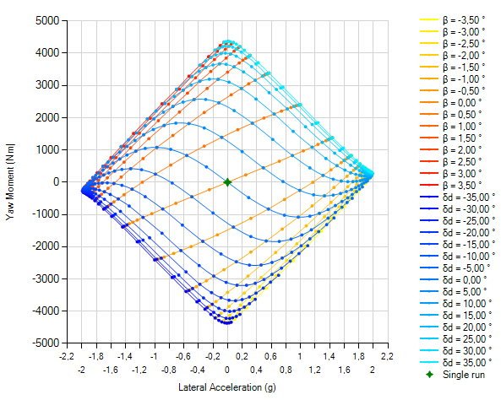
Source: the author.

Constant cornering radius YMD
Constant cornering radius YMDs tend to have an iconic “split” shape. All points of this YMD are simulated with the same cornering radius, and the velocity tends to grow towards the edges of the plot, laterally. Figure X represents a generic constant cornering radius YMD. Appendix X shows the effect of different inputs on the shape and size of the constant cornering radius YMD.

Figure 2– Generic representation of a constant cornering radius YMD
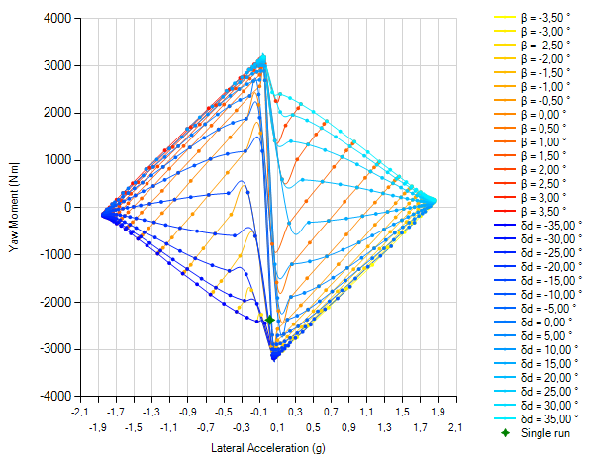
Source: the author.

future developments

Many further developments are possible (and encouraged) both in terms of the mathematical model and of analysis tools. This section describes improvements that should be developed in the future.

Improving the mathematical model

Different physical phenomena should be implemented in the mathematical model to increase its realism and help the users to understand vehicle behavior. This section provides some ideas and ways of accomplishing that.
Allowing the user to insert a proper aerodynamic map shall help in a more holistic approach to vehicle development. The aerodynamic and suspension departments shall then work together to optimize the use of an aero package in tune with the suspension. The implementation may follow the directives described in Chapter 2 of this document.
The implementation of an engine torque map allows for the simulation of conditions where the performance of the vehicle is not limited by the tires, but by the engine itself. The map may be as simple as a torque curve versus engine rotational speed with a gearbox model contemplating different gear ratios. A more sophisticated model could include engine load, TPS, transmission efficiency and other thermodynamical phenomena.
Additional tire behavior could be implemented, like overturning moments and self-aligning moments. The effect of those additions on yaw moment and lateral load transfer should be investigated and implemented. Also, that would allow for a complete definition of loads imposed on the suspension components, allowing for a more realistic structural analysis of the whole system.
Other kinematics phenomena should also be included, like the displacement of the center of gravity due to ride height variation, caused by downforce and jacking forces, for example. Track and wheelbase variation, steering load transfer caused by caster and kingpin inclination, are other examples. Additionally, a complete kinematics model could be implemented to improve realism on phenomena already contemplated in the original model, like roll center lateral and vertical displacements, motion ratio variations, etc.

IMPROVING THE ANALYSIS TOOLS

The current analysis tool available is too simple, being basically only of academic use. Improving the already existing and implementing new analysis tools is necessary for a proper design aiding development software.
The user should be able to compare multiple YMD plots simultaneously, varying any desired variable. Being able to directly compare different longitudinal accelerations and velocities or cornering radii is extremely useful. However, these are not the only possibilities. Allowing the user to compare different vehicle setups and parameters would profoundly impact decision making during design phases. Plotting multiple YMDs varying tire pressures, toe angles, track lengths and roll center positions are a few examples of what is possible.
On that note, the simulated data acquired via creating different YMDs with different parameters allow for the creation of different plots regarding the maximum capabilities of the vehicle. The YMD gives the user the maximum lateral acceleration and yaw moment possible, so comparing those values when changing vehicle parameters is extremely useful. That idea opens the possibility for sensitivity analyses, and other visualizations of the full capabilities of the vehicle, like a more sophisticated GGV diagram.

  - REFERences
DRISSEN, G, S. Development of a Four-Wheel Quasi-Steady State Numerical Model for Vehicle Dynamics Simulation. Bachelor’s Thesis in Mechanical Engineering – Universidade Federal de Santa Catarina, Florianópolis, 2025.

GUIGGIANI, M. The Science of Vehicle Dynamics: Handling, Braking and Rid of Road and Race Cars, Third Edition. Cham: Springer, 2023, https://doi.org/10.1007/978-3-031-06461-6.

  - APPENDIX A – CONSTANT VELOCITY YMDS

Figure 3 – Constant velocity YMD for $V=100 km/h$, $a_{lon}=0 g$, open differential

Source: the author.

Figure 4– Constant velocity YMD for $V=100 km/h$, $a_{lon}=-1 g$, open differential
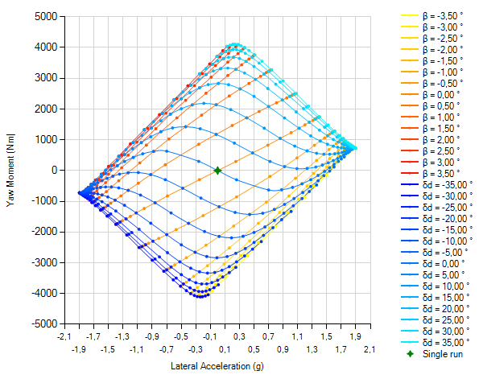
Source: the author.

Figure 5 – Constant velocity YMD for $V=100 km/h$, $a_{lon}=0.5 g$, open differential
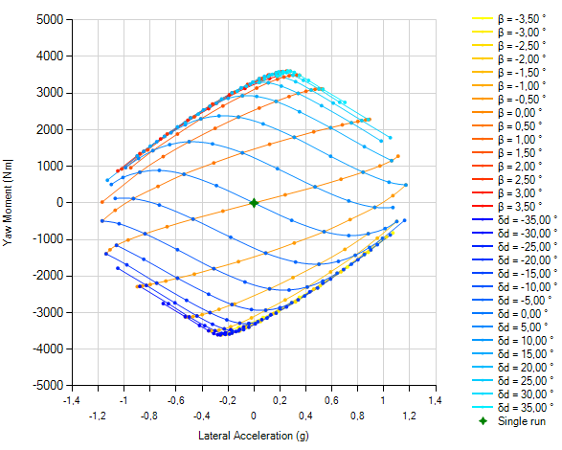
Source: the author.

Figure 6 – Constant velocity YMD for $V=100 km/h$, $a_{lon}=0.5 g$, geared differential
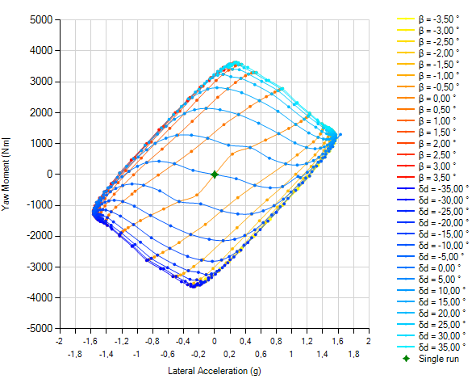
Source: the author.

  - APPENDIX B – CONSTANT CORNERING RADIUS YMDS

Figure 7 – Constant cornering radius YMD for $R=30 m$, $a_{lon}=0 g$, open differential

Source: the author.

Figure 8 – Constant cornering radius YMD for $R=30 m$, $a_{lon}=-1 g$, open differential
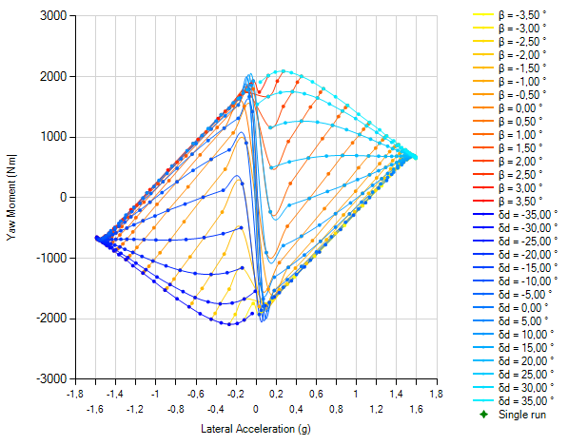
Source: the author.

Figure 9 – Constant cornering radius YMD for $R=30 m$, $a_{lon}=0.5 g$, open differential
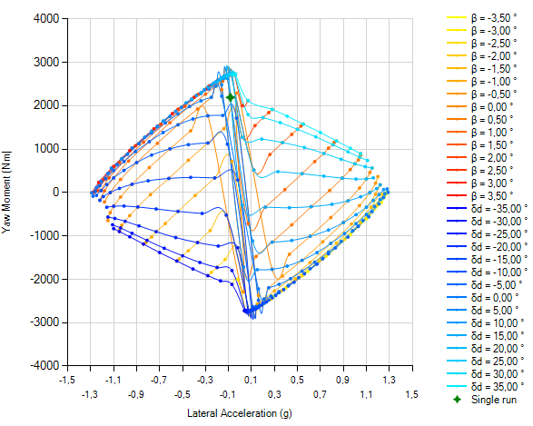
Source: the author.

Figure 10 – Constant cornering radius YMD for $R=30 m$, $a_{lon}=0.5 g$, geared differential
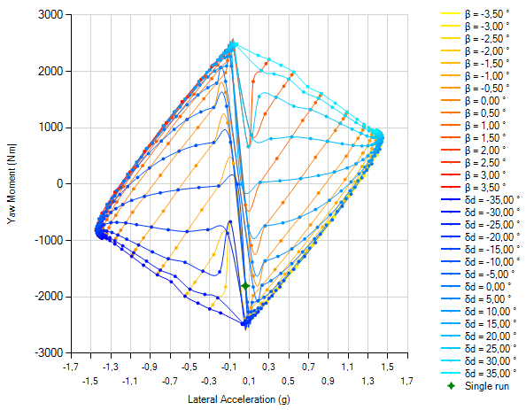
Source: the author.

