

**PENSION PAYMENT ORDER:EPS-95**

**EMPLOYEES PROVIDENT FUND ORGANISATION**

**REGIONAL OFFICE:BARRACKPORE(TITAGARH)**

|  |  |
| --- | --- |
| **PPO NO. With Region Code** | **Aadhaar No.(Member)** |
| WBTLO00082241 |  |
| **UAN:** | **Pension Amt:** 2892 |

# Particulars of Member

|  |  |  |  |  |  |  |  |  |  |  |  |  |  |
| --- | --- | --- | --- | --- | --- | --- | --- | --- | --- | --- | --- | --- | --- |
| **Member ID** | **Name of Member** | | | | **Gender** | | | **DOB** | | | | **Marital Status** | |
| WBTLO00006630000000290 | SHYAMAL GHOSH DASTIDAR | | | | M | | | xx/xx/1959 | | | | M | |
| **Date of Joining** | **Date of Exit** | | | | **Reason of Exit** | | | | **Date of Death(if applicable)** | | | | |
| 01/04/1983 | 19/07/2017 | | | | SUPERANNUATION | | | |  | | | | |
| **Service upto 15.11.95** | **Service after 15.11.95** | | | | **NCP Days** | **Wages on 15.11.95** | | | | | **Wages on Date of Exit** | | |
| 12 Years, 7 Months, 15 Days | 21 Years, 8 Months, 4 Days | | | | 6 | 2492 | | | | | 15000 | | |
| **Actual Service** | **Eligible Service** | | | **Pensionable Service** | | | **Pensionable Salary** | | | | **Weightage** | | **Yrs to 58 Yrs** |
| 21 Years, 8 Months, 4 Days | 34 | | | 21 Years, 7 Months, 28 Days | | | 11317 | | | | 2 | |  |
| **Name of Claimant & Relation** | |  | **Aadhaar No** | | **Type of Pension** | | | | |  | **Date of Commencement** | | |
| SHYAMAL GHOSH DASTIDAR | |  |  | | SUPERANNUATION | | | | |  | 20/07/2017 | | |
|  | |  | | |  | | | | |  |  | | |
| **Mobile No of Claimant** |  | 94 xxxxxx 35 | | |  | | | | |  |  | | |
|  | |  | | |  | | | | |  |  | | |
| **Postal Address of Claimant** | 33 /11, B.L GHOSH ROAD,G-1 GRD FLOOR , NOWDAPARA, ARIADAHA KOL-57 , , 427 , WB , 700057 | | | | | | | | | | | | |

# Beneficiary Details

|  |  |  |  |  |  |  |  |  |  |
| --- | --- | --- | --- | --- | --- | --- | --- | --- | --- |
| **Sl No.** | **Name** | **Relation with**  **Member** | | **Date of Birth** | **Aadhaar No.** | **Amount of**  **Pension** | **Pension Payable** | | |
| **From** | **To** | |
| 1 | BARNALI GHOSH DASTIDAR | W | | 20/01/1965 |  | 1446 |  |  | |
| 2 | SABARNA GHOSH DASTIDAR | S | | 19/09/2001 |  | 362 |  |  | |
| **Name of Guardian in case of Minor Beneficiary** | | | |  | | | | | |

# Benefit & Elibility

|  |  |
| --- | --- |
| **Widow(er) Pension** | On death of member pensioner(including disablement/short Service Pensioner) |
| **Children Pension** | At a time 2 children upto the age of 25 years along with Widow(er) Pension |
| **Orphan Pension** | On death/remarriage of widow(er). At a time 2 children upto the age of 25 years. |
| **Dependent Pension** | On death of dependent father followed by dependent mother |

# Disbursing Authority

|  |  |  |  |  |  |  |  |
| --- | --- | --- | --- | --- | --- | --- | --- |
| **Name of Office** | |  | **Address** | | |  | **Pin Code** |
| BARRACKPORE(TITAGARH) | |  | 4/2, S.N. BANERJEE ROAD, BARRACKPORE, Kolkata | | |  | 700120 |
|  | | |  | **Bank Details** |  |  | |
| **S. NO.** | **Pensioners Name** | |  | **Name of Bank** | **IFS Code** | **Bank A/C No.** | |
| 1 | SHYAMAL GHOSH DASTIDAR | |  | UNITED BANK OF INDIA |  | xxxxxxxxx8131 | |

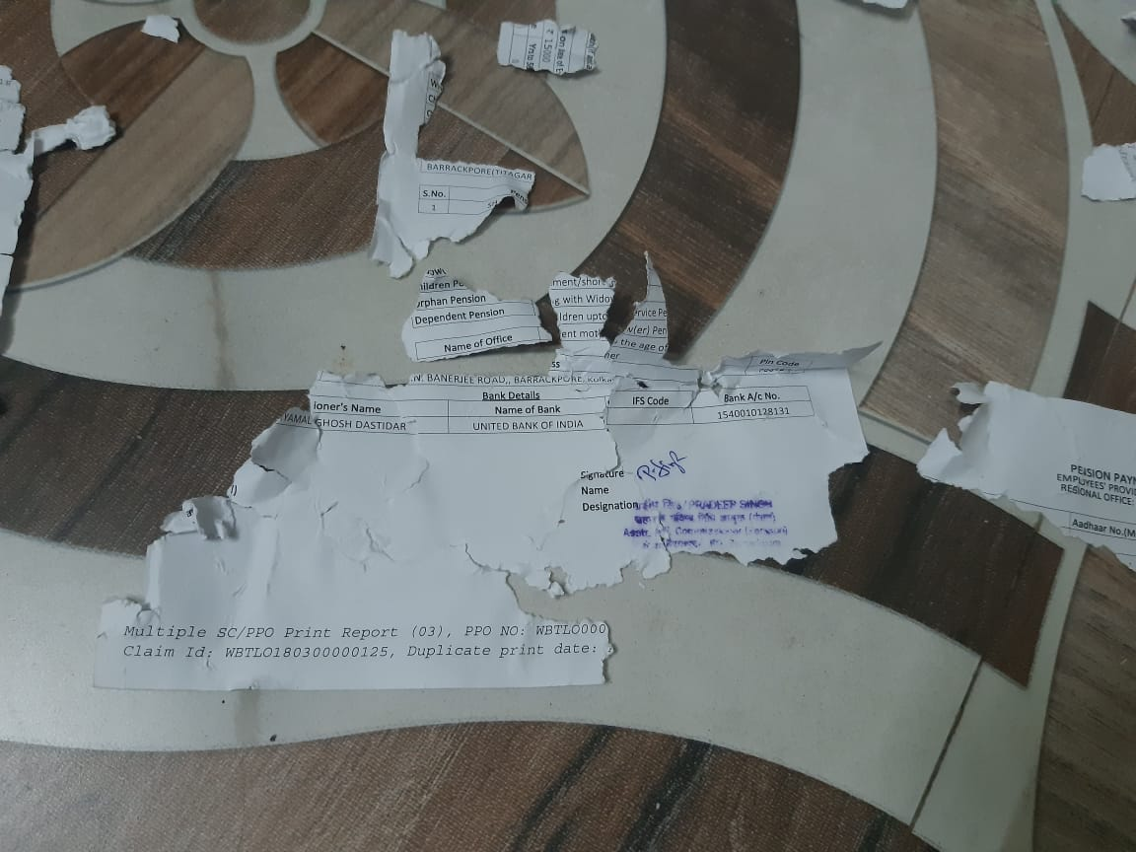

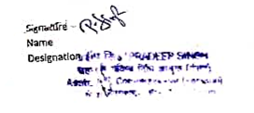





09

/11/2023 23:06:27 IST

[Powered by TCPDF (www.tcpdf.org)](http://www.tcpdf.org)