|  |  |
| --- | --- |
| **Project – External Documentation** |  |
| ISYS6211003  Web Based Application Development |
| Even Semester Year 2023/2024 |

* Project Title

wHeel Hub

* Introduction

wHeel Hub is an automotive retailer that is currently trying to expand their wings to online market by creating a web application that is used to showcase wHeel Hub’s automotive collections online. This project is to create the said web application.

* Report / Documentation

1. Home Page  
   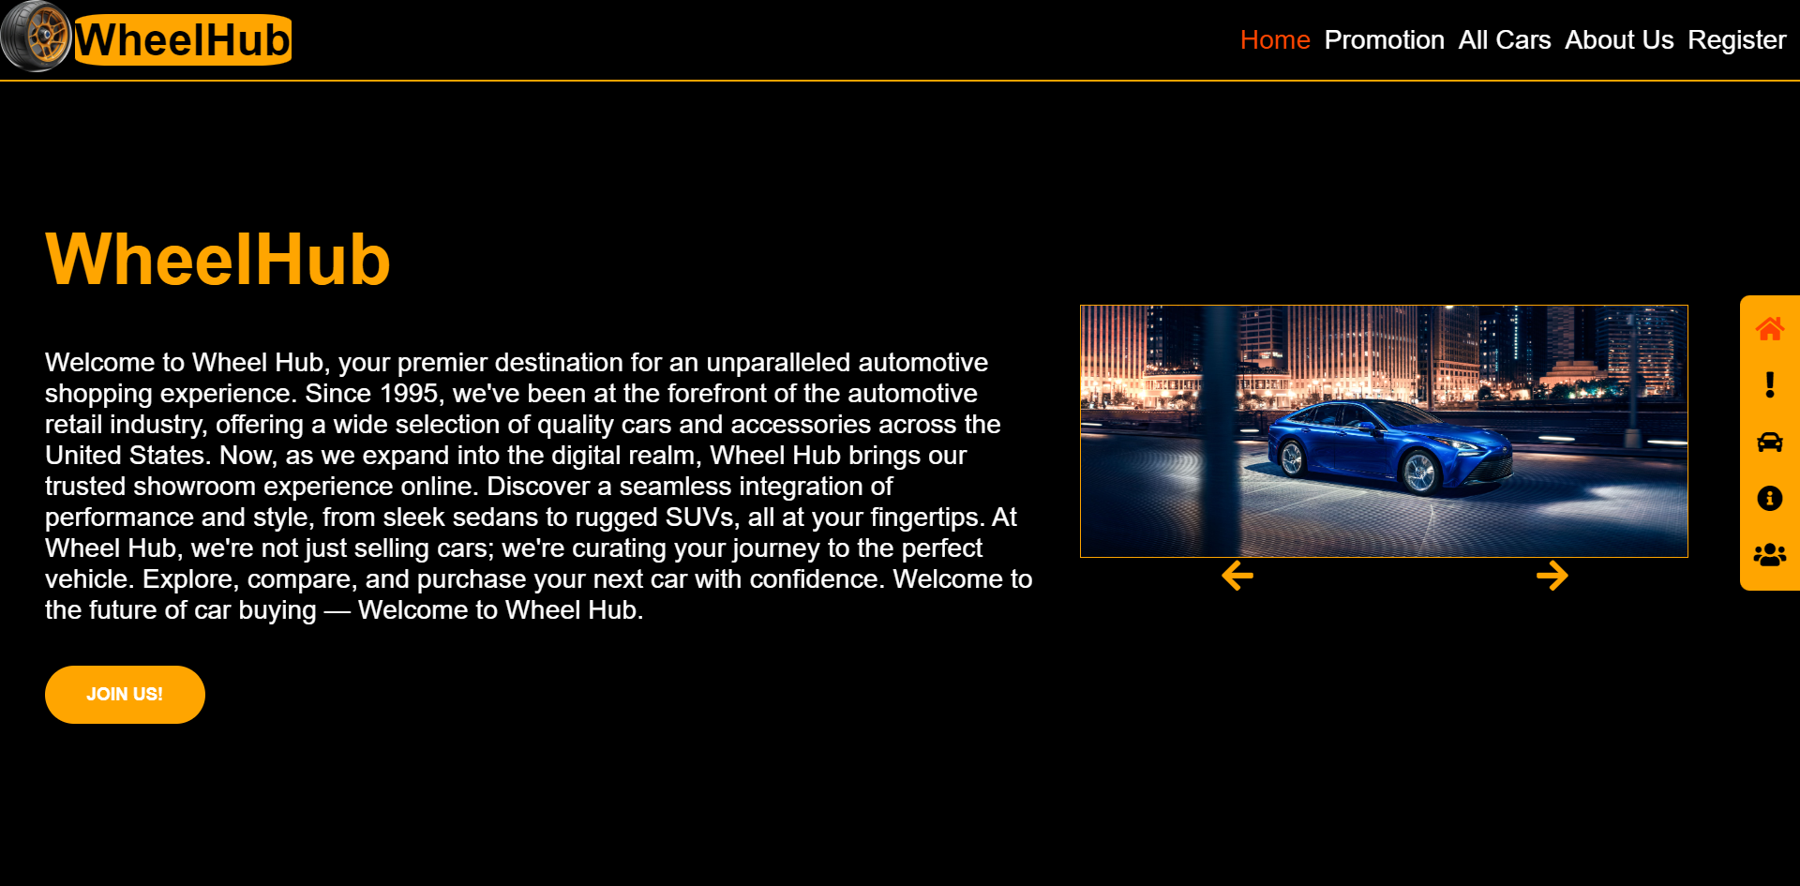  
   The main landing page that shows introduction to wHeel Hub, it has a button that leads to register form and an image carousel to show wHeel Hub’s cars.
2. Promotion Page  
   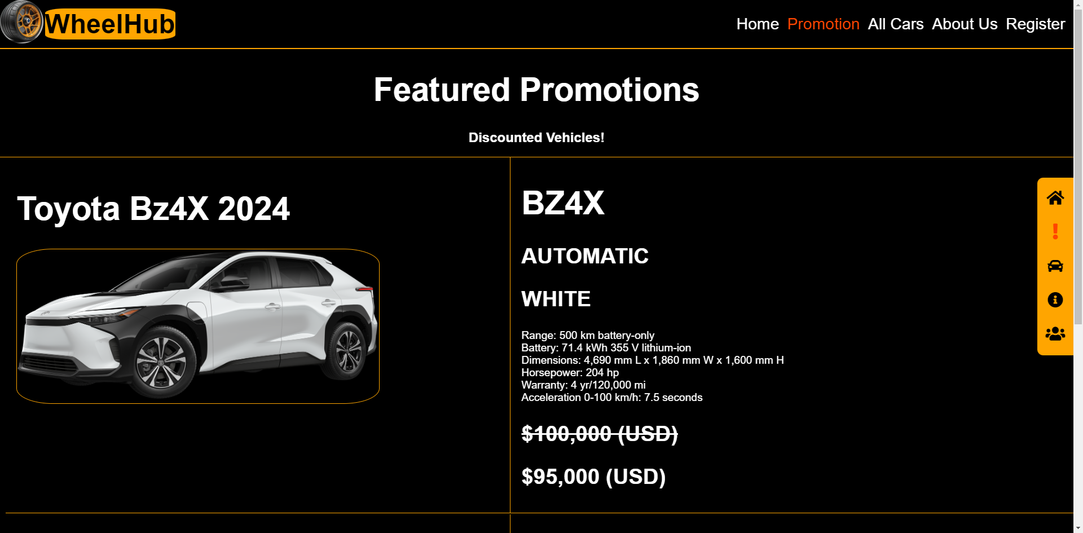  
   Is a page used to show cars that are on sale with the detail of the car containing the name, photo, type, transmission, color, etc., and also the sale price.
3. All Cars Page  
   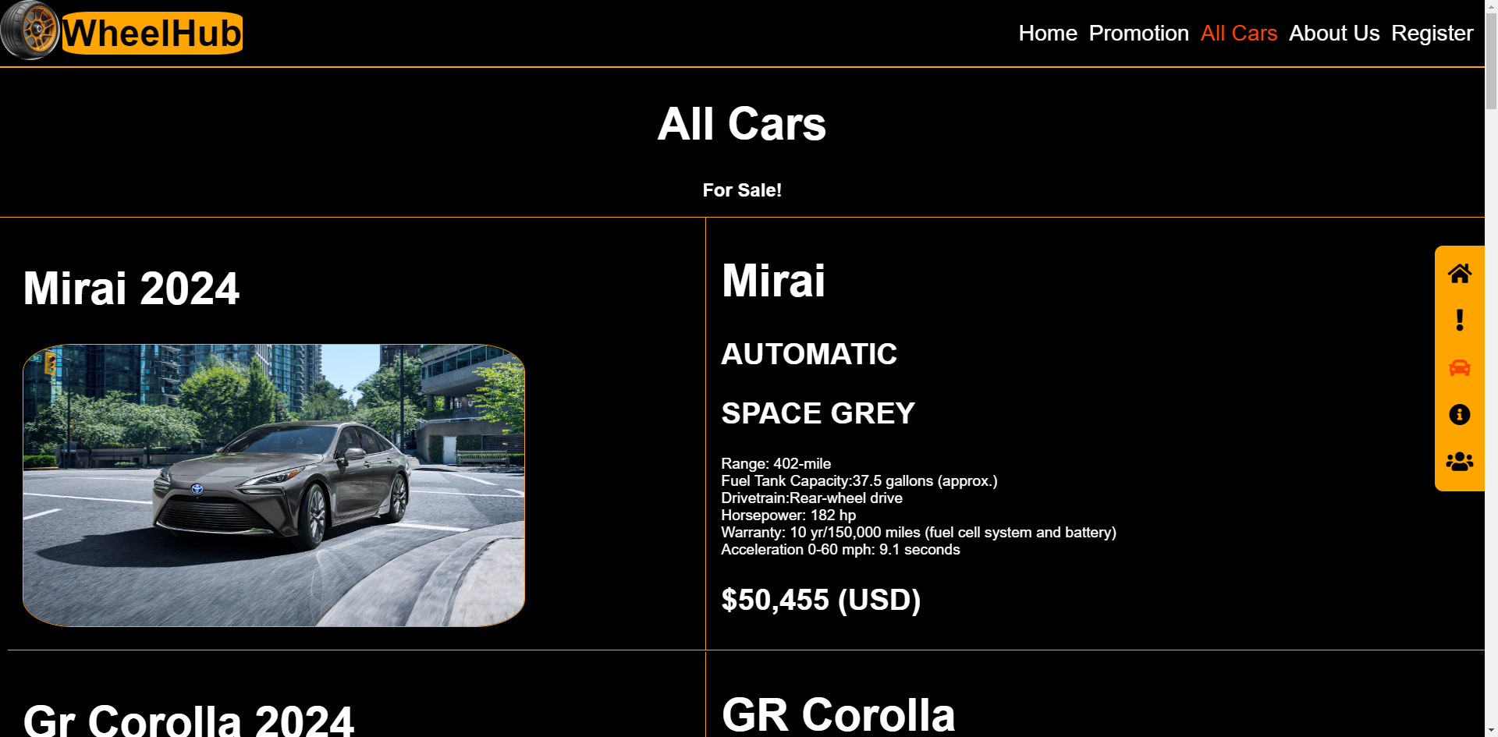  
   Is a page used to show all cars sold by wHeel Hub with the details of the car similar to promotion page.
4. About Us Page  
   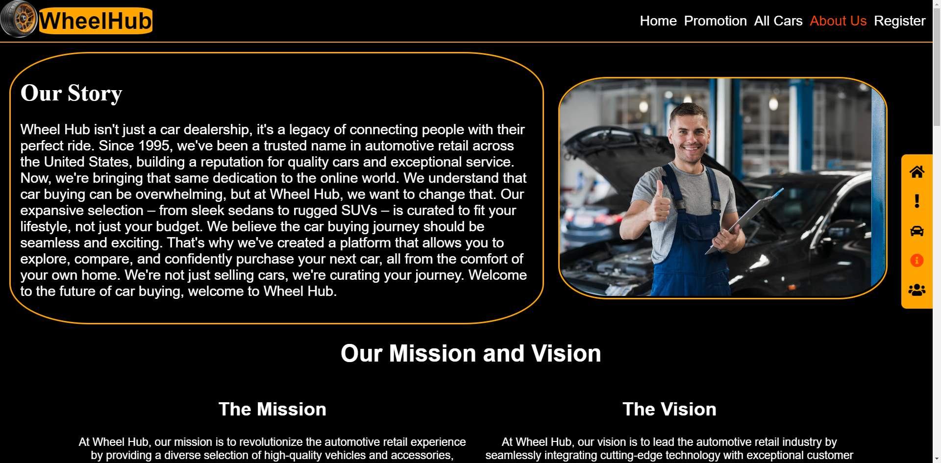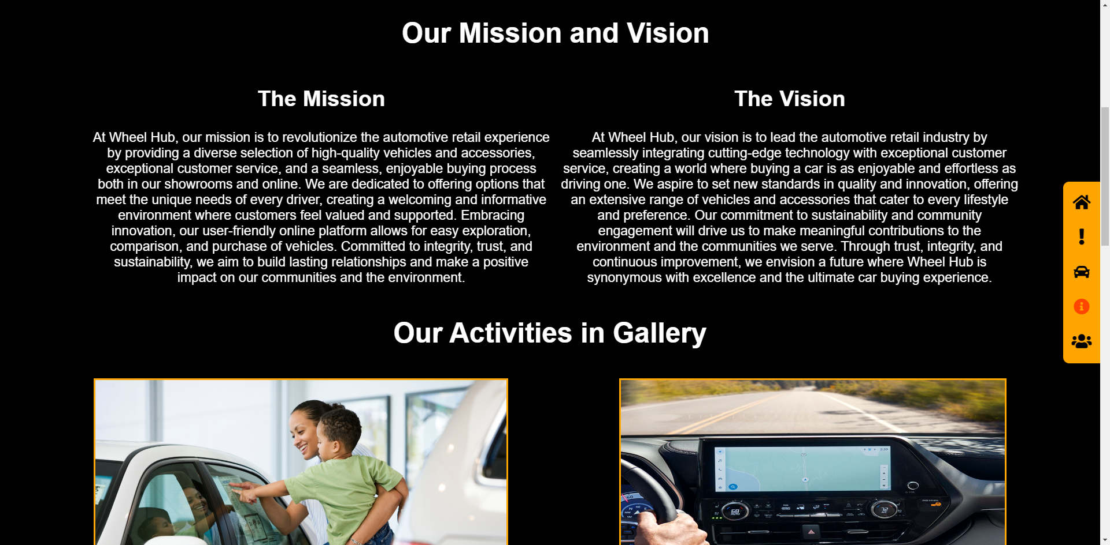Is a page used to show wHeel Hub’s profile including their back story, mission and vision. There are also wHeel Hub’s activities shown in a gallery.
5. Register Page  
   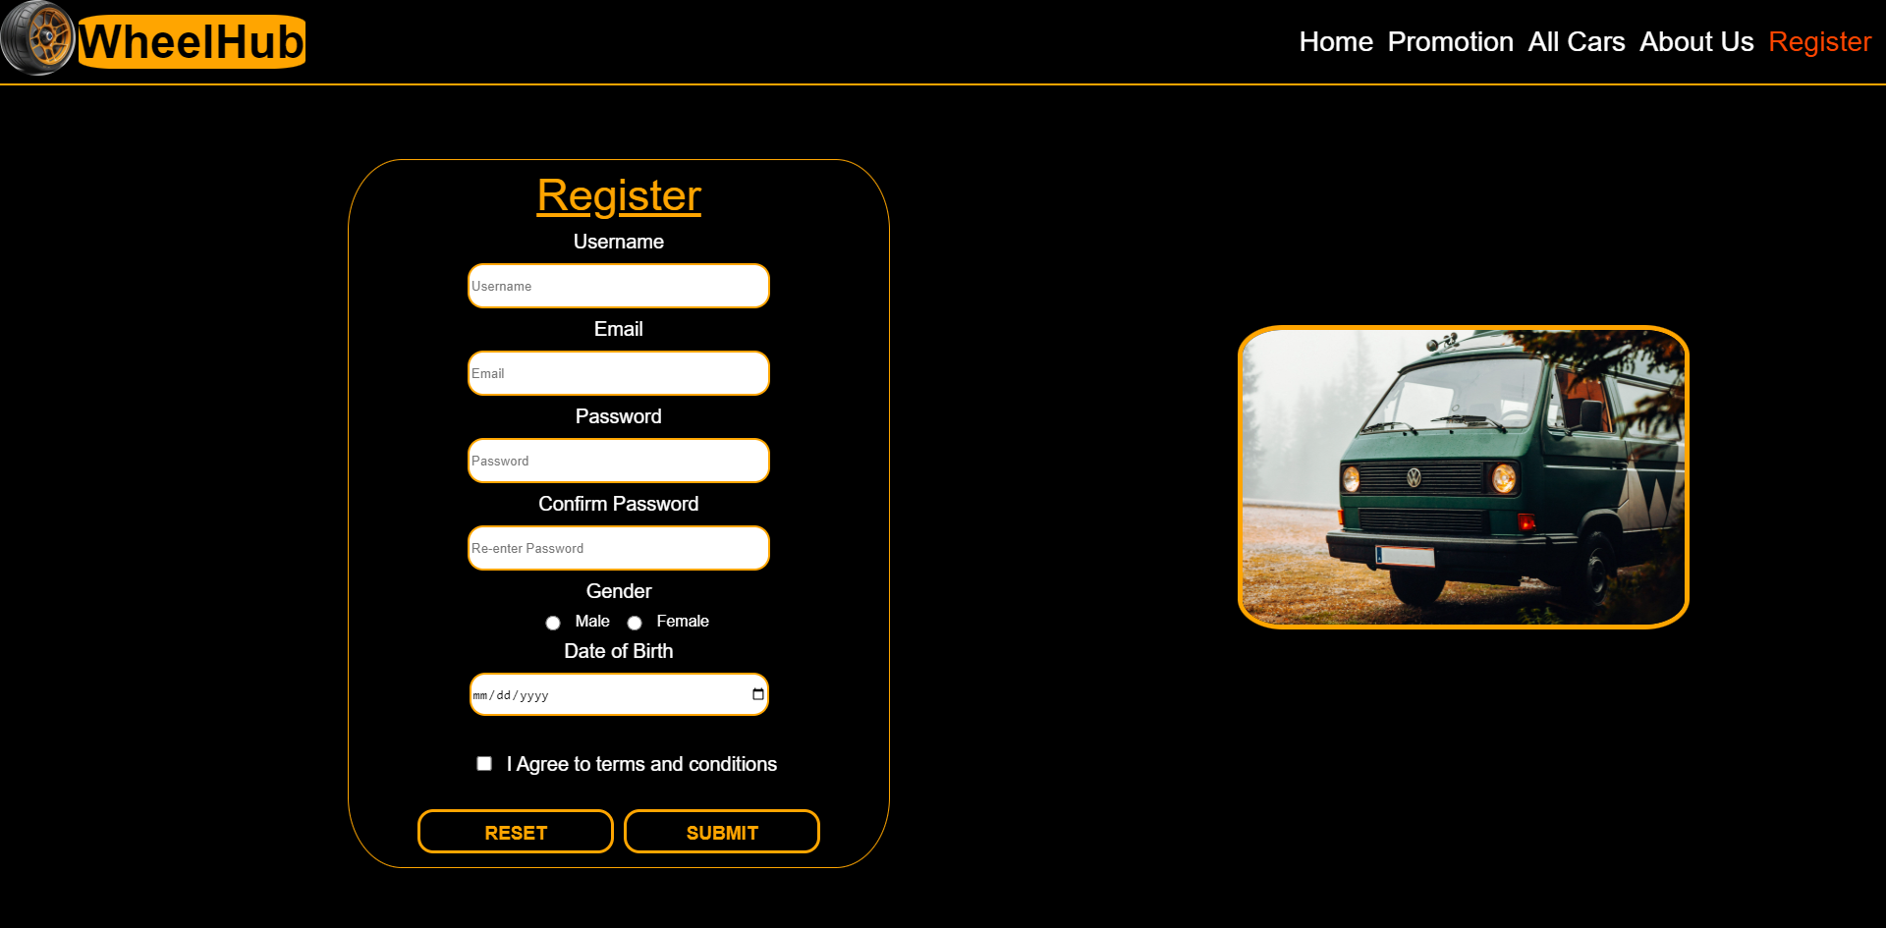  
   Is a page containing the form used to register to wHeel Hub’s web application asking user to input their usename, email, password, gender, and date of birth.

* Reference
* https://www.toyota.com/
* https://www.geeksforgeeks.org/how-to-design-image-slider-using-jquery/
* https://drive.google.com/drive/folders/1DsTyQkpcIbaOk3fhTaufhrEjhcYo2JOB
* Group Member
* 2602135004 – Gregorius Darren Tanaya
* 2602144526 – Laurensius Ricky Fernando
* 2602118912 – Ryan Rafael