Garrett Dunn

18th August 2022

CS 340

SNHU (Southern New Hampshire University)

Project Two README

**About**

The goal of this project was to develop a dashboard for the client, Grazio Salvare. This dashboard allows the user a simple and effortless way to find pets available for adoption around Austin, Texas. The dashboard has three major features that help achieve this: a main data table that contains all the relevant pet information, a pie chart displaying the different pet breeds according to the table, and a map that displays the pet’s current location for adoption. All these features can be easily filtered using check boxes.

**Using the Program**

The setup is straightforward but will be broken into three distinct parts:

- MongoDB setup and utilizing the data

- Installing the required files

- Accessing the dashboard

**Part 1: MongoDB setup**

You will need a computer with Linux and the current version of Python and Pymongo installed. To use this dashboard, the first preliminary step is importing the pet data into MongoDB:

- Open your computer terminal.

- Engage MongoDB:

/usr/local/bin/mongod_ctl start

- Load the desired datasets into MongoDB:

cd/usr/local/datasets

/usr/local/bin/mongod_ctl start-noauth

**IMPORTANT: A prompt will appear after the execution of the command above that will display your port number being used, KEEP THIS NUMBER IN MIND as it will be needed for the next step.**

mongoimport --port (**YOUR PORT NUMBER**) --db city --collection inspections ./city_inspections.json

mongoimport --port (**YOUR PORT NUMBER)** --db AAC --collection animals -- type=csv –headerline ./aac_shelter_outcomes.csv

- Start authentication

- Suspend MongoDB:

/usr/local/bin/mongod_ctl stop

- Restart MongoDB with authentication

/usr/local/bin/mongod_ctl start

You can see this process in the screenshot below:

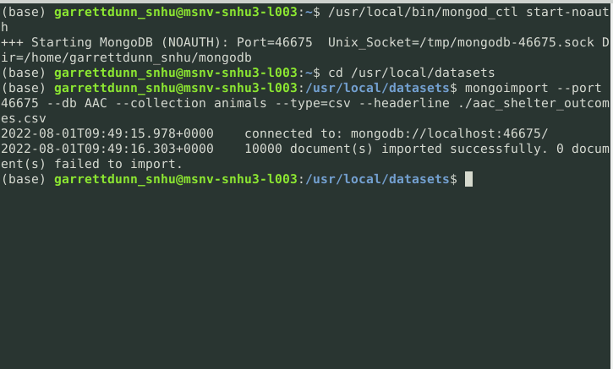

Next, we will set up the privileges for the admin and user. This can be done by following the screenshots below:

**Admin**

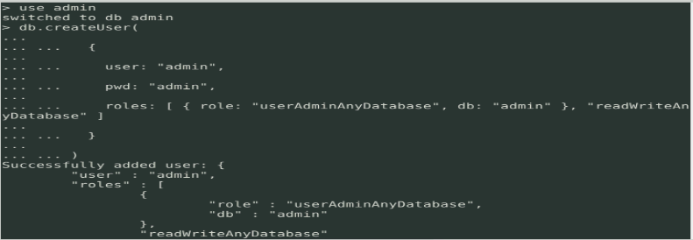

**AACuser**



**Part 2: File installation**

This part is amazingly simple and only requires both the cs340CRUD.py and project2Dash.ipynb files to be downloaded to your home directory.

**Part 3: Utilizing the dashboard**

Once you access the dashboard, select the desired filter boxes at the top lefthand side of the dashboard to filter the table’s results. Here is the dashboard that you should be viewing:

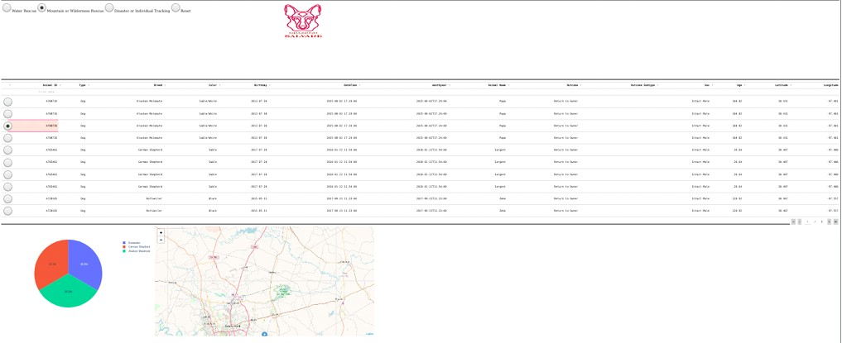**Code blocks of dashboard functionalities**

**Filter Buttons**

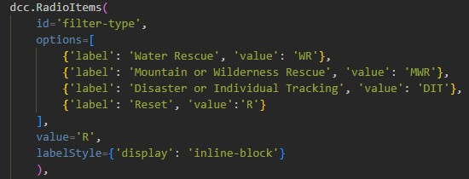

**Table**

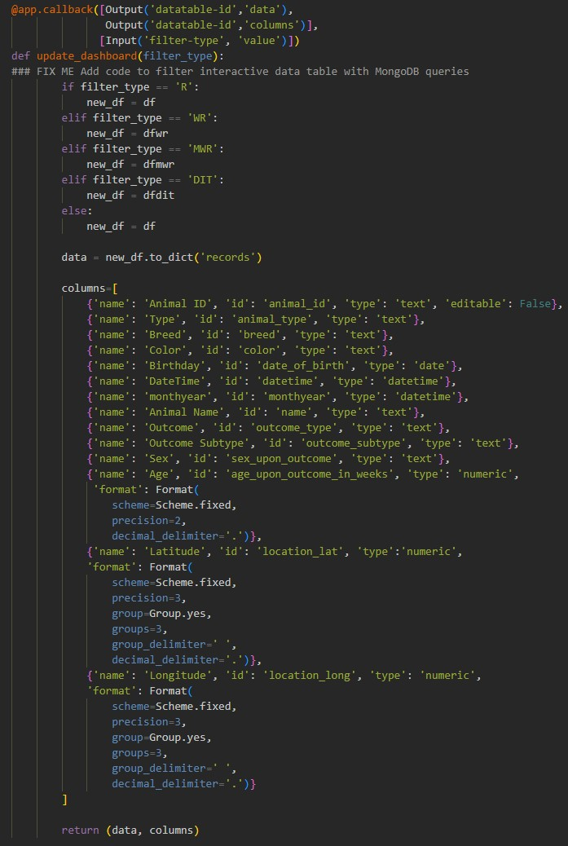

**Graph**

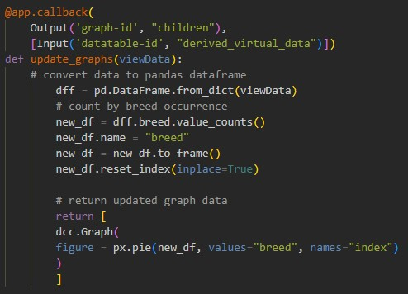

**Map**

