**GIT interview questions TASKS**

1. What is Version control system or Source code manager?

Version control system is also known as source code manager.

It is a practice of tracking and managing changes to software code.

It is a kind of a software that helps developer team to efficiently communicate and track the changes the have been made to the source code along with the information like who made the change and what change had been made.

There are 2 types version control system:

Centralized version control system : for example SVN

Distributed version control system: for example GIT , BITBUCKET…..

1. Benefits of VCS or SCM?

Benefits:

* Project development speed is enhanced,
* reduces the possibilities of error and conflicts in development,
* helps in recovery in case of disaster situation.
* Leverage productivity and expedite the product delivery.
* Informs us who, when, what, why changes have been made in the repos.

1. What is Git and What is a repository in GIT?

* GIT is a software, command line tool. GIT is installed locally in the system.
* Git is a open source distributed version control system
* Git is installed on a workstation and acts as a client and a server.
* In GIT there is no need to connect to server all the time because, Every developer has a local copy of the full version of their project in their local system.
* GIT repository contain collection of files of various versions of a project.
* In GIT repository allows us performing various operations on it to create different versions of a project and these ops include addition of files, creating repositories, committing an action, deleting a repository.

1. Difference between Git and SVN?

|  |  |
| --- | --- |
| SVN | GIT |
| SVN is a centralised version control system. | GIT is a distributed version control system. |
| SVN has a complicated process for branching and merging. | In GIT you can create, delete, change a branch at any time, without effecting commits. |
| SVN has a separate server and a client,  only the files which are working by the developer are kept in local machine. Due to this developer always be online and connected to the server | Git is installed on a workstation and acts as a client and a server.  Every developer has a local copy of the full version of their project in their local system.  Due to this, there is no need of get connected to server all the time |
| SVN allows you to specify the read and write access per file level and per directory level. | By default, GIT takes all the users have same permissions. |
| SVN can handle large binary files and in addition to code and storing them. | GIT can’t handle compressing and storing large binary files |

1. Two types of git authentication?

SSH and HTTPS:

For HTTPS, Git authenticates with username + Password and with GitHub instead of password you can also use a PAT (personal access token) and they are stored in Git credential stores.

For SSH, Git authenticates with personal SSH key and they are stored in file id_rsa or ssh-agent.

1. Branches in Git and its purpose? What is the common branching pattern in GIT?

A branch in Git is simply a lightweight movable pointer to one of these commits. The default branch name is master.

As you start making commits, you're given a master branch that points to the last commit you made. Every time you commit, the master branch pointer moves forward automatically.

For creating a new branch command is,

===== $git branch branch-name

If you want to switch a branch then command is,

===== $ git checkout branch-name

1. What is Pull requests?

Pull requests let you tell others about changes you've pushed to a branch in a repository on GitHub.

Once a pull request is opened, you can discuss and review the potential changes with collaborators and add follow-up commits before your changes are merged into the base branch.

When working with pull requests, keep the following in mind:

* If you're working in the [shared repository model](https://docs.github.com/en/articles/about-collaborative-development-models), we recommend that you use a topic branch for your pull request. While you can send pull requests from any branch or commit, with a topic branch you can push follow-up commits if you need to update your proposed changes.
* When pushing commits to a pull request, don't force push. Force pushing can corrupt your pull request.

1. How to setup repository through command line?

First let’s create a directory named “development”

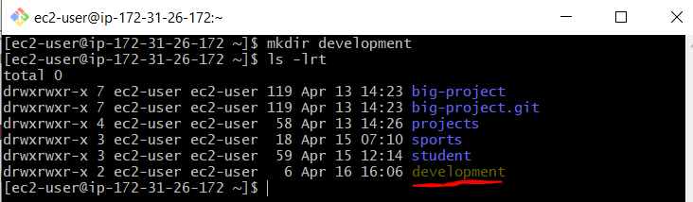

Let’s initialise it:



Now I have created a file named “programmer.txt” and added some text in it:

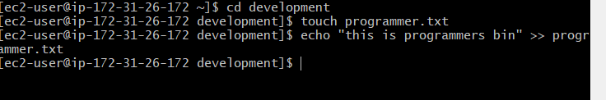

I want to see the status of it, as it display as untracked files:

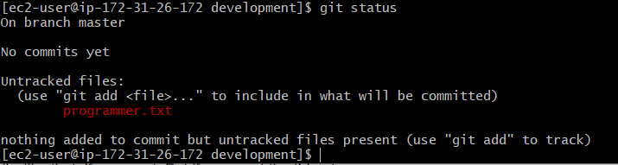

Let us add the file to stage area:

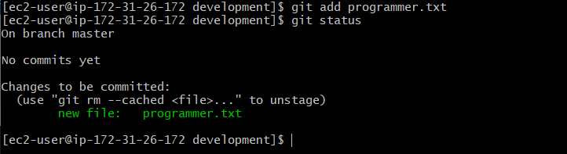

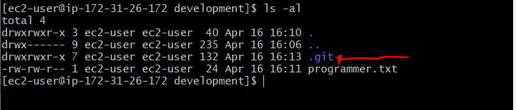

Let us commit:

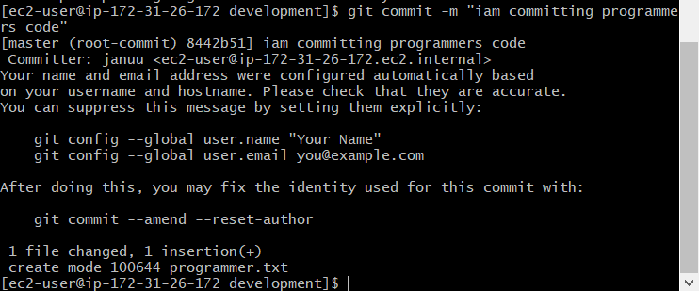

Now we are adding the file to the remote server:



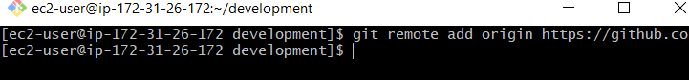

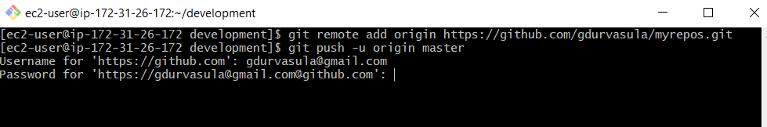

Now push the file to the remote:

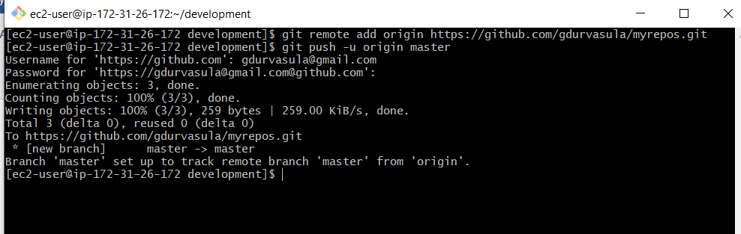

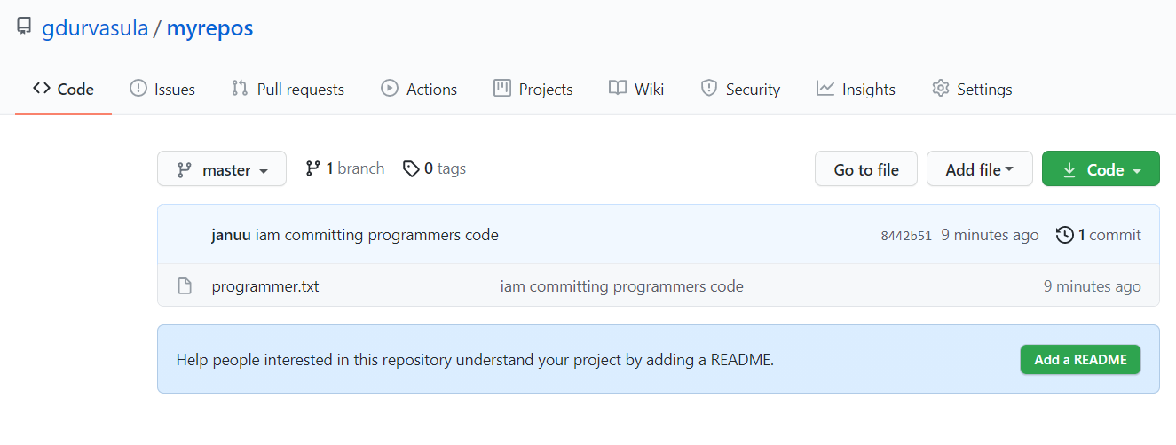

1. How to setup repository in github and clone it.

Open the github and goto 🡺 new option

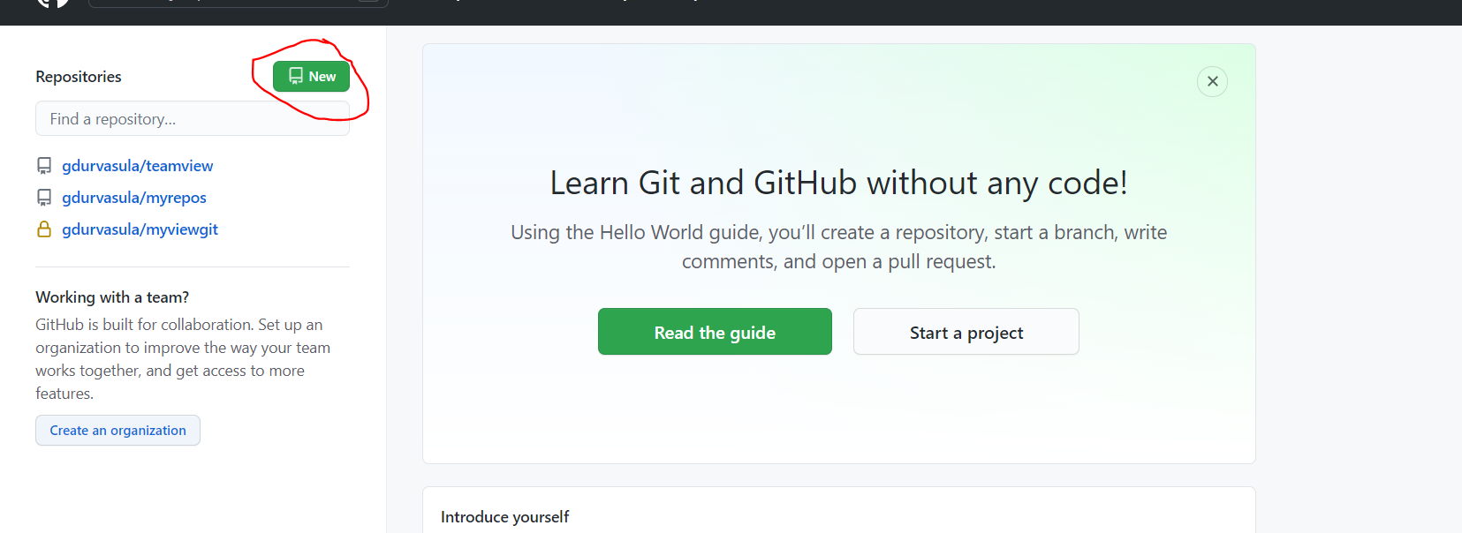

Now let’s create a new repository:

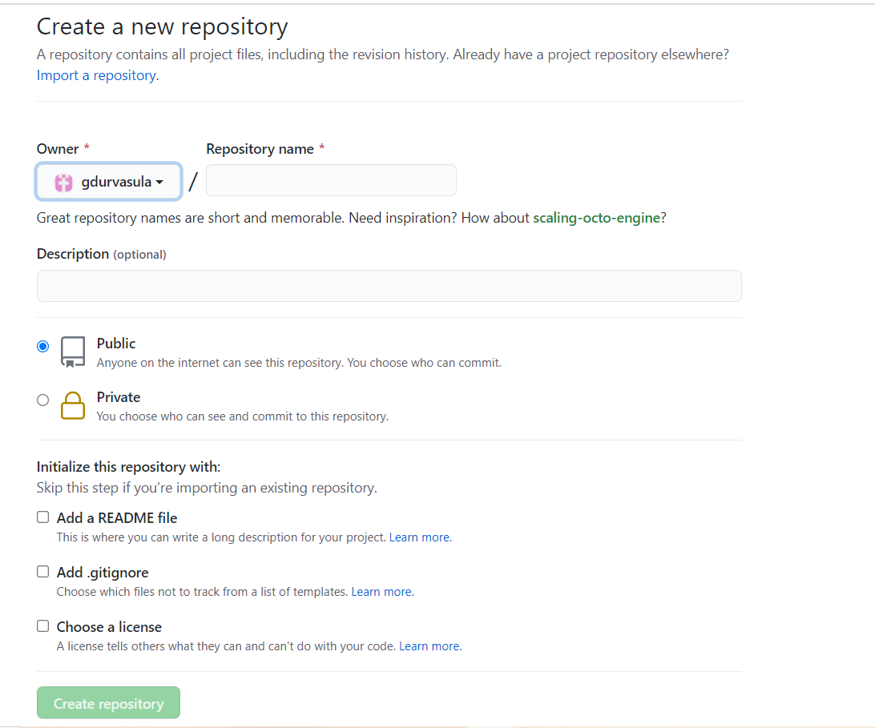

A new repo got created in GitHUB

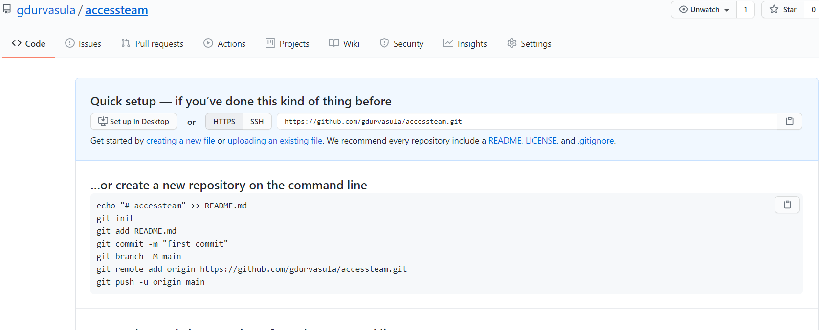

Now from Git BASH lets clone it using command:

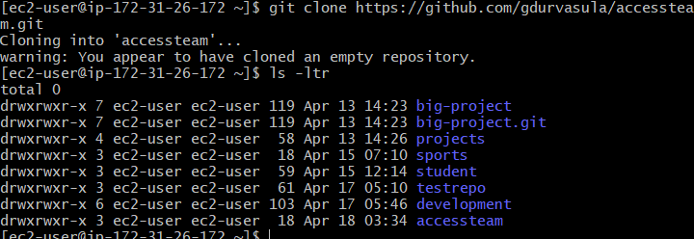

1. What is git clone command used for?

$ git clone command is used to clone a repository from GitHub to your local computer to make it easier to fix merge conflicts, add or remove files, and push larger commits. When you clone a repository, you copy the repository from GitHub to your local machine.

1. What is git config command user for?

Git config command is used to specify the configuration settings

$ git config –list gives the list of configurations.

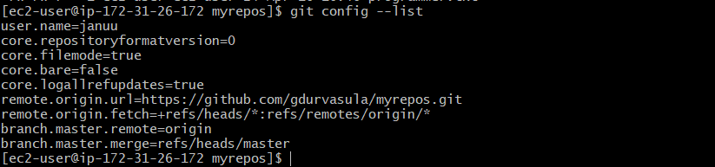

If you want to setup username and email etc command as follows:

$ git config --global user.name "John Doe"

$ git config --global user.email johndoe@example.com

1. Git config data is stored in what location?

Git config data is stored at == “.git/config” directory

1. Git config global and local files?

In windows we can find git configuration files in:

Local == config

Global == .gitconfig

1. Content of git config file?

Contents of git config file below:

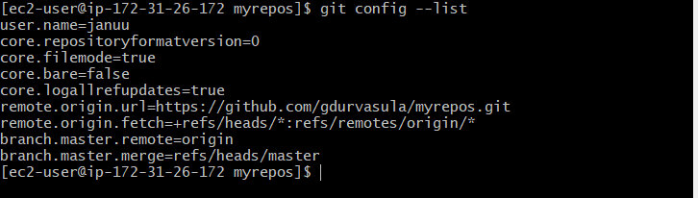

1. Git add command’s purpose?

Main purpose of git add command is to add the changed or new file of your directory to the staging area from where we can commit the file.

===== $git add filename ===

1. How to remove/rename files in local git repo?

If we want’s to remove a file then we should contain file.

Command for removing a file is ,

====== $git rm filename ======

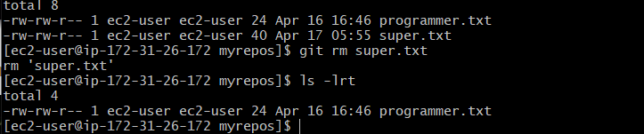

If you want to rename the file then the command is,

=========== $ git mv originalfile newfile ==============

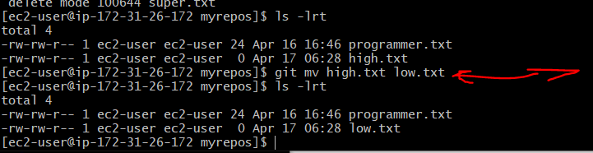

1. git commit command’s purpose?

First if we have to create a file using touch command then after that we have to add it to the staging area using “$git add “command and then we will find some untracked files if we did not added them to staging area if it done then we have to make use of “$git commit” command.

================= $git commit -m “message” =======================

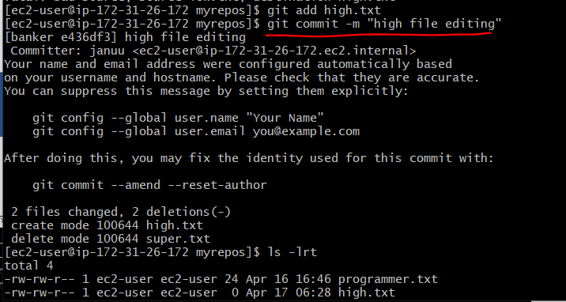

1. How to sync local git repo data with github?

The process of Syncronizing local repo wit github below:

First, we have created file in certain repository and then we added some text to it.

Next we added the file to staging area by [ $ git add file ] command.

Next, we committed it by the command.

After committing we have pushed to the file to github.

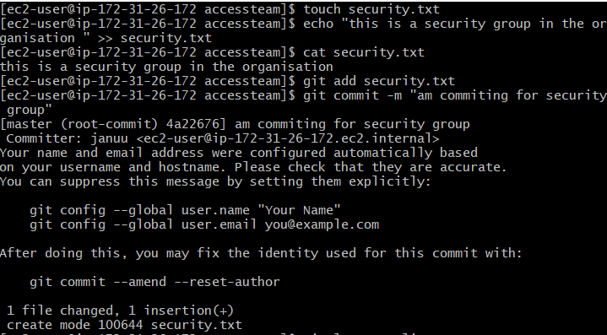

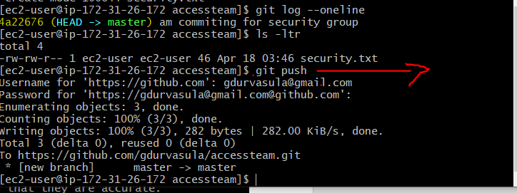

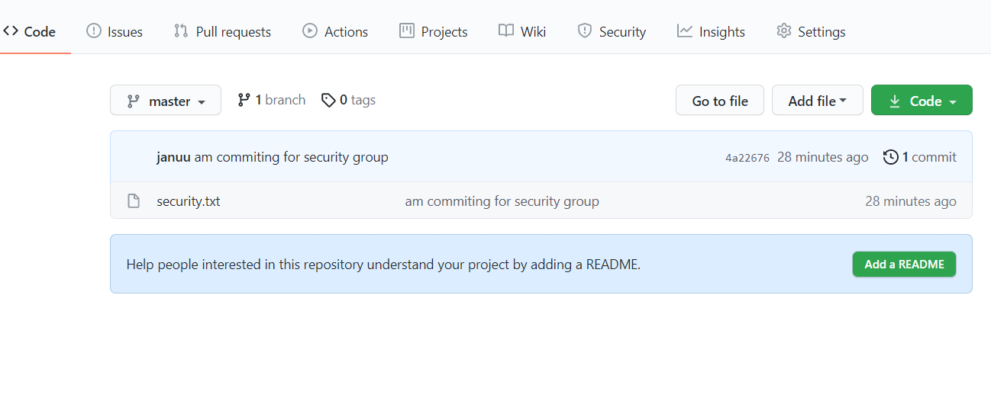

1. pull origin master (to sync local repo with remote repo)

First I have created a branch in the github and then added a file with text to that branch.

Now my moto to fetch the created branch in git bash.

Goto🡪git bash

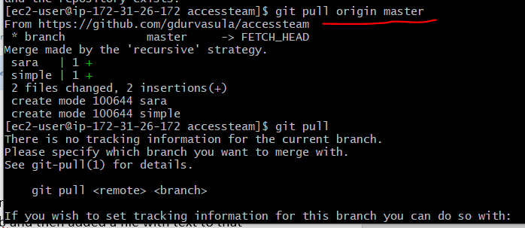

Sometimes If we could not able pull then, just checkout all other branches by using command,

======$ git checkout -b ===========

======$ git checkout -b [ branch ] [ originbranch ] ==========

======$ git branch ======= now we can see the created branches in git cmd.

1. git fetch?

If we want to download objects and refs from another repository we’ll make use of “fetch”

============$git fetch [options] ===========

It can fetch from either a single named repository or URL or from several repositories at once.

Some examples:

* To fetch remote repository : $ git fetch <repo Url>
* To fetch a specific branch: $ git fetch <branch url> <branch name>
* To fetch all the branches: $ git fetch -all
* To synchronize the local repo: $ git fetch origin

1. git merge?

To merge two or more development histories together we make use of it.

1. git pull?

This command fetches and merges changes on the remote server to your working directory.

====== $ git pull [ repository link] ============

1. How to change branches in local git repo?

We can change branches in local git repo by using a command ,

========== $ git checkout <changebranch> ===========

To quickly switch branch we have another command,

==========$ git switch <existingbranch> ================

1. What is the difference between ‘git remote’ and ‘git clone’?

Git remote : this command is used to connect your local repository to the remote server.

It just creates an entry in your git configuration that specify a name for a particular URL.

Here we must have a git repository to use this.

========= $ git remote add [variable name] [remote server link]============== 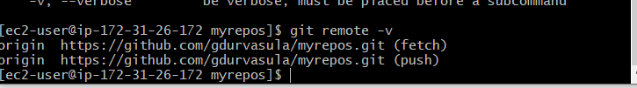

Git clone : this command is used to obtain a repository from existing URL.

It creates a new git repository by copying an existing local repo.

=========$ git clone [ url ] =====================

1. git status?

This command lists the all the files that have to be committed.

======= $git status ==========

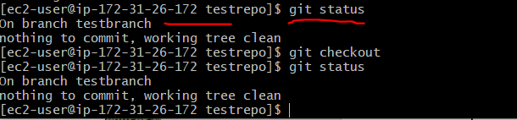

1. What commands you know in git./ What commands you used in git .

* For initialising the git we use command,===> $ git init



* Command that lists the all the files that have to be committed ===> $ git status



* To add file to the staging area command is, ===> $ git add [ file ]
* $ git commit -m “message” ====== used to commit the file which is in staging area.
* $ git clone ====== used to copy one file to another file
* $ git - - version ====== we can know git version
* $ git config - - list =====this lists the configuration files in git
* $ git rm -f [ source file/path ] === if want to remove file from staging area.
* $ git log ============if want to see the log of the file where we can get commit ID.
* $ git tag =======this command is used to create a tag.
* $git tag show ===========shows the tag
* $ git branch [ branch-name ] === this creates a branch for us.
* $ git checkout branch-name ====== we will switch to the given branch.
* $ git rebase branch-name === unwanted history it removes by keeping only wanted history.
* $ git reset HEAD file ====== to un-stage a file we use this command

1. how you used git. Explain git flow in your company / organization.

As per project requirement we have moved to GIT.

Our usage of git in day-to-day life is quite frequent.

If we comes to the flow :

We have a master branch which is used for production releases.

A develop branch is created from the master here it contains stable features for further releases.

Now we creates as many feature branches like Feature/f1 , Feature/f2 .

When feature is stable and tested then we integrate by merging the develop branch into feature branches.

Now we go for release v1.1.0 and we use this release branch to isolate and stabilize the release.

In this stage itself we look for bugfixes.

Creates a hotfix branch to patch a production releases.

Hotfixes are integrated into both master and develop.

1. What is git ignore. How to ignore a branch or files in git.

Git ignore means intentionally untracked files. Sometimes we do not want to push the files into github and want them to be ignored. They are explicitly ignored by git.

If we want ignore a particular file then we will create a .gitignore and we will add the file.

Now we cannot able to see the file once we add it in .gitignore

1. How to migrate from svn to git.

* Firstly check whether we have git repo or not if not create by the command ,

$git init ------------------- now it got initialised an empty repo got created.

* Copy the Url of the SVN repo. Goto svn server manager and from the repository copy the Url
* To clone SVN to GIT run command,

$git svn clone <svn repo Url>

* By above command we can copy svn repo files to Git and it ask for svn user access like username and password.

Now clone got created

* Now we will add the cloned repo to remote server

$git remote add origin <remote URL>

$git remote add origin https://github.com/gdurvasula/myrepos.git

* We push the project to remote server

$git push origin master

* If you want to clone all trunks, branches , tags then command is

$git svn clone <svn url> -T trunk -B branches -t tags

1. Why git is better then SVN repo.What are difference between SVN repo and git.

==============================================================

🡪SVN is a open source centralised version control system. SVN is free of cost.

🡪Git is a open source distributed version control system

************************************************************************

🡪GIT uses multiple repositories like central repository, server and as well as local repository

🡪But SVN does not centralized repository and server.

GIT has staging area.

*****************************************************************

🡪Git is installed on a workstation and acts as a client and a server.

Every developer has a local copy of the full version of their project in their local system.

Due to this, there is no need of get connected to server all the time

🡪SVN has a separate server and a client,

only the files which are working by the developer are kept in local machine.

Due to this developer always be online and connected to the server.

*********************************************************************

In GIT checkout time is high due to this performance gets slowdown.

Only a working tree and the latest changes are checked out in local machines itself so

As the checkout time will be less and performance will be maintained high.

********************************************************************

In GIT you can create, delete, change a branch at any time, without effecting commits.

So, it is ideal for branching but with SVN it is a complicated process for branching and merging.

***************************************************************************

By default, GIT takes all the users have same permissions but SVN allows you to specify the read and write access per file level and per directory level.

**************************************************************************

GIT can’t handle large binary files but SVN can handle in addition to code and storing them SVN would takes less space than GIT. SVN isn’t a great tool for automation and DevOPS

1. What is git / git hub / git lab explain in detail.

GIT:

* It is a software, command line tool and
* It is installed locally in the system.
* It is a version control system .

GitHub:

* GITHUB is hosted on the web.
* GITHUB is a service, and is a graphical user interface.
* GITHUB is a hosting service for the git repos.
* GitHub is a repository hosting service tool that features collaboration and access control.
* It is a platform for programmers to fix bugs together and host open-source projects.
* GitHub projects can be made public and every publicly shared code is freely open to everyone.

GitLAB: It is an opensource repository hosting manager tool and is used for the software development process.

It also allows us to import the repository from Google Code, Bitbucket, etc.

1. How to install git in Linux & Windows?

We have to download latest git for windows or linux as per our requirements from the git page.

After download we have to install it our system with git bash.

Here we have to check version with command == $git –version ===

For any help regarding git we have a command == $ git help ===

