**1) Create one maven project , add two plugins , 5 different dependencies in pom.xml , build the maven project ,change m2 repo path in setting.xml**

**----->Create one maven project**:

I have created a project by naming it as “MywebApplication”

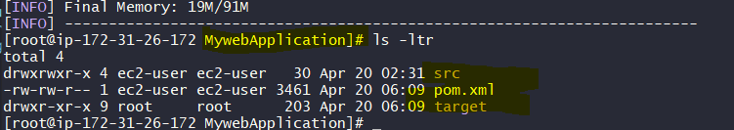

**add two plugins , 5 different dependencies in pom.xml :**

After that I have gone into pom.xml file where I have added some dependencies like below:

<!-- https://mvnrepository.com/artifact/log4j/log4j -->

<dependency>

<groupId>log4j</groupId>

<artifactId>log4j</artifactId>

<version>1.2.17</version>

</dependency>

===================================

<!-- https://mvnrepository.com/artifact/org.springframework/spring-beans -->

<dependency>

<groupId>org.springframework</groupId>

<artifactId>spring-beans</artifactId>

<version>5.3.6</version>

</dependency>

=====================================

<!-- https://mvnrepository.com/artifact/org.springframework/spring-jdbc -->

<dependency>

<groupId>org.springframework</groupId>

<artifactId>spring-jdbc</artifactId>

<version>5.3.6</version></dependency>

=========================================

<!-- https://mvnrepository.com/artifact/com.amazonaws/aws-java-sdk-ec2 -->

<dependency>

<groupId>com.amazonaws</groupId>

<artifactId>aws-java-sdk-ec2</artifactId>

<version>1.11.1000</version>

</dependency>

===========================================

<!-- https://mvnrepository.com/artifact/com.googlecode.concurrentlinkedhashmap/concurrentlinkedhashmap-lru -->

<dependency>

<groupId>com.googlecode.concurrentlinkedhashmap</groupId>

<artifactId>concurrentlinkedhashmap-lru</artifactId>

<version>1.4.2</version>

</dependency>

============================================

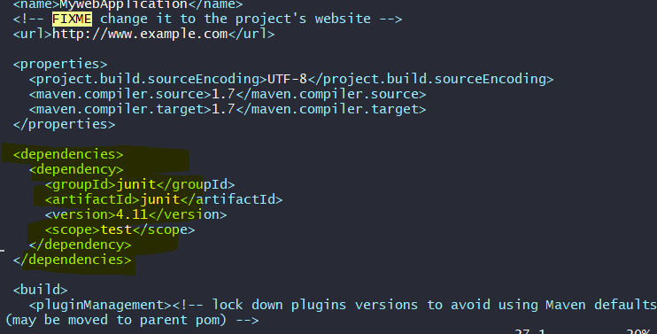

After adding dependencies I have added some <plugins> in <build>

<plugin>

<artifactId>maven-war-plugin</artifactId>

<version>3.3.1</version>

</plugin>

============================================

<plugin> <artifactId>maven-rar-plugin</artifactId><version>2.4</version></plugin>

============================================

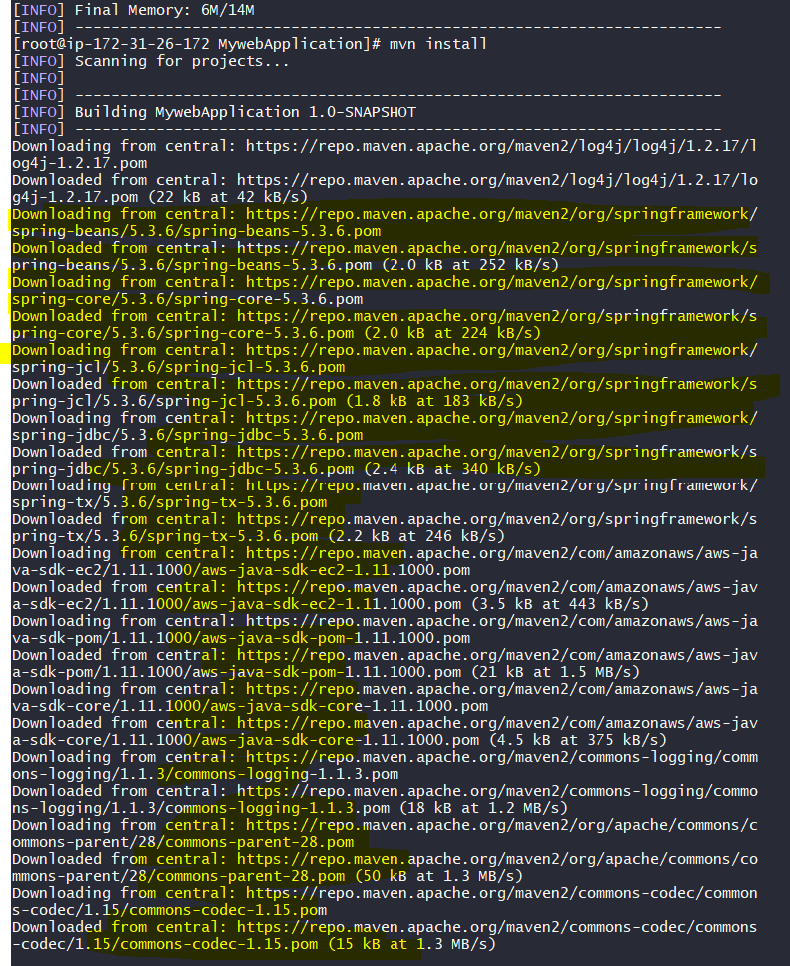

**Change m2 repo path in setting.xml and build the maven project:**

Next, I have changed my path from m2 repo path in setting.xml to home directory instead .m2 repo.

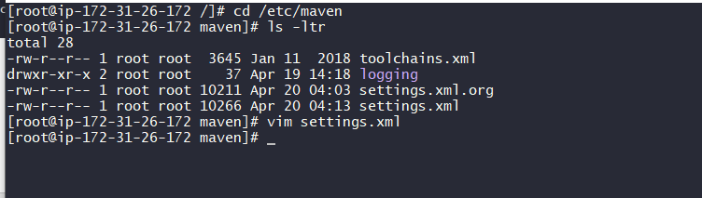

Here I went to “$ cd /etc/maven” ==== once I listed it I found “settings.xml” file.

Then I made a editing at local repo from “<localRepository>/path/to/local/repo</localRepository>” to

“<localRepository>/home/ec2-user/</localRepository>”

Before doing that I have made a copy of “settings.xml” as “settings.xml.org” file for future safety purpose.

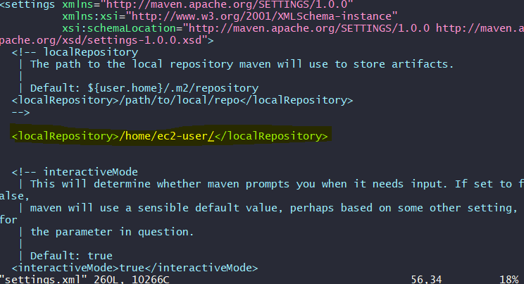

Now I used two commands:

* $ mvn clear ---- for clearing everything that previously done.
* $ mvn install -------installed maven again

So now all initiated dependencies, plugins, and change of path all are downloaded, installed, and build process got successfully implemented.

