Project Proposal
Date of submission : 29-03-2014
Mode of Preparation : Single
Submitted to: deepti.janand@iiitb.org, khusbu.bubna@iiitb.org

Project Title
Visual Programmable Environment for Electric Ray Robot

Team members (Name & Roll Number)
Rahul R, MT2013119

Name of the Supervisor
Prof. Madhav Rao
mr@iiitb.ac.in

Date
29-03-2014

Version Number
1.0

Timeline
Start Date: 27-01-2014
End Date: 30-06-2014

Objectives of the Project
Develop a visual programmable environment based on Minibloq for Electric Ray Robot.

Functionalities
Minibloq is a free, intuitive graphical programming environment for Arduino, physical computing devices and educational robots. One of its main goals is to bring closer Arduino, Multiplo and other platforms to primary schools, kids and beginners. A snapshot of the programming environment is shown in Fig (1)

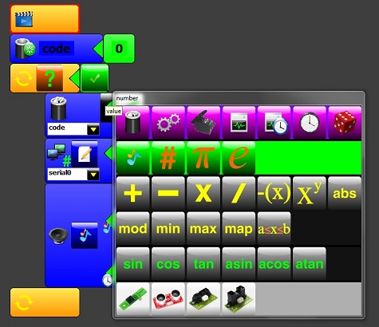
Fig (1)

Electric Ray is a Arduino-Uno compatible, entry-level, low-cost complete robotic platform. It has following components on board

- Arduino shield expansion headers
- Ultrasonic distance sensor
- 3x IR sensors
- OLED display
- Piezo buzzer
- FTDI USB-to-serial coverter
- TB6612FNG Motor Driver
- Atmega328 microcontroller with Optiboot bootloader

A snap shot of Electric Ray Robot is shown in Fig (2).

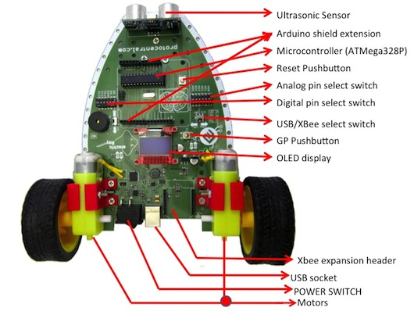
Fig (2)

As a part of this project, Minibloq will be enhanced with features to recognize and easily control the Electric Ray Robot. Following enhancements will be done on Minibloq
- A new visual block to program the motors.
- A new visual block to program the Ultrasonic sensor.
- A new visual block to program the IR sensor.
- A new visual block to program the Piezo buzzer.
- A new visual block to program the OLED display.

Project Deliverables
- Milestones

No. | Milestone | Completion Date | Verification
1 | Project Start | 27-01-2014 | Supervisor Approval
2 | Requirement Gathering | 28-02-2014 | Supervisor Approval
3 | Design | 31-03-2014 | Supervisor Approval
4 | Implementation | 31-05-2014 | Supervisor Approval
5 | Project End | 30-06-2014 | Supervisor Approval

- List of final deliverables
    - Complete documentation (internal included)
    - Report for audit
    - User guide (includes deployment guide, end user guide etc.)
    - Demonstration of the enhanced minibloq robotic program.
    - Video demonstration.

Estimated total time

Task | No. of hours
Requirement Gathering,  Mnibloq Installation and Setup | 10
As-Is and To-be study, Design | 10
Development of Enhancement 1 and Testing | 10
Development of Enhancement 2 and Testing | 10
Development of Enhancement 3 and Testing | 10
Development of Enhancement 4 and Testing | 10
Development of Enhancement 5 and Testing | 10
Integration Testing | 10
Total | 80 hrs

H/W and S/W requirements

Hardware requirements:
- Processor: 2 GHz or higher
- RAM: 1 GB
- Hard disk: 1 GB

Software requirements:
- Operating System: Windows XP or higher
- Code Blocks
- Arduino IDE

Technology / Architecture
C++, Arduino libraries.

Standard to be followed throughout the project
- GitHub will be used for storing and versioning documents and programs.
- Test driven development methodology will be followed throughout the life cycle

