Appendix-numerical results

"5 5 3 5 5 5 6 7", "A3 B1"

X-effort level Y-effort level No.Xwins No.Ywins Draw

80 80 56 44 0

80 150 45 55 0

80 500 19 81 0

80 2000 8 92 0

150 80 59 41 0

150 150 56 44 0

150 500 28 72 0

150 2000 17 83 0

500 80 77 23 0

500 150 70 30 0

500 500 52 48 0

500 2000 26 74 0

2000 80 87 13 0

2000 150 88 12 0

2000 500 71 29 0

2000 2000 58 42 0

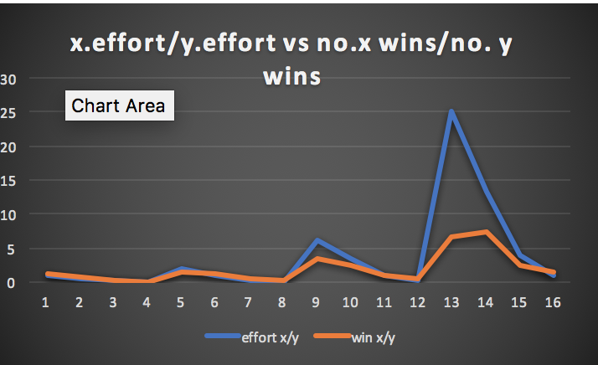

"5 5 5 6 7", "B3 A1"

run:

X-effort level Y-effort level No.Xwins No.Ywins Draw

80 80 53 46 1

80 150 37 62 1

80 500 29 69 2

80 2000 24 74 2

150 80 61 38 1

150 150 51 46 3

150 500 35 63 2

150 2000 30 69 1

500 80 77 23 0

500 150 58 41 1

500 500 48 52 0

500 2000 35 64 1

2000 80 78 20 2

2000 150 74 24 2

2000 500 47 51 2

2000 2000 47 51 2

BUILD SUCCESSFUL (total time: 6 minutes 9 seconds)

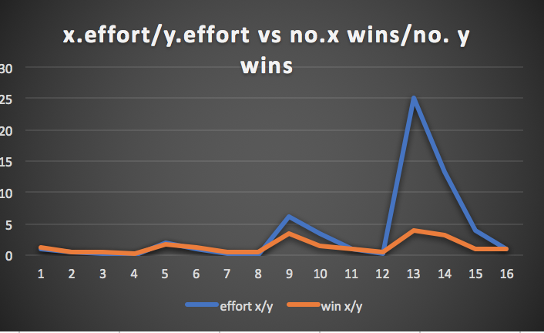

"4 6 7 5 5 6 7", "B2 A4"

X-effort level Y-effort level No.Xwins No.Ywins Draw

80 80 64 36 0

80 150 36 64 0

80 500 20 80 0

80 2000 13 87 0

150 80 59 41 0

150 150 48 52 0

150 500 26 74 0

150 2000 17 83 0

500 80 81 19 0

500 150 69 31 0

500 500 44 56 0

500 2000 32 68 0

2000 80 89 11 0

2000 150 82 18 0

2000 500 66 34 0

2000 2000 45 55 0

BUILD SUCCESSFUL (total time: 11 minutes 17 seconds)

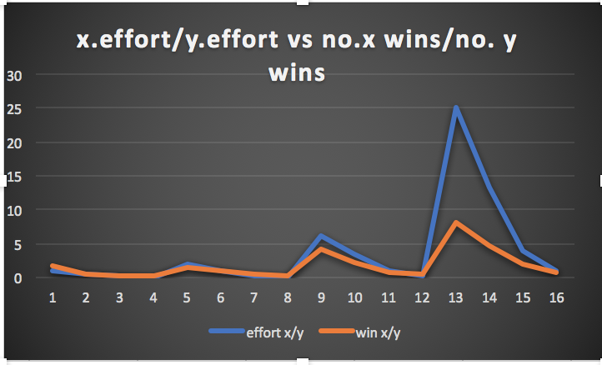

"7 6 3 5 6 7", "A4 B4"

X-effort level Y-effort level No.Xwins No.Ywins Draw

80 80 54 45 1

80 150 45 55 0

80 500 31 68 1

80 2000 11 89 0

150 80 60 40 0

150 150 49 51 0

150 500 38 62 0

150 2000 29 71 0

500 80 68 32 0

500 150 69 30 1

500 500 46 54 0

500 2000 37 62 1

2000 80 82 18 0

2000 150 80 20 0

2000 500 57 43 0

2000 2000 54 46 0

BUILD SUCCESSFUL (total time: 8 minutes 25 seconds)