Variant： 1-b 2-b 3-a

Below graph shows that the fastest performance we get from the test is around 10-20 threads, once we have more than 20 threads, the performance will drop and form a linear relation with the number of thread.

above is the time vs performance, we cans see that regardless the number of thread we use, the bigger the matrix size the poorer the performance is.

The speedup over a serial counterpart of the program:

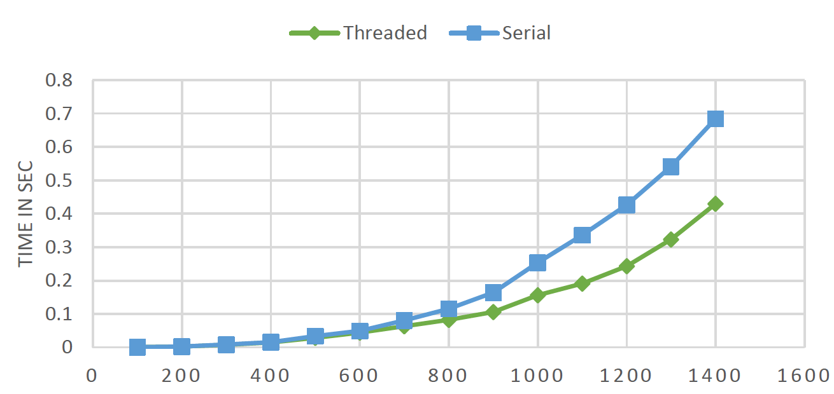

above graph show the performance difference between using threaded program and serial program indeed we can see there is a dramatic increase on performance especially on larger matrix operations.

Below are the output of the program:

