# Transistor Calculation Example Web Manual

Updated v0.1.53

By Yiyang Luo, Chuan Liu

School of Electronics and Information Technology, Sun Yat-Sen University, China.

## 1 Overview

Transistor-Calculation webpage is a simplified transistor simulator for demonstration and testing. It calculates transfer and output characteristics and some voltages with input parameters for regular transistors, drain-offset transistors, transistor-PD/LED, mid-gate transistors, static induction transistor (SIT), and split-gate transistors. Maybe, more will be developed in future. The theory and calculation methods are developed by Prof. Chuan Liu and the webpage is developed by his student Mr. Yiyang Luo.

Please contact [liuchuan5@mail.sysu.edu.cn](mailto:liuchuan5@mail.sysu.edu.cn) or [luoyy29@mail2.sysu.edu.cn](mailto:luoyy29@mail2.sysu.edu.cn) for any problem.

## 2 Using it

1. Open the web page "index.html".

2. Choose one of the simulators on the web.

3. Change parameters, and click the "Submit" button.

If you want to initialize default data, click the "init" button. Or if you want to download the data in the page including data of chart, click the "ExportData" button.

## 3 Details

### 3.1 Parameters

The meaning of most parameters can be found in the manuscript and the supplementary information. The input parameters should be in the format of numbers or scientific notation. For example, “14000”, “1.4e4” or “-0.1”.

### 3.2 Buttons

<Submit>: Input the parameters into the model, calculate and show the result.

<Init>: Reset the parameters back to the defaults.

<ExportData>: Export data from current chart. Please be sure to click the Submit button after changing the parameters. User should submit the parameters before clicking ExportData button.

<ExportScanData>: Additional function in split-gate part. User can obtain the scan data from two variables ( $V_{d}$/ $V_{g1}$/ $V_{g2}$), based on *scan range* and a fixed voltage. User can also call the function “scanloop(V_fix, Vmax, Vtype)” in console.

### 3.3 Charts

The charts are based on open-source JavaScript library *ECharts*. If the charts cannot be displayed because of the large data, please fill in the reasonable parameters and submit again.

Logarithmic axis cannot be switched for now. If user wants to print the charts in form of logarithmic axis, user can export the data and do it by other tools.

### 3.4 Legend of Charts

The legends above the charts are able to hide or show the curves in the charts by clicks. For example, by clicking “ $I_{d}-regular$”, the drain current of regular transistor that appear to be compared (on the left) would disappear as shown on the right.

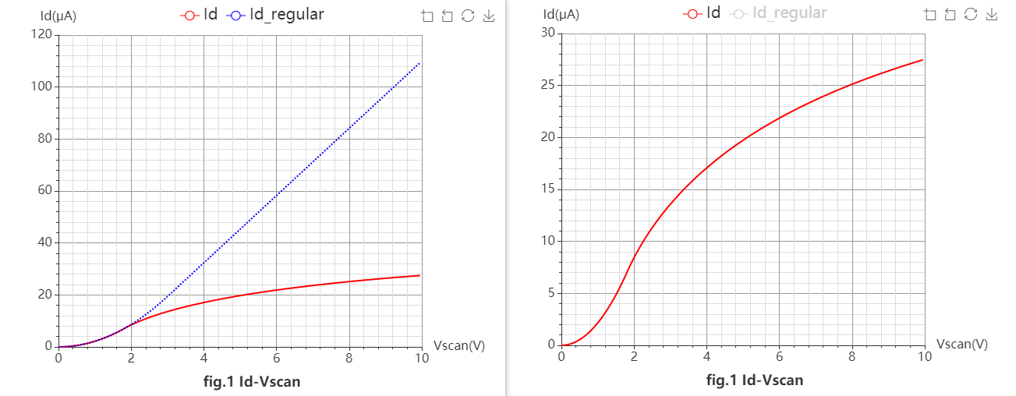

### 3.5 Toolbox of Charts

User can use the toolbox to zoom in curves. If user wants to zoom out, clicks "zoom back" or "restore" button in toolbox, or clicks the legends above charts to hide/show some of the curves.

<Zoom in>: Zoom the area in a chart by dragging the mouse.

<Zoom back>: Return to the last zoom.

<Restore>: Reset the chart.

<Save image>: Save the chart in *.png format.

### 3.6 Common Problems and Solutions

1. If the web page does not response, please check network and reopen the web.

2. If the values are so small that the curves cannot be seen clearly, users can use the zoom tool to check them, or export data for further use. Users may disable any curve by clicking the legend so that others could be seen.

3. In split-gate transistors, the fixed voltages are divided into three cases as follow:

<1> If scanning $V_{d}$, the former one (fixed $V_{g1}$ or $V_{d}$ [V]) is $V_{g1}$, and the latter one (fixed $V_{g2}$ or $V_{g1}$ [V]) is $V_{g2}$.

<2> If scanning $V_{g1}$, the former one (fixed $V_{g1}$ or $V_{d}$ [V]) is $V_{d}$, and the latter one (fixed $V_{g2}$ or $V_{g1}$ [V]) is $V_{g2}$.

<3> If scanning $V_{g2}$, the former one (fixed $V_{g1}$ or $V_{d}$ [V]) is $V_{d}$, and the latter one (fixed or [V]) is .

4. and is the reference value of $Q_{0}$ and $α$ based on the parameter $n_{0}$ and other structure parameters.

5. If the curves don’t start from $I_{d} = 0$ (as the following figure) due to off current, user can increase the parallel resistance *Rback* or $ρ_{mid0}$ (in SIT), e.g., by hundreds of times, to reduce the off current.

