Dynamic Real-Time Report
Report generated on: 2026-02-20 15:04:37
User: m.miani
Operating System: Windows 10.0.26100
Machine Name: CAREC-MM-03
Architecture: AMD64
Python Version: 3.14.3
Processor: AMD64 Family 25 Model 68 Stepping 1, AuthenticAMD

Section 1: Cryptocurrency Data
This section presents Bitcoin price trends over the last 10 days fetched in real-time from CoinGecko API.
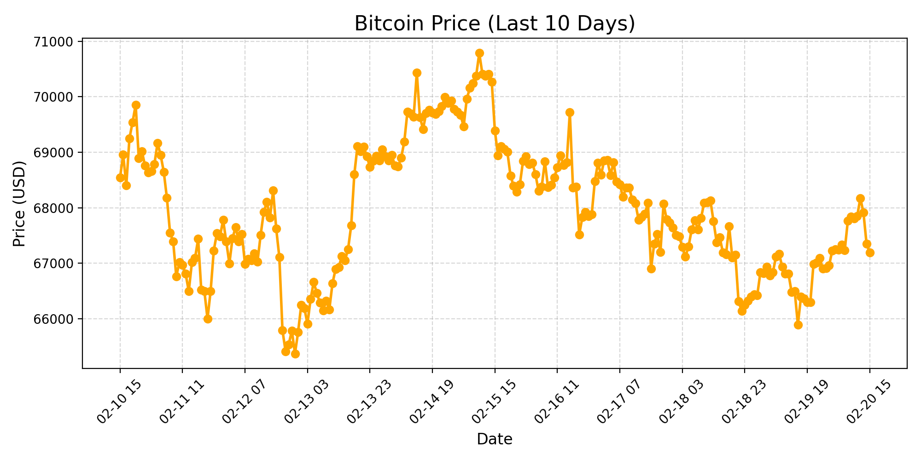
Figure 1: Real-time Bitcoin prices (USD) over the last 10 days.

Section 2: Latest Prices (last 10)
Date | Price (USD)
02-20 06 | 67,334.83
02-20 07 | 67,232.69
02-20 08 | 67,767.36
02-20 09 | 67,839.84
02-20 10 | 67,806.37
02-20 11 | 67,850.72
02-20 12 | 68,172.86
02-20 13 | 67,910.90
02-20 14 | 67,346.76
02-20 15 | 67,191.55
Table 1: Last 10 Bitcoin prices (USD).

