Rezolvare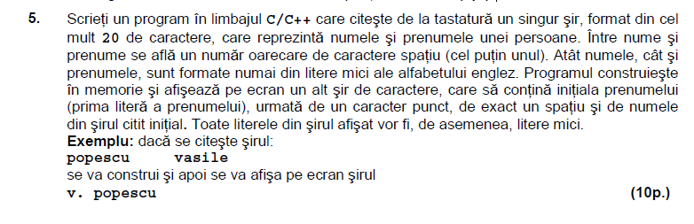

#include <iostream>

#include <string.h>

using namespace std;

int main()

{char n[101], p[101], *q, *z;

int i, j;

cin.get(n,101); cin.get();

cin.get(p,101);

q=strlen(n); z=strlen(p);

for(i=0; i<=z; i++)

cout<<p[0];

for(j=0; j<=q; j++)

cout<<n;

while(!q && !z)

cout<<p[0]<<". "<<n;

return 0;

}



Rezolvare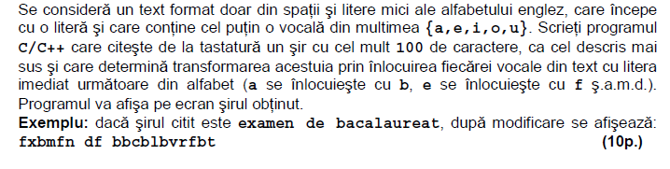

#include <iostream>

#include<string.h>

using namespace std;

int main()

{char sir [101],i,n;

cin.get (sir,101);

n=strlen (sir);

for (i=0;i<n;i++)

if (strchr ("aeiou", sir[i]))

sir[i]++;

cout << sir << endl;

return 0;

}



Intr-un vector de inregistrari, se pastreaza atributele a n dreptunghiuri: lungimea, latimea, aria siperimetrul. Numarul n si dimensiunea laturilor se introduc de la tastatura. Sa se afiseze dreptunghiul cu suprafata cea mai mare si dreptunghiul cu perimetrul cel mai mic.

Rezolvare

#include<iostream>

#include<math.h>

#include<limits>

using namespace std;

int main()

{struct dreptunghi {int lungime, latime, aria, perimetru;};

dreptunghi v[30];

int n, min=INT_MAX, max=INT_MIN;

int i;

cout<<"n="; cin>>n;

for(i=1; i<=n; i++)

{cout<<i<<endl; cout<<"lungime: "; cin>>v[i].lungime;

cout<<"latime: "; cin>>v[i].latime;

v[i].aria= (v[i].lungime)*(v[i].latime);

v[i].perimetru= 2*(v[i].lungime+ v[i].latime); }

cout<<endl;cout<<endl;

for(i=1; i<=n; i++)

{if (max < v[i].aria)

max=v[i].aria;

if (min>v[i].perimetru)

min=v[i].perimetru; }

for(i=1; i<=n; i++)

if (v[i].aria==max)

cout<<v[i].lungime<<" "<<v[i].latime<<" "<<v[i].aria<<" "<<v[i].perimetru<<endl;

cout<<endl;

for(i=1; i<=n; i++)

if (v[i].perimetru==min)

cout<<v[i].lungime<<" "<<v[i].latime<<" "<<v[i].aria<<" "<<v[i].perimetru<<endl;

return 0;}