Mackenzie_Extension

Mackenzie Fry

October 30, 2017

knitr::opts_chunk$set(echo = TRUE, message = FALSE,  
warning = FALSE)

# GGRAPH package

[link to ggraph package website](https://cran.r-project.org/web/packages/ggraph/vignettes/Edges.html)

Packages needed for this method: **ggraph, igraph**

## Layouts

Here is the sample code:

library(ggraph)  
library(igraph)  
set_graph_style(plot_margin = margin(1,1,1,1))  
hierarchy <- as.dendrogram(hclust(dist(iris[, 1:4])))  
  
# Classify nodes based on agreement between children  
hierarchy <- tree_apply(hierarchy, function(node, children, ...) {  
 if (is.leaf(node)) {  
 attr(node, 'Class') <- as.character(iris[as.integer(attr(node, 'label')),5])  
 } else {  
 classes <- unique(sapply(children, attr, which = 'Class'))  
 if (length(classes) == 1 && !anyNA(classes)) {  
 attr(node, 'Class') <- classes  
 } else {  
 attr(node, 'Class') <- NA  
 }  
 }  
 attr(node, 'nodePar') <- list(class = attr(node, 'Class'))  
 node  
}, direction = 'up')  
  
hairball <- graph_from_data_frame(highschool)  
  
# Classify nodes based on popularity gain  
pop1957 <- degree(delete_edges(hairball, which(E(hairball)$year == 1957)),   
 mode = 'in')  
pop1958 <- degree(delete_edges(hairball, which(E(hairball)$year == 1958)),   
 mode = 'in')  
V(hairball)$pop_devel <- ifelse(pop1957 < pop1958, 'increased',  
 ifelse(pop1957 > pop1958, 'decreased',   
 'unchanged'))  
V(hairball)$popularity <- pmax(pop1957, pop1958)  
E(hairball)$year <- as.character(E(hairball)$year)

## Elbow

### Heirachy is the data frame name we want to reference

ggraph(hierarchy, layout = 'dendrogram') +   
 geom_edge_elbow()

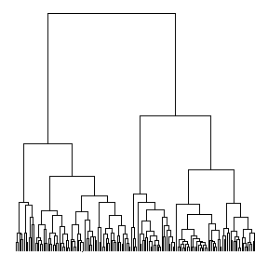

## Heirachy

graph <- graph_from_data_frame(flare$edges, vertices = flare$vertices)  
set.seed(1)  
ggraph(graph, 'circlepack', weight = 'size') +   
 geom_node_circle(aes(fill = depth), size = 0.25, n = 50) +   
 coord_fixed()

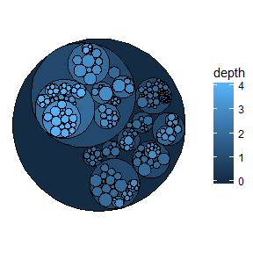

## 2-Variant

ggraph(hierarchy, layout = 'dendrogram') +   
 geom_edge_elbow2(aes(colour = node.class))

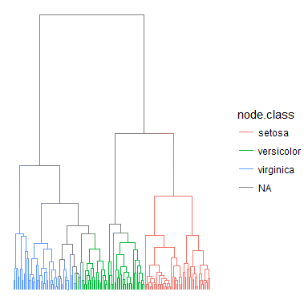

## Diagnols

ggraph(hierarchy, layout = 'dendrogram') +   
 geom_edge_diagonal()

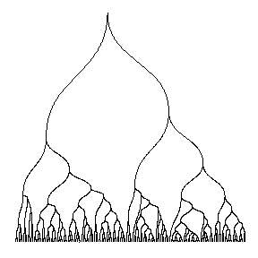 ##########################################

# Geomnet