Chapter 1: Structural Equation Models

Prerequisites: Chapter 9

1.1 The Basic Structural Equation Model

In this chapter we are going to look at models where the theme is cause and effect. Unlike regression, these models are explicitly formulated as causal models, not just predictive models. We will also be using a notation that is quite similar to that used in Chapter 9 for Confirmatory Factor Analysis, which is to say that we will have a column vector, y, containing p dependent variables. The vector y is understood to represent an arbitrarily chosen observation from the population, maybe the ith. We will have a similar situation with the vector x that is a q by 1 column vector. In SEM (Structural Equation Model) terms, we say that y contains the endogenous variables and x contains the exogenous variables. An endogenous variable is one that appears at least once as the dependent variable in an equation. On the other hand, variables that do not appear on the left hand side are exogenous, or "given." In other words, all variances of, and covariances between, exogenous variables are determined outside of the system. They are not at issue. The variances and covariances of the endogenous variables are being modeled as a function of the exogenous variables. The basic model looks like

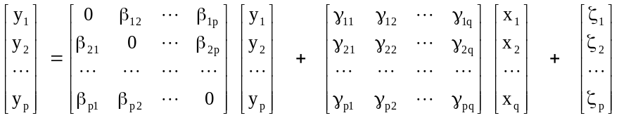

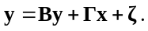 (1.1)

So we have p simultaneous equations. Note that for each of the causal parameters, the γ’s and the β’s, the subscripts follow the same pattern. The first subscript refers to the equation, in other words the y variable which is the effect. The second subscript refers to the cause.

The p by p B matrix contains the coefficients of the regressions of y variables on other y variables with 0’s on the diagonal which implies that a variable cannot cause itself. The p by q matrix Γ contains the coefficients of the y’s on the x’s. The error vector, ζ, is p by 1. These errors are different than factor analysis errors, they represent errors-in-equations, in the way that these equations are specified. Thus they are also called specification errors.

In order to get to a point where we can estimate the model, we need to add some assumptions. To start off innocuously enough, we assume that E(y) = 0 and E(x) = 0, which has absolutely no impact on the variances or covariances of these variables [see Equation (4.8)]. We then assume that the x and ζ vectors are independent,

Cov(x, ζ) = 0 (1.2)

which is to say that the covariances between the x’s and the ζ’s consist of a q by p rectangular array of zeroes. We will also need to assume that the determinant

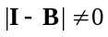. (1.3)

Now let us define

V(x) = E(xx′) = Φ and (1.4)

V(ζ) = E(ζζ′) = Ψ . (1.5)

Note that we have “reused” the Ψ matrix from Chapter 9. In confirmatory factor analysis, Ψ was used for the factor covariance matrix. In fact, the use of Ψ as the covariance matrix of the ζ’s is actually consistent with its Chapter 9 meaning. At this point we are ready to deduce what is known as reduced form. Reduced form requires that we solve for the y vector, as below:

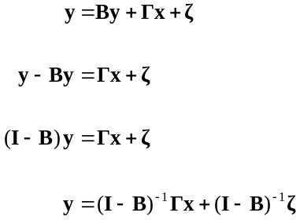

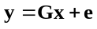. . (1.6)

The matrices G = (I – B)⁻¹Γ and e = (I – B)⁻¹ζ are defined merely for convenience, but G does highlight the fact that we can go from the structural parameters in B and Γ to the classic regression parameters with some algebra. Of course, that does not prove we can go in the opposite direction!

What is the variance of the y variables? We can use the reduced form derived above to simplify our explanation,

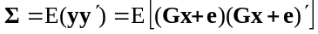

(1.7)

The 2nd and 3rd terms vanish. To see this, we look at the 2nd component which is given by

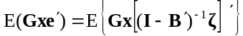

which, using the fact that the transpose of an inverse is the inverse of the transpose [Equation (1.40)], and passing the constants in G and (I - B)⁻¹ through the Expectation operator [remember Equations (4.5) and (4.6)], is equivalent to

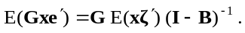

Here we note that E(xζ′) that appears immediately above is another way to express the Cov(x, ζ), and that covariance must be zero by previous assumption. The 3rd term is just the transpose of the 2nd. What the cancellation of the 2nd and 3rd components in equation (10.7) means is that we end up with the following expression for Σ,

E(yy′) = GE(xx′)G′ + E(ee′) (1.8)

At this point we might pause and note the similarity between this expression and it's equivalent for factor analysis, Equation (9.3)! Now, to further flesh out this last equation we need to remember that we had previously defined V(x) = E(xx′) = Φ, and V(ζ) = E(ζζ′) = Ψ. Proceeding along those lines we see that

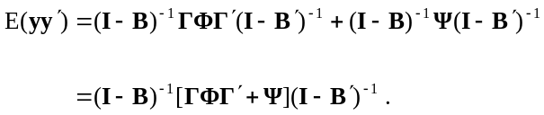

How about the covariance between x and y? That would be

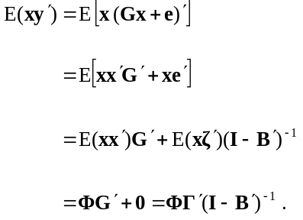

The null matrix appears above because we have previously assumed that E(xζ′) = 0 [in equation (10.2)], that is to say the x variables are not correlated with the errors in the equations. Putting all the pieces together,

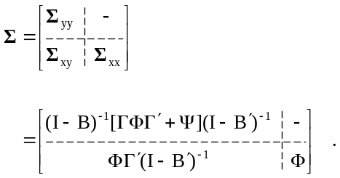 (1.9)

The structure above constitutes H₀ and H_{A}: Σ = S is as before in Chapter 9.

1.2 A Simple Example with Four Variables

At this point I would like you to imagine that we have measured the following four variables:
Variable | Description
x₁ | Perceived Attractiveness of Product
x₂ | Perceived Cost of Product
y₁ | Intention to Purchase
y₂ | Purchasing Behavior

Now let us look at the path diagram for a causal model.

x₂
y₁
y₂
x₁
φ₂₁
γ₁₁
γ₁₂
β₂₁

There are a few things we might note about this diagram. As is the tradition with confirmatory factor analysis, we usually leave off a label for errors; they are just represented as single headed unlabeled arrows. Covariances, such as the one between x₁ and x₂, are represented by two-headed arrows. Causal paths are represented by one-headed arrows. By tradition, the variances of the exogenous variables do not appear on path diagrams.

The structural equations for this model are

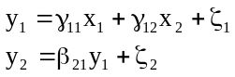

and in matrix terms

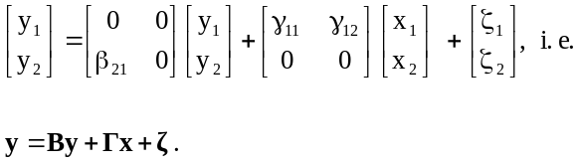

In addition we need to specify the variances of any variable appearing on the right hand side:

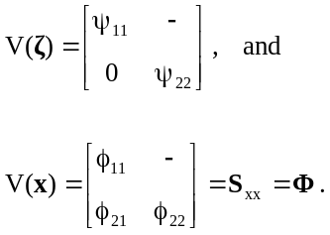

Since the x’s are exogenous, their variances and covariances are given, and are estimated by the sample values. Thus they cannot contribute to the falsification of the model. Counting up all the free parameters, we have 1 β, 2 γ’s, 2 ψ’s and 3 φ’s. There are (4⋅5)/2 = 10 data values, leaving 2 degrees of freedom for the model. This can be seen in the path diagram by the fact that there are two missing arrows; the arrow that does not appear between x₁ and y₂, and the arrow not present between x₂ and y₂. It is actually these two missing arrows that are being tested by the Chi Square statistic for this model. Their absence is what we can falsify using the SEM technique.

1.3 All y Models

Any model that can be expressed with x and y variables can be expressed with y variables alone. Consider the following two sets of equations,

y = By + Γx + ζ

x = 0y + Ix + 0 ,

where the second set of equations, involving the x variables, is present just to create a similarity between the x’s and y’s. In fact, the second set really just sets x = x! Now define

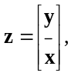

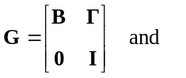

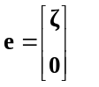

so that we can rewrite the two sets of structural equations

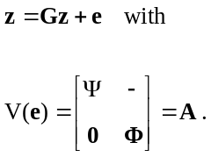

We define z, G and A temporarily just to illustrate the point. The point being that we need only one set of variables with one regression coefficient matrix and one variance matrix. It is most convenient to use y, B and Ψ to play these roles.

1.4 In What Sense Are These Causal Models?

Using Structural Equation models we have the potential to reject the hypothesis H₀ that embodies the causal model. Rejecting H₀ is a definitive event. If H₀ is not rejected, the results are a bit more ambiguous. All we can say in that case is that we have failed to reject the hypothesis. In other words, it is still in contention but by no means can it be considered proven. In point of fact, there are an infinite number of other possible models that could also be true. H₀ is merely among the survivors. To illustrate this point, consider the two causal structures below:

y₂
y₁
y₃

and

y₃
y₂
y₁

Note that the path diagrams above have been simplified somewhat from the traditional conventions. Both models have one degree of freedom that corresponds to the missing path between y₂ and y₃. In point of fact, the one degree of freedom, or the restriction implied by that degree of freedom, is identical in both cases. To explore the nature of this restriction, we revisit Section 5.8. Consider the regressions

y₂ = y₁ + e₂ and

y₃ = y₁ + e₃.

Both causal diagrams require only that the partial covariance σ_{23·1} = 0 where σ_{23·1} is the Cov(e₂, e₃) from the above two regression equations. Failure to reject does not prove your model.

1.5 Regression As a Structural Equation Model

Consider a regression model with three independent variables and one dependent variable. The path diagram for this appears below;

x₂
y₁
x₁
φ₂₁
γ₁₁
γ₁₂
x₃
γ₁₃
φ₃₂
φ₃₁

Now let us count up degrees of freedom for the model. We have six elements in the Φ matrix (remember that the variances of the exogenous variables do not appear on a path diagram), there are three γ values, and one ψ. Among the four observed variables there are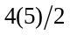= 10 covariances and variances. Thus there are exactly as many free parameters as there are data points. In effect, the parameters are just transformations of the data. We say in this case that the model is just identified. The model does not impose any restrictions on the Σ matrix, which is to say that it has 0 degrees of freedom. Now lets look at the multivariate case with multiple dependent variables. For example, below we can see a model with two y variables and three x variables:
x₂
y₁
x₁
φ₂₁
γ₁₁
γ₁₂
x₃
γ₂₃
φ₃₂
φ₃₁
y₂
γ₂₂
γ₂₁
γ₁₃

ψ₁₂

We leave it to the reader to calculate the degrees of freedom in this case and to verify that here too, we will end up with a just identified structural equation model. Regression, whether it is with one or more dependent variables, is not falsifiable in the sense of structural equation modeling. Regression is not a causal model.

1.6 Recursive and Nonrecursive Models

At this point we need to learn an important term that unfortunately sounds as if it means the opposite of what it actually means. A recursive system is characterized by V(ζ) = Ψ diagonal, and by the fact that it is possible to arrange the y variables so that B is lower (or upper) triangular. It is probably easier to illustrate the concept of a recursivity by referring to its opposite. Some example systems that are non-recursive are shown below.

x₂
y₁
x₁
y₂

and

x₂
y₁
x₁
y₂

Both of these would be called non-recursive. Generally, non-recursive models can be very difficult to estimate using structural equation models. There are certain specialized econometric techniques, discussed in Chapter 17, specially constructed to facilitate these sorts of models.

1.7 Structural Equation Models with Latent Variables

It is possible to combine the latent variables models of Chapter 9 with the structural equation models of this chapter. In other words, we can have path models between factors. While we have already shown we can always get by with just y-variables, here, if only for notational clarity, we will assume we have two sets of variables, an x set and a y set, and therefore we need two measurement models,

y = Λ_{y} η + ε (1.10)

x = Λ_{x} ξ + δ . (1.11)

The y-variables are a function of certain latent variables, the η’s, while the x-variables are a function of other latent variables, the ξ’s. The next step would be that we can have structural equation models amongst these latent variables as below:

η = Bη + Γξ + ζ . (1.12)

Needless to say, there are a set of assumptions that we must make before we can use these models. These are listed now

Cov (η, ε) = 0 (1.13)

Cov (ξ, δ) = 0 (1.14)

Cov (ξ, ζ) = 0 (1.15)

Cov (ε, δ, ζ) = 0 (1.16)

Diag (B) = 0 (1.17)

| I – B| ≠ 0 . (1.18)

The first two assumptions in equations (10.13) and (10.14) are that the common factors and the unique factors are independent. In the structural equation model, the independent variable and the error must be uncorrelated [assumption (10.15)]. Each of the three types of errors are mutually uncorrelated [assumption (10.16)] . The diagonal of the B matrix is a set of p zeroes, and the expression (I – B) must be nonsingular, meaning that its determinant cannot be zero so that it can be inverted (as is discussed in Section 1.8).

To review, we have now introduced four parameter matrices: Λ_{y} which contains factor loadings for y variables, Λ_{x} which contains loadings for the regression of x variables on their factors, the ξ’s, Γ containing regression coefficients for η on ξ, and B with the regression coefficients for η’s on other η’s. To round out the picture, we have four variance matrices. The variance of all inputs must be specified, and that includes

V(ξ) = Φ, (1.19)

V(ζ) = Ψ, (1.20)

V(ε) = Θ_{ε} and (1.21)

V(δ) = Θ_{δ} . (1.22)

Our first example involves a longitudinal study in which a group of customers is asked the same two items on four different purchase occasions. These two items are hypothesized to be unidimensional. Here, we have to admit that this is just an illustrative example since any two items are unidimensional! You need more than two items to create a scale, otherwise you are just modeling a plain household variety correlation. But, proceeding anyway, here is the path diagram:

y₁
λ₂₁
1
η₁
β₂₁
y₂
y₃
λ₄₂
1
η₂
β₃₂
y₄
y₅
λ₆₃
1
η₃
β₄₃
y₆
y₇
λ₈₄
1
η₄
y₈

Perhaps we are interested in the persistence of the attitude towards the brand over time. All of the variables have been labeled in such a way as to illustrate an all-y model. The measurement model is

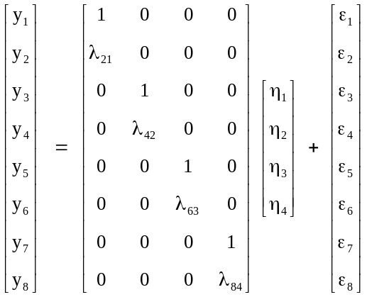

with the structural model

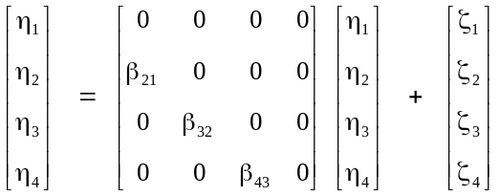 .

To this we add the variance matrices of ε and ζ, respectively,

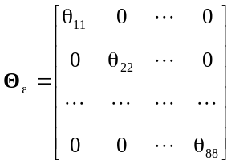 and

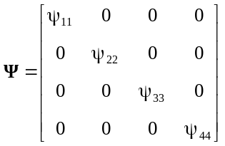.

In the Ψ matrix, the parameter ψ₁₁ is exogenous.

It is important to be able to calculate the degrees of freedom for this or any other model you are working on. The raw data for the model, given that there are eight observed variables, is given by the expression 9(8)/2 = 36. From this we must subtract the four free elements in the loading matrix, three β’s, eight elements in Θ_{ε} and then four elements on the diagonal of Ψ. This leads to 15 degrees of freedom.

1.8 Second Order Factor Analysis

One very beautiful, if rarely applied, model is the second order factor model. In effect, the factors themselves may form a higher order factor. In other words, if the correlations amongst the factors have the right structure, these may be the result of a latent variable. A path diagram of this model appears below:
y₂
y₁
y₃
λ₂₁
1
η₁
η₂
y₅
y₄
y₆
η₃
η₄
y₇
y₈
ξ₁
1
1
1
λ₄₂
λ₆₃
λ₈₄
1
γ₄₁
γ₃₁
γ₂₁

Note that the η’s have their own loadings and their own unique factors. Here, the variable ξ₁ serves as the higher order factor. In general terms, the second order factor analysis model can be written as

y = Λ_{y} η + ε and (1.23)

η = Γ ξ + ζ , . (1.24)

which the reader will recognize as a special case of a SEM with latent variables. We can write the model more compactly as

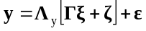 . (1.25)

We need to assume that Cov(ε, ζ) = 0 and Cov(ξ, ζ) = 0. Here we also have V(ε) = Θ_{ε}, V(ζ) = Ψ and V(ξ) = Φ. The variance matrix of y, Σ, takes on a particularly aesthetic form with this model,

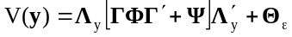 , (1.26)

with the internal part in the brackets being the V(η). Again, students should make certain they can calculate the degrees of freedom for this model.

1.9 Models with Structured Means

In order to look at means, something that is useful especially when there are multiple groups, we need to include a unit vector as an “independent variable” and analyze the raw SSCP matrix [see Equation (2.9)] instead of a covariance matrix. Our model is

y = ν_{y} + Λ_{y} η + ε (1.27)

x = ν_{x} + Λ_{x} ξ + δ (1.28)

η = α + B η + Γ ξ + ζ . (1.29)

Now define E(ξ) = κ. Then

E(η) = (I - B)⁻¹(α + Γκ), (1.30)

E(x) = ν_{x} + Λ_{x} κ and (1.31)

E(y) = ν_{y} + Λ_{y} (I – B)⁻¹ (α + Γκ) . (1.32)

In order to fit this model in the context of a SEM, we need to include a vector of 1’s that we will call x₀. It will be the only variable labeled as an x. For the rest of the real x’s and the y’s, we will utilize an all-y model. For x₀ we have

1 = 1ξ₀ + 0 .

For all of the rest of the variables, we have

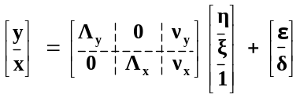 (1.33)

as the measurement model. The structural equation model looks like

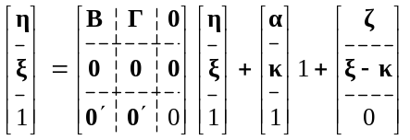 . (1.34)

The means of the latent variables, the α_{i}, show up in the position usually occupied by the "Γ" matrix, which in this case is a vector. There is a sequence of hypotheses and models that can be tested. If we assume there are two groups, we would start by testing

H₀: Σ₁ = Σ₂. (1.35)

Failure to reject this hypothesis implies that we should pool the groups. At this point any between group analysis stops.

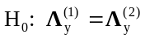 (1.36)

Failure to reject the hypothesis in Equation (10.36) implies each population has the same factor structure. Otherwise, if you reject this hypothesis, it doesn’t make sense to compare factor means across groups because these means correspond to different factors in the two groups. Therefore if we reject the hypothesis of Equation (10.36), between group analysis stops.

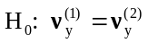 (1.37)

Failure to reject the above hypothesis implies that the items work the same way in each population. If you reject it, between group comparison stops.

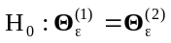

There are no consequences of either rejecting or failing to reject the above hypothesis. However, as always, we should seek to end up with the simplest model possible so failing to reject this one would be considered positive.

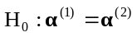 (1.38)

This would ordinarily be considered the key hypothesis. Do the groups vary on the factor means? Finally, we could look at

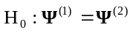 (1.39)

which asks whether the groups differ on the factor space.

References

Joreskog, Karl Gustav (1970). A General Method for Analysis of Covariance Structures. Biometrika. 57 (2), 239-51.

Kenny, David. A (1979) Correlation and Causality. New York: Wiley.

