Gintas Pociunas
Web Development 2 semester
Mandatory Assignment 1: Umbraco

Project Report
Introduction

In this project, students were required to create an Umbraco solution for the Aarhus Web Developers Coop (later AWDC). Solution should look like a real website project for a company and it must include the following areas:
- Home section
- About page
- News section
- Projects section
- Contact section
- Members section
- Login section
There were additional requirements, like specific navigation menu. It was important to make it drop-down to list "Completed" projects when hovering mouse on "Projects" item in the menu, as well as listing News articles when hovering mouse on "Articles" section. Another requirement was to style the website using Bootstrap or our own custom styling to make it look nice and add some "real" content, f.x. articles and projects with desctiptions and pictures.
If we get a bit deeper into the requirements, there is not only the "page" that is required to be created, but the functionality is also very important. In our "About us" page, we had to include a Grid Layout, which would seperate picture and text below it. Also, we had to create few members with specific roles and, based on roles, members should be able to do/see certain actions/areas when logged in. This includes:
- Public role. Should be able to read about the network, read news articles, look for member profiles, contact the network and only see projects that have status "Completed".
- Guest member role. Has the same role as Public, however, should be able to see projects have "Initiated" and "Under development" statuses.
- Active member role. This role has the highest "rank" of all member types, and has the same roles as Public and Guest, but moreover, it should be able to see projects with all statuses.
Other than the above described member roles, we were required to have Umbraco Backend roles. This means that we must have users which can connect to Umbraco Backend and add/remove/edit content or have full control. These roles would include:
- Editors. They can publish new pages.
- Authors (or writers). Edit existing news pages and create new pages. Once they create a new page, a notification to editor is being sent and they have to approve it. Pages are not published until editor approves .
- Administrators. Full control.
I have completed all requirements for this solution and I will briefly explain how did I solve the tasks. I must mention, that all the content, including text and pictures for articles and projects, is taken from few different sources on the internet.
Sitemap

Sitemap in my project is generated using an umbraco integrated code snippet, where additionally I added some code to filter our the unnecessary pages from the tree. Please see the images below.

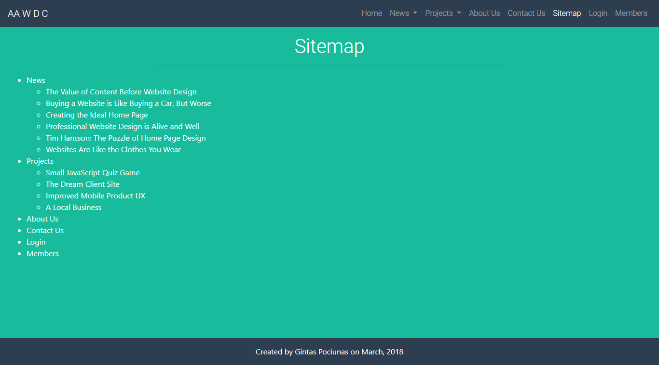Illustration 1: Sitemap

This sitemap lists all News and only visible projects, that have a "Completed" status. While doing the exercises, we had a requirement not to show the Sitemap item itself in the tree, so we had to add some additional code into the snippet.
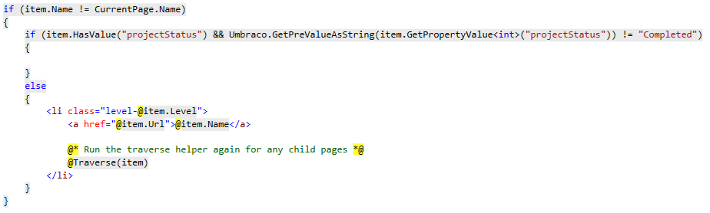Illustration 2: Filtering out items from the Sitemap tree

Code above shows how we filter out the projects that do not have a status "Completed" (by leaving it blank) and filtering out the Sitemap page itself (condition asks if the item.Name is not Sitemap and if yes, then it lists the items to the tree).

The website menu

First of all, the navigation menu is one of the most complex pages in the project. It must have a lot of styling, conditions in the code itself to filter out the projects that are not available to every member group, and it has to be functional, with drop-down items.
I have solved this task in a pretty basic way. Styling is done with bootstrap, functionality based on "if" conditions, drop-down menu implemented by following few sources on the internet and in the end I have this result:
Menu is generated by selecting all items on the model and place them in an unordered list by using foreach loop. However, inside of this loop, we have conditions applied, like showing only the completed projects. Here is a piece of code, which filters out the projects:
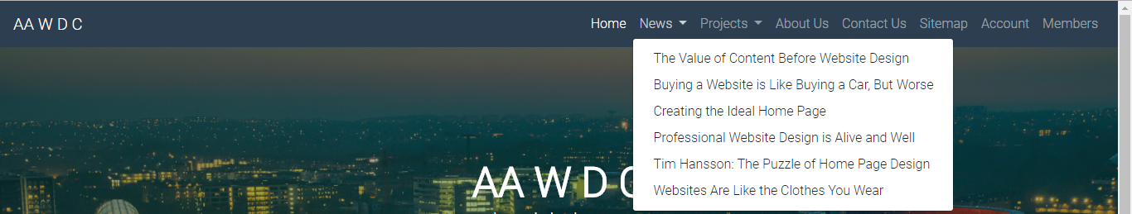Illustration 3: Navigation menu with drop-down
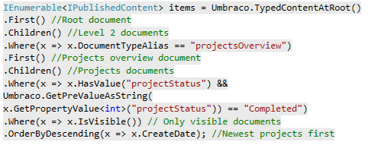Illustration 4: Selecting only the completed projects

Also, there is a piece of code which creates the dropdown menu for other items than projects (if needed):
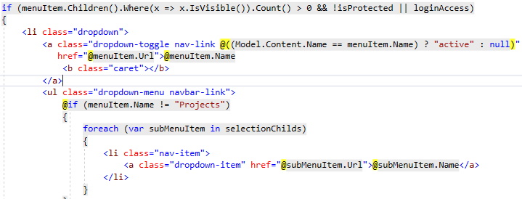Illustration 5: Adding a dropdown menu

And, in the end, it lists the project items, based on logged in member type.
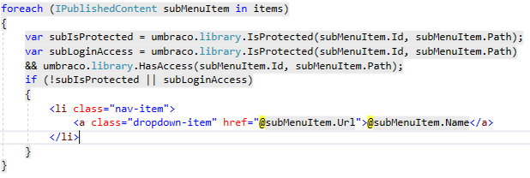Illustration 6: Listing project items

Menu is actually a macro partial view, which is rendered in Master template, so we avoid rewriting the same code everytime we are creating a new page.

Website access control

Website has to be protected in order to avoid public users to view the content which is forbidden. In this case, we have to create members and only allow them to use certain parts of the website, f.x. some project items. We call it a "Role based protection".
To implement this, we have to create members in Umbraco backend.
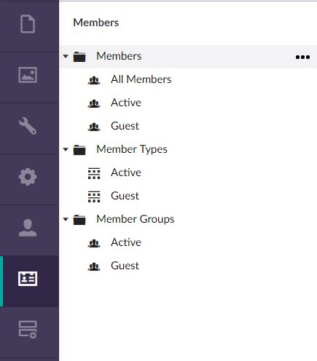Illustration 7: Members in Umbraco backend

Then, in certain articles/projects, we can select which user group should be able to access that page and if not, they are redirected into the login page or to forbidden access page.
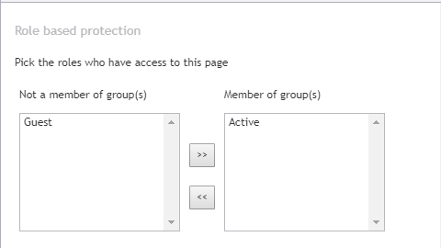Illustration 8: Assigning a member category

We also have to create a login system, in order to determine exactly which member is using the website. To do this, we create a partial view of login form, which is later renderred into the main Login page.
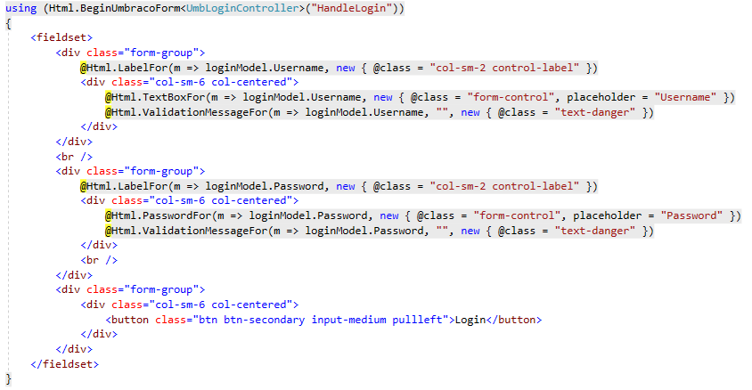Illustration 9: Login form partial view

With a bit of styling added, we can have a nice looking, perfectly working login menu:
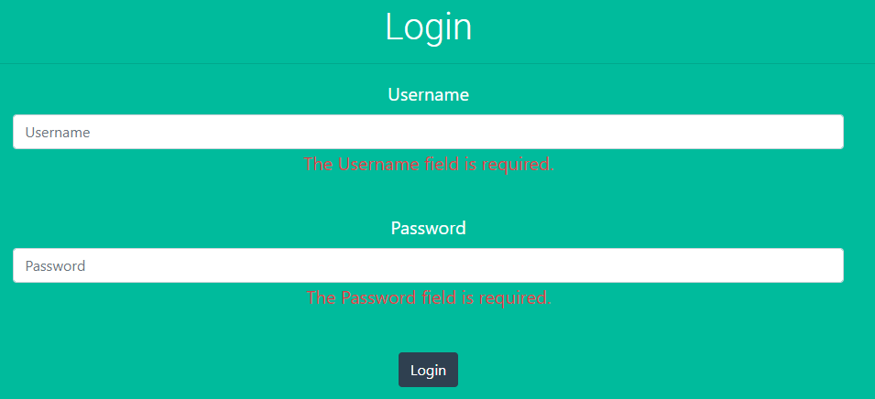Illustration 10: Login form

There is also an added validation in this form. It uses JavaScript client-side validation. If user will leave an empty field or write an incorrect password – the page will throw an error.
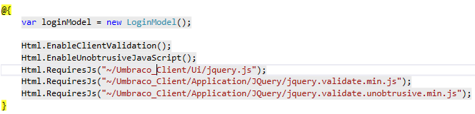Illustration 11: Login form validation

And that is not all. If we want the unnaccessible items to dissapear from Sitemap or Navigation menu, we have to add some code to check which user is connected and if they have access to the item.
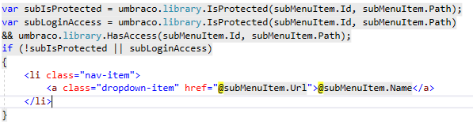Illustration 12: Checking if the item is protected and if not, then listing it on the menu.

After adding all this validation, protection and filtering items, we have the following results:
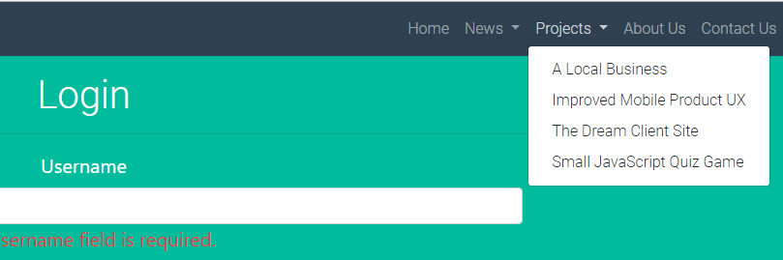Illustration 13: Public visitors see this projects dropdown menu

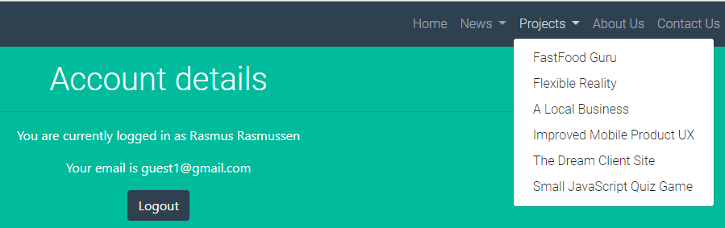Illustration 14: Guest members have this projects dropdown menu
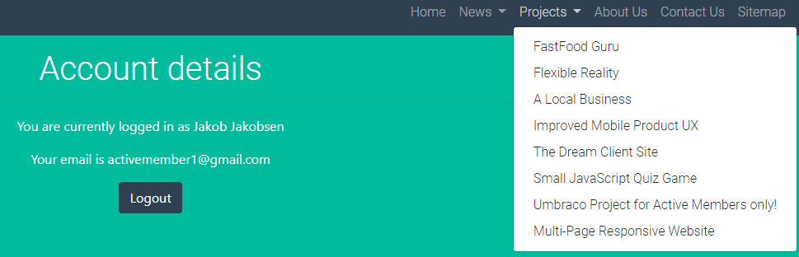Illustration 15: Active members see this projects dropdown menu

Most of this was achieved by adding some code, based on "if" conditions. It is quite a long code, so I will not post a screenshot here, however it will be attached to the project.

The Contact Form

Contact form was one of the challenges I have faced while working on this project. The most confusing part was to set up the smtp server to use my google account and actually send the emails. But I have managed to create this contact form and make it working perfectly and I will briefly explain how it was done.
First, I had to create a contact page. Then, we create a contact form view model:
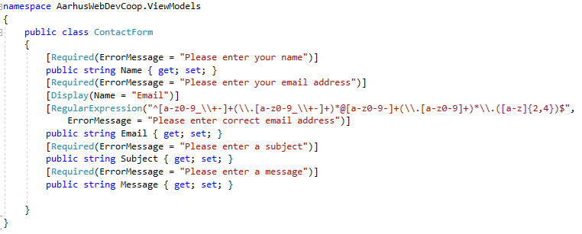Illustration 16: Contact form View Model

The form itself has validation by using DataAnnotations. If users will leave the fields empty or enter an email with wrong format, they will receive an error message.
Moving on, we create a Contact Form Surface Controller. By referring to the contact form view model, the controller will return a view (a page that I created before). It will also handle two methods: GET and POST. GET method just returns the contact form, and POST method is a bit more complicated. It receives inputs from form view model which handles the form fields and creates a message object. Then it uses a SMTP client to send an email and adds the message to umbraco document (saves it into the database) When looking at the created document in Umbraco backend, we can see all the details which user have entered, and we also can reply directly from the backend. If there were no problems to send the email, then it returns a message that it was successful.
There is also a client-side validation added in the form, which checks if the fields are not left empty and if the email format is correct. Without entering the correct names, it is not possible to send an email.
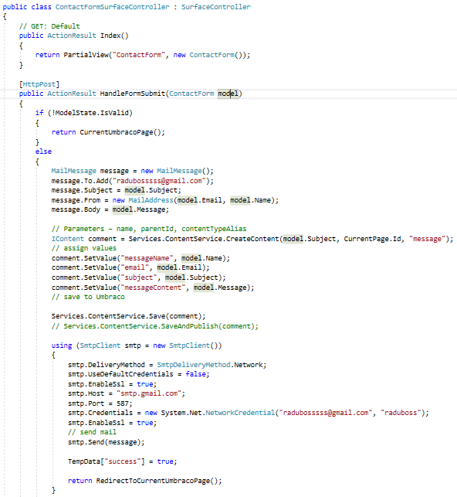Illustration 17: Contact Form Surface Controller

Conclusion

Even though the project was a challenge and I have never been doing anything like this before, previous semester knowledge and careful following of the teacher's instructions led me to fully complete the project and meet all requirements. There are, of course, some parts that could also be extended and which I did not implement, f.x. Sitemap which could also have projects listed in the tree depending on which member is logged in. Also, there could be a filter of 3-5 newest projects/articles in the dropdown menu and have another option to see it all in the end, and much more further implementation can be done. By referring to a project like this, we can create big solutions for the future, as this was just a beginner's stuff.
This project was probably the most interesting project I have ever been doing during my studies. I have enjoyed the learning process and apply the knowledge gained in classes into a real project, which could certainly be used for some company as their home website. I think that learning Umbraco is very important in understanding how CMS works and with these little steps, some day we can become professionals in the web development industry.

