GintasView hardware setup

For a full setup of GintasView system we need:
1. 1 x laptop. Lenovo ThinkPad T440p recommended.
http://shop.lenovo.com/us/en/laptops/thinkpad/t-series/t440p/
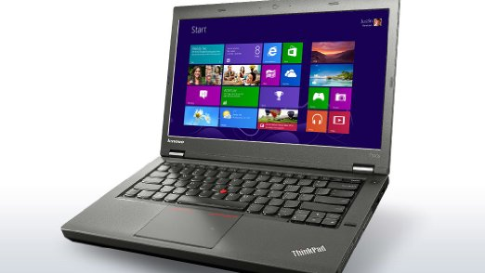
2. 4 x GoPro Hero3+ Black edition camera.
http://shop.gopro.com/EMEA/cameras/hero3plus-black-edition/CHDHX-302-EU.html
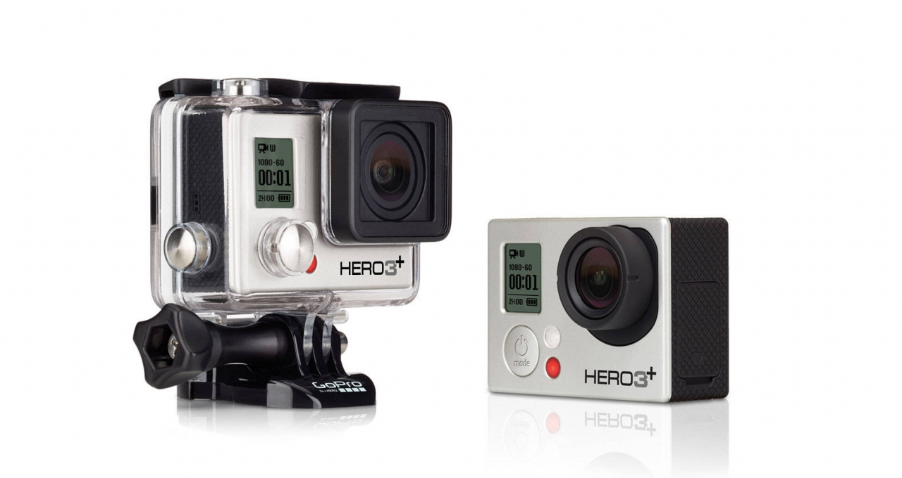
3. 4 x SD cards 64 GB.
http://shop.gopro.com/accessories/sandisk-extreme-64gb-microsdxc/ASDMC-364.html#/start=1
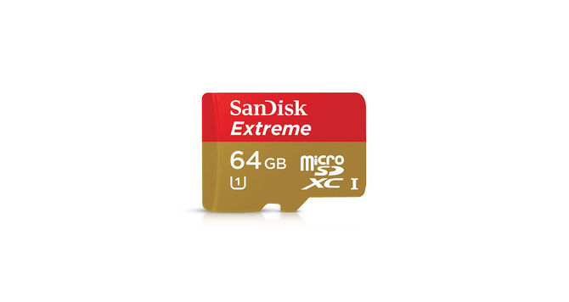
3. 1 x GoPro remote control.
http://shop.gopro.com/accessories/smart-remote/ARMTE-002.html
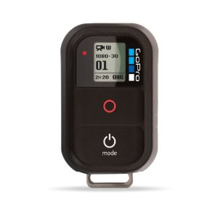
4. 1 x USB hub with 4 USB ports in it. Sandberg recommended.
http://www.sandberg.it/en-us/product/USB-3.0-Hub-4-ports
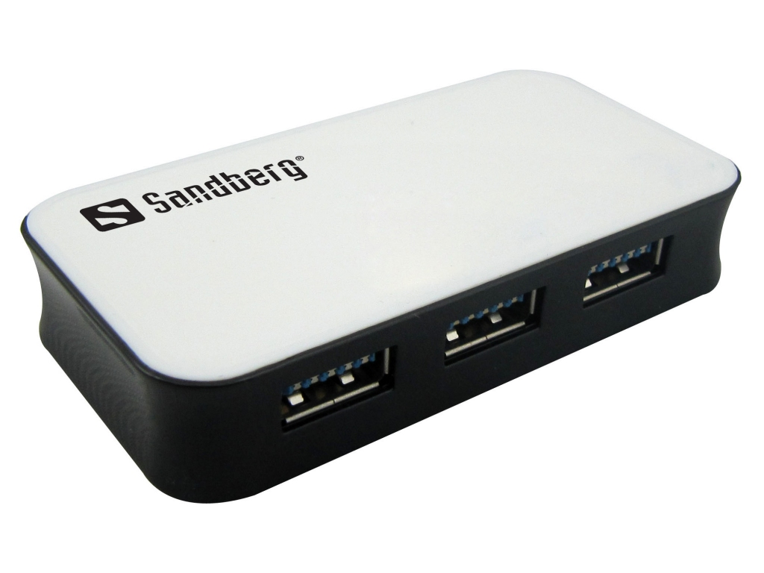

5. Mounts to hold cameras. 5 x gooseneck mounts and 1 x suction cup mount.
http://shop.gopro.com/mounts/gooseneck/ACMFN-001.html
http://shop.gopro.com/mounts/suction-cup/AUCMT-302.html
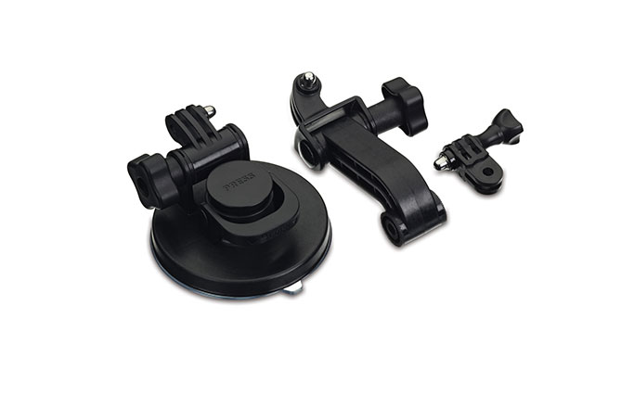
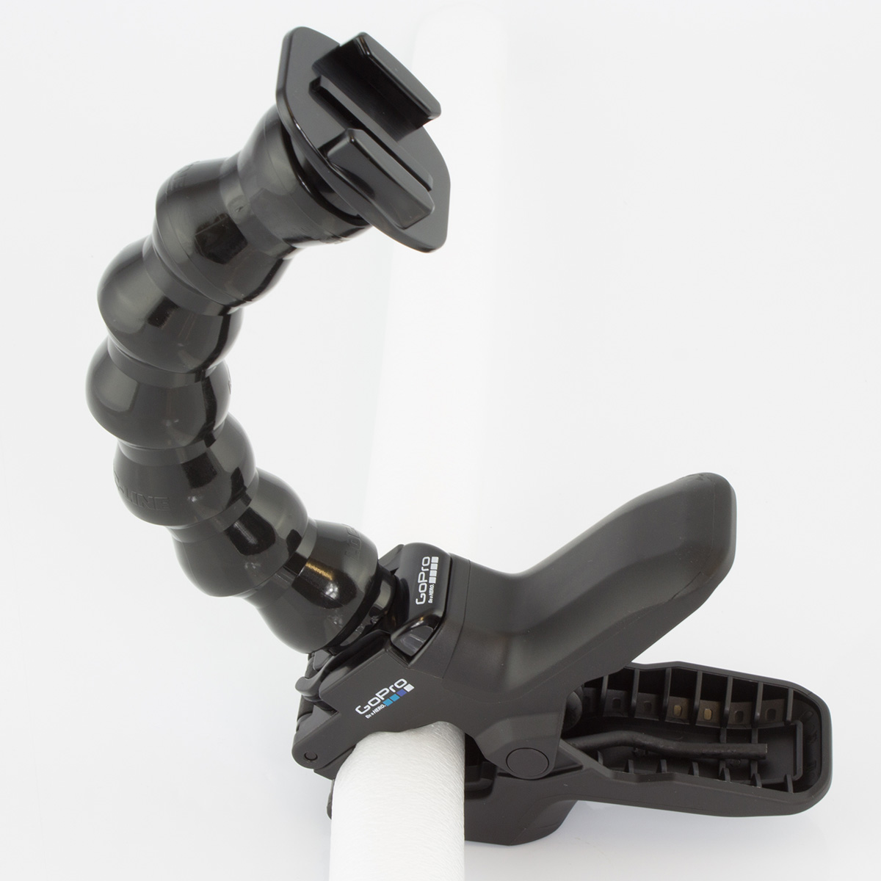
6. 1 x bag for carrying the system.
http://salestores.com/taonbanoplla.html
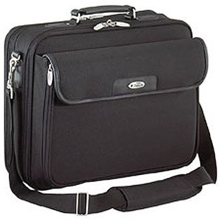
7. OPTIONAL. 8 x Black GoPro frame.
http://shop.gopro.com/mounts/the-frame/ANDFR-302.html
http://www.amazon.com/GoPro-Frame-Mount-ANDMK-301-Cameras/dp/B009PK9QGU
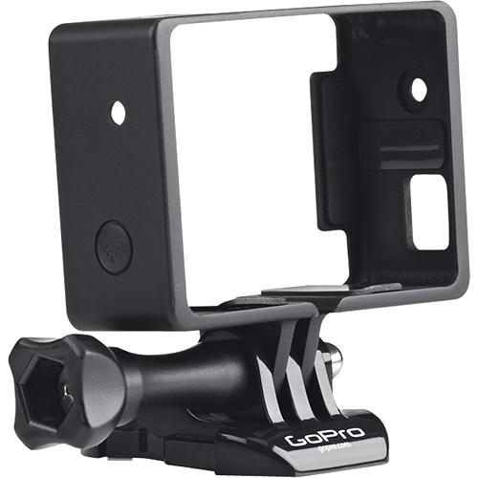
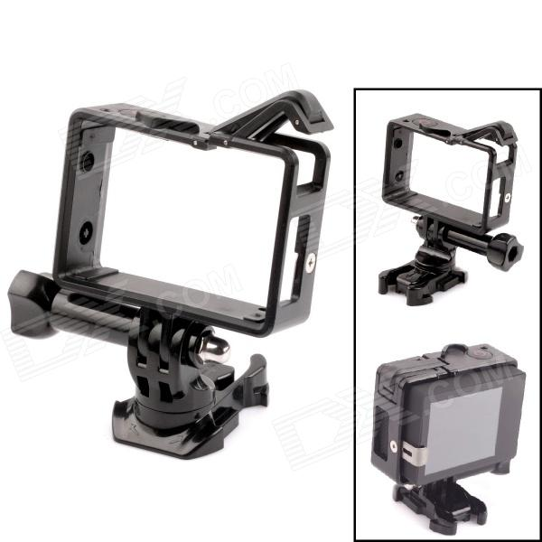

8. OPTIONAL. 2 x Apple AirPort Express.
https://www.apple.com/airport-express/
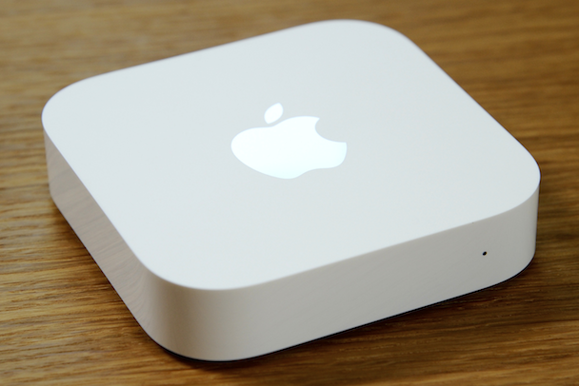
9. OPTIONAL. 3 x 8GB DDR3 RAM blocks.
http://www.newegg.com/Laptop-Memory/SubCategory/ID-381

