一、Let 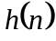 be the impulse response of a FIR filter with 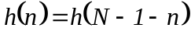, please draw the direct form of its network structure when  is odd/even.

二、Suppose the function system of a filter is
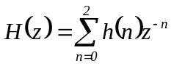, 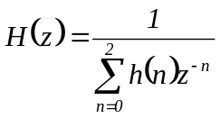

where 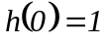, 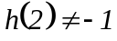. realize 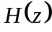 using an all-zero grid network structure.

三、Analog Butterworth Filters：cutoff frequency：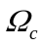，order：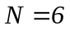，write out the system function of analog Butterworth filter：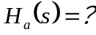

四、Let 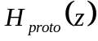 be the system function of a digital lowpass filter with cutoff frequency 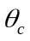, please find out a function 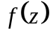 such that 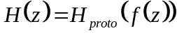 is a lowpass/highpass filter with cutoff frequency 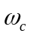
1.5CM
1.5CM
1.5CM

五、Please prove that 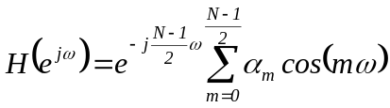 is the frequency response of a linear phase FIR filter when even symmetric and odd.

