Jordan Longato & Matt Mahnke  
SE 4910 Final Assignment  
11/13/2016

# Rain?

Rain? Is an application that queries the Dark Sky api and will display weather information for you. It also provides a widget which will update with the temperature and a quick description about the weather. Rain? also, has the feature of providing a sassy description of the weather similar to whatsthefuckingweather.com.

# Functionality and Android Version

Android version: 21+

* The app is able to query DarkSky.net and display the result on the app
* The app has a widget that functions similarly to the main app
* The app has a splash screen!
* The app can get the users location

# Test plan

1. Open up the Rain? App
2. Witness the glory that is the splash screen
3. Revel in the beauty that is the home screen
4. Verify that the home screen displays the weather for your location
5. Verify the home screen displays a sentence describing the weather

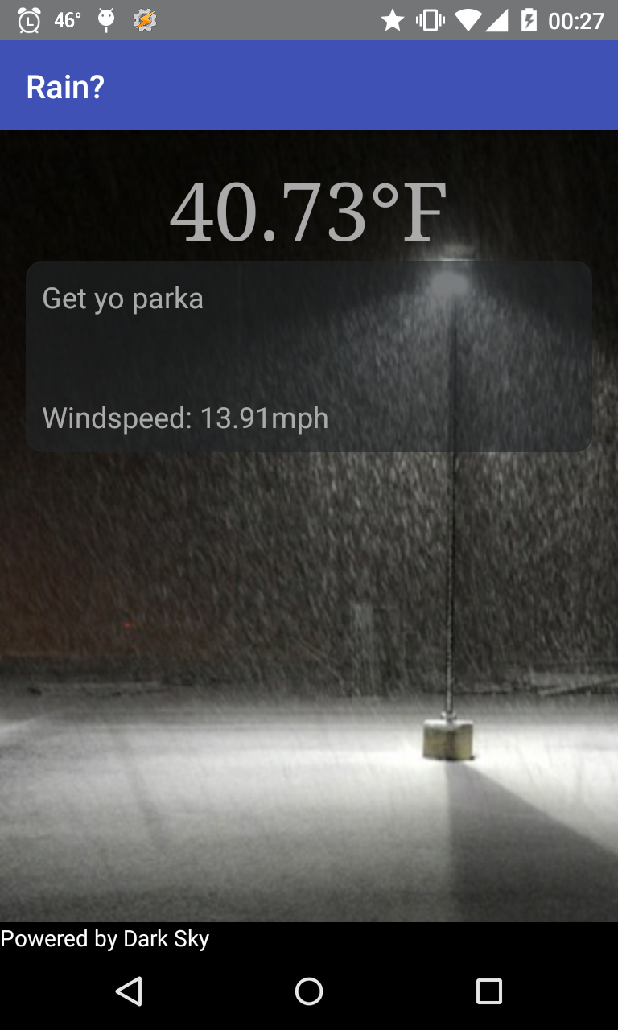

1. On your home screen add the Rain? Widget
2. Verify it displays the weather for your current location.
3. Verify there is a word describing the weather

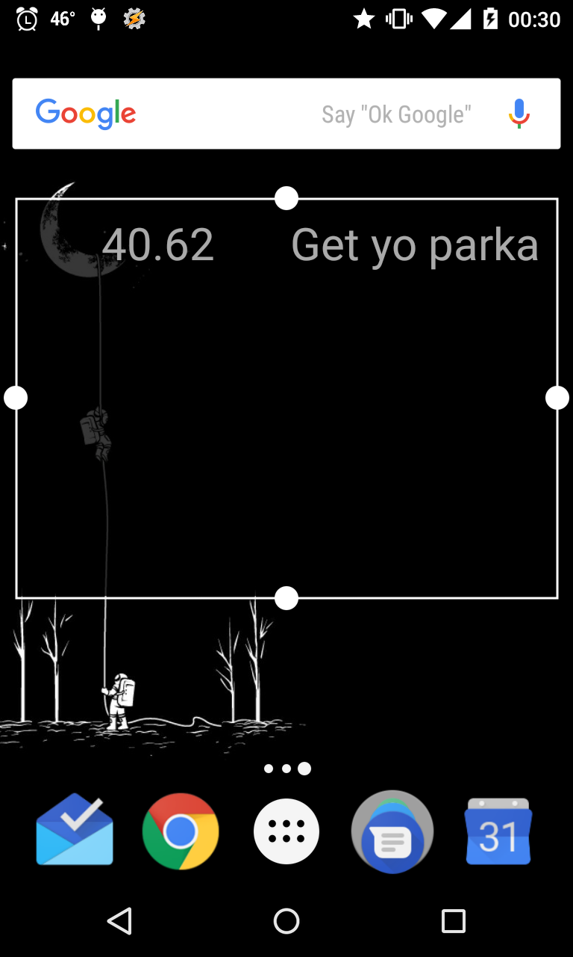

1. Open up the Rain? App.
2. Select the “Read to me” button.
3. Verify that the app speaks the paragraph describing the weather
4. Open up the Rain? App.
5. Verify you can’t search for any other location besides your current.
6. Question why this app can’t search other locations
7. Remember that this feature is out of scope.