PSU Capstone CS487 Spring 2009
gearman-jms
Eric Day

Adam Elston-Jones
Nick Harsh
Rogelio Hernandez
Scott Merz
John Ogle
Isaiah van der Elst
Project Plan
Overview:
Gearman provides a generic application framework to farm out work to other machines or processes that are better suited to do the work. It allows you to do work in parallel, to load balance processing, and to call functions between languages. It can be used in a variety of applications, from high-availability web sites to the transport of database replication events. In other words, it is the nervous system for how distributed processing communicates.
Current API exists in C. We will implement in Java, using the Java Messenger Service (JMS) APIs.
Deliverables:
A BZR repository hosted on Launchpad will contain the source code for download. Also, we are creating a Wiki which explains our development process and other decisions we made, so that future developers on the project can have an easy time coming into it.
Key Assumptions, Constraints, and References:
We assume that using JMS to communicate amongst the computers is actually feasible and will work.
We are constrained by using Java, JMS, and the Google ProtoBuffer packets. These also end up being key references. An additional constraint is that we must have the functionality mirror the C API’s after all is said and done.
Development Process:
Establish Customer Needs – We had a meeting with Eric on 05/04/09 to get information for the requirements. All of us attended.
Write Needs Down – All of us met 05/08/09 to synthesize our notes from the last meeting.
Customer Approval of Needs – By 05/19/09, we will submit a formal requirements document to Eric for approval. Nick and Rogelio will create this document using the notes from our last meeting.
Specify needs in terms of application functions/features – Documentation on Wiki. BZR Repository hosted on Launchpad made available to the public community (working on the project). Implementation of Java APIs using JMS and Google ProtoBuffers
Create System Architecture – Create system architecture and show to Eric for discussion/validation by 06/01/09. Scott and Isaiah will develop this document.
Code the Components - We will all develop (see Milestones/Pert Chart/Schedule)
Test Each Component – Adam will help Rogelio with testing.
Integrate Components – see Milestones/Pert Chart/Schedule
Testing the Integration – see Milestones/Pert Chart/Schedule
Milestones:
Expected = (Optimistic + 4*Likely + Pessimistic) / 6
10 – Coding Conventions, Styles: Code Kickoff Meeting (Entire Group)
- Indentation/Naming Conventions
- Package Hierarchy
- Development Tree
- Commit Methodology
- Define testing methodology
Total Time = 12/18/30
Total Man Hours = 12/18/30
Expected Time = 19
Expected Man Hours = 19
20 – Send ProtoBuf object through gearmand
- Google ProtoBuf (Nick T=3/5/10)
- Read Documentation
- Understanding the message format
- Compiling with ProtoBufC (ProtoBuf compiler)
- How to use the output Java class
- Understand/Wrap gearman-ij (Rogelio T=4/8/20)
- Branching gearman-ij down from Launchpad
- Analyze source and develop wrapper if necessary
- Send/Receive Gearman packets using gearman-ij
- Send/Receive ProtoBuf packets (Nick & Rogelio T=2/5/10)
- Merge parts 1 & 2
Total Time = 6/13/30
Total Man Hours = 9/18/40
Expected Time = 14.67
Expected Man Hours = 20.17
30 – Send/Receive JMS Packets amongst Java Clients
- Understand and learn JMS
- “Fake” JNDI (Isaiah T=2/5/10)
- Use 3rd Party JMS Provider to send JMS Packets amongst test clients (John T=10/15/20)
Total Time = 10/15/20
Total Man Hours = 12/20/30
Expected Time = 15
Expected Man Hours = 20.3
40 – JMS Provider Skeleton
- ConnectionFactory, Connection (Scott T=10/20/30)
- Session, Destination (Adam T=10/20/30)
- Message (Isaiah T=20/40/60)
- MessageProducer, MessageConsumer (Nick T=20/40/60)
Total Time = 20/40/60
Total Man Hours = 60/120/180
Expected Time = 40
Expected Man Hours = 120
50 – Explicit Debug and merge phase
Total Time = 2/20/80
Total Man Hours = 30/60/120
Expected Time = 27
Expected Man Hours = 41
60 – Create and Implement Test Harness/Suite
- Create complex high level (and package level) tests to run as part of suite (Adam & Rogelio)
Total Time = 20/20/20
Total Man Hours = 40/40/40
Expected Time = 20
Expected Man Hours = 40
70 - Documentation
- Create documentation for design architecture and use cases (Adam & Rogelio)
Total Time = 10/10/10
Total Man Hours = 20/20/20
Expected Time = 10
Expected Man Hours = 20
Pert Chart
10
T=19
T=19
70
20
30
60
40
50
80
T=19
T=19
T=15
T=15
T=20
T=10

T=19
T=40
T=27

Schedule:
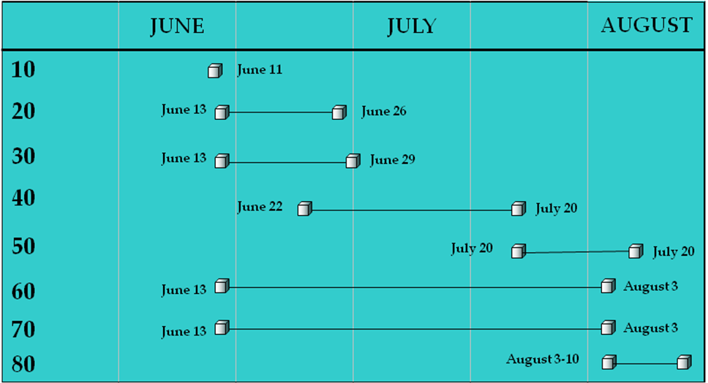
Calendar:
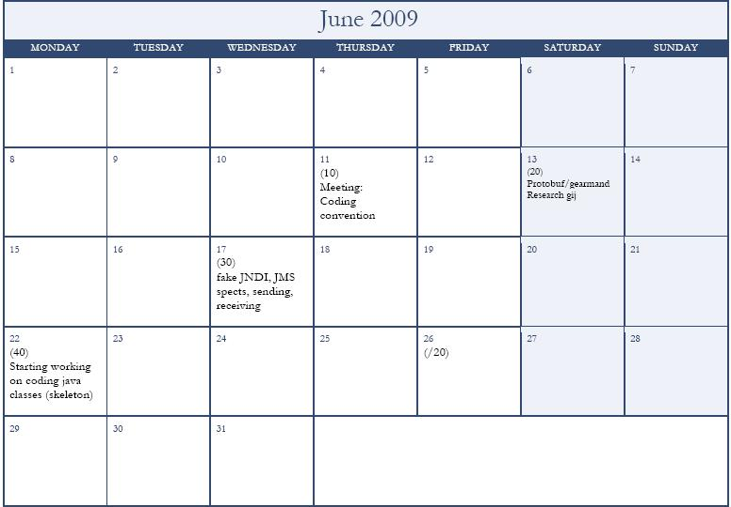

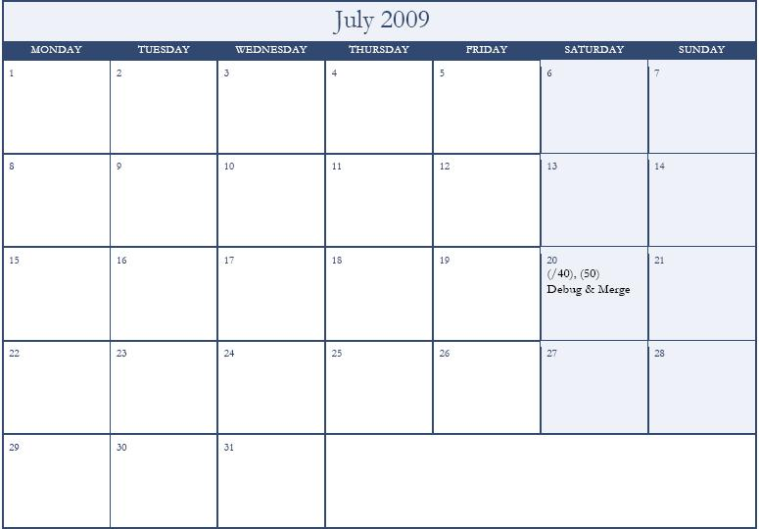

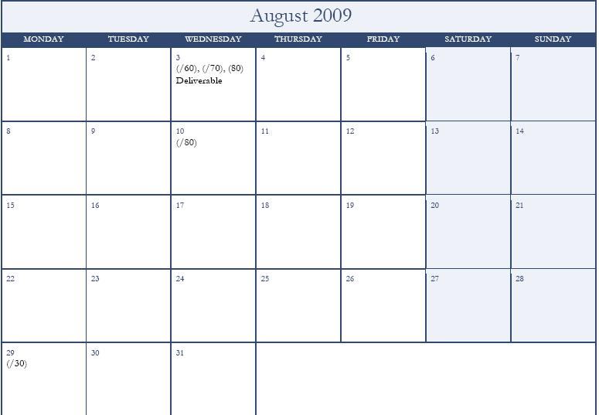
Meetings and Reviews:
- 05/01/09 @ 9:00am, Capstone Lab – Kick off meeting: Eric + Group.
- 05/04/09 @ 7:30pm, Capstone Lab – System Architecture and Requirements: Eric + Group.
- 05/08/09 @ 7:30pm, Capstone Lab – Requirements: Group.
- 05/12/09 @ 07:30pm, Capstone Lab – Requirements: Eric + Group.
- 05/18/09 @ 6:40pm, Capstone Lab – Project Status: Warren + Group.
- 05/19/09 @ 7:30pm, Capstone Lab – Requirements: Eric + Group.
- 05/26/09 @ 7:30pm, Capstone Lab – Requirements: Group.
- 05/29/09 @ 11am, Capstone Lab – System Design/Architecture: Group.
- 06/01/09 @ 8:30pm, Capstone Lab – Project Architecture/Plan Status: Warren + Group.
- 06/05/09 @ 7:30pm, Capstone Lab – Presentation: Group.
- 06/07/09 @ 4pm, Capstone Lab – Presentation: Group.
Resource Identification:
- 1 Developer station
- 1 Job Server (runs gearmand)
- 2 Workers
- All machines are running Ubuntu v9.04 Jaunty Jackalope
Configuration Management:
We will use a BZR repository hosted on Launchpad. There is already a public community setup on here for the Gearman project. Eric will give us access to this, and we will store our code here. Note that this also makes it unnecessary for us to deploy our code.
Roles/Responsibilities:
Project Manager – Adam
User Needs – Nick & Rogelio
Designer – Scott & Isaiah
Computer Nerd(s) – John, Scott, & Nick
Developer – Everyone
QA – Rogelio & Adam
Risk Management:
We made sure we have at least two people at each role.
We will keep a local copy of our Dev trunk on one of our capstone lab computers just in case.
If Eric were suddenly pulled off the project, or had his time available cut, or even if Oracle stepped in and ended the project… We would still be able to finish since its open source.
JMS may not work; to deal with this possibility we will use the architectural design to make JMS a layer that can be swapped out. Essentially, we will develop the JMS layer separately from the main Gearman logic, using an Interface as a place-holder.
Quality Assurance:
Rogelio and Adam will develop tests. However, according to Eric their already exist some tests we may be able to import/use in our scenarios. When developing, each group member is for creating a test for any objects/classes they create AS THEY CREATE THEM (not before because we aren’t doing TestDriven development; but close to when you made the class).
Deployment:
- Deployment is non-existent for us in this project. Since we are using a public code repository, which also happens to be the heart of the open source community, there is no install or distribution specifics that we need to handle. Once the library is finished, anyone (who is accepted into the community) who wants to use it, add-on to it, or maintain it will have complete access to do so.

