**3DS Max exports to FBX, OBj, X3D**

The fbx, obj and x3d files were all exported from the same scene in 3D Studio Max 2009.

The teapot and the torus are each textured and located at (0, 0, 0). Each torus scene uses the same “torus.png” texture map, and each teapot scene uses the same “teapot.png” texture map.

Due to the dimensions of each mesh, a translation of (0, 0, -100) will enable each to appear in GearVR. In addition, some of the FBX files have the Y and Z axis switched. A rotation of -90 degrees (1, 0, 0, -1.57 in axis-angle format) and the x-axis will show the teapot and torus upright.

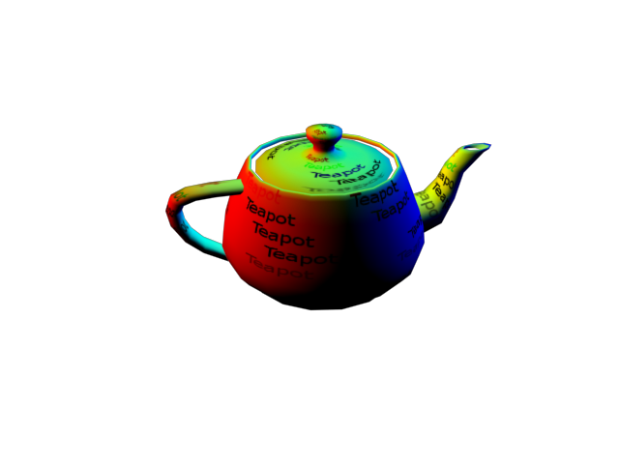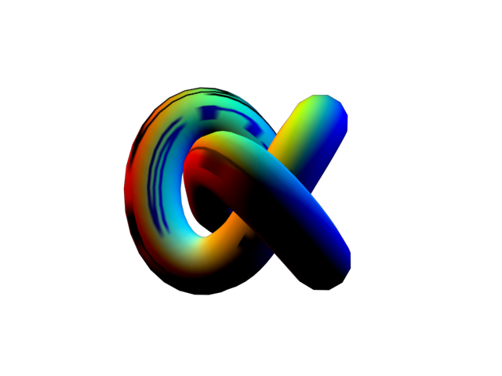

There are 3 sets of files: mesh only with no lights or animation; a 3 1/3 second animation 360 clockwise rotation; and the same animation with red light at (80, 58, 0), a green light at (0, 59, 0), and a blue light at (-78, 58, 0) shown above.

The FBX file exported from 3DS Max 2009 to FBX 2013 using “Autodesk FBX Converter x64 2013”. The FBX 2013 files removed the absolute directory address (such as “D:/GearVR/Max files/myTexture.png”) of texture maps and other references (for example “D:/GearVR/Max files/myTexture.png” to become “myTexture.png”).

In the OBJ files, the accompying MTL (material) file was edited to remove the absolute directory and leave only the texture map file. For example, “D:\temp\teapot.png” was edited to be “teapot.png”.

The X3D file was converted from the VRML (.WRL) file from 3DS Max using Instant Reality’s Converter (http://doc.instantreality.org/tools/x3d_encoding_converter/).