**MultiTexture**

Demo’s of X3D’s MultiTexture node with its modes. Here are the texture maps used in the demo’s

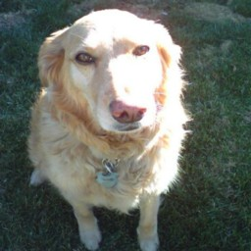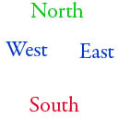

Deedee1.jpg green.jpg news_texture_map.jpg red.jpg

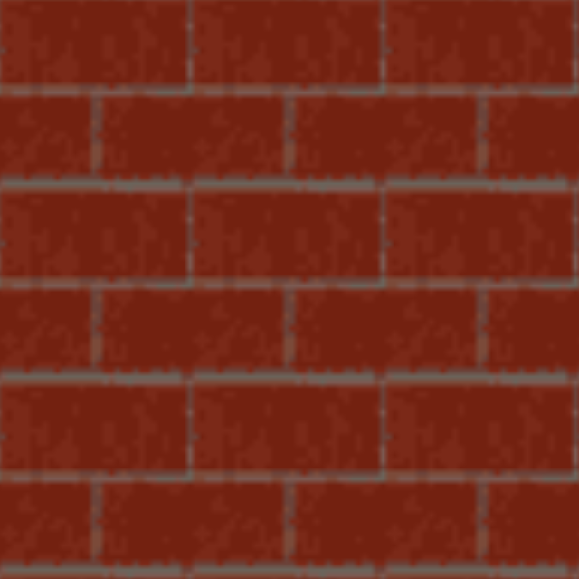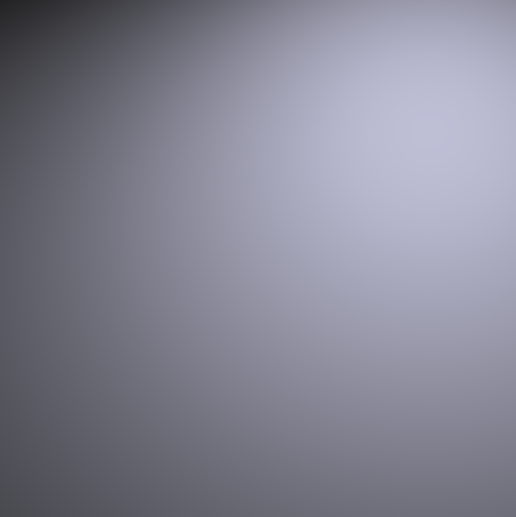

Brickwall.png brickwall_lightmap.png

**multi-texture_Add.x3d**

Adds green.jpg + red.jpg

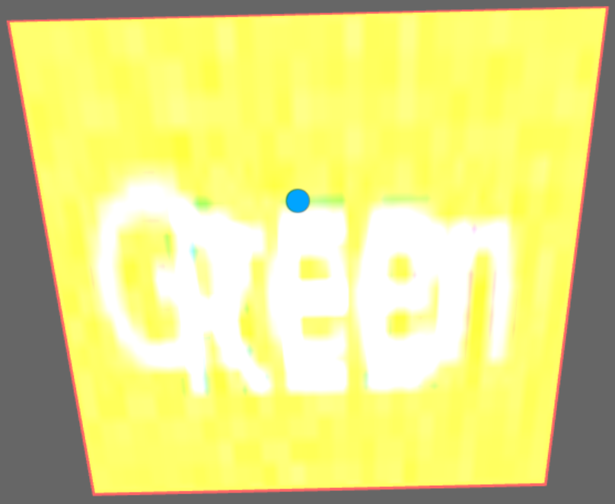

**multi-texture_AddSigned.x3d**

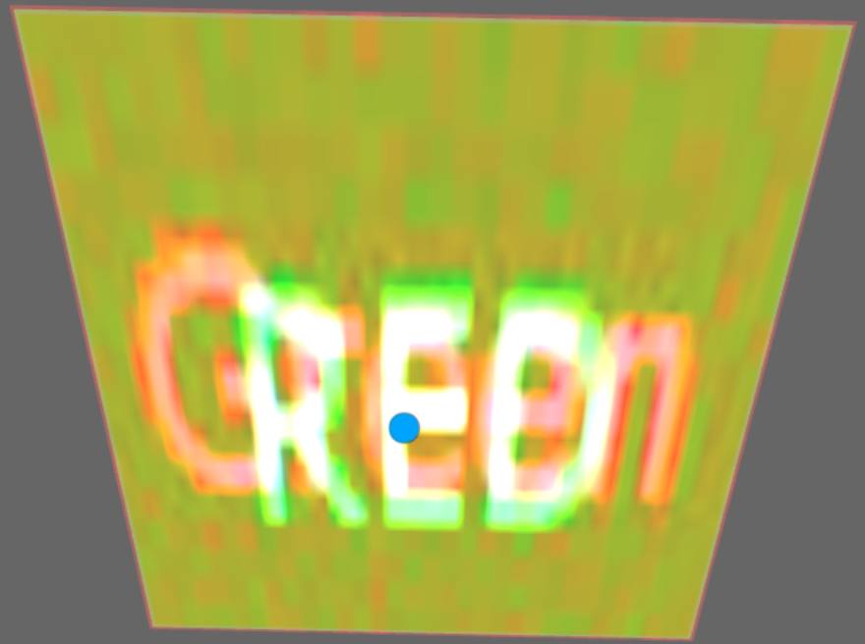

**multi-texture_AddSmooth.x3d**

Adds brickwall.png with brickwall_lightmap.png

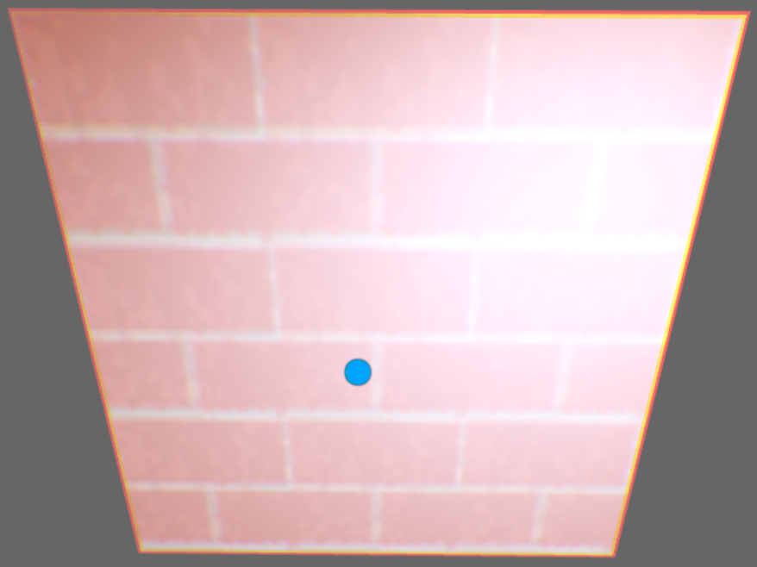

**multi-texture_GeneralDemo.x3d**

The four upper and lower left and right object are just regular textured primitives, no multi-texturing.

The middle images are both multi-textured. The left is SUBTRACTing the brickwall from the dog image. The right image is ADDing red.jpg + green.jpg.

This demo is just a test to make sure we can still mix regular textured images with multi-textured images.

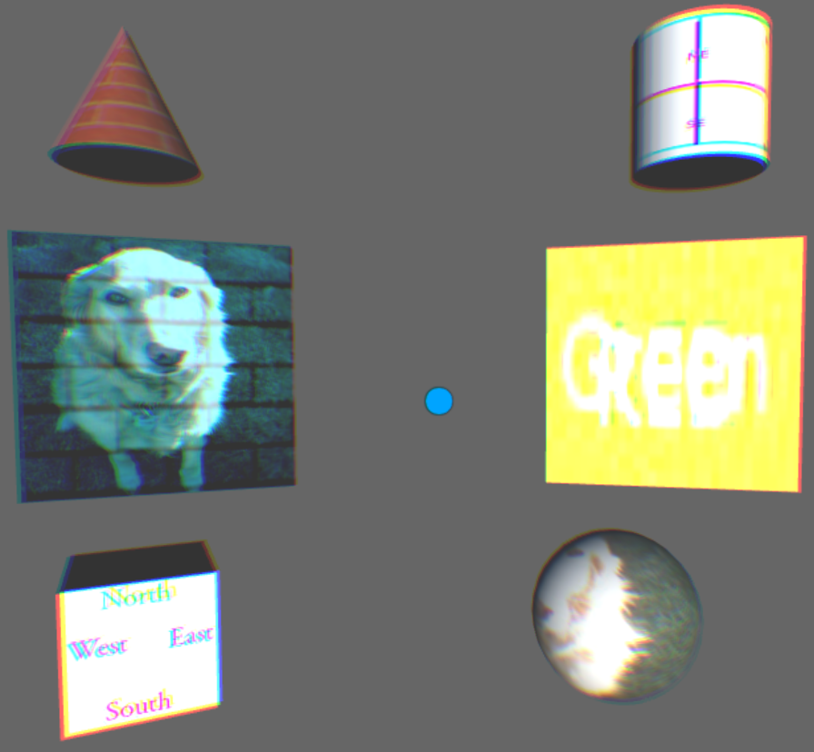

**multi-texture_Modulate.x3d**

Modulate multiplies the new_texture_map with the dog image.

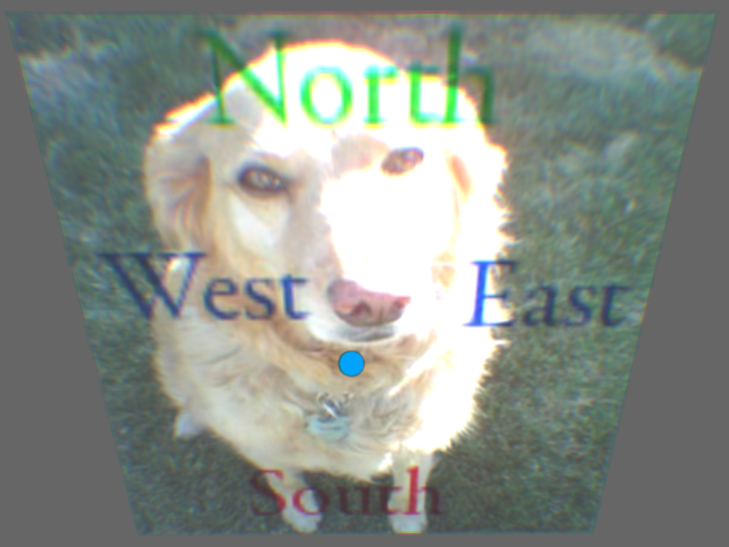

**multi-texture_None.x3d**

This demo sends a dummy mode of “NONE” which thus should default to MODULATE, using the dog image with the brick wall.

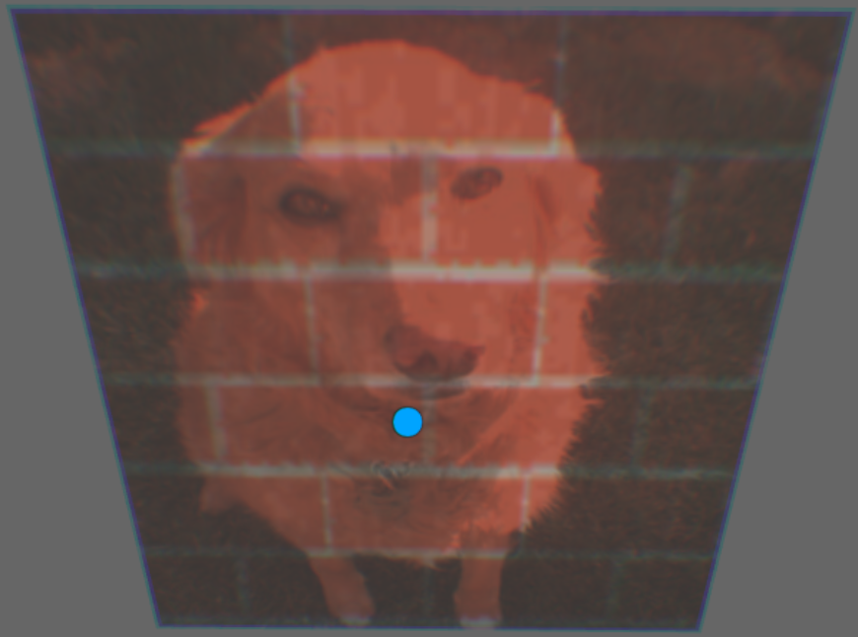

**multi-texture_Subtract.x3d**

SUBTRACT the dog image from the news_texture_map image.

