**PROTO with interactivity (no javascript)**

Tests for X3D Proto without Sensors (for interactivity), Animation nor Scripts. This enables the instancing of objects PROTO’d and allows for modifications to the properties of these objects.

**ProtoExample.x3d**

Simple Proto sample Cylinder. The diffuseColor plus Cylinder height and radius are set in the <ProtoInterface> and <ProtoBody>.

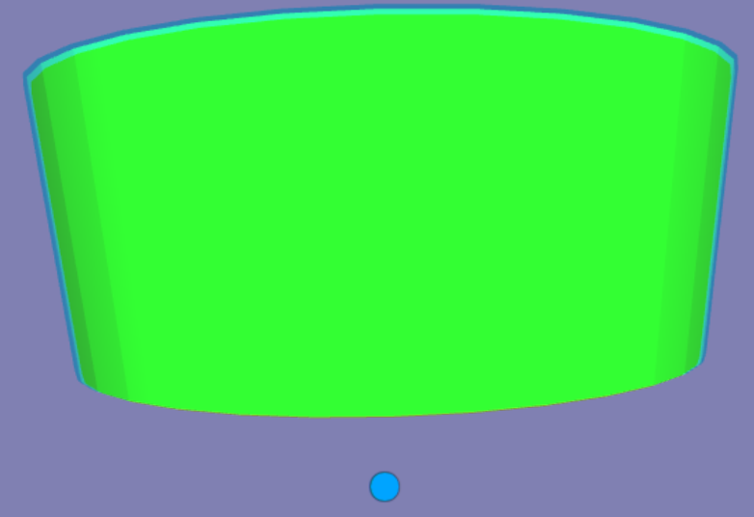

**Proto_Cylinders.x3d**

The <ProtoInterface> sets the Cylinder height, radius to 4.5 and .5, and top to false. The <ProtoInstance> sets the red Cylinder height and radius to 2.5 and 2 respectively; the green Cylinder to 1.3 height, radius to 1 and the top to true; and the yellow Cylinder with default <ProtoInterface> values.

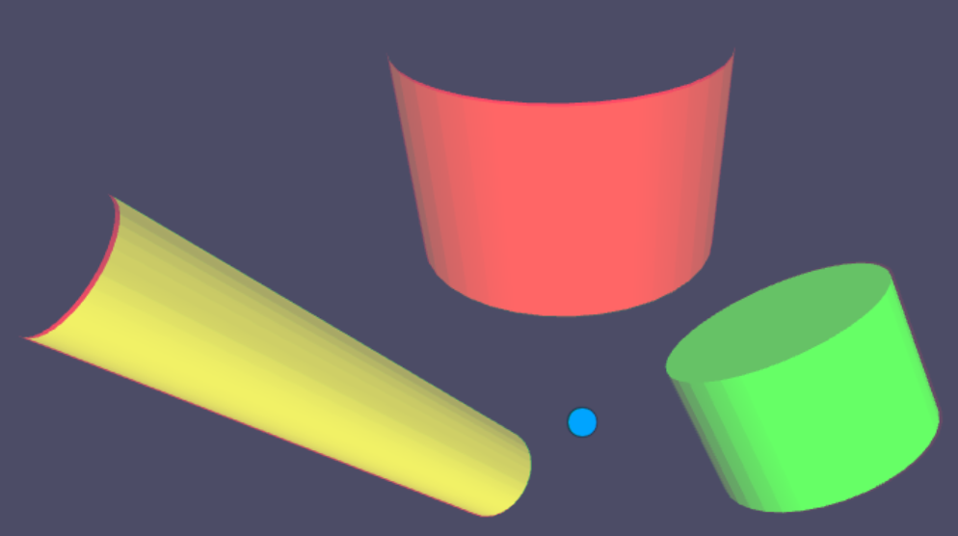

**Proto_Cones.x3d**

The <ProtoInterface> sets the Cone’s height, bottomRadius to 3.5 and .5, and color to light blue. The <ProtoInstance> sets the default light blue Cone height and radius to 2.5 and 2 respectively; the green Cone to 1.3 height, radius 1; and yellow Cone to the default height and bottomRadius.

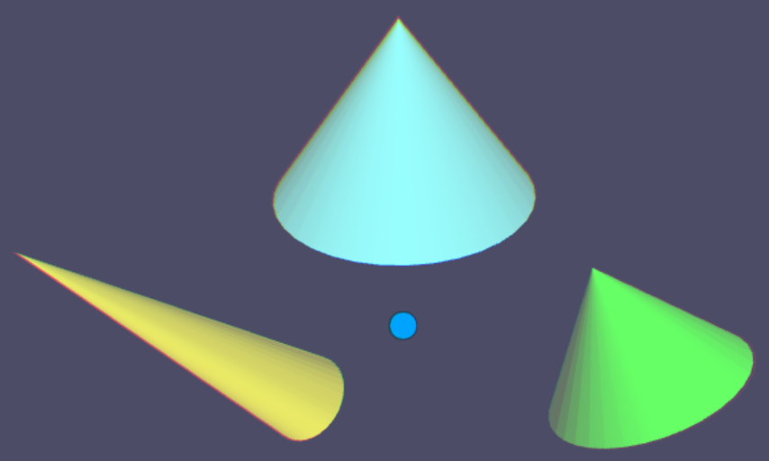

**Proto_Boxes.x3d**

The <ProtoInterface> sets the light blue Box’s default size to 2, 1.5, 1. The <ProtoInstance> sets red Box size to 3, .75, 1; the green Box size to .5, 1, 2; and the yellow Box’s size to the default size.

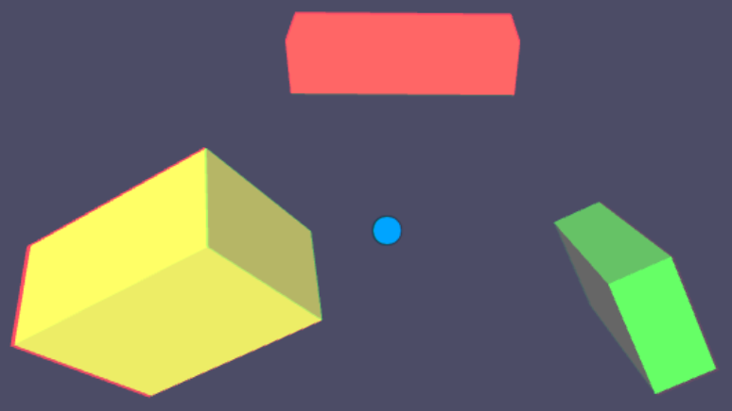

**Proto_Spheres.x3d**

The <ProtoInterface> sets the light blue Sphere’s default radius to 1.5. The <ProtoInstance> sets the red Box radius to .5; the green Sphere radius to 2.4; and the yellow Sphere’s radius to the default size.

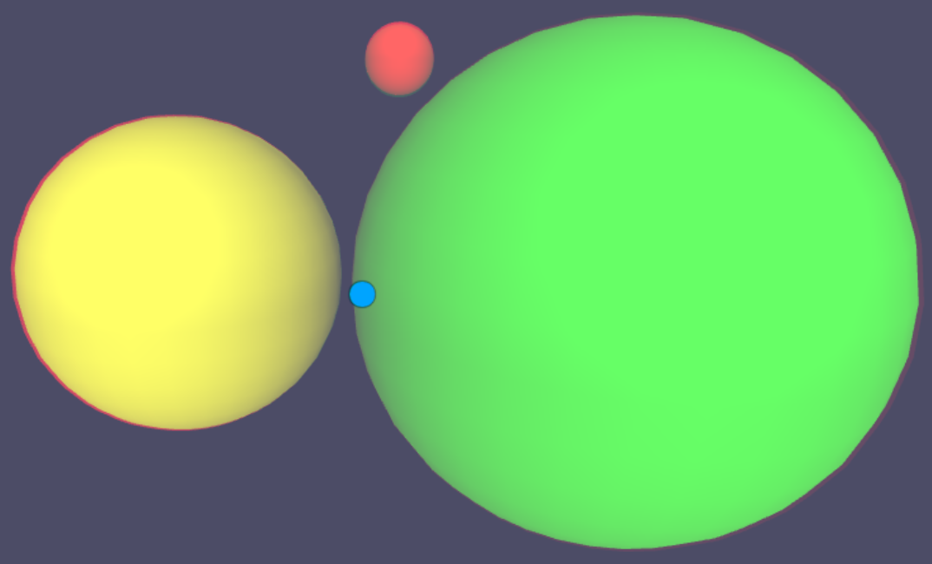

**Proto_TextString.x3d**

The Scene has 3 non-PROTO text strings in Prisma.ttf font with text “TEST BEFORE BOLD”, “TEST BEFORE PLAIN” and in light blue “TEST AFTER” to help randomize the test.

The <ProtoInterface> sets text to “String Interface”, size 2.8, justify right (END), bold-italic Prisma true type font and spacing of 4.0.

The default “String Interface” text in the lower left of size 0.9 and Plain instead of bold-italic.

The other PROTO text ‘”my text” “demo”’, center justification, 1.55 size, plain style, 36.0 line spacing and uses “BroadcastTiling true type font. It was intended to overlap the other text blocks.

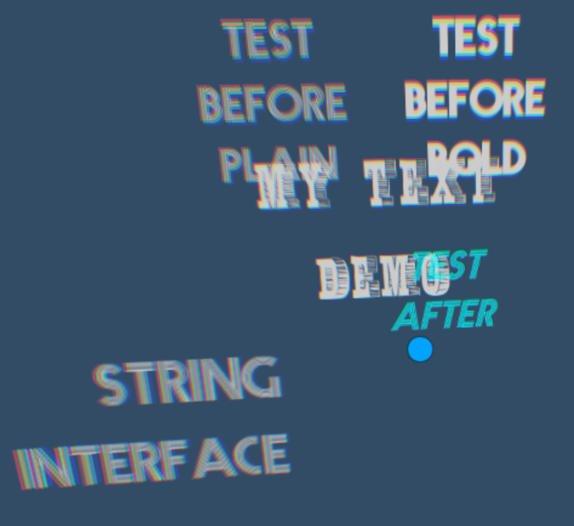

**Proto_SimpleIFS.x3d**

The Scene has 2 textured images on the left to help randomize the test.

The <ProtoInterface> sets the default IndexedFaceSet with scale of 2, 3.

The two <ProtoInstance>’s makes no changes to the original <ProtoInterface>.

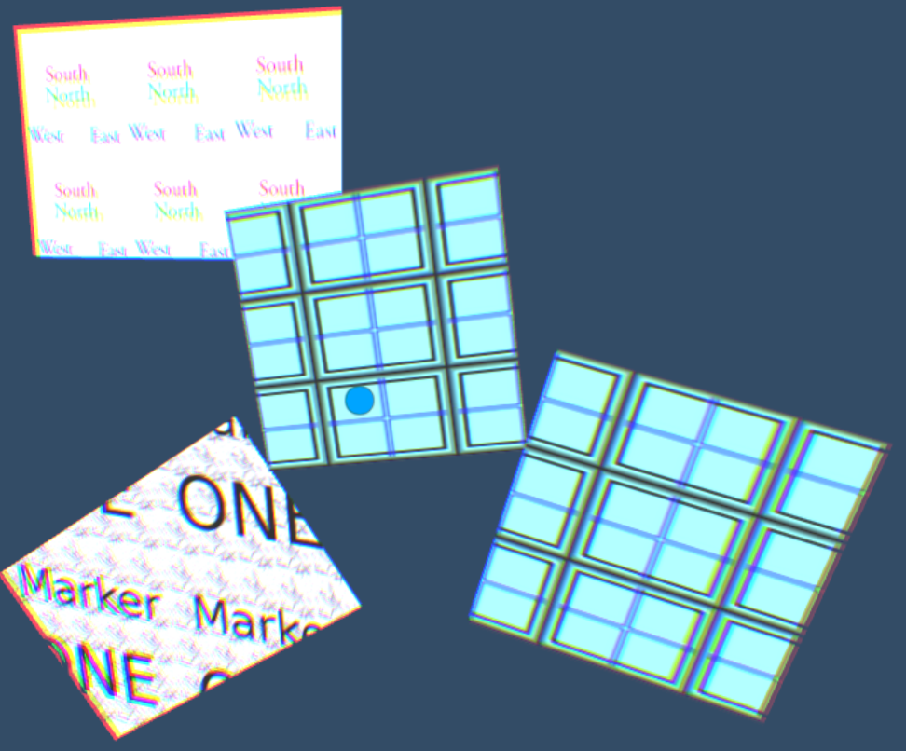

**Proto_TextureTransform.x3d**

The Scene has 2 textured images on the left to help randomize the test.

The <ProtoInterface> sets the default <TextureTransform> scale of 2, 3; rotation of -.3 and translation of .2, .6.

The two <ProtoInstance>’s makes no changes to one of the original <ProtoInterface>, and the upper right one changs the default rotation from -.3 to -.6 .

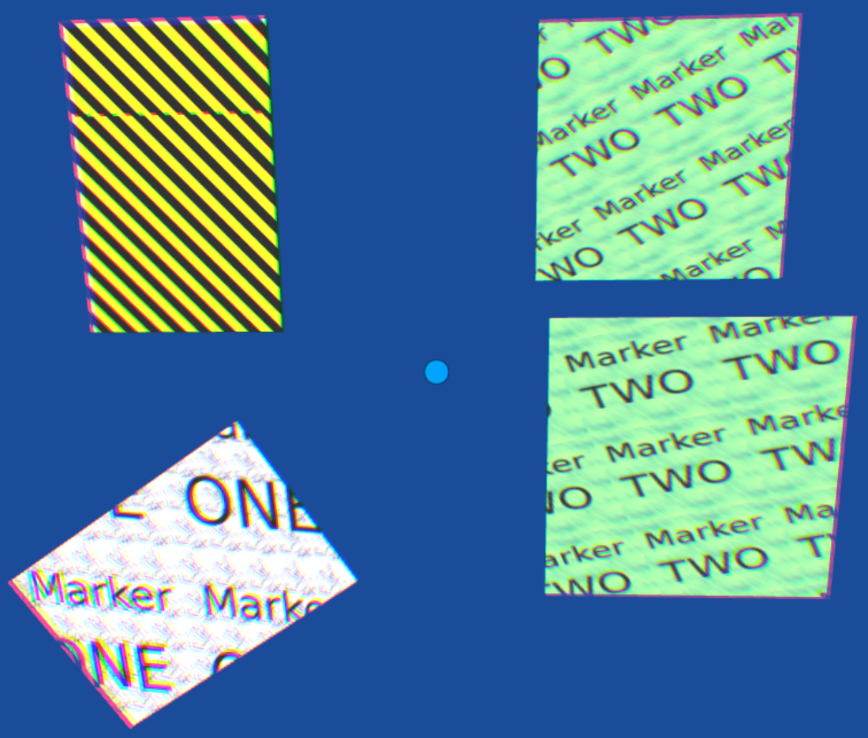

**Proto_ImageTexture.x3d**

The Scene has 2 textured images on the left to help randomize the test.

The <ProtoInterface> has a default image of a dog, texture rotation of 0 and diffuseColor of 1,1,1..

The <ProtoInstance>’s includes:

A texture map rotation 0f -.4 in the upper right of the scene .

A texture map change on a rotated mesh in the lower right (the white image with blue lines).

And in the center is a rotated mesh where the diffuseColor is set to yellow (1, 1, 0).

