**Control FBX Key Frame Animations**

These demonstrations test an extended feature of X3D to use a Touch Sensor to invoke an FBX file’s key frame animation. In addition, X3D’s ROUTE can designate the key frames to animate.

The FBX file is embedded into an X3D file using the <Inline> mode

<Inline DEF='someObject' url='coneScale.FBX'/>  
  
The X3D file uses a TouchSensor. The ROUTE’s ‘*toNode’* is the name DEFINED in the <Inline> node.

<ROUTE fromField="isOver" fromNode="*myTouchObj*"

toField="set_enabled" toNode="*someObject*"/>

The ‘*toField’* can also set a pair of frames to animate from and to. In the example below, we animate from key frame 1 to key frame 2.

<ROUTE fromField="isOver" fromNode="*myTouchObj*"

toField="**1, 2**" toNode="*teapotObject*"/>

**fbx_teapot_and_torus_anim.x3d**

Scene has two animated FBX objects, a teapot and a torus, that each rotate for 3.3 seconds around the y-axis. Rolling over the green box invokes the torus’ animation.

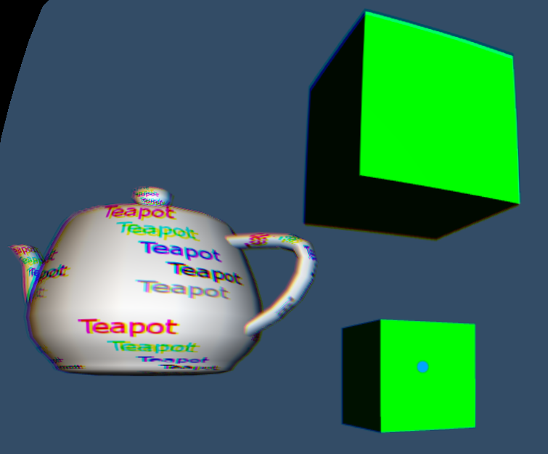

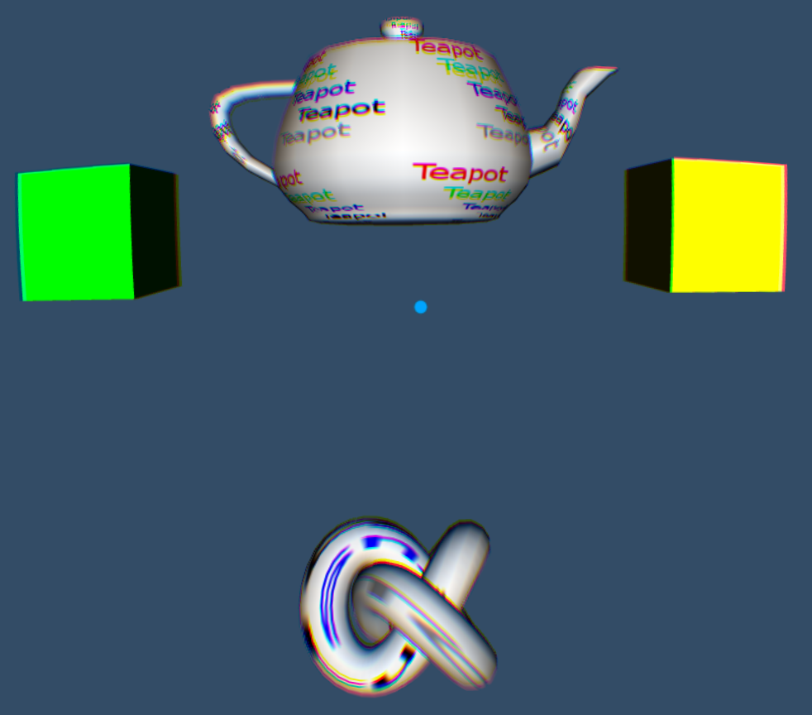

Rolling over the yellow box invokes the teapot’s animation and a JavaScript script that changes the yellow box to green, and moves the green box to a new location just above the original yellow box. This just tests to ensure other functions from before still work.

**fbx_teapotorcone_byframe.x3d**

This scene has two independent FBX objects, a teapot and a cone. The teapot has a rotation and translation (not the same animation as the teapot in the previous example). The cone has a translation and a scaling.

Rolling over the white box on the upper left and the white cone on the upper right run the entire animation for the teapot or the cone respectively.

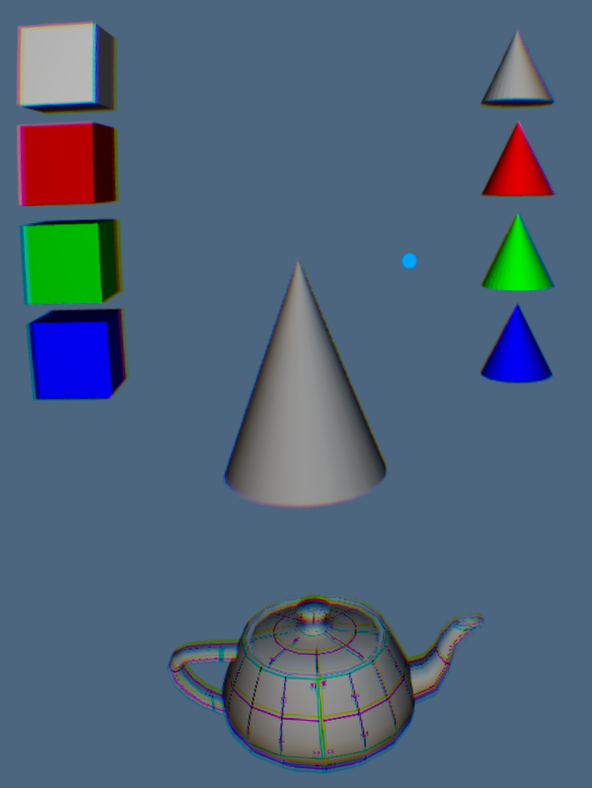

Rolling over the red box and red cone run the animations from frame 1 to frame 2 for the teapot and the cone respectively. Note that the animations return to the starting frame, in this case, frame 1.

The green box and green cone animate from frame 2 to frame 4 for the teapot and cone respectively.

The blue box and blue cone animate from frame 2 to 5 for the teapot and cone respectively.

**fbx_teapotandcone_byframe.x3d**

This animation uses spheres to invoke the animations for both the teapot and cone simultaneously. Rolling over the white sphere will run both the enitre teapot and cone animations at the same time. Rolling over the red sphere animates both objects at their same time from their frame 1 to 2.

Rolling over the green sphere animates both objects from their frame 2 to 4. And rolling over the blue sphere animates both objects from frame 2 to frame 5.

Note that while teapot and cone each have 5 second animations, they have different key frames set. Thus, they will not take the same amount of time for their frame-to-frame animations.

