**Texture_coordinates**

Tests with texture mapping. Various lights, rotations and texture transforms on objects. No interactivity.

**singletexturetransforms.x3d**

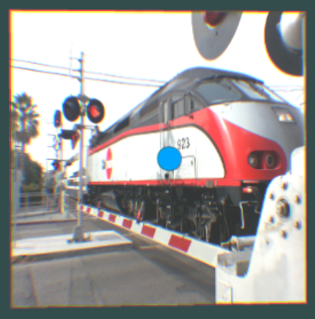

**texturecoordinatetest.x3d**

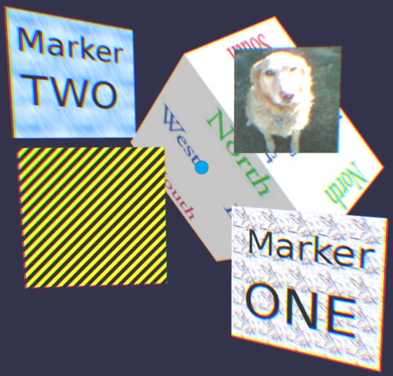

**texturecoordinatetestsubset.x3d**

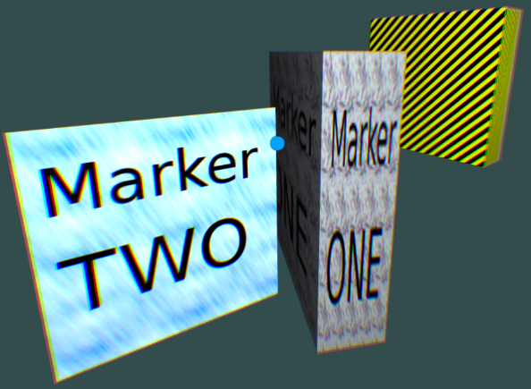

**texturecoordinatetestsubset2.x3d**

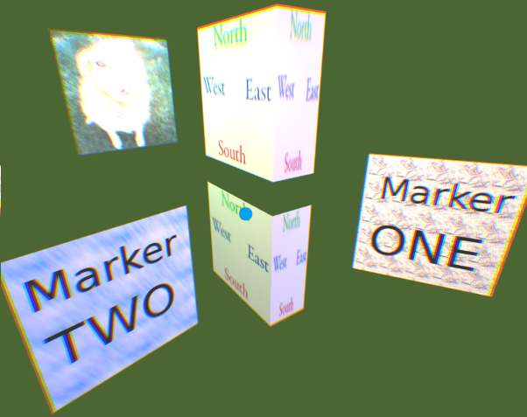

**texturecoordinatetestsubset3.x3d**

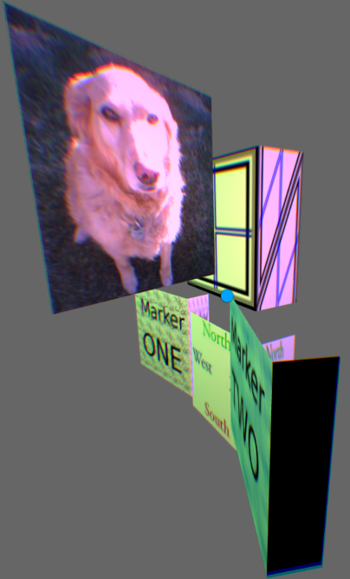

**texturetransforms.x3d**

