Total Cost of Ownership of Vehicles with Different Powertrains

Executive Summary

- Introduction
Motivation, scope, perspective, intended audience/users

- Review of Previous Work

  - General TCO Studies
Lit reviewed by the Lit review team
  - Specific Vehicle and Associated Cost Studies
Battery costs, vehicle costs, fuel cell costs, commercial vehicle costs, etc.

- Data, Methods, and Assumptions

  - General Assumptions
Assumptions and methods used for multiple cost components, e.g., aggregation to size classes, etc.
  - Vehicle and Component Costs
Data sources
Assumptions about production volume, RPE markup factors
  - Vehicle Depreciation

  - Fuel Price and Fuel Economy
Energy cost is an important factor in the TCO estimation of vehicles, and it depends on two major components, fuel price and fuel economy. The team reviewed existing studies that estimate fuel price and fuel economy for different powertrain technologies and vehicle classes, including light duty vehicles (LDVs) and medium- and heavy-duty vehicles (MHDVs). The following two formulas, presumably for calculating the annual energy cost for LDVs and MHDVs respectively, are used to guide the literature review and data collection. For both formulas, the common component is the motion-related energy cost, which is the product of vehicle activities (i.e. annual driving mileage), energy use rate, and energy price. Uniquely for MHDVs, there is one additional component, called the idling fuel consumption cost, which is the product of annual average idling time, idling fuel rate, and energy price. Idling involves energy output for comfort, convenience or habit purposes (i.e. air conditioning) or for business purposes (e.g. power takeoff). Data collected in this section are energy use rate for LDVs and MHDVs, energy prices, and idling fuel rates for MHDVs, as underlined in the formulas below. The data collections methods and scopes are described below.
Energy cost for LDVs:
annual energy cost = vehicle activity (miles) x energy use rate (gge/mile) x energy price ($/gge)
Energy cost for MHDVs:
annual energy cost = vehicle activity (miles) x energy use rate (gde/mi) x energy price ($/gde) +
idling time (hr) x idling fuel rate (gde/hr) x energy price ($/gde)
3.4.1 Data Source and Scope
For energy use of LDVs, data are collected, by powertrain type (SI Conv, CI Conv, HEV, PHEV, BEV, and FCEV), by class (Mid-sized car, CSUV, M-SUV, Pickup, and Van), by fuel type and by CS/CD mode. The primary data source for these is from the powertrain simulation results from the ANL’s Autonomie which presents the simulation of current and future vehicle. Additional comparison is also conducted on fuel economies between luxury and non-luxury vehicles. The fuel economy of luxury and non-luxury are estimated based on the harmonic mean of EPA’s fuel economy ratings of actual vehicle individual make/models with their sale volumes in each category (REF: Wards; fuel economy.gov).
For energy use and idling fuel rate of MHDVs, there is no single representative and exclusive data source that contains the energy use data for most of MHDV types. In addition to ANL’s Autonomie simulation results, the team collected related data from journal papers, conference papers, and government and lab reports (e.g., the NHTSA report, Transportation Energy Data Book). Also, compared to LDVs, vehicle type classification is more complex with MHDVs. In this project, only certain vehicle types with respect to weight class, vocational type, and powertrain types are considered. Selected vehicle types with collected data are listed in Table 1. In Table 1, each row shows one vocational type (e.g., bucket truck), each column shows one weight class (i.e., classes 2b - 8), and each cell shows powertrain technologies collected from the literature. The collected data cover the priority list as shown in Table 2 which is pre-determined by the entire TCO project team.
Table 1. Collected energy use data for MHDVs by weight class, by vocational type, and by powertrain technology
Weight Class
Vocational | 2b | 3 | 4 | 5 | 6 | 7 | 8
max wt, lbs | 10,000 | 14,000 | 16,000 | 19,500 | 26,000 | 33,000 | 80,000+ | Name in Table2
Arnored | * | * | * | * | * |  | *
Beverage | * | * | * | * | * | * | *
Bucket Truck |  | Conv/PHEV/BEV | PHEV | PHEV | PHEV |  | PHEV | Utility Aerial
Concrete | * | * | * |  | * | * | *
Construction |  |  |  |  | Conv/ISG/HEV/PHEV/BEV/FECE |  | Conv/FCEV
Crane | * |  |  | * | * | * | *
Curtainside | * | * | * |  | * | * | *
Dump | * | * | * | * | * | * | *
Delivery Truck |  |  |  |  |  | Conv/PHEV/BEV
Food Delivery Truck |  | Conv/BEV |  | Conv/BEV |  | Conv/BEV
Linen Delivery Van |  |  |  | Conv/BEV
NACFE |  |  |  |  |  |  | Conv/ISG/HEV/PHEV/BEV/FECE
Parcel Delivery Van |  |  | Conv/BEV
Vans |  | Conv | Conv/ISG/HEV/PHEV/BEV/FECE |  | Conv/ISG/HEV/PHEV/BEV/FECE
Passenger - city transit |  |  |  |  |  | Conv/BEV | Conv/ISG/HEV/PHEV/BEV/FECE/B20 | Bus, Transit/Commuter
Passenger - school bus |  |  |  | Conv/BEV | Conv/PHEV | Conv/ISG/HEV/PHEV/BEV/FECE |  | Bus, school
Passenger-shuttle
Pickup | Conv/PHEV/BEV/FCEV | Conv | Conv/ISG/HEV/PHEV/BEV/FECE |  | Conv/ISG/HEV/PHEV/BEV/FECE |  |  | Pickup
Flatbed/state/flatform | * | * | * | * | * | * | *
Freight - drayage |  |  |  |  |  |  | Conv/BEV/LNG/CNG
Port Drayage |  |  |  |  |  |  | Conv/BEV/LNG/CNG
Pole/logging/pulpwood/pipe | * | * | * | * | * | * | *
Refuse Truck |  |  |  |  |  |  | Conv/ISG/HEV/PHEV/BEV/FECE
semi-truck |  |  |  |  |  |  | Conv/BEV
Sevice-utility |  | Conv/ISG/HEV/PHEV/BEV/FECE
Short-hual |  |  |  |  |  |  | Conv/BEV
Long-hual |  |  |  |  |  |  | Conv/BEV/LNG/FCEV
Low boy | * | * | * | * | * |  | *
Straight Box |  |  | HEV | HEV | Conv/HEV |  |  | Box truck
Street sweeper |  |  | * |  | * |  | *
Tank | * | * | * | * | * | * | *
Tow Truck |  |  |  |  | Conv
Tractor Trailer |  |  |  |  |  | Conv/ISG/HEV/PHEV/BEV | Conv/ISG/HEV/PHEV/BEV/FECE/LNG | Day/Sleeper Cab Tractor
Utility |  |  |  |  | Conv/ISG/HEV/PHEV/BEV/FECE
Vacuum | * | * | * | * | * | * | *
Vocational |  |  |  |  |  | Conv | Conv/ISG/HEV/PHEV/BEV/FECE
Walkin |  |  | Conv/ISG/HEV/PHEV/BEV/FECE

Note: (The full list of vocation types are from identified literature including VIUS, and article papers, etc., which are listed in the results spreadsheets highlighted green, yellow, and red colors correspond to the priority list in Table 2; a cell with powertrain type labels indicates MPG data of this powertrain technology is available in the database. ; a cell with “*” indicates the MPG data is available in VIUS but is not included in the database )
For energy prices, the team collected data from 2020 AEO, DOE BaSce studies, DOE targets, AFDC data, and other references, covering gasoline, diesel, electricity, hydrogen, and natural gas, are the focus of this study. These energy prices are not specifically defined to be related to LDV and/or MHDVs. However, information is provided on whether the energy price is related to public/private, retail/wholesale, etc. Historical premium gasoline prices are also collected and a simple statistical relationship model is generated to estimate future premium gasoline prices based on the regular gasoline price projection.
Table 2. Priority List of MHDV Types for Data Collection
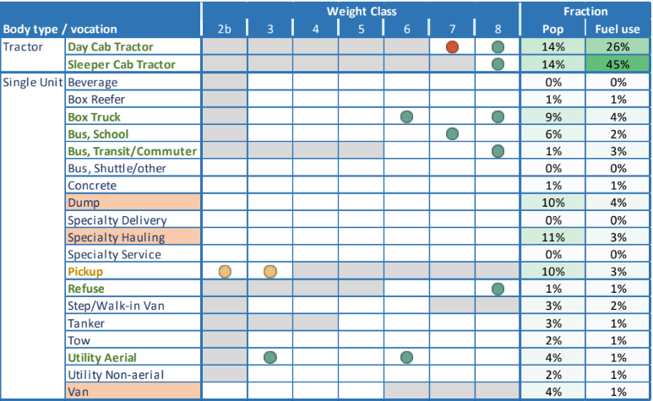

  - Insurance Cost

  - Maintenance and RepAIr costs

  - Taxes and Fees

  - Costs Specific to Commercial Vehicles

  - Vehicle Travel and Survival

- Results
Main findings, example results
Discuss the Visualization Tool here or in a separate section?
Results of Fuel Price and Fuel Economy
With extensive literature reviews, the team created a database on energy use for LDVs and MHDVs and energy price. All these data are stored in the form of excel spreadsheets. In total, the team identified 1,047 records for LDV energy use, 1,684 records for MHDV energy use, and 123 records for energy prices. Each record is distinguishable by vehicle type (e.g., powertrain, class, and use type), driving conditions (e.g., CS and CD), and reference source (i.e., different papers and reports). The team demonstrated example results as follows.
Figure 1 and Figure 2 show liquid fuel and electricity fuel economies for mid-size cars and SUVs by powertrain technologies for both DOE low and high technologies assumptions. These fuel economies are combined adjusted fuel economies considering urban and highway driving cycles, and are based on Autonomie’s simulation results (REF). Figure 1shows that hybrid vehicles (e.g., PHEVs) or fuel cell systems have better fuel economies than conventional liquid fuel vehicles. Figure 2 shows that for electric vehicles, vehicles with smaller batteries (lower range on single charge) generally have higher fuel economies due to weight penalty of larger battery packs. Both figures indicate that the DOE’s high technology scenario has better fuel economies compared to the low technology scenario, and all fuel economies are generally improved over time.
Figure 1. LDV Fuel Economy Estimates of Mid-size Cars and Mid-size SUVs – Liquid Fuels and Hydrogen

Figure 2. LDV Fuel Economy Estimates of Mid-size Cars and Mid-size SUVs – Electricity Consumption

Figure 3 shows the fuel economy comparison between luxury and non-luxury LDVs by sedan, SUV, CUV, van and pickup. The values shown represent the weighted average fuel economies, calculated based on the harmonic means using vehicles sales, and model-specific highway and urban combined fuel economies from 2019 Wards data (REF). Wards numbers are consistent with EPA rating. For PHEVs and BEVs, MPG calculations are based on EPA data (REF). A full comparison in fuel economy is not made due to unavailable fuel economy data for several classes and technologies for luxury vehicles (e.g., fuel economy for luxury PHEVs). However, for available luxury vehicle data, luxury vehicles’ fuel economies are generally higher than non-luxury vehicles due to potentially better vehicle performances. Note that Wards provides luxury indicator data, but without clear definition of luxury.
Figure 3. Comparisons in Weighted Average Fuel Economies between Luxury and Non-Luxury LDVs
Another factor that contributes to different energy cost between luxury and non-luxury LDVs is the energy price. For conventional gasoline vehicles, premium gasoline prices are used which are expected to be higher than regular gasoline prices. However, a projection of future premium gasoline prices is not available compared to the gasoline prices which are projected by EIA. Therefore, the team developed similar statistical relationship model to estimate the premium gasoline prices based on regular gasoline prices (Figure 4). Historical annual average gasoline prices from 1994 to 2020 are collected from the EIA website (REF), and are used to fit the relationships. The un-weighted model assumes that all historical data are treated equal, while the weighted model assigns higher weights to more recent gasoline price data compared to older ones. The data weights are arbitrarily assigned as 1 for the year 1994, linearly increased to 27 for the data point of the year 2020. The statistical relationship formulas are also present in the graph.
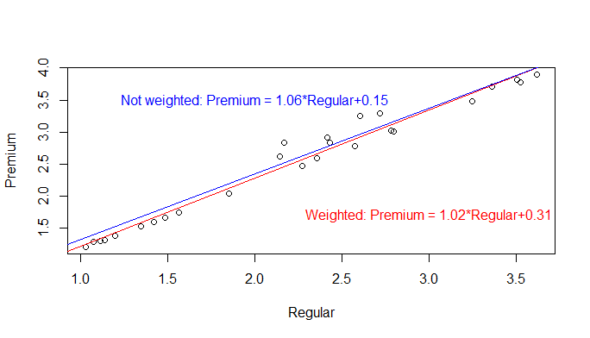
Figure 4. Relationship between Premium and Regular Gasoline Prices

MHDV fuel economies data are mostly from the simulation results of Autonomie. Note that Autonomie MHDV simulation mainly considers motion energy and do not account for accessory loads for power takeoff (PTO) and hotel-use idling. This can represent a significant gap for certain types of commercial vehiclese.g. utility trucks where PTO and idling consume a significant amount of energy in addition to the regular on-road driving,. Figure 6 shows the roles of PTO and idling for utility truck activities from the NREL’s study (REF). It is shown that, in total PTO and idling can take 63% of total operation time and 21% of total energy use. The shares between PTO and idling are similar in both operation time and energy use. In particular, PTO accounts for 33% of time and 11% of fuel use while idling accounts for 30% of time and 10% of fuel use. From the electrification perspective, the long PTO and idling time could provide potential opportunities for charging for battery-powered utility trucks. This could lead to longer driving ranges, fewer operation interruptions (due to insufficient ranges), and smaller batteries for cost savings. Although not entirely the same, the use of idling time for electricity charging has already been applied to diesel long-haul trucks.
Payload affects passenger- or freight-transporting commercial vehicles. Figure 5 shows the variations in truck fuel economies with different driving cycles and payload levels for Kenworth long haul class 8 diesel tractors based on the NHTSA’s study (REF). Five driving cycles and three different payload levels are considered. The figure shows that significant variations in fuel economies exist could range between 3.78 MPG for CARB driving cycle with full payload and 9.26 MPG for 55 MPG driving cycle with empty payload. For all driving cycles, the payload assumption is an important factor that affects the fuel economies. Generally, full payloads result in significant reduction in fuel economies compared to the empty payloads.

Figure 5. Variation in Truck Fuel Economies with Different Driving Cycles and Payload levels for Kenworth Long Haul Tractors (REF).

Figure 6. Time and Energy Shares of PTO and Idling for Utility Trucks (REF)

- Discussion
Discussion of findings, caveats, uncertainties
- Conclusions
Summary of findings and uncertainties
Suggested future research

- References

https://afdc.energy.gov/files/u/publication/pto_idle_behavior_utility_vehicles.pdf
Data source: NHTSA, 2015, Commercial Medium- and Heavy-Duty Truck Fuel Efficiency Technology Study – Report #1

