## Supplementary material

### Data Collection and Description

The data used in this study was meticulously collected from various academic papers and technical reports related to radiation hardening, spanning from 1985 to 2024 [1-41]. The collected steel types include Eurofer97, F82H, T91, OPTIFER, JLM, JLF, and CLAM. This dataset includes detailed information on the chemical composition of reduced-activation steels, the conditions of radiation exposure, and the yield strength.

Fig. 1 presents the distribution of various input variables within the dataset. These variables encompass the chemical elements, Carbon (C), Chromium (Cr), Tungsten (W), Molybdenum (Mo), Tantalum (Ta), Vanadium (V), Silicon (Si), Manganese (Mn), Nitrogen (N), Aluminium (Al), Arsenic (As), Boron (B), Cobalt (Co), Copper (Cu), Oxygen (O), Phosphorus (P), Titanium (Ti), and Zirconium (Zr). Additionally, it includes irradiation conditions such as Irradiation Dose (Dose), Helium Production (He), and Irradiation Temperature (Tirr), as well as Yield Stress.

Table 1 offers a statistical summary of these variables, displaying their minimum, maximum, mean, and standard deviation values. The elements commonly used in reduced-activation steels include C, Cr, W, Mo, Ta, V, Si, and Mn. Other elements such as N, B, As, Co, Cu, Ni, Al, P, Pb, S, Ti, and Zr are present in relatively low amounts in the samples. The mean and standard deviation values of these elements show their distribution across different samples. Although these elements are present in low concentrations, they can significantly impact the properties of the steel in trace amounts. The data also includes radiation conditions and yield stress.

The collected data covers a wide range of RAFM steel samples and their performance under various irradiation conditions. This comprehensive statistical summary not only provides the fundamental characteristics of the materials but also lays a solid foundation for subsequent analysis and modelling. We aim to gain valuable, data-driven insights into the behaviour of these materials under irradiation exposure.

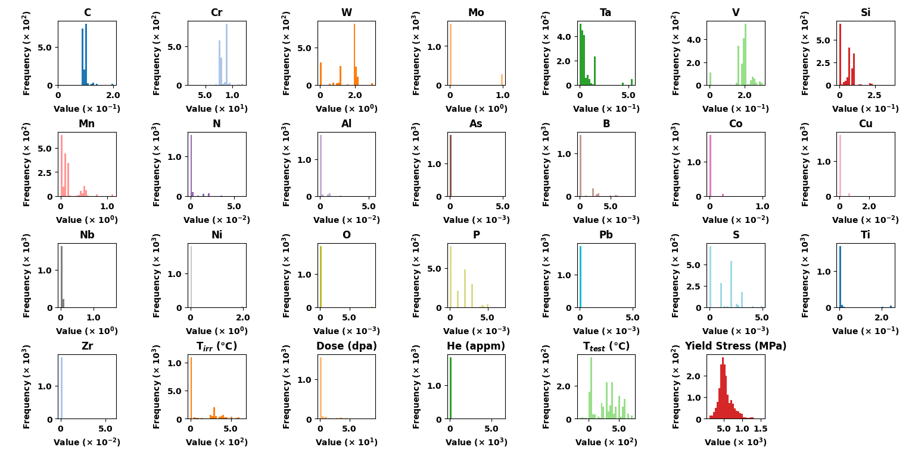

**Fig. 1.** Histograms displaying the distribution of variables such as elements, irradiation dose, helium production, irradiation temperature and yield stress.

**Table 1**

Statistical summary of variable measurements (Composition elements in wt.%).

|  |  |  |  |  |
| --- | --- | --- | --- | --- |
| Variables | Mean | Standard Deviation | Maximum | Minimum |
| C | 0.09719 | 0.01307 | 0.2 | 0.0092 |
| Cr | 8.37662 | 0.83372 | 12 | 2.25 |
| W | 1.49473 | 0.77203 | 3 | 0 |
| Mo | 0.14963 | 0.35411 | 1 | 0 |
| Ta | 0.06326 | 0.10049 | 0.54 | 0 |
| V | 0.18353 | 0.05377 | 0.3 | 0 |
| Si | 0.05564 | 0.05114 | 0.37 | 0 |
| Mn | 0.15650 | 0.20740 | 1.13 | 0 |
| N | 0.00268 | 0.00800 | 0.06 | 0 |
| Al | 0.00111 | 0.00413 | 0.054 | 0 |
| As | 0.00002 | 0.00028 | 0.005 | 0 |
| B | 0.00074 | 0.00142 | 0.0085 | 0 |
| Co | 0.00015 | 0.00088 | 0.01 | 0 |
| Cu | 0.00056 | 0.00308 | 0.035 | 0 |
| Nb | 0.01594 | 0.10509 | 1.6 | 0 |
| Ni | 0.05615 | 0.30222 | 2 | 0 |
| O | 0.00015 | 0.00103 | 0.009 | 0 |
| P | 0.00136 | 0.00140 | 0.007 | 0 |
| Pb | 0.00002 | 0.00028 | 0.005 | 0 |
| S | 0.00123 | 0.00116 | 0.005 | 0 |
| Ti | 0.00977 | 0.04504 | 0.25 | 0 |
| Zr | 0.00023 | 0.00325 | 0.059 | 0 |
| Tirr (℃) | 137.06 | 182.33523 | 652 | 0 |
| Dose (dpa) | 3.85271 | 10.37125 | 90 | 0 |
| He (appm) | 55.99097 | 577.83253 | 6315 | 0 |
| Ttest (℃) | 280.94598 | 208.85996 | 732 | -150 |
| Yield Stress (MPa) | 544.03315 | 189.58747 | 1539 | 117 |

**Data preprocessing**

Generally, the original data obtained is incomplete and may contain a significant number of missing values, outliers, and duplicate entries. If these unprocessed data are directly used to build a prediction model, the prediction accuracy of the model would be adversely affected [42, 43]. Therefore, normalisation was applied as a data preprocessing method in the current study as shown in Eq. (1).

$X_{norm}=\frac{X_{max}-X_{min}}{X-X_{min}}$ (1)

where $X_{norm}$ is the normalised value, $X$ is the original value, and $X_{min}$ and $X_{max}$ are the minimum and maximum values of the dataset respectively.

This normalisation process scales the data to a range between 0 and 1, ensuring that all variables contribute equally to the analysis and model training, thus improving the overall prediction accuracy.

Outliers can significantly affect the accuracy and robustness of prediction models [43]. Therefore, it is crucial to detect and treat outliers appropriately. In this study, boxplot analysis was conducted to identify outliers in the dataset. Fig. 2 illustrates the boxplots for various input variables, including chemical elements, irradiation conditions and Yield Stress. Each boxplot provides a visual representation of the distribution of values for a particular variable, highlighting the central tendency and spread of the data, as well as identifying any outliers.

From the boxplots, it was evident that several variables contained outliers. These outliers appear as individual points that lie significantly outside the range of the majority of the data. To address the presence of these outliers, the Interquartile Range (IQR) method was employed. The IQR method involves calculating the range between the first quartile (Q1) and the third quartile (Q3) of the data. Data points that lie below Q1 - 1.5IQR or above Q3 + 1.5IQR are considered outliers.

By applying the IQR method, outliers were systematically identified and removed from the dataset. This process ensured that the remaining data is more representative of typical conditions and reduced the likelihood of skewed analysis or model performance. The removal of outliers contributes to the overall robustness and accuracy of the predictive models developed in this study.

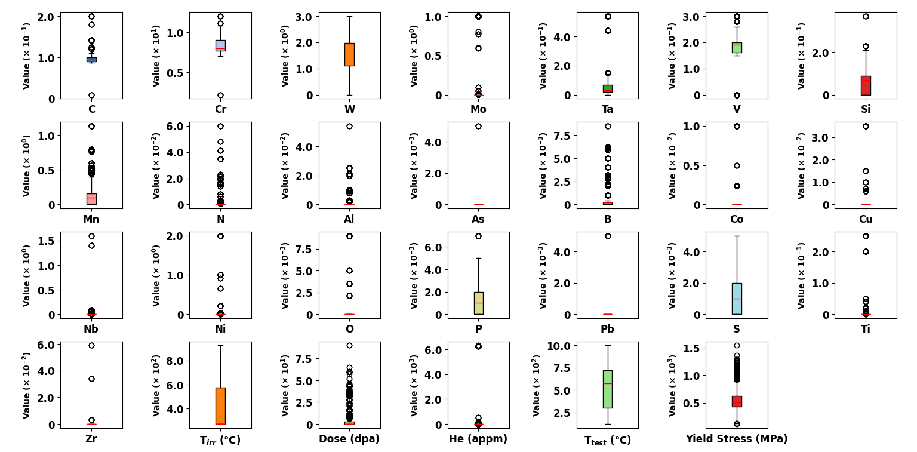

**Fig. 2.** Boxplots representing the spread and central tendency of variables, with values on the vertical axis. Each plot corresponds to a different variable, such as elements or conditions. The red line within each box indicates the median of the data.

**Hyperparameter Optimisation**

In the hyperparameter optimisation stage, the data was split into a training set and a testing set in an 8:2 ratio. For the neural network models, we used grid search to optimise the hyperparameters, and the results are shown in Table 2.

**Table 2**

Optimised Hyperparameters for 1D-CNN, and ResMLP Models Using Grid Search.

|  |  |  |
| --- | --- | --- |
| Hyperparameter | 1D-CNN | ResMLP |
| Batch Size | 32 | 64 |
| Dropout Rate | 0.3 | 0.5 |
| Hidden Size | / | 512 |
| Input Size | 26 | 26 |
| Learning Rate (lr) | 0.01 | 0.0005 |
| Loss Function | MSELoss | MSELoss |
| Number of Epochs | 1500 | 1000 |
| Number of Layers | / | / |
| Optimizer | Adam | Adam |
| Fully Connected Layers | 2 layers: Linear (64*input_size → 128), Linear (1 → 281) | / |
| Convolutional Layers | 3 layers: Conv1d (1 → 16), Conv1d (16 → 32), Conv1d (32 → 64) | / |

For the ensemble algorithms, instead of using automated hyperparameter optimisation methods, which can be inefficient and do not always guarantee the best results while also increasing the risk of overfitting, we manually selected the three most important hyperparameters for each model and fixed the remaining hyperparameters. Table 3, lists the key hyperparameters chosen for each model and their respective ranges.

**Table 3**

Hyperparameter selection and range specification for XGBoost, GBDT, and RF models.

|  |  |  |  |  |  |
| --- | --- | --- | --- | --- | --- |
| Model | | Hyperparameter | | Range | |
| XGBoost | | n_estimators | | 5000, 10000, 15000, 20000 | |
| max_depth | | 5 to 20 (incrementing by 1) | |
| eta | | 0.00035 to 0.0015 (5 evenly spaced values) | |
| GBDT | | n_estimators | | 5000, 10000, 15000, 20000 | |
| learning_rate | | 0.0001 to 0.001 (5 evenly spaced values) | |
| max_depth | | 5 to 12 (incrementing by 1) | |
| RF | | n_estimators | | 50 to 1000 (incrementing by 50) | |
| max_features | | 1 to 17 (incrementing by 1) | |
| max_depth | | 5 to 20 (incrementing by 1) | |

To evaluate the models, we used metrics such as coefficient of determination (R²), Pearson Correlation Coefficient (PCC), and Root Mean Square Error (RMSE). The formulas for these metrics are as shown in Eqs. (2-4).

$R^{2}=1-\frac{\sum_{i=1}^{n}{(y_{i}-{\hat{y}}_{i})^{2}}}{\sum_{i=1}^{n}{(y_{i}-\overline{y})^{2}}}$ (2)

$RMSE=\sqrt{\frac{1}{n}\sum_{i=1}^{n}{(y_{i}-{\hat{y}}_{i})^{2}}}$ (3)

$PCC=\frac{n\left(\sum{xy}\right)-(\sum{x})(\sum{y})}{\sqrt{\left[n\sum{x^{2}-{(\sum{x)}}^{2}}\right]\left[n\sum{y^{2}-{(\sum{y)}}^{2}}\right]}}$ (4)

Where, $y_{i}$ is the actual value of the i-th observation, ${\hat{y}}_{i}$ is the predicted value of the i-th observation, $\overline{y}$ is the mean of the actual values, $x$ and $y$ are the first and second sets of data.

To see the relationship between the three selected hyperparameters and the evaluation metrics, ternary contour plots were used, Figs. 3-5. Each axe represents one of the normalised hyperparameters and the colours indicate the evaluation metrics. We prioritise regions where both the training and testing sets exhibited good performance, ensuring the model’s effectiveness on new data and avoiding overfitting. Selecting overlapping regions enhances the model's stability and reliability, ensuring consistent performance across different datasets.

Figs. 3-5 show the three-dimensional contour plots for the GBDT, XGBoost and RF models on the training set (a, c, e) and the test set (b, d, f). Each pair of plots represents different evaluation metrics.

For the GBDT Mode, Fig. 3 depicts model performance metrics visualized through colour gradients, each correlating with hyperparameter variations. Fig. 3(a) and Fig. 3(b) illustrate R² values, showing a range from 0.49 to 0.96 in the training set and 0.49 to 0.86 in the test set, peaking in regions with higher n_estimators and max_depth, and moderate learning_rate. Fig. 3(c) and Fig. 3(d) represent PCC, with the training set values between 0.90 to 0.98 and the test set from 0.89 to 0.93, also favouring similar hyperparameter settings. Fig. 3(e) and Fig. 3(f) display RMSE, indicating lower errors under higher n_estimators and max_depth in the training set, with moderate n_estimators and max_depth showing benefits in the test set, consistently with a moderate learning_rate.

Based on the detailed chart interpretation, the red dashed areas in the test set plots denote the overlapping regions between the training and test sets, indicating the optimal hyperparameter combinations.

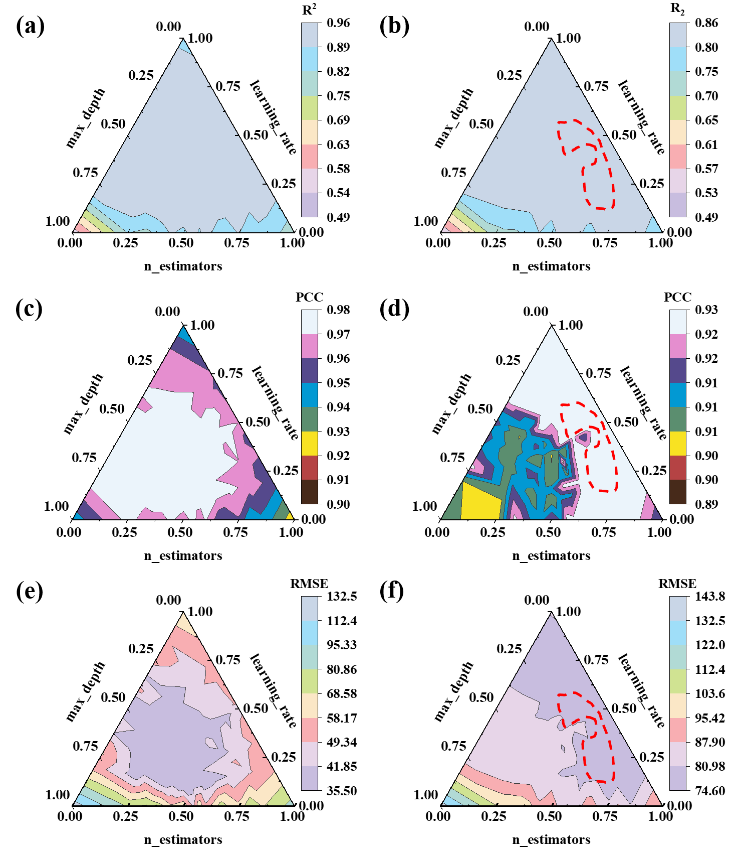

**Fig. 3.** Ternary contour plots for the GBDT model on training (a, c, e) and test (b, d, f) sets. Optimal hyperparameter ranges are indicated by the overlapping regions.

For the XGBoost model, Fig. 4(a) and Fig. 4(b) illustrate R2 values, which in the training set are optimized with high n_estimators (0.75 to 1.00), max_depth (0.50 to 1.00), and moderate eta (0.25 to 0.50). Conversely, the test set shows optimal R2 with more moderate n_estimators (0.50 to 0.75), high max_depth (0.75 to 1.00), and lower eta (0.00 to 0.25). Fig. 4(c) and Fig. 4(d) present PCC values, peaking in the training set under high n_estimators and max_depth with a moderate eta, while the test set finds higher PCC values under moderate n_estimators settings, high max_depth, and low to moderate eta. Fig. 4(e) and Fig. 4(f) show RMSE patterns, where the training set exhibits lower errors with high n_estimators and max_depth, and moderate eta. In the test set, lower RMSE is achieved with moderate n_estimators, high max_depth, and low to moderate eta, marking a notable contrast to the training set settings.

The absence of overlapping optimal regions between the training and test sets indicates that the XGBoost model is overfitting, showing high performance on the training data but poor generalisation to new data. Consequently, XGBoost is not well-suited for this dataset.

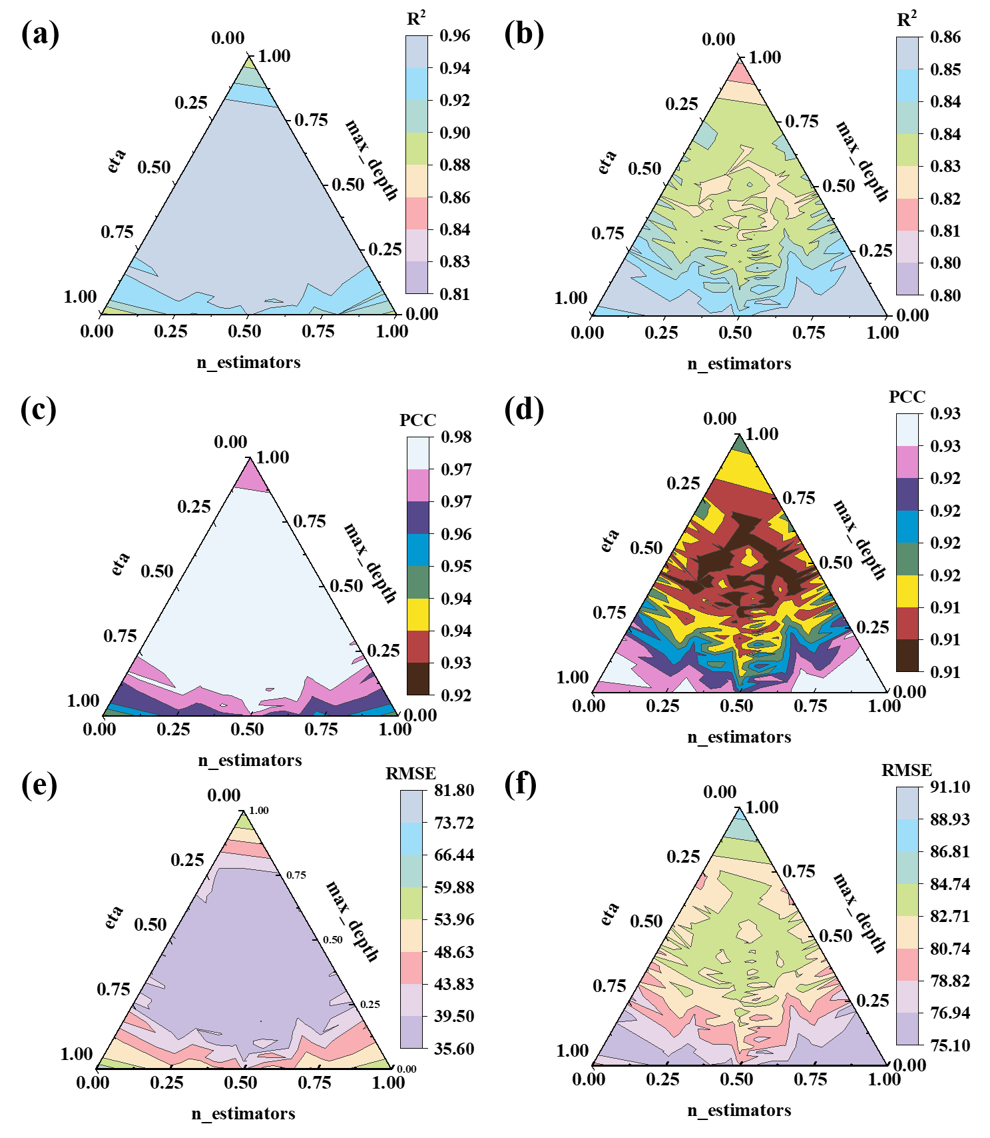

**Fig. 4.** Ternary contour plots for the XGBoost model on training (a, c, e) and test (b, d, f) sets. The plots reveal that the optimal hyperparameter regions differ between training and test sets, indicating overfitting.

For the RF model, Fig. 5(a) and Fig. 5(b) show that higher R2 values in the training set correlate with high n_estimators (0.75 to 1.00), high max_depth (0.75 to 1.00), and low max_features (0.00 to 0.25), whereas in the test set, optimal R2 values occur with moderate n_estimators (0.50 to 0.75), max_depth (0.50 to 0.75), and max_features (0.50 to 0.75). Fig. 5(c) and Fig. 5(d) indicate that the training set's PCC is highest under similar high settings, while the test set achieves higher PCC with moderate settings. Finally, Fig. 5(e) and Fig. 5(f) illustrate that the training set achieves lower RMSE values with high settings, and the test set shows lower RMSE with moderate settings of n_estimators, max_depth, and max_features. The red dashed areas in the test set plots highlight overlapping regions indicating the optimal hyperparameter ranges.

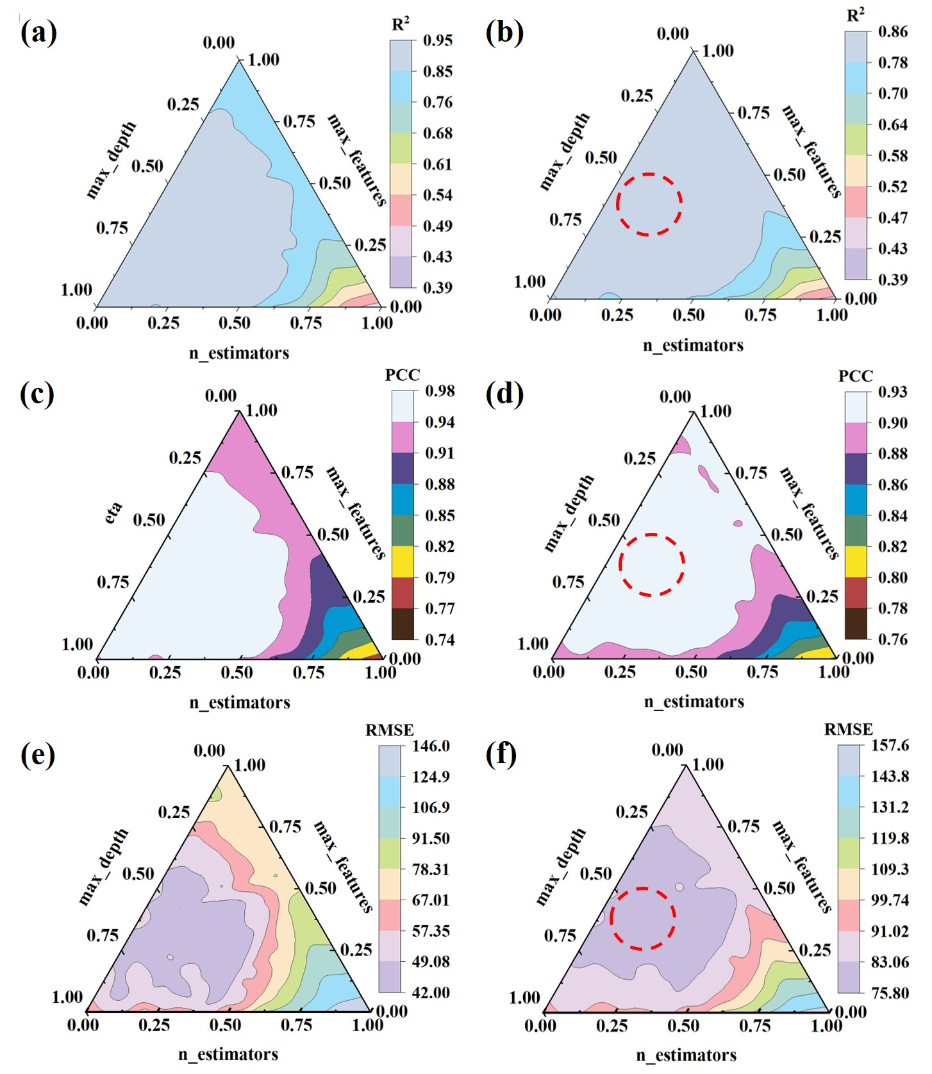

**Fig. 5.** Ternary contour plots for the RF model on training (a, c, e) and test (b, d, f) sets. The red dashed areas in the test set plots highlight overlapping regions with the training set, indicating optimal hyperparameters.

## References

[1] Abe, F., T. Noda, H. Araki, and M. Okada. Development of Reduced-Activation Martensitic 9Cr Steels for Fusion Reactor. J. Nucl. Sci. Technol., 31 (1994) 279-292, <https://doi.org/10.1080/18811248.1994.9735152>.

[2] Alamo, A., M. Horsten, X. Averty, E.I. Materna-Morris, M. Rieth, and J.C. Brachet. Mechanical behavior of reduced-activation and conventional martensitic steels after neutron irradiation in the range 250–450°C. J. Nucl. Mater., 283-287 (2000) 353-357, <https://doi.org/10.1016/S0022-3115(00)00076-3>.

[3] Baluc, N., R. Schäublin, C. Bailat, F. Paschoud, and M. Victoria. The mechanical properties and microstructure of the OPTIMAX series of low activation ferritic–martensitic steels. J. Nucl. Mater., 283-287 (2000) 731-735, <https://doi.org/10.1016/S0022-3115(00)00282-8>.

[4] Belianov, I. and P. Marmy. The effect of low dose irradiation on the impact fracture energy and tensile properties of pure iron and two ferritic martensitic steels. J. Nucl. Mater., 258-263 (1998) 1259-1263, <https://doi.org/10.1016/S0022-3115(98)00193-7>.

[5] Dai, Y., X.J. Jia, and K. Farrell. Mechanical properties of modified 9Cr–1Mo (T91) irradiated at ⩽300 °C in SINQ Target-3. J. Nucl. Mater., 318 (2003) 192-199, <https://doi.org/10.1016/S0022-3115(03)00100-4>.

[6] Dai, Y., S.A. Maloy, G.S. Bauer, and W.F. Sommer. Mechanical properties and microstructure in low-activation martensitic steels F82H and Optimax after 800-MeV proton irradiation. J. Nucl. Mater., 283-287 (2000) 513-517, <https://doi.org/10.1016/S0022-3115(00)00267-1>.

[7] Farrell, K. and T.S. Byun. Tensile properties of candidate SNS target container materials after proton and neutron irradiation in the LANSCE accelerator. J. Nucl. Mater., 296 (2001) 129-138, <https://doi.org/10.1016/S0022-3115(01)00515-3>.

[8] Farrell, K. and T.S. Byun. Tensile properties of ferritic/martensitic steels irradiated in HFIR, and comparison with spallation irradiation data. J. Nucl. Mater., 318 (2003) 274-282, <https://doi.org/10.1016/S0022-3115(03)00102-8>.

[9] Fernández, P., A.M. Lancha, J. Lapeña, and M. Hernández-Mayoral. Metallurgical characterization of the reduced activation ferritic/martensitic steel Eurofer'97 on as-received condition. Fusion Eng. Des., 58-59 (2001) 787-792, <https://doi.org/10.1016/S0920-3796(01)00563-4>.

[10] Gorynin, I.V., V.V. Rybin, I.P. Kursevich, A.N. Lapin, E.V. Nesterova, and E.Y. Klepikov. Effect of heat treatment and irradiation temperature on mechanical properties and structure of reduced-activation Cr–W–V steels of bainitic, martensitic, and martensitic–ferritic classes. J. Nucl. Mater., 283-287 (2000) 465-469, <https://doi.org/10.1016/S0022-3115(00)00210-5>.

[11] Henry, J., X. Averty, Y. Dai, P. Lamagnère, J.P. Pizzanelli, J.J. Espinas, and P. Wident. Tensile properties of 9Cr–1Mo martensitic steel irradiated with high energy protons and neutrons. J. Nucl. Mater., 318 (2003) 215-227, <https://doi.org/10.1016/S0022-3115(03)00119-3>.

[12] Henry, J., M.H. Mathon, and P. Jung. Microstructural analysis of 9% Cr martensitic steels containing 0.5 at.% helium. J. Nucl. Mater., 318 (2003) 249-259, <https://doi.org/10.1016/S0022-3115(03)00118-1>.

[13] Jung, P., J. Henry, J. Chen, and J.C. Brachet. Effect of implanted helium on tensile properties and hardness of 9% Cr martensitic stainless steels. J. Nucl. Mater., 318 (2003) 241-248, <https://doi.org/10.1016/S0022-3115(03)00014-X>.

[14] Kasada, R., A. Kimura, H. Matsui, M. Hasegawa, and M. Narui. Effects of varying temperature irradiation on the neutron irradiation hardening of reduced-activation 9Cr–2W martensitic steels. J. Nucl. Mater., 271-272 (1999) 360-364, <https://doi.org/10.1016/S0022-3115(98)00749-1>.

[15] Kasada, R., A. Kimura, H. Matsui, and M. Narui. Enhancement of irradiation hardening by nickel addition in the reduced-activation 9Cr–2W martensitic steel. J. Nucl. Mater., 258-263 (1998) 1199-1203, <https://doi.org/10.1016/S0022-3115(98)00186-X>.

[16] Klueh, R.L. Irradiation hardening of ferritic steels: Effect of composition. J. Nucl. Mater., 179-181 (1991) 728-732, <https://doi.org/10.1016/0022-3115(91)90192-A>.

[17] Klueh, R.L., D.J. Alexander, and M. Rieth. The effect of tantalum on the mechanical properties of a 9Cr–2W–0.25V–0.07Ta–0.1C steel1Research sponsored by the Office of Fusion Energy Sciences, U.S. Department of Energy, under contract DE-AC05-960R22464 with Lockheed Martin Energy Research Corp.1. J. Nucl. Mater., 273 (1999) 146-154, <https://doi.org/10.1016/S0022-3115(99)00035-5>.

[18] Klueh, R.L., D.J. Alexander, and M.A. Sokolov. Effect of chromium, tungsten, tantalum, and boron on mechanical properties of 5–9Cr–WVTaB steels. J. Nucl. Mater., 304 (2002) 139-152, <https://doi.org/10.1016/S0022-3115(02)00885-1>.

[19] Klueh, R.L., J.-J. Kai, and D.J. Alexander. Microstructure-mechanical properties correlation of irradiated conventional and reduced-activation martensitic steels. J. Nucl. Mater., 225 (1995) 175-186, <https://doi.org/10.1016/0022-3115(95)00061-5>.

[20] Klueh, R.L. and P.J. Maziasz. Effect of irradiation in HFIR on tensile properties of Cr-Mo steels. J. Nucl. Mater., 187 (1992) 43-54, <https://doi.org/10.1016/0022-3115(92)90317-E>.

[21] Klueh, R.L., M.A. Sokolov, K. Shiba, Y. Miwa, and J.P. Robertson. Embrittlement of reduced-activation ferritic/martensitic steels irradiated in HFIR at 300°C and 400°C. J. Nucl. Mater., 283-287 (2000) 478-482, <https://doi.org/10.1016/S0022-3115(00)00086-6>.

[22] Klueh, R.L. and J.M. Vitek. Elevated-temperature tensile properties of irradiated 9 Cr-1 MoVNb steel. J. Nucl. Mater., 132 (1985) 27-31, <https://doi.org/10.1016/0022-3115(85)90389-7>.

[23] Klueh, R.L. and J.M. Vitek. Fluence and helium effects on the tensile properties of ferritic steels at low temperatures. J. Nucl. Mater., 161 (1989) 13-23, <https://doi.org/10.1016/0022-3115(89)90457-1>.

[24] Lindau, R., A. Möslang, D. Preininger, M. Rieth, and H.D. Röhrig. Influence of helium on impact properties of reduced-activation ferritic/martensitic Cr-steels. J. Nucl. Mater., 271-272 (1999) 450-454, <https://doi.org/10.1016/S0022-3115(98)00724-7>.

[25] Lucon, E., M. Decréton, and E. van Walle. Mechanical characterization of EUROFER97 irradiated (0.32 dpa, 300°C). Fusion Eng. Des., 69 (2003) 373-377, <https://doi.org/10.1016/S0920-3796(03)00075-9>.

[26] Maloy, S.A., M.R. James, G. Willcutt, W.F. Sommer, M. Sokolov, L.L. Snead, M.L. Hamilton, and F. Garner. The mechanical properties of 316L/304L stainless steels, Alloy 718 and Mod 9Cr–1Mo after irradiation in a spallation environment. J. Nucl. Mater., 296 (2001) 119-128, <https://doi.org/10.1016/S0022-3115(01)00514-1>.

[27] Rensman, J., J. van Hoepen, J.B.M. Bakker, R. den Boef, F.P. van den Broek, and E.D.L. van Essen. Tensile properties and transition behaviour of RAFM steel plate and welds irradiated up to 10 dpa at 300 °C. J. Nucl. Mater., 307-311 (2002) 245-249, <https://doi.org/10.1016/S0022-3115(02)01196-0>.

[28] Zhang, L., Y. Zhang, W. Han, X. Yi, P. Liu, K. Yoshida, T. Toyama, Q. Zhan, Y. Nagai, S. Ohnuki, A. Kimura, and F. Wan. Impact of trace silicon on irradiation hardening and embrittlement of RAFM steel subjected to neutron irradiation. Fusion Eng. Des., 201 (2024) 114309, <https://doi.org/10.1016/j.fusengdes.2024.114309>.

[29] Liu, Y., Y. Xie, L. Peng, J. Shi, S. Chen, and Y. Sun. Irradiation Effects on Tensile Properties of Reduced Activation Ferritic/Martensitic Steel: A Micromechanical-Damage-Model-Based Numerical Investigation. Crystals, 14 (2024) 417, <https://doi.org/10.3390/cryst14050417>.

[30] Zhu, P., Y.-R. Lin, S. Agarwal, V. Pauly, S. Taller, and S.J. Zinkle. Comparison of hardening and microstructures of ferritic/martensitic steels irradiated with fast neutrons and dual ions. J. Nucl. Mater., 599 (2024) 155211, <https://doi.org/10.1016/j.jnucmat.2024.155211>.

[31] Liang, Y., L. Wang, A. Luo, Q. Wan, and H. Duan. Helium irradiation-induced segregation and mechanical response in China low activation martensitic (CLAM) steel. J. Mater. Res. Technol., 25 (2023) 4622-4633, <https://doi.org/10.1016/j.jmrt.2023.06.238>.

[32] Ando, M., D. Hamaguchi, Y. Watanabe, and T. Nozawa. Irradiation hardening and void swelling behaviors of F82H IEA by using dual-ion irradiation. J. Nucl. Sci. Technol., 60 (2023) 1116-1124, <https://doi.org/10.1080/00223131.2023.2180452>.

[33] Klimenkov, M., U. Jäntsch, M. Rieth, and A. Möslang. Correlation of microstructural and mechanical properties of neutron irradiated EUROFER97 steel. J. Nucl. Mater., 538 (2020) 152231, <https://doi.org/10.1016/j.jnucmat.2020.152231>.

[34] Liu, P.P., M.Z. Zhao, Y.M. Zhu, J.W. Bai, F.R. Wan, and Q. Zhan. Effects of carbide precipitate on the mechanical properties and irradiation behavior of the low activation martensitic steel. J. Alloys Compd., 579 (2013) 599-605, <https://doi.org/10.1016/j.jallcom.2013.07.085>.

[35] Henry, J., X. Averty, and A. Alamo. Tensile and impact properties of 9Cr tempered martensitic steels and ODS-FeCr alloys irradiated in a fast reactor at 325°C up to 78dpa. J. Nucl. Mater., 417 (2011) 99-103, <https://doi.org/10.1016/j.jnucmat.2010.12.203>.

[36] Materna-Morris, E., A. Möslang, and H.C. Schneider. Tensile and low cycle fatigue properties of EUROFER97-steel after 16.3dpa neutron irradiation at 523, 623 and 723K. J. Nucl. Mater., 442 (2013) S62-S66, <https://doi.org/10.1016/j.jnucmat.2013.03.038>.

[37] Gaganidze, E., C. Petersen, E. Materna-Morris, C. Dethloff, O.J. Weiß, J. Aktaa, A. Povstyanko, A. Fedoseev, O. Makarov, and V. Prokhorov. Mechanical properties and TEM examination of RAFM steels irradiated up to 70dpa in BOR-60. J. Nucl. Mater., 417 (2011) 93-98, <https://doi.org/10.1016/j.jnucmat.2010.12.047>.

[38] Hirose, T., N. Okubo, H. Tanigawa, M. Ando, M.A. Sokolov, R.E. Stoller, and G.R. Odette. Irradiation hardening in F82H irradiated at 573K in the HFIR. J. Nucl. Mater., 417 (2011) 108-111, <https://doi.org/10.1016/j.jnucmat.2010.12.044>.

[39] Tanigawa, H., R.L. Klueh, N. Hashimoto, and M.A. Sokolov. Hardening mechanisms of reduced activation ferritic/martensitic steels irradiated at 300°C. J. Nucl. Mater., 386-388 (2009) 231-235, <https://doi.org/10.1016/j.jnucmat.2008.12.094>.

[40] Tanigawa, H., H. Sakasegawa, N. Hashimoto, R.L. Klueh, M. Ando, and M.A. Sokolov. Irradiation effects on precipitation and its impact on the mechanical properties of reduced-activation ferritic/martensitic steels. J. Nucl. Mater., 367-370 (2007) 42-47, <https://doi.org/10.1016/j.jnucmat.2007.03.167>.

[41] Klueh, R.L., M.A. Sokolov, and N. Hashimoto. Mechanical properties of unirradiated and irradiated reduced-activation martensitic steels with and without nickel compared to properties of commercial steels. J. Nucl. Mater., 374 (2008) 220-228, <https://doi.org/10.1016/j.jnucmat.2007.08.006>.

[42] Lakshminarayan, K., S.A. Harp, and T. Samad. Imputation of Missing Data in Industrial Databases. Applied Intelligence, 11 (1999) 259-275, <https://doi.org/10.1023/A:1008334909089>.

[43] Blessing, R. Outlier Treatment in Data Merging. J. Appl. Crystallogr., 30 (1997) 421-426, <https://doi.org/10.1107/S0021889896014628>.