1, What will happen with a Daemon Set on a Kubernetes node that has all the resources consumed by another Pod managed by a ReplicaSet?
2, How does Pod Disruption Budget work?
3, What Istio deployment model do you prefer? Explain your choice.
4, Received a scenario-based questions troubleshooting the kubernetes objects
5, “Your Docker container keeps restarting—what do you do?”
Q: “How do you debug Kubernetes in production?”
“First I check pod status to identify failing components. Then I inspect logs to find errors. After that, I verify resource usage to rule out CPU/memory issues, and finally check recent deployments to see if any changes caused the problem.”

bash, kubernetes and IaC:-
Write a script to process logs or system data,
build a service that reads system metrics and returns alerts when thresholds are exceeded.
System Design: -
- “Design a scalable logging/monitoring system.”
- “How would you design a high-availability service?”
- “Explain load balancing and failover strategies.”
Cloud & DevOps: -
- “How do you deploy services in Amazon Web Services or Microsoft Azure?”
- “Explain Docker and Kubernetes.”
- “What is CI/CD and how have you used it?”
OS / Networking: -
- “How does a TCP handshake work?”
- “What happens when you type a URL in a browser?”
- “Explain memory management in Linux.”
Troubleshooting:-
- “A service is slow—how do you debug it?”
- “CPU usage is 100% on a server—what steps do you take?

Coding + DevOps Test
This is the most telling round for Systems Engineers.
🔹 Likely coding part
- Script-based problem (Python/Bash)
- API or backend logic
- Data processing task
👉 Example:
- “Parse a log file and return error counts”
- “Write a script to monitor CPU/memory usage”
⚙️ DevOps questions (VERY likely core)
Expect things around:
🐳 Containers
- “What is Docker?”
- “Difference between container and VM?”
- “Write a simple Dockerfile”
☸️ Orchestration
- “What is Kubernetes?”
- “What are pods, deployments, services?”
- “How do you scale an application?”
🔁 CI/CD
- “What is a CI/CD pipeline?”
- “Have you used Jenkins/GitHub Actions?”
- “How do you automate deployments?
If you’re more Systems/Infra focused:
- “Explain how a Linux system boots”
- “What happens when a process crashes?”
- “How do you debug high memory usage?”
- “Explain threads vs processes”
🌐 Networking (almost always asked)
- “What is DNS?”
- “Explain TCP vs UDP”
- “What happens when you hit a URL?”
🏗️ System Design (mid-level+ candidates)
- “Design a scalable web service”
- “How do you ensure high availability?”
- “How would you design logging/monitoring?”
• “How do you check CPU/memory usage in Linux?”
• “What tools do you use to debug a slow system?”
• “Explain process vs thread”
• “What happens when a process is killed?”
• “Explain how you deploy an application using Docker”
• “How does Kubernetes manage scaling?”
• “What steps are in a CI/CD pipeline?”
• “How do you monitor services in Amazon Web Services?”
Scenario 1: Production Issue
“Your application is down. What do you do?”
Expected approach:
- Check logs
- Check system metrics (CPU, RAM, disk)
- Verify services are running
- Check recent deployments
- Rollback if needed
🐢 Scenario 2: Slow System
“The system is very slow suddenly”
They expect:
- Identify bottleneck (CPU / memory / I/O)
- Use tools like top, htop, logs
- Check database / network latency
📦 Scenario 3: Deployment Failure
“Your deployment failed in production”
Good answer includes:
- Check pipeline logs
- Identify failing step
- Rollback
- Fix & redeploy
🌐 Scenario 4: Networking Issue
“Service is not reachable”
Steps:
- Check DNS
- Check ports
- Check firewall
- Ping / curl test

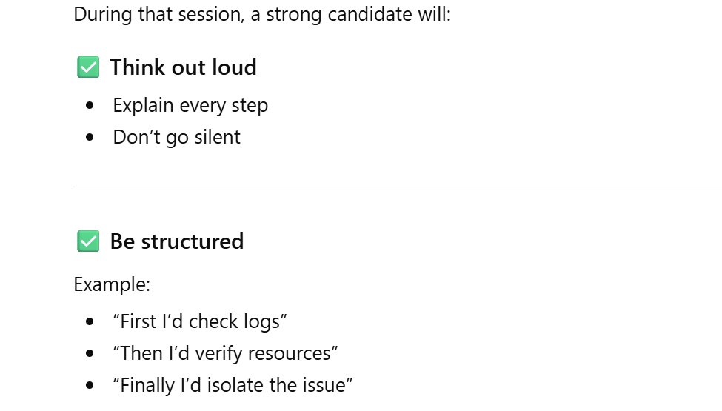
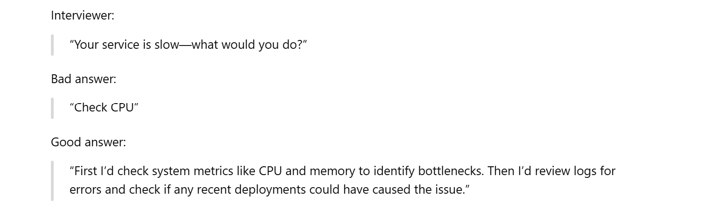
🧠 1. Kubernetes & Cloud (CORE FOCUS)
🔹 Typical questions you listed
- “Based on what metrics would you scale your K8s clusters?”
- “How do you debug Kubernetes in production?”
- “Kubernetes vs OpenShift”
- “How do we share Docker containers across nodes?”
Scaling Kubernetes……………………………………………………….
- CPU / Memory usage
- Request rate (RPS)
- Queue length
- Custom metrics (Prometheus)
👉 Bonus:
- Horizontal Pod Autoscaler (HPA)
- Cluster Autoscaler
Debugging in Production
Structured answer:
- Check pod status (kubectl get pods)
- Inspect logs (kubectl logs)
- Describe pod (kubectl describe)
- Check metrics (CPU/memory)
- Validate networking/services
- Check recent deployments
Docker Image Sharing
- Use container registries:
  - Amazon Web Services ECR
  - Docker Hub
- Nodes pull images from registry
Kubernetes vs OpenShift
- Kubernetes = open-source orchestration
- OpenShift = enterprise platform built on Kubernetes
  - Adds security, CI/CD, developer tools
🔐 2. Architecture, Scalability & Security
🔹 Questions you mentioned
- High availability
- Scalability
- System architecture
- API Gateway
- OAuth2
API Gateway
👉 Answer:
- Entry point for all client requests
- Handles:
  - Routing
  - Authentication
  - Rate limiting
  - Logging
High Availability
- Load balancing
- Multiple replicas
- Failover strategies
- Multi-zone deployments

Docker: -
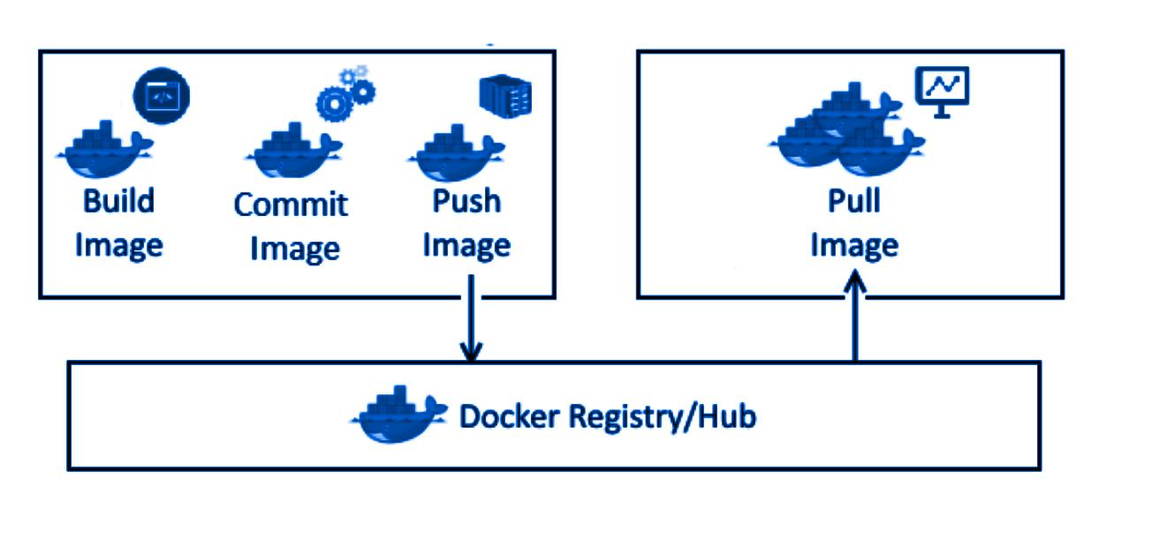
Kubernetes1: -
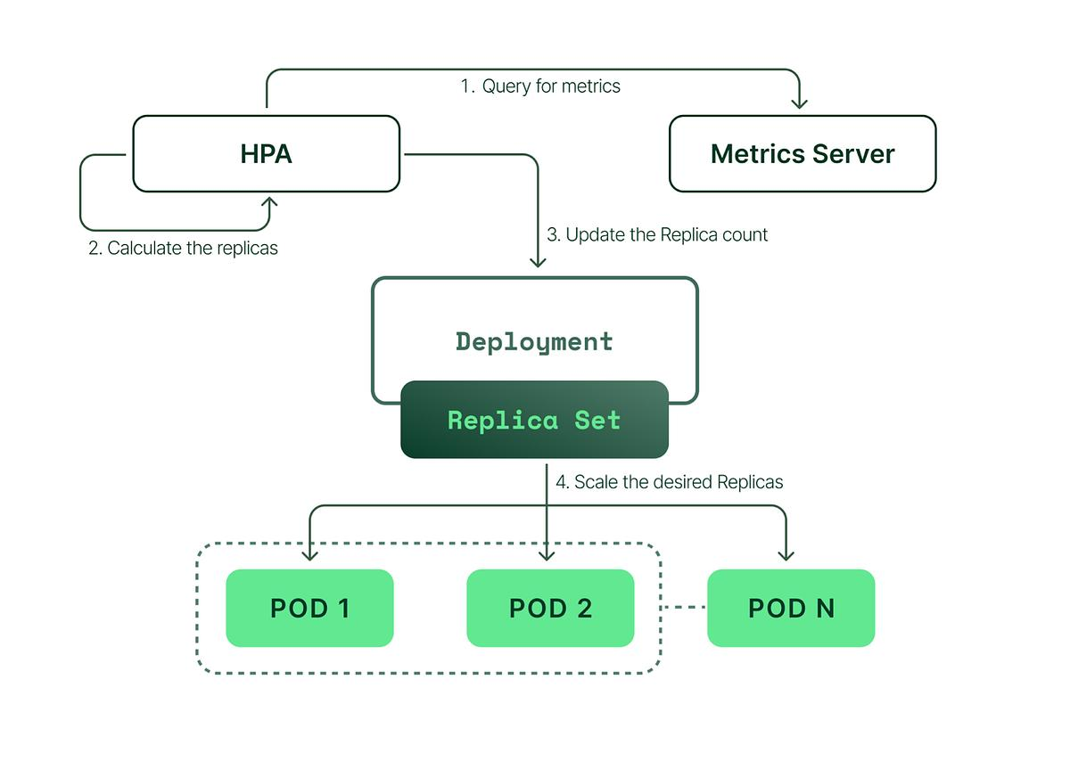

Kubernetes2: -
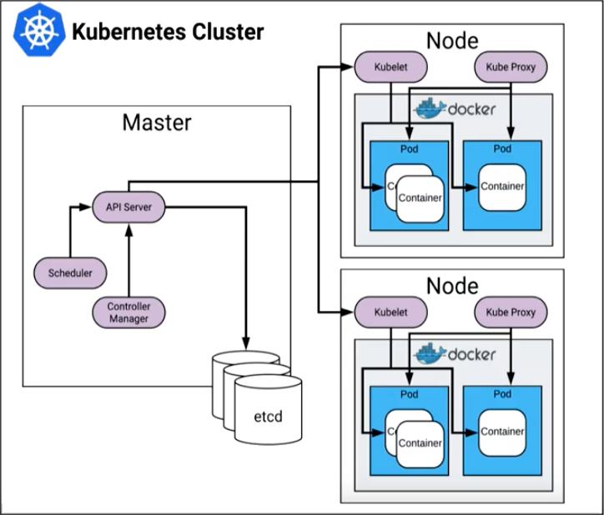

🎯 How to Explain Your Experience (Structured)
🐳 Docker (Containerization)
“In the Ericsson 5G Core data plane project, I used Docker to containerize network functions (CNFs). These included data plane components that required high performance and low latency.
I built optimized Docker images with minimal base layers, ensured proper resource limits, and integrated them into CI/CD pipelines for consistent deployments across environments.”

☸️ Kubernetes (Orchestration)
“I deployed and managed these containerized network functions on Kubernetes clusters.
I configured:
- Deployments and StatefulSets for CNFs
- Services for internal communication
- Horizontal Pod Autoscalers to handle traffic spikes
- Node affinity and tolerations for performance-sensitive workloads
This ensured high availability and scalability, which is critical in telecom workloads.”

📦 Helm (Package Management)
“I used Helm charts to standardize and automate deployments.
I created and maintained Helm charts for:
- Packaging Kubernetes manifests
- Managing environment-specific configurations
- Simplifying deployments across dev, staging, and production
This reduced manual effort and improved consistency.”

📄 YAML Files (Configuration)
“Kubernetes and Helm configurations were defined using YAML files.
I worked extensively with:
- Deployment YAMLs for pod configuration
- Service YAMLs for networking
- ConfigMaps and Secrets for configuration management
- Helm values.yaml for environment customization
All configurations were version-controlled and integrated into GitOps workflows.”

🧠 Stronger Version (What Interviewers LOVE)
Here’s a polished answer you can say directly:
“In my Ericsson 5G Core data plane project, I used Docker to containerize cloud-native network functions, ensuring consistency and portability across environments.
These containers were orchestrated using Kubernetes, where I managed deployments, scaling, and high availability. I also configured node affinity and resource limits to meet the performance requirements of telecom workloads.
To standardize deployments, I used Helm charts to package Kubernetes manifests and manage environment-specific configurations through values files. This significantly reduced manual effort and improved deployment consistency.
All configurations were defined in YAML and stored in Git, following a GitOps approach. This allowed automated, version-controlled deployments and quick rollbacks when needed.”

🚀 Bonus: Add Impact (VERY IMPORTANT)
If you can, add something like:
- “Reduced deployment time by X%”
- “Improved system availability to 99.9%”
- “Handled high throughput traffic efficiently”

Main Test Categories (PCG — 1,675 TCs)
1. Stability (234 TCs) — Long-running tests (2h–12h)
- System runs under load, verify no degradation over time
- Includes GeoRed switchover/switchback during traffic
- KPI checks: CPU, memory, PFCP rates, NAT counters, IPFIX
- Sub-types: DPI, CGNAT, eSF, Multifeature, GeoRed, L3VPN, IPsec
- What you learn: How the system behaves under sustained load, what KPIs matter, what thresholds are acceptable
2. Robustness (324 TCs) — Fault injection tests
- Kill/restart specific components during traffic and verify recovery
- Naming pattern tells you the fault type:
  - SF = Single Fault (kill 1 pod)
  - MF = Multi Fault (kill multiple pods)
  - R = Restart (node restart)
  - UG = Ungraceful (hard kill)
  - G = Graceful (drain/cordon)
- Target components: DataPlane, CRE, KVDB, Replicator, PEP, ECFE, Coredns
- What you learn: System resilience, which components are critical, recovery times, what happens when things break
3. Maintainability (176 TCs) — Upgrade/lifecycle tests
- HelmUpgrade (39) — Upgrade PCG via Helm chart
- ISSU (40) — In-Service Software Upgrade (no traffic loss)
- ScaleOut/In (10) — Add/remove pods
- Drain (9) — Drain worker nodes
- DNC (9) — Dynamic Network Config changes
- DeleteRecreate (8) — Delete and recreate NIs, IP pools
- What you learn: How to upgrade without downtime, scaling strategies, day-2 operations
4. Characteristics (198 TCs) — Performance/capacity tests
- MaxThroughput — Maximum data plane throughput (Gbps)
- MaxSignaling — Maximum PFCP signaling rate (sessions/sec)
- MaxPDUSession — Maximum concurrent sessions
- SingleUser — Per-user throughput
- LatencyJitter — Packet latency and jitter
- Capacity — ADP CM, IP pools, NI limits
- What you learn: System limits, dimensioning, performance baselines

1. SCALABILITY — "Can the system handle more?"
How it's tested:
Horizontal Scaling (Scale Out/In)
- resource is scaled to 4 within 2 minutes
— add more pods of a component
- Components scaled: DataPlane, PfcpEndpoint, PartitionDistributor, RoutingAggregator
- Verify: traffic not impacted during scaling, signaling success rate > 99.99%
Vertical Capacity (Characteristics)
- Max Throughput: Ramp up traffic until CPU hits target (e.g.
ingress_egress:69%+/-2
), measure Gbps
- Max Sessions: Ramp up subscribers, measure
pcuppep_pfcp_total_sessions
at peak
- Max Signaling Rate: Measure
pfcp_establishment_request
,
pfcp_modification_request
,
pfcp_deletion_request
in TPS
Key metrics for scalability:
Metric | What it tells you
pcupdp_cpu_load_15s_percent  per role | Which CPU role is the bottleneck (ingress_egress, input_output, control, spare)
pcupdp_cpu_load_15s_percent  stddev | Load balance across CPUs — stddev < 20-30% means even distribution
pcupdp_memory_used_bytes | Memory capacity limit (e.g.  less than 5.6GB  )
pcuppep_pfcp_total_sessions | Session capacity
pcupdp_gtp_sent_bytes_total * 8 / 1000000000 | Throughput in Gbps
What you learn: A scalable system separates CPU roles (ingress/egress for packet processing, I/O for session management, control for signaling). You scale the bottleneck component, not everything.

2. AVAILABILITY — "Does it stay up when things fail?"
How it's tested:
GeoRed Switchover (Active/Standby)
- gsa switchover is performed
— switch traffic to standby cluster
- Measured by:
  - pckvdbrdr_bulk_sync_percent = exactly 100
— all sessions synced
  - pckvdbrdr_bulk_sync_duration_seconds < 300
— sync completes within 5 min (REQ16848: < 15 min)
  - ready to switchover is true within 720 seconds
— standby ready within 12 min
  - pcuppep_pfcp_total_sessions on all clusters differ by less than 0.1%
— session parity
Zero-Downtime Upgrade (ISSU)
- Upgrade PCG while traffic is running
- packet loss during failure event is at most 0.5 percent
- signaling success rate > 99.99%
during upgrade
- packet loss < 10 ppm
(parts per million) after upgrade
Packet Loss During Failures
- pcupdp_core_interface_packet_drop_ppm = exactly 0
— zero packet loss on core interface
- pcupdp_access_interface_packet_drop_ppm = exactly 0
— zero packet loss on access interface
- average of traffic UL/DL loss ppm should be below 10
— less than 10 packets lost per million
Worker Node Drain
- worker nodes are drained and blocking pods are deleted
— graceful node removal
- Verify traffic continues on remaining nodes
Key metrics for availability:
Metric | What it tells you
pckvdbrdr_bulk_sync_percent | Data replication completeness (must be 100%)
pckvdbrdr_bulk_sync_duration_seconds | How fast standby catches up
pcupdp_*_packet_drop_ppm | Packet loss in parts per million
pcupdp_geored_client_state | 2 = ACTIVE, 3 = STANDBY
gsa-state: ACTIVE (WITH PEER) | Both clusters connected
ready-to-switchover: Yes | Standby is ready to take over
What you learn: High availability = data replication (KVDB bulk sync) + fast failover (< 5 min) + zero/near-zero packet loss during switchover. The system uses Active/Standby with continuous session sync.

3. RELIABILITY — "Does it work correctly over time?"
How it's tested:
Stability (Long-running)
- Run 2h–12h under load, check nothing degrades
- Memory leak detection:
verify:delta < 20
on
pmrm_container_mem_usage_percent
— memory shouldn't grow more than 20% over the test duration
- CPU stability: stddev of CPU < 20-25% — no spikes or oscillation
- No crashes:
System Crashes Attempted = 0
- No coredumps:
there are no coredumps on all clusters
- No unexpected pod restarts:
pod restart count values have not increased
- No unexpected alarms:
no alarms have been active since...
Robustness (Fault Recovery)
- Kill a pod with
sigkill
→ measure recovery time
- recovery time is at most 77 seconds
(REQ9854)
- After recovery: signaling success rate > 99.99%, packet loss < threshold
- Kill on active cluster → verify standby takes over
- Kill on standby cluster → verify active not impacted
Data Integrity
- sum(pcupdp_nat_active_flows) - sum(pcupdp_nat_pool_active_flows) = 0.0
— NAT flow counters match between different counter sources
- pcuppep_pfcp_total_sessions on all clusters differ by less than 0.1%
— session count consistent across clusters
IPFIX/Reporting Reliability
- pcupdp_reporting_overload_total < 1
— no reporting overload
- event_reporting_transaction_round_trip_time < 0.035s
— reporting latency stable
Key metrics for reliability:
Metric | What it tells you
pmrm_container_mem_usage_percent  delta | Memory leak detection
pmrm_container_cpu_usage_percent  avg/max | Resource stability over time
Pod restart count | Unexpected crashes
Coredumps | Software bugs
Alarms | System health
pcupdp_upf_sent_error_messages_total = 0 | No error messages
pcupdp_packet_detection_max_memory_flow_hits_total = 0 | No memory overflow
Signaling success rate > 99.99% | Control plane reliability
What you learn: Reliability = no leaks + no crashes + fast recovery + data consistency. You measure it by running long, breaking things, and checking everything still adds up.

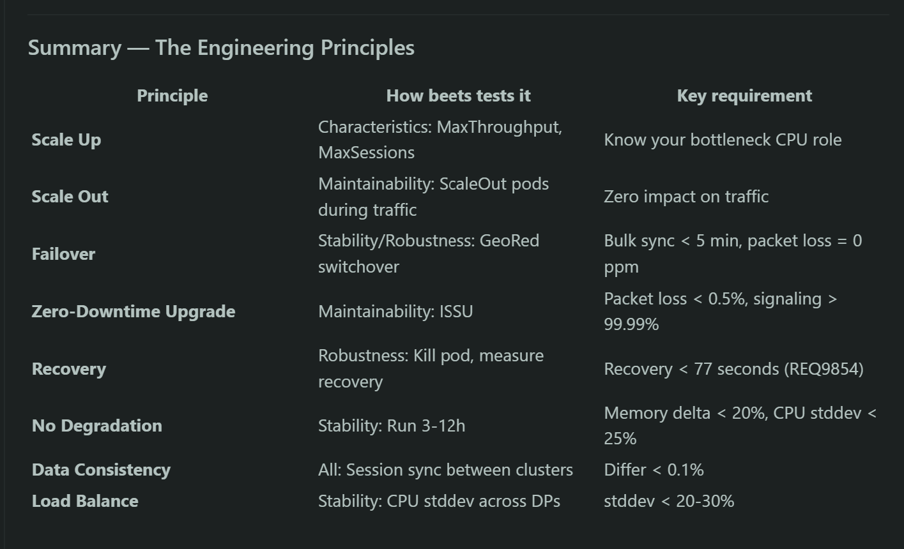

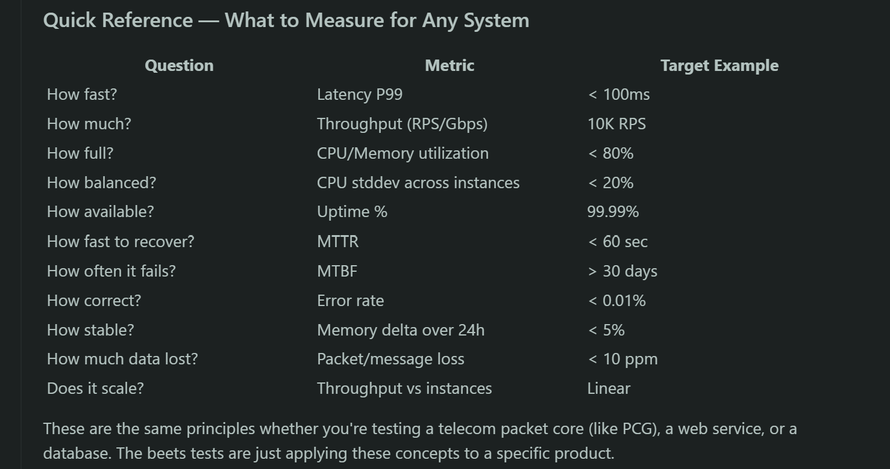

Availability — "How much uptime?"
The metric: Uptime percentage (the "nines")
Level | Downtime/year | Downtime/month
99.9% (3 nines) | 8.76 hours | 43.8 min
99.99% (4 nines) | 52.6 min | 4.38 min
99.999% (5 nines) | 5.26 min | 26.3 sec
Formula:
Availability = (Total Time - Downtime) / Total Time × 100
Copy
What we measure in real systems:
- MTBF (Mean Time Between Failures) — how long the system runs before it fails
- MTTR (Mean Time To Recovery) — how fast we recover after failure
- Formula:
Availability = MTBF / (MTBF + MTTR)
How to improve:
- Redundancy (Active/Standby like GeoRed)
- Fast failover (bulk sync, session replication)
- Zero-downtime upgrades (ISSU)
- Health checks and auto-restart
Real-world tools to measure:
- Uptime monitoring (Prometheus + Alertmanager, Datadog, PagerDuty)
- SLI/SLO tracking (e.g. "99.99% of requests succeed within 200ms")

Reliability — "Does it work correctly?"
The metrics:
Metric | Formula | Meaning
Error Rate | Failed requests / Total requests | How often things go wrong
MTBF | Total operating time / Number of failures | How long between failures
Success Rate | Successful operations / Total operations × 100 | How often things go right
Data Integrity | Corrupted records / Total records | Data correctness
What we measure in real systems:
- HTTP error rate — 5xx errors / total requests (target: < 0.01%)
- Message loss rate — lost messages / total messages (target: < 0.001%)
- Data consistency — replicas in sync (target: 100%)
- Crash rate — crashes per day/week (target: 0)
- Memory leak — memory growth over time (target: flat line)
How to improve:
- Retry with backoff
- Circuit breakers
- Idempotent operations
- Data replication + checksums
- Chaos engineering (kill things on purpose, like robustness tests)
Real-world tools:
- Error tracking (Sentry, CloudWatch)
- APM (Application Performance Monitoring)
- Chaos tools (AWS Fault Injection Service, Chaos Monkey, Litmus)

Scalability — "Can it handle more load?"
The metrics:
Metric | What it measures
Throughput | Requests/sec or Gbps the system handles
Latency at load | Response time as load increases (P50, P95, P99)
CPU/Memory utilization | Resource usage at different load levels
Saturation point | Load level where performance degrades
Linear scalability | Does 2x resources = 2x capacity?

Two types:
Vertical scaling (Scale Up):
Same machine, more resources (CPU, RAM)
Measure: throughput vs CPU cores
Limit: single machine max
Copy
Horizontal scaling (Scale Out):
More machines/pods
Measure: throughput vs number of instances
Ideal: linear — 2 pods = 2x throughput
Reality: sub-linear due to coordination overhead

1. Start with baseline load → measure throughput, latency, CPU
2. Increase load by 10-20% steps
3. At each step measure:
- Throughput (requests/sec)
- Latency P50, P95, P99
- CPU utilization
- Memory utilization
- Error rate
4. Find the saturation point (where latency spikes or errors increase)
5. Add more instances → repeat → check if capacity increases linearly

