Projct1:-
kmock documentation
kubesim - Kubernetes cluster simulator for learning, testing, and security
envtest package - sigs.k8s.io/controller-runtime/pkg/envtest - Go Packages
Home | KWOK
LitmusChaos - Open Source Chaos Engineering Platform
Chaos Mesh: A Powerful Chaos Engineering Platform for Kubernetes

⚔️ Kind vs KWOK (Summary)
🟦 Kind
👉 What it is:
- Runs a real Kubernetes cluster inside Docker containers
- Each “node” is a Docker container
- Everything is real Kubernetes behavior
Key idea
“Real Kubernetes, but inside Docker”
Pros
- Very realistic (production-like behavior)
- Full Kubernetes features work
- Great for testing YAML, CI/CD, apps
Cons
- Needs Docker
- Heavier than KWOK
- Uses real CPU/RAM

🟩 KWOK
👉 What it is:
- A Kubernetes simulator
- Nodes and pods are fake (no containers run)
- Only API behavior is simulated
Key idea
“Fake Kubernetes for learning and scaling tests”
Pros
- No real containers
- Very lightweight
- Can simulate 100s–1000s of nodes/pods
- Great for learning scheduling/controllers
Cons
- Not real workloads
- Not for app testing
- More “simulation” than real cluster

🧱 KWOK Setup (Step-by-step)
✅ STEP 1 — Install kubectl (DONE) :- kubectl version --client
✅ STEP 2 — Install KWOK CLI :- kwokctl help
✅ STEP 2 :- kwokctl create cluster --dry-run
dry-run for: -
- checking what will be created

The user is asking why KWOK is preferred over plain kind for their project, especially since KWOK uses kind internally anyway.
Let me explain the key differences and advantages of KWOK:
- Scale - KWOK can simulate thousands of nodes/pods on a single machine, while kind creates actual containers so you're limited by your laptop's resources (maybe 10-20 nodes max)
- Speed - KWOK spins up in seconds; kind takes longer because it actually provisions containers
- Resource usage - KWOK uses minimal CPU/memory since no real containers run; kind uses significant resources for each node's kubelet/container runtime
- Test automation - KWOK provides fake pods/nodes that work via Kubernetes API without real workloads - perfect for testing automation logic, not app functionality

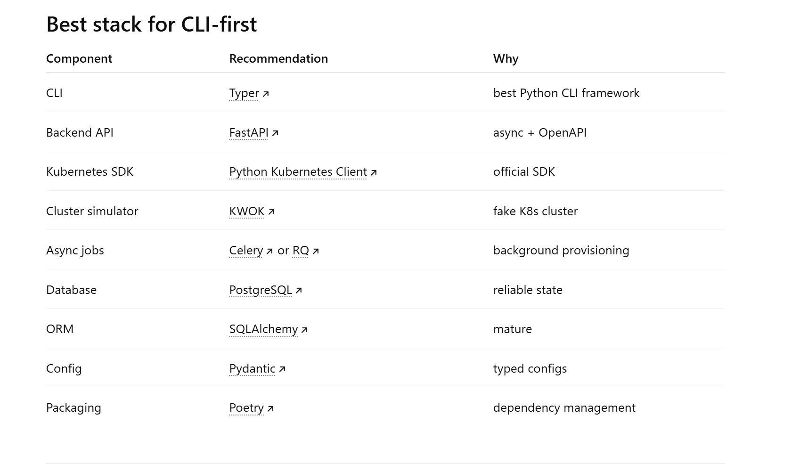
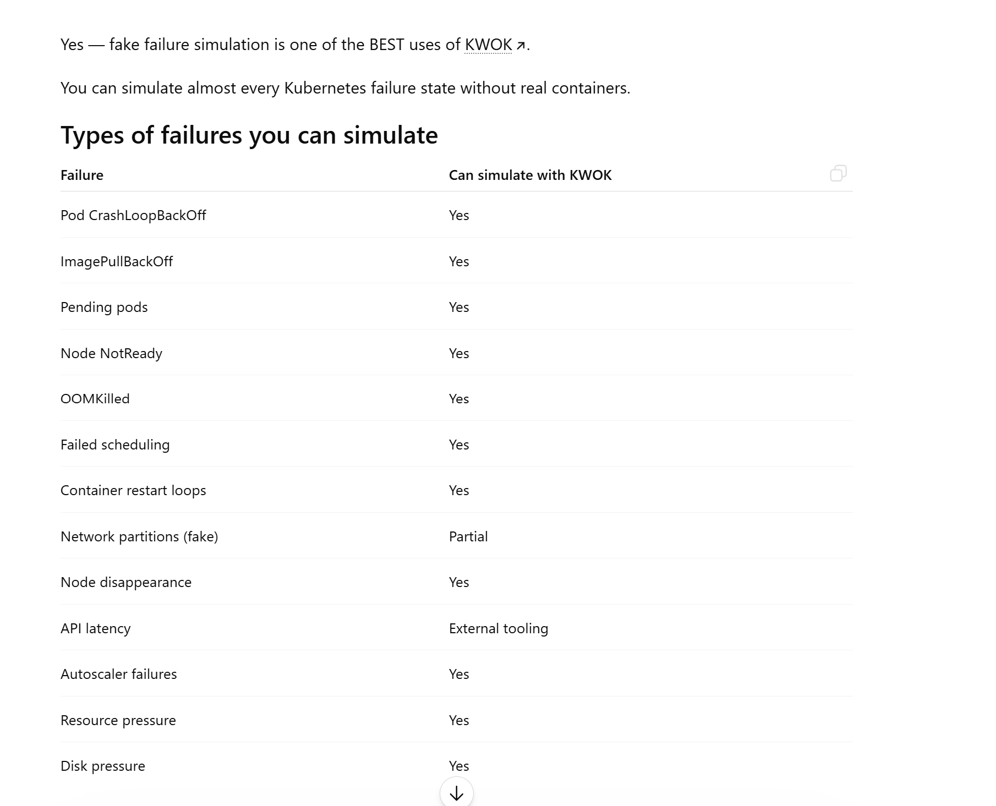

For Golán based:-
What companies use this for
Very common for:
- Kubernetes operator testing
- autoscaler testing
- CI systems
- platform engineering
- chaos engineering
- cloud simulation
- API testing
- load testing
- GitOps validation

The official Helm project does not provide a native Python SDK. To programmatically interact with Helm using Python, use one of the strategies outlined below. [1]

Implementation Strategies
1. Native Subprocess Wrappers (Recommended for Production) [1]
The most resilient and production-stable pattern is using Python’s standard subprocess module to call the installed helm binary directly. This ensures complete compatibility with all Helm core features, versions, and security plugins. [1]
python
import subprocess
import json

def install_helm_chart(release_name: str, chart_name: str, namespace: str):
command = [
"helm", "upgrade", "--install",
release_name, chart_name,
"--namespace", namespace,
"--create-namespace",
"--output", "json" # Forces Helm to output structured data
]

try:
# Executes the command and captures terminal outputs safely
result = subprocess.run(command, capture_output=True, text=True, check=True)
release_data = json.loads(result.stdout)
return release_data
except subprocess.CalledProcessError as e:
print(f"Helm Command Failed: {e.stderr}")
raise
Use code with caution.
2. Open-Source Wrapper Libraries (Recommended for Clean Syntax)
If you prefer a clean object-oriented Python syntax without writing standard subprocess scripts, you can leverage third-party community libraries.
- pyhelm3: An asynchronous Python wrapper that acts as a client interface over the local Helm 3 binary execution pipeline.
- helm-client: A library that maps Python method keyword arguments directly to standard Helm CLI strings using Pydantic models. [1, 2, 3]
python
# Example using the pyhelm3 library interface
import asyncio
from pyhelm3 import Client

async def main():
# Automatically tracks and utilizes local Kubeconfig files
client = Client(kubeconfig="/path/to/kubeconfig")

# Programmatically audit active cluster rollouts
releases = await client.list_releases(all=True, all_namespaces=True)
for release in releases:
revision = await release.current_revision()
print(f"Release: {release.name} | Namespace: {release.namespace} | Revision: {revision}")

asyncio.run(main())
Python client for Helm · Issue #12267 · helm/helm

