Best Structure For Nile
STAGE 1 — RaaS / Remittance Platform
BEST:
Spain
Reason:
- your users are in Spain
- local remittance business
- easier trust/marketing
- easier first operations
- possible lower practical startup costs

STAGE 2— PI
BEST:
Lithuania
Because now:
- scaling matters
- EU passporting matters
- regulator quality matters
- fintech ecosystem matters
Spain becomes slower/heavier here.
Lithuania becomes stronger.

STAGE 3 — EMI
BEST:
Lithuania
Because EMI requires:
- advanced regulator
- fintech ecosystem
- experienced compliance environment
- international scaling support
Lithuania is one of the best in Europe for this.

Saas covers: -
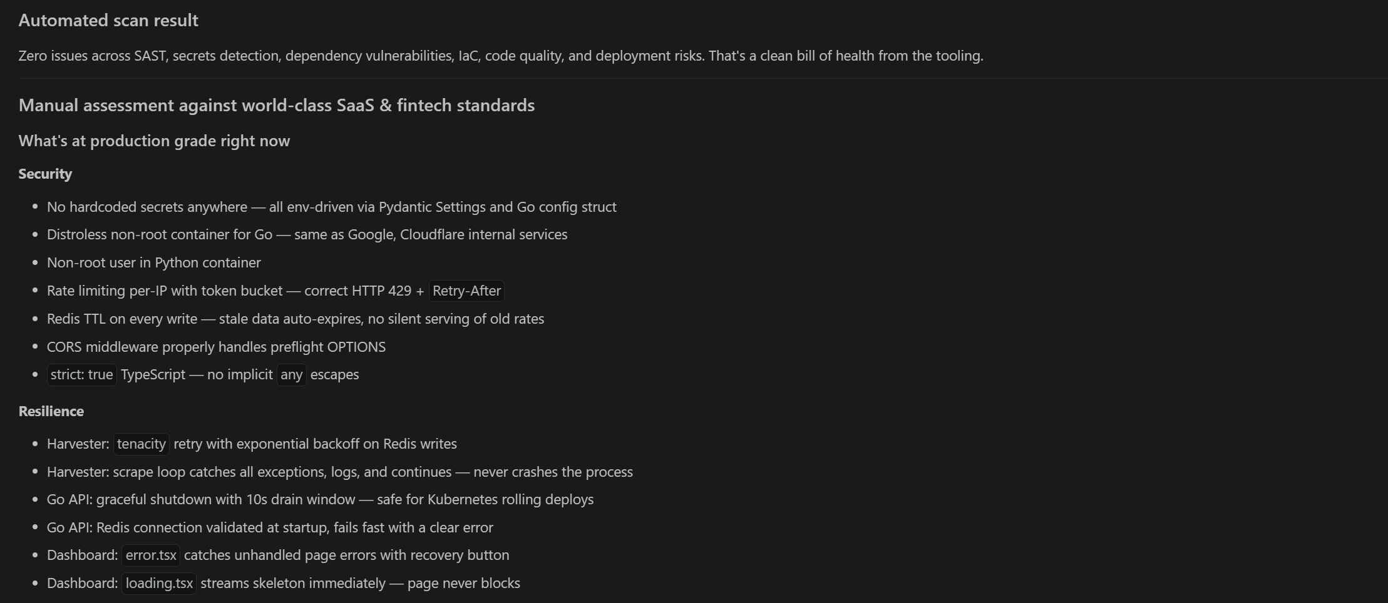
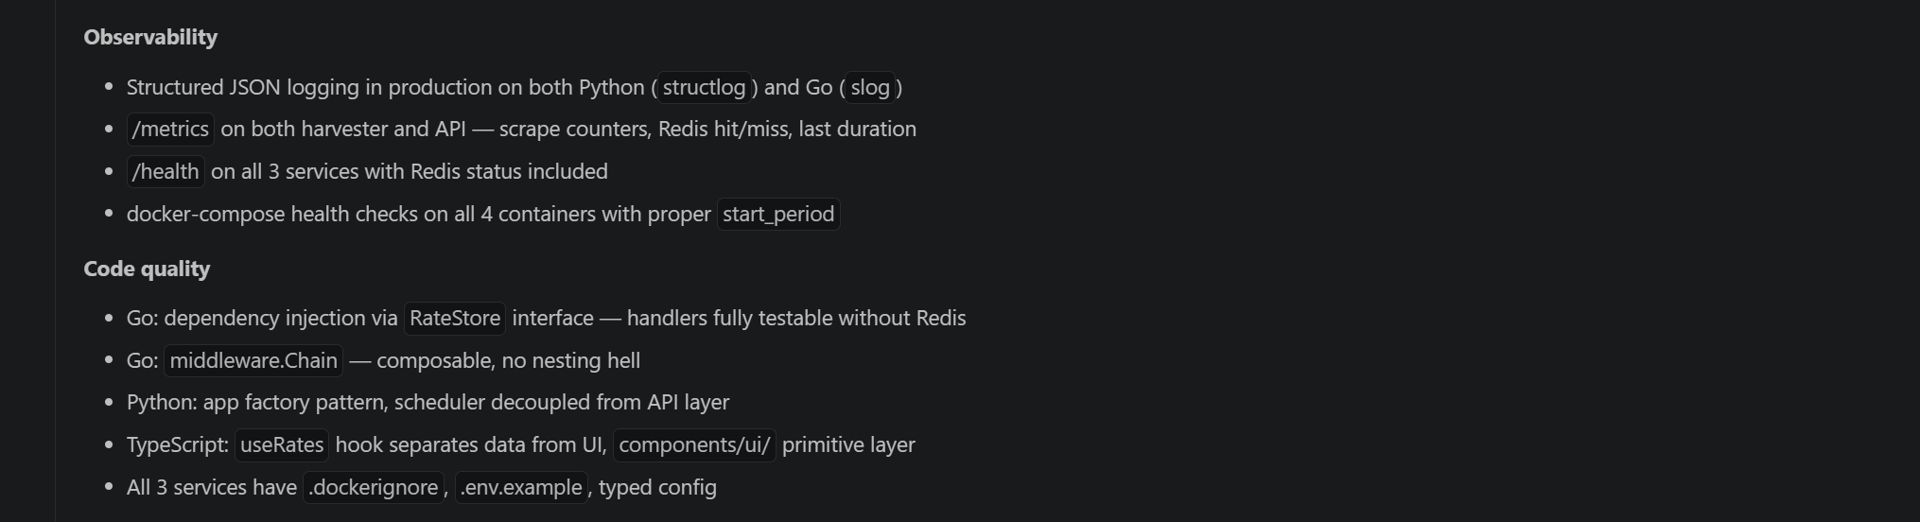

Improvements: -
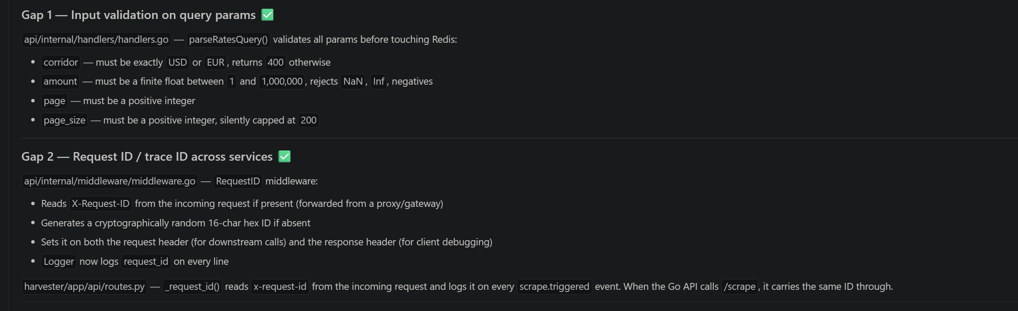
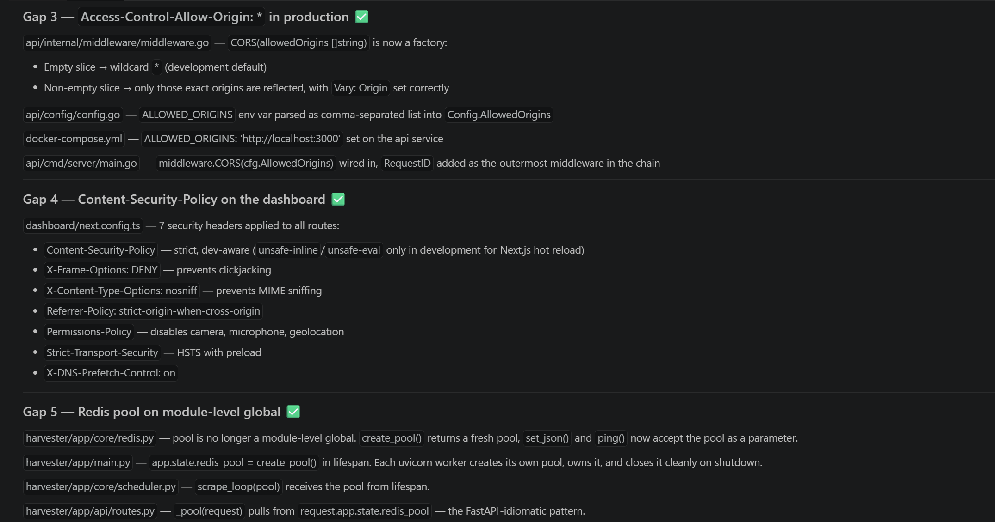

Deployments and infrastructure: -
