Struct, slice, constructior:-
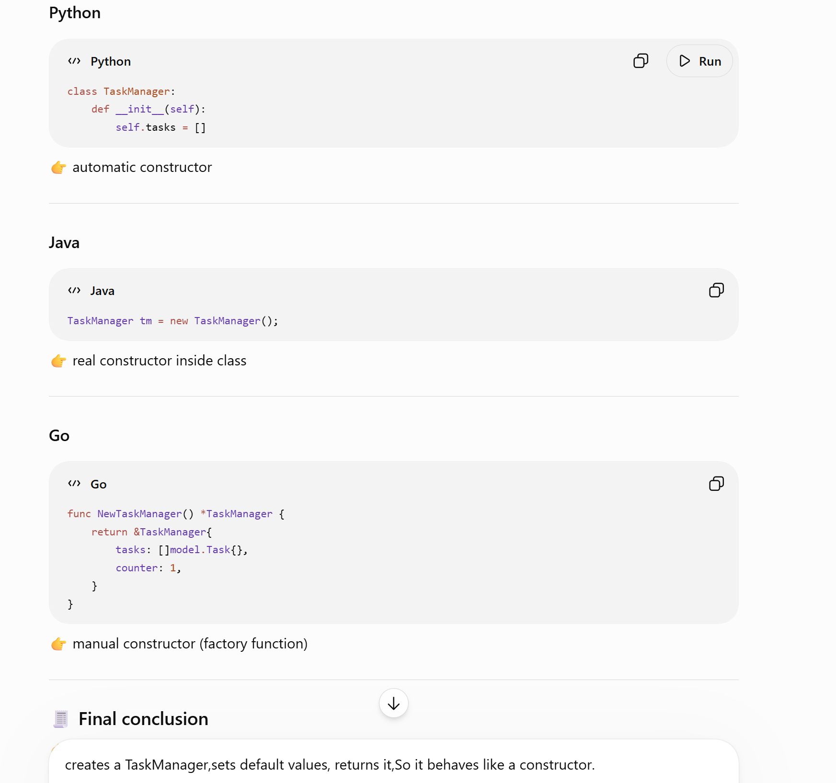

Create and return objects: -
Two ways: -
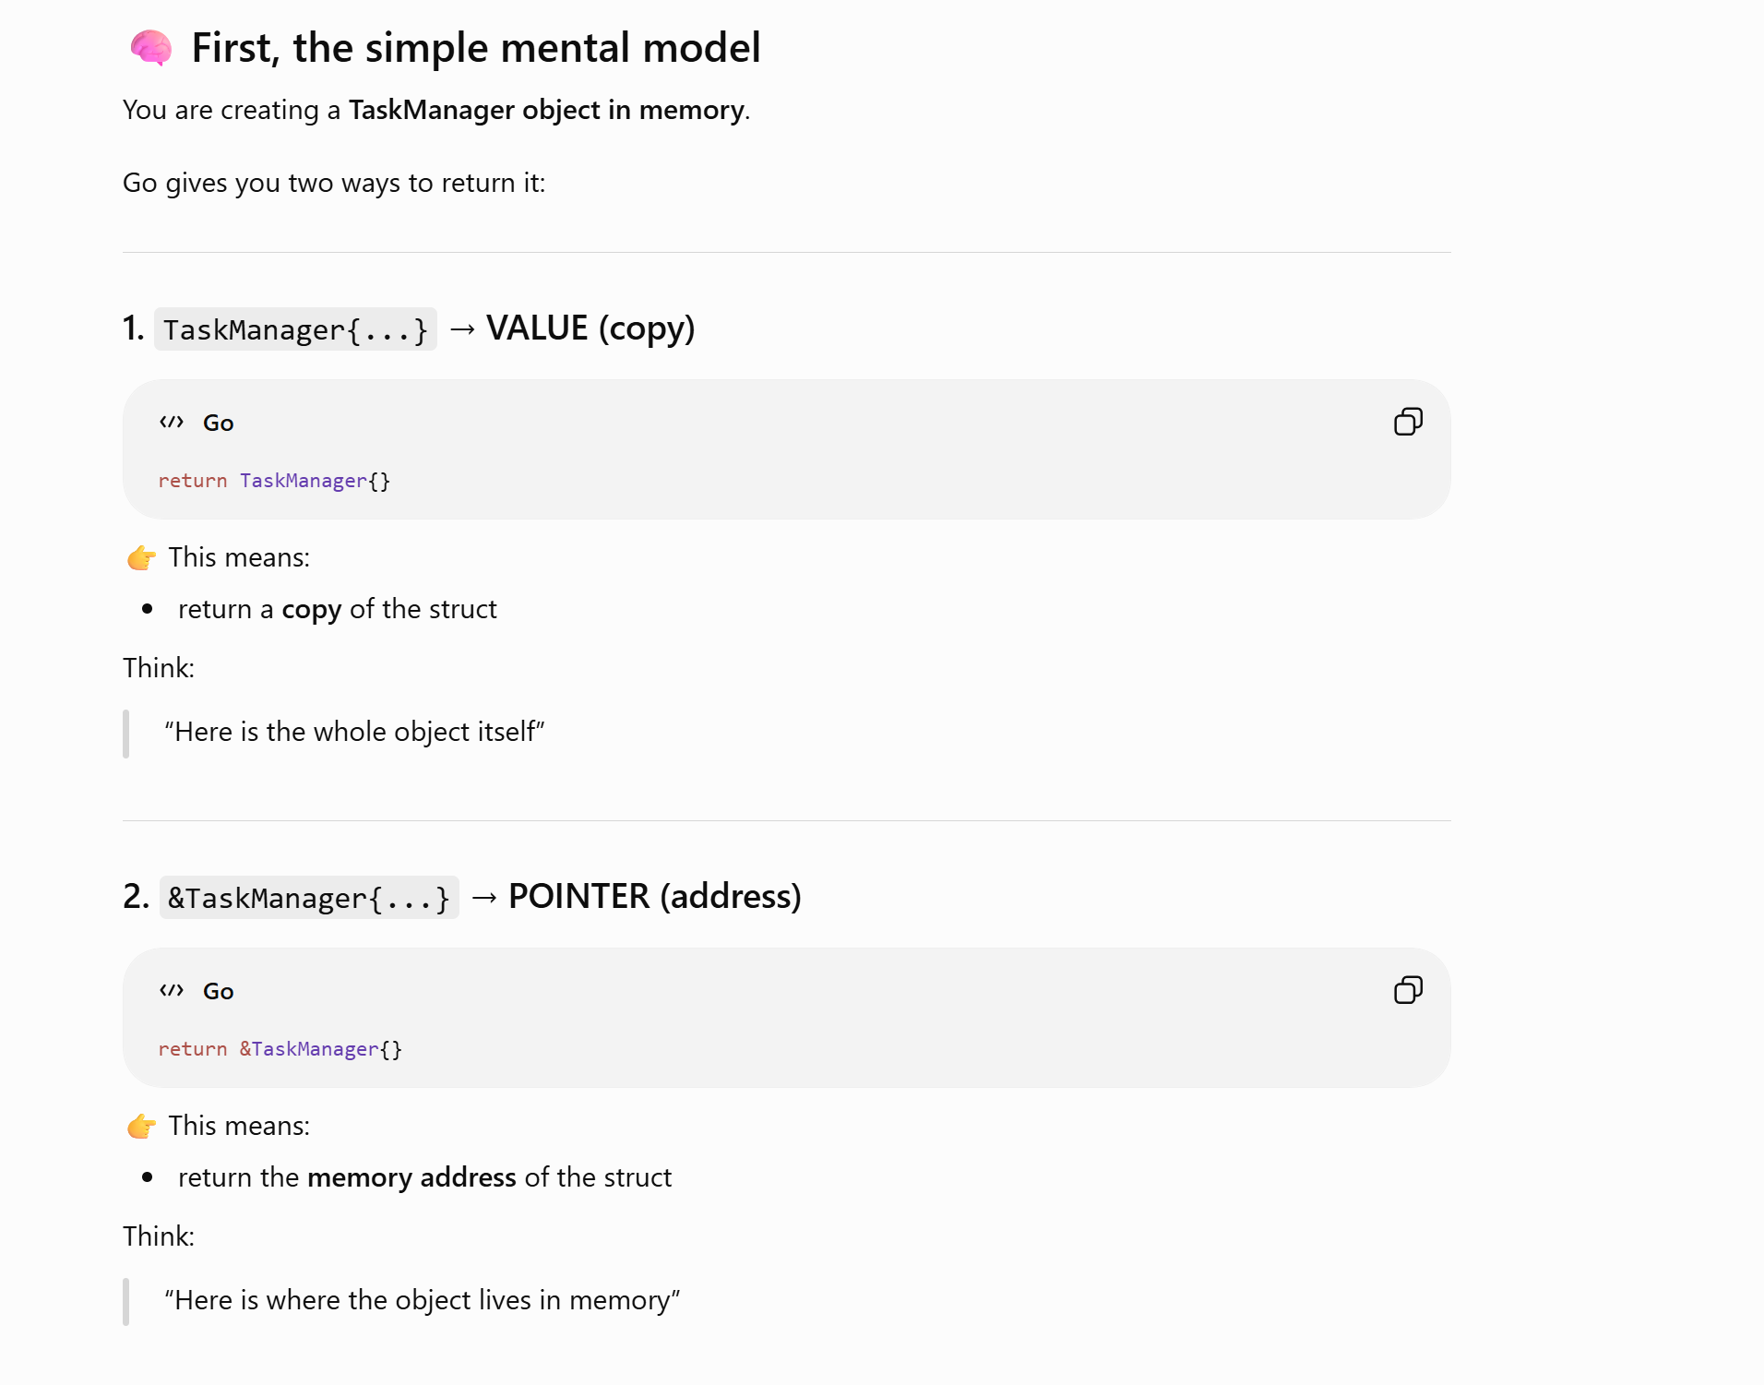

Pointer/memory address: -
- Go creates the object in memory
- Gets its address
- Returns that address
- Caller receives pointer (*TaskManager)
One-line super simple explanation: -
👉 &TaskManager = “create object + give me its address instead of copying it”

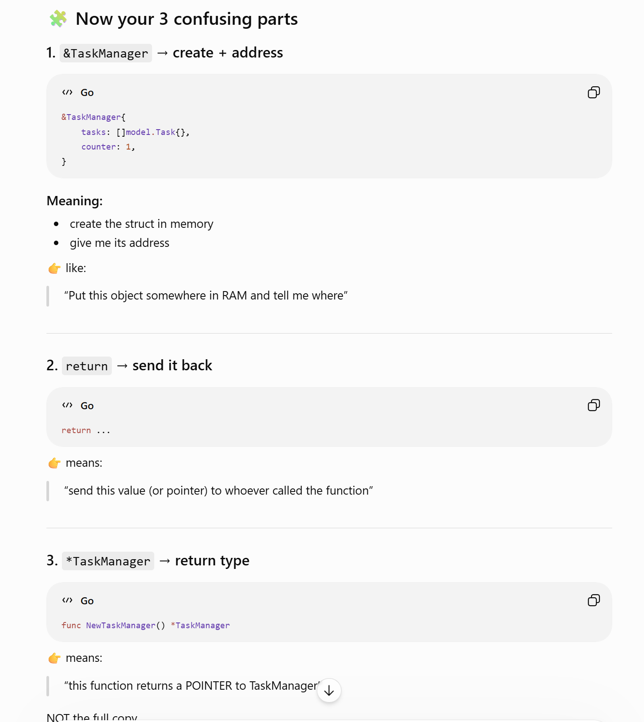

💡 One-line super simple explanation
👉 &TaskManager = “create object + give me its address instead of copying it”

Golang Architecture: -
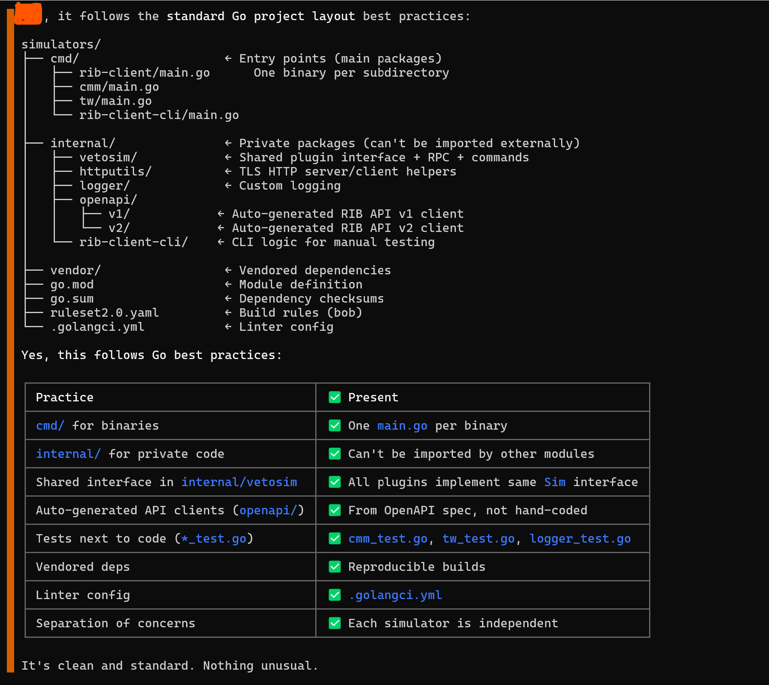

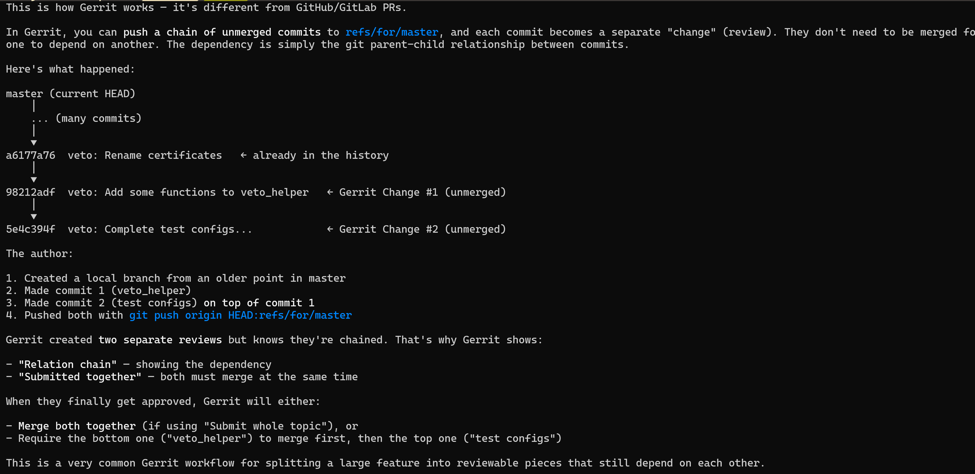

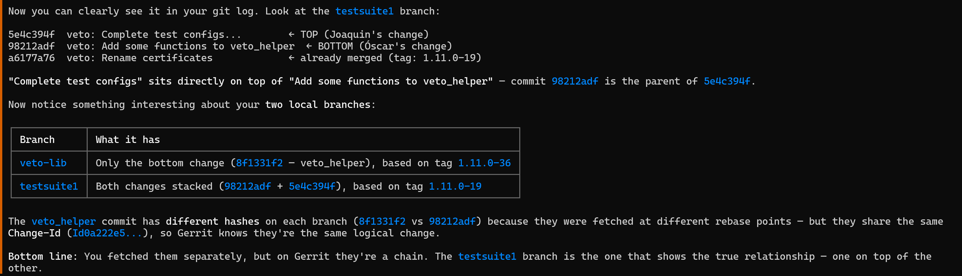

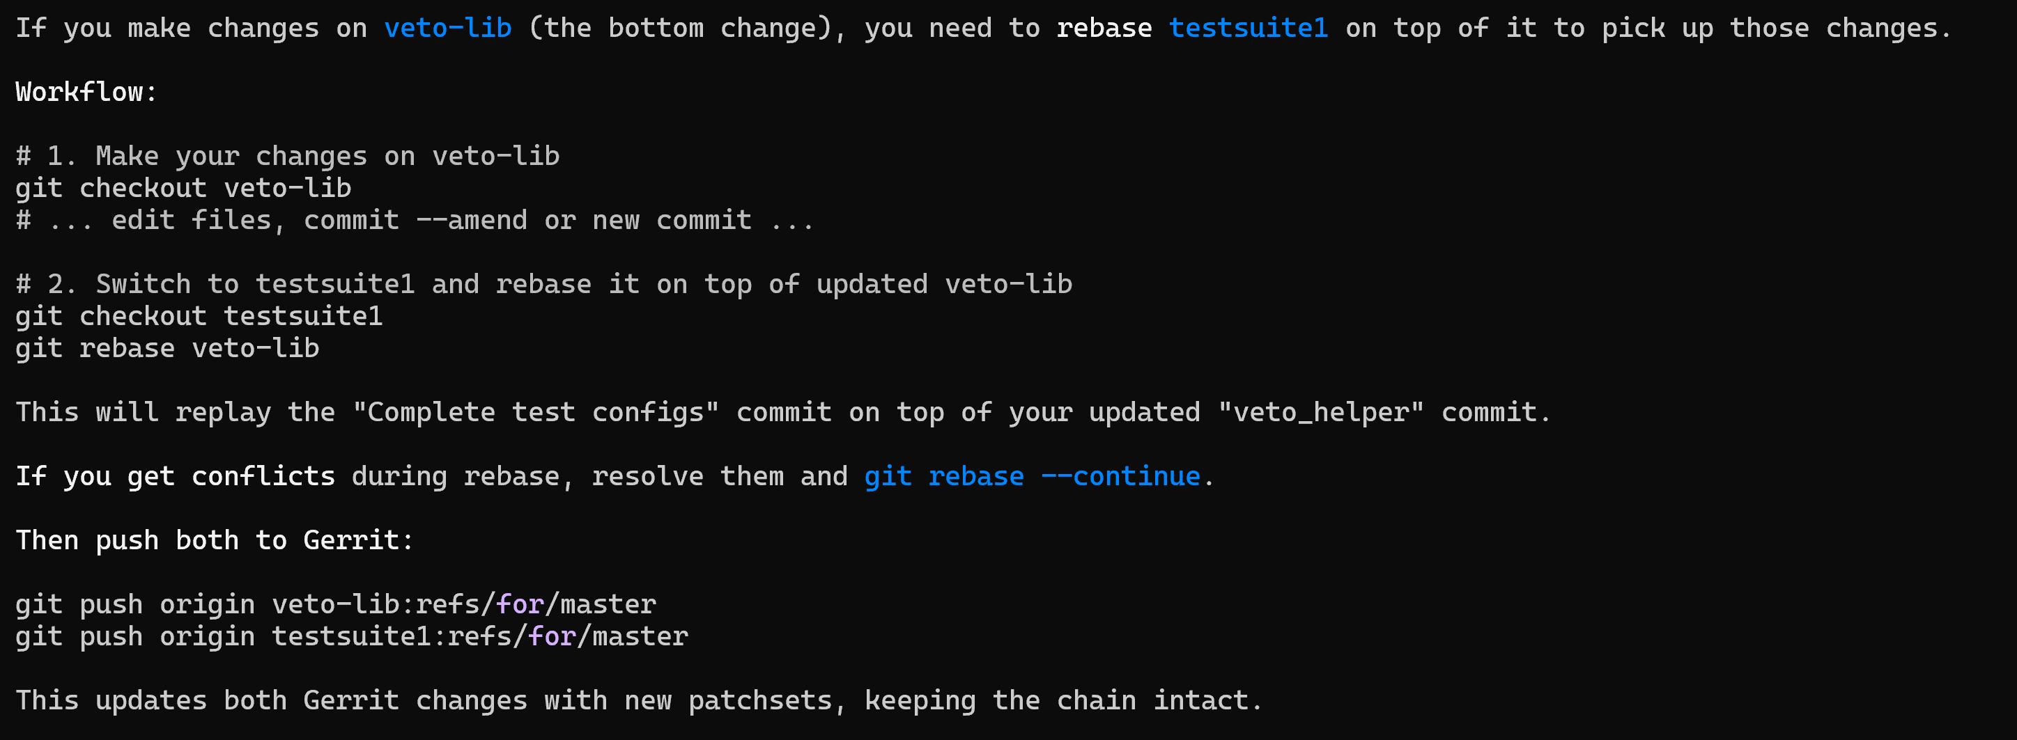

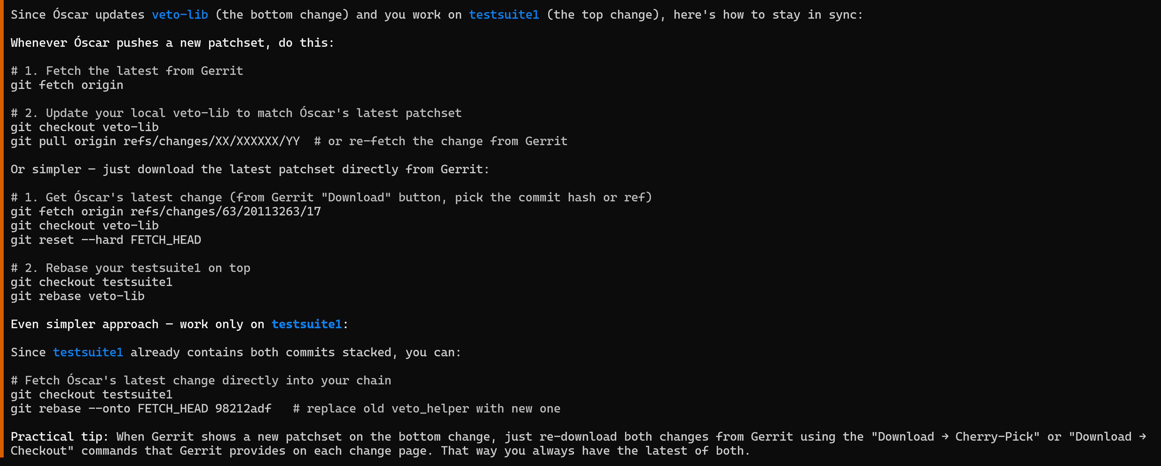

The correct order:
# 1. Update master
git checkout master
git pull

# 2. Rebase veto-lib onto master
git checkout veto-lib
git rebase master

# 3. Rebase testsuite1 onto veto-lib (NOT onto master directly)
git checkout testsuite1
git rebase veto-lib

Why not rebase testsuite1 directly onto master?
If you rebase testsuite1 onto master, you'd flatten the chain — both commits would be on master but Gerrit might lose the parent-child relationship between the
two changes. The "Submitted together" link could break.
The chain must stay:
master → veto-lib (veto_helper) → testsuite1 (test configs)
So always: master ← veto-lib ← testsuite1, in that order.

Perfect. Your chain is now clean and up to date:
master (3b1d9133) → veto-lib (07dde546) → testsuite1 (bed2e20c)
Both are sitting on top of latest master. From now on, whenever you need to update:
1. If you change veto-lib → rebase testsuite1 onto veto-lib
2. If Óscar pushes a new patchset → fetch it, reset veto-lib, then rebase testsuite1
3. If master advances → rebase veto-lib onto master, then testsuite1 onto veto-lib
Always maintain the order: master ← veto-lib ← testsuite1.

git checkout testsuite1
# Basic test
veto run tests/veto/testsuites/TCxx_Veto_RIB_Basic.py

# Capacity tests
veto run tests/veto/testsuites/L3VPN_capacity/TCxx_Veto_RIB_L3VPN_512NI.py
veto run tests/veto/testsuites/PCPB23628_capacity/TCxx_Veto_RIB_400K_FabricRoutes.py
veto run tests/veto/testsuites/ISSU/TCxx_Veto_RIB_ISSU_512NI.py

Note: These all require a deployed RIB environment (K8s cluster with the helm chart). The Basic test is the lightest one to start with. The capacity tests (L3VPN, PCPB23628, ISSU) need a full test environment with multiple producers/consumers

