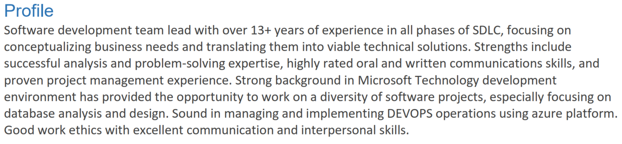

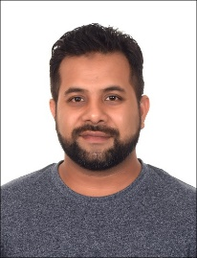

[Gecezeeshan@gmail.com](mailto:Gecezeeshan@gmail.com)

[www.linkedin.com/in/gecezeeshan](http://www.linkedin.com/in/gecezeeshan)

**Technologies:**





















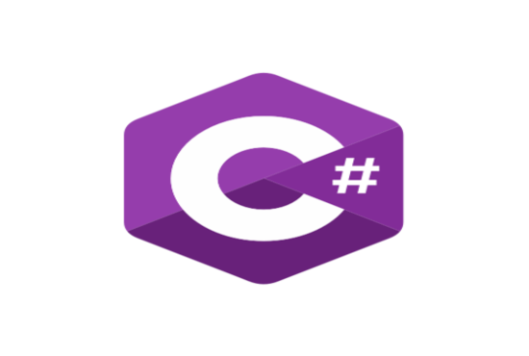

**Projects**

1. warranty management System ([www.homeinformationpackages.com](http://www.homeinformationpackages.com)).
2. Survey Application for buyers (<http://wosvoc.com>),
3. customer connect (<http://Customer-connect.ca>)
4. customer insight (<http://customerinsight.ca/>)
5. 4Tanslation ([www.4translation.com](http://www.4translation.com))
6. Physician Office Solutions
7. Patient Kiosk
8. ezWayFinder
9. EzDictate
10. E-Learning.
11. Inventory Management
12. Import Bond
13. GatePass
14. Finance Module
15. Procurement Module
16. Fippex
17. Net2Invoice
18. Net2Survey

