
Debre Birhan University
College of Computing
Department of Computer Science
Internship Report

Project Title: Hawi Software Solutions Website
Hosting Company: Hawi Software Solutions

Internee: Ananiya Ephrem(ID:1500989)
Mentor: Betselot Y.
Company Supervisor: Biniyam A.

October, 2025
Hawi Software Solutions, Adama

Declaration
Hawi Software Solutions Website completed during my internship at Hawi Software Solutions. All sources used are acknowledged, and this work has not been submitted elsewhere.

Acknowledgement
I would be glad to put my sincere thanks to Debre Birhan University(DBU) as it enabled me to take this internship programme that has been a crucial component in my career growth.
I would like to thank Hawi Software Solutions where I have gained this important internship experience. I would most like to thank my supervisor, Mr. Biniyam to guide me and support me through the internship. I also appreciate the whole development staff at Hawi Software solutions because of their cooperative attitude and their ability to provide an encouraging and friendly virtual environment in which to learn.
I would also like to note the helpfulness and assistance of my department supervisor, Mr. Betselot. I as well praise my family and friends who have been supportive and encouraging throughout this learning process.

EXECUTIVE SUMMARY
During the internship, my primary objective was to gain practical experience in a professional work environment under the supervision of experienced mentors. I effectively achieved this goal by actively participating in assigned tasks, collaborating with fellow interns, working against deadlines, improving my communication skills with senior staff and supervisors, and brainstorming effective strategies to accomplish my responsibilities. The internship not only provided me with valuable insights into my chosen field but also served as a tremendous source of motivation for my future endeavors. This report serves as a concise summary of my internship experience, encompassing various aspects such as my assigned responsibilities, the company's background, the technical knowledge and resources I acquired, the challenges encountered, the impact of the internship on my career goals, and my personal impressions of both the company and the overall internship program.

List of Acronyms
- DBU:Debre Birhan University
- HSS:Hawi Software Solution
- RESTful API:Representational State Transfer Application Programming Interface
- PHP: Hypertext Preprocessor
- SQL: Structured Query Language
- ORM: Object-Relational Mapping
- SDK:Software Devlopment Kit
- UX:User Experience
- UI:User Interface

Contents
1. Company Background 1
1.1 Description of the Organizatio 1
1.2 Vision 1
1.3 Mission 1
1.4 Products and service 2
1.5 Main customers and end users 2
2. The overall internship Experience 3
2.1Objective of the internship 3
2.2 Section of Company Worked With Internship Group 3
2.3 System Development,tools and techniques 6
3. Experience and transferrable skill 6
3.1 Work Experience 6
3.2 Improvement in Practical Skills 7
3.3 Upgrading Theoretical Knowledge 8
3.4 Interpersonal Communication Experience 8
3.5 Understanding Work Ethics and Company Psychology 9
3.6 Gaining Entrepreneurship Skill 11
3.7 Improving Interpersonal Communication Skills 13
3.8 Challenges I faced while performing 15
3.9 Measures Taken to Overcome Challenges 16
4 General overview of the project 17
4.1 Project Overview 17
4.2 Objective of Project 18
4.3 Problem Statement 18
4.4 Methodology and Development Tool 19
4.5 Functional Requirements 20
4.6 Non Functional Requirements 21
4.7 Conclusion and Recommendation 21
5 Recommendation and conclusion of my internship 22
5.1Recommendation About Internship 22
5.2 Conclusion 23
APPENDICES 24
REFERENCE 31

1. Company Background
1.1. Description of the Organization
Hawi Software Solutions (HSS) is an emerging software firm based in Adama, Ethiopia, dedicated to delivering high-quality software solutions for its clients. Established to navigate customers through the next generation of business innovation. HSS specializes in business automation, software development, and consultation services. The organization is powered by a team of highly skilled professionals and developers who utilize the latest managerial and IT tools. HSS operates around the clock to ensure the timely delivery of applications with the highest quality standards.


Figure1.Hawi Software Solutions Logo

1.2.Vision
HSS envisions becoming a world-class software development and technology provider, committed to delivering client-oriented solutions that are highly reliable, ensuring long-term success and satisfaction.

1.3. Mission
Hawi Software Solutions’ mission is to enable businesses and institutions to grow by creating high quality, reliable and user-centric software. Their goal is to convert the complex requirements into useful and effective digital solutions that can spur the growth and bring enhanced efficiency in the operations of their clients.

1.4. Products and service
HSS offers a wide range of products and services including:
Products:
- Education Management Systems (Estudent) for both K-12 and Higher Education.
- Learning Management Systems (LMS) for online learning.
- Human Resource Management Systems.
- Record Management Systems.
Services:
- Custom Software Development
- Web Development
- Mobile App Design and Development
- Software Consultancy
- E-commerce Solutions
- UI/UX Design
- Quality Assurance and Testing
- Brand Identity Development

1.5. Main customers and end users

MAIN CUSTOMERS (People who BUY the software)
Ethiopian businesses needing software solutions
Companies wanting custom software development
Organizations needing business automation
Startups requiring web/mobile apps

END USERS (People who USE the software)
Employees using HawiHR (HR management)
Customers using HawiWeb (websites)
Website visitors browsing client sites
App users on mobile applications

The overall internship Experience

2.1.Objective of the internship
2.1.1.General objective:
The general objective of an internship is to provide students with practical, hands-on experience that allow them to apply their academic knowledge in a real-world environment.

2.1.2. Specific objectives:
The specific objectives of an internship may include:
- Gaining industry-specific skills and experience.
- Developing problem-solving and critical thinking abilities.
- Building professional networks.
- Enhancing communication and teamwork skills.
- Understanding workplace dynamics and expectations.
- To allow the students to prepare for their future

2.2. Section of Company Worked With Internship Group
I was assigned to develop front-end component to create a responsive, user-friendly, and visually appealing interface. Front-end development focuses on crafting the parts of a website that users interact with directly, including layout, design, and interactive elements like buttons, forms, and images. The key tasks involved:
➢ Design Implementation:
● Translated user interface designs from Figma into functional components using React 18.
● This involved creating reusable components that adhered to the design specifications, ensuring a consistent look and feel across the application.
● We utilized Tailwind CSS for rapid styling, allowing for quick adjustments and ensuring that the UI was both modern and responsive.
➢ Frontend Development:
● Developing and maintaining features for the application’s frontend.This encompassed writing clean, modular code and ensuring that the application was performant and user-friendly.
● Incorporated TypeScript to enhance the reliability of the codebase, catching errors early in the development process and improving overall code quality.
➢ Testing and Debugging:
● Performed thorough testing of user interface components, ensuring that they functioned as intended across different browsers and devices.
● Regularly checking for responsiveness and usability was crucial, especially given the application’s focus on providing a smooth experience for both clients and administrators.
➢ Collaboration with Team:
● Daily stand-up meetings allowed us to communicate progress, challenges, and upcoming tasks with the team.
● This collaborative environment improved knowledge sharing and collective problem-solving.
➢ Documentation and Knowledge Sharing:
● Contributed to maintaining documentation that detailed the application’s architecture, features, and requirements.
● This included updating technical specifications and ensuring that all information was current for future reference.
● Participating in discussions about the technical stack and architecture (such as the use of MySQL for database management) ensured that I learned of how different components worked together.
2.2.1.Other Responsibilities During Internship
During the internship, I took on various additional responsibilities that contributed to my
professional growth and the success of our projects.These responsibilities included:
➢ Continuous Learning and Research:
● I explored online resources, tutorials, and courses to stay updated on the latest technologies.
● Regularly shared insights from our research during team meetings, fostering a culture of learning.
➢ Agile Methodologies:
● Sprint Planning actively participated in defining objectives and prioritizing tasks for each sprint, ensuring alignment with project goals.
● Daily Stand-Ups contributed to brief daily meetings to discuss progress, challenges, and plans for the day, enhancing team communication.
● Retrospectives took part in end-of-sprint meetings to reflect on successes and areas for improvement, promoting a mindset of continuous enhancement.
➢ Bug Fixing and Troubleshooting:
● Debugging tools utilized like browser developer tools and logging to identify and resolve issues effectively.
● Testing practices conducted thorough testing of new features and existing functionalities to ensure quality and performance.
➢ Continuous Improvement:
● Seeking feedback from mentors and team members to identify areas for improvement and professional growth.
● Embracing a growth mindset, adopting new technologies, and experimenting with innovative approaches to app development.

2.3. System Development, tools and techniques
During internship at Hawi Software Solutions, I engaged in a variety of technical duties that contributed to both my professional growth and the success of the application development.These tasks provided us with valuable hands-on experience in web development using various technologies:
- Frontend: React 18 to build dynamic user interfaces, implemented TypeScript for
- type safety, and styled components with Tailwind CSS for a responsive design.
- Backend: Laravel 10 to manage server-side logic, enabling us to handle routing,
- middleware, and database interactions effectively.
- Database: MySQL for data management, learning to design structured tables and
- write efficient SQL queries for data retrieval.
- API: RESTful APIs using Axios, facilitating communication between the frontend
- and backend and ensuring secure data handling through user authentication.
- Experience and transferrable skill
3.1.Work experience
An internship program provides practical experience in a professional environment where the student can apply the theoretical concepts learned in the classroom to practical activities in the workplace. By actively engaging in the day-to-day running of the organization, the student gains insight into the culture and ethics of the workplace. Under the constant guidance and supervision of the internship supervisor, the student is able to develop their skills and grow as a person. Additionally, the internship experience provides the student with the opportunity to network in their profession. The student is thus able to build important connections in their industry. This experience is a vital link between the student's academic and professional life.

3.2.Improvement in Practical Skills
During my internship at HSS, I experienced significant growth in various practical skills that are crucial for my future career in software development. The hands-on experience and exposure to real-world projects contributed to the following skill enhancements:
- Front-End Development Skills:
  - My proficiency in front-end technologies, particularly React.js, improved substantially. I gained practical experience in building user interfaces, managing state, and utilizing component lifecycle methods. This deepened my understanding of how to create responsive and dynamic web applications.
- Coding Efficiency and Best Practices:
  - I learned to write cleaner and more efficient code by adhering to best practices such as code modularization and documentation. Regular code reviews with my peers helped me understand the importance of maintainable code and refactoring techniques.
- Collaboration and Communication:
  - Working closely with team members and engaging in Agile methodologies improved my collaboration and communication skills. I learned how to articulate my ideas, seek feedback, and contribute to team discussions, fostering a collaborative work environment.
- Problem-Solving and Critical Thinking:
  - The challenges I faced during development required me to think critically and develop problem-solving strategies. I learned to approach problems methodically, breaking them down into manageable components and exploring multiple solutions.
- Adaptability to New Technologies:
  - Being exposed to various tools and frameworks in the software development process enhanced my ability to adapt to new technologies quickly. This skill will be invaluable as I continue to grow in the fast-evolving tech landscape.
3.3.Upgrading Theoretical Knowledge
My internship at HSS not only provided hands-on experience but also significantly enhanced my theoretical knowledge in software development and related fields. The following aspects highlight the key areas of theoretical understanding I gained:
- Fundamentals of Front-End Development:
  - I deepened my understanding of core front-end development principles, including the Document Object Model (DOM), responsive design, and the importance of user experience (UX) principles. This theoretical foundation informed my practical coding decisions and design choices.
- Frameworks and Libraries:
  - Through extensive work with React.js, I gained insights into the theoretical underpinnings of component-based architecture, state management, and the use of hooks. Understanding these concepts enriched my ability to build efficient and maintainable applications.
- Software Development Methodologies:
  - My involvement in Agile practices provided a deeper comprehension of software development methodologies. I learned about the Agile lifecycle, Scrum practices, and the significance of iterative development and continuous feedback in producing high-quality software.
- Software Design Patterns:
  - Exposure to common software design patterns (e.g., MVC, Singleton, Observer) enhanced my understanding of how to structure code for scalability and maintainability. This theoretical insight is vital for producing high-quality software solutions.

3.4.Interpersonal Communication Experience
During my internship period some of the experiences involve the exchange of information, ideas, and feelings between interns, supervisors, colleagues. These interactions foster collaboration, enhance teamwork, and help interns build relationships within the workplace. This interaction allows interns to seek clarification, learn workplace norms, and improve their skills based on feedback, contributing to their growth.
- Collaborate with coworkers on tasks, projects, or group activities, requiring effective teamwork and communication.
- It helps me to learn how to share ideas, divide responsibilities, and contribute to team success.
- Participate in formal and informal interactions with other employees, including fellow interns. This could be during meetings, breaks, or social events.
- Receive feedback on their work from supervisors, and in some cases, they may also be asked to provide feedback on team projects or workplace processes.
- Practice active listening in conversations with supervisors and colleagues to fully understand instructions, expectations, and feedback.

3.5.Understanding Work Ethics and Company Psychology
During my internship at HSS, I gained valuable insights into work ethics, company culture, and the psychological dynamics that influence workplace behavior. The following points highlight my key learning in these areas:
1.Importance of Professionalism:
  - I learned the significance of maintaining professionalism in all interactions, whether with colleagues, supervisors, or clients. This includes being punctual, meeting deadlines, and consistently delivering high-quality work. Understanding these professional standards reinforced my commitment to upholding ethical behavior in the workplace.
2.Respect and Inclusivity:
  - Observing the company culture emphasized the value of respect and inclusivity among team members. I recognized that fostering a respectful environment encourages collaboration, enhances communication, and ultimately leads to better team performance. This understanding will guide my interactions in future professional settings.
3.Integrity and Accountability:
  - I gained a deeper appreciation for the importance of integrity and accountability in the workplace. I learned that being honest about one’s capabilities, admitting mistakes, and taking responsibility for one’s actions are essential traits of a trustworthy employee. This principle is crucial for building credibility and maintaining strong working relationships.
4.Understanding Company Values:
  - Familiarizing myself with HSS’s core values helped me understand how they shape the company’s vision and operations. Recognizing the alignment between personal values and company culture is vital for employee satisfaction and engagement, motivating me to contribute positively to the organizational goals.
5.Team Dynamics and Psychology:
  - I observed how team dynamics influence individual behavior and productivity. Understanding the psychological factors that affect team interactions—such as motivation, trust, and conflict resolution—enabled me to navigate relationships more effectively. This awareness is essential for promoting a harmonious work environment.
6.Work-Life Balance:
  - I learned the importance of maintaining a healthy work-life balance. The company encouraged employees to prioritize their well-being, which I found beneficial for overall job satisfaction and productivity. This understanding will guide me in managing my time and stress levels in future roles.
7.Feedback and Growth Mindset:
  - The culture of providing constructive feedback fostered a growth mindset among team members. I realized that embracing feedback as a tool for improvement not only enhances personal development but also contributes to a culture of continuous learning within the organization.
8.Adaptability to Change:
  - The fast-paced nature of the tech industry necessitated adaptability. I learned that being open to change and willing to embrace new ideas is crucial for thriving in a dynamic work environment. This adaptability is vital for both individual and organizational success.
3.6.Gaining Entrepreneurship Skills
During my internship at HSS, I had the opportunity to develop essential entrepreneurship skills that will be invaluable in my future career endeavors. The following points outline the key areas where I gained insights and skills related to entrepreneurship:
- Innovative Thinking:
  - My exposure to various projects encouraged me to think creatively and develop innovative solutions to problems. I learned the importance of approaching challenges with an open mind and considering alternative perspectives, which is vital for entrepreneurial success.
- Problem-Solving Skills:
  - I honed my problem-solving abilities by tackling real-world issues that arose during development. This experience taught me to analyze problems critically, identify potential solutions, and implement effective strategies, reflecting the problem-solving mindset essential for entrepreneurs.
- Understanding Market Needs:
  - Engaging with different teams helped me gain insights into identifying market needs and customer pain points. I learned the importance of user-centered design and how understanding the target audience is crucial for developing products that meet their needs.
- Project Management:
  - My involvement in various projects provided me with hands-on experience in project management. I learned how to set clear objectives, allocate resources, and manage timelines effectively. These skills are vital for entrepreneurs who must juggle multiple aspects of a business.
- Networking and Relationship Building:
  - I recognized the importance of building relationships and networking within the industry. Interacting with colleagues and other professionals allowed me to expand my network, which is essential for future collaboration and business opportunities.
- Financial Awareness:
  - Although my role was primarily focused on software development, I gained insights into the financial aspects of running a business. Understanding budgeting, cost management, and return on investment (ROI) helped me appreciate the financial considerations that entrepreneurs must navigate.
- Adaptability and Resilience:
  - Working in a dynamic environment taught me the importance of adaptability and resilience. I learned to embrace change, recover from setbacks, and remain focused on long-term goals qualities that are crucial for entrepreneurial success.
- Risk Assessment and Management:
  - I developed a better understanding of risk assessment and management. Evaluating the potential risks associated with projects and understanding how to mitigate them is essential for entrepreneurs who must make informed decisions.

3.7. Improving Interpersonal Communication Skills
Throughout my internship at HSS, I had numerous opportunities to enhance my interpersonal communication skills, which are essential for effective collaboration in any professional environment. The following points highlight the key areas where I developed these skills:
1.Active Listening:
  - I learned the importance of active listening during team discussions and meetings. By paying close attention to my colleagues' inputs and feedback, I became better at understanding different perspectives and responding thoughtfully, which fostered more productive conversations.
2.Clear and Concise Communication:
  - I improved my ability to communicate ideas clearly and concisely, especially when explaining technical concepts to non-technical team members. This skill is crucial for ensuring that everyone is on the same page and can contribute effectively to discussions.

3.Adapting Communication Styles:
  - I gained insights into the importance of adapting my communication style based on the audience. Whether addressing colleagues, supervisors, or clients, I learned to tailor my language and approach to suit different contexts, enhancing overall engagement.
4.Constructive Feedback:
  - Providing and receiving constructive feedback became a significant part of my communication skill development. I learned how to give feedback in a way that is supportive and encourages improvement, while also being open to receiving feedback on my own work with a positive mindset.
5.Conflict Resolution:
  - I encountered situations where differing opinions led to conflicts. I learned to approach these situations diplomatically, using effective communication strategies to facilitate open discussions and find mutually agreeable solutions. This experience underscored the importance of maintaining professionalism in challenging conversations.
6.Building Rapport:
  - Engaging with colleagues and participating in team activities allowed me to build rapport and establish positive working relationships. I learned how small interactions, such as showing genuine interest in others and being approachable, contribute to a cohesive team environment.
7.Cultural Sensitivity:
  - Working in a diverse environment made me more aware of cultural differences in communication styles and practices. I learned to be sensitive to these differences, which improved my ability to communicate effectively with team members from various backgrounds.
8.Confidence in Public Speaking:
  - Presenting my work during team meetings and participating in discussions improved my public speaking skills. I became more comfortable expressing my thoughts and ideas in front of groups, which is a vital skill for professional success

3.8.Challenges I faced while performing
During our internship, we encountered several challenges that tested our adaptability and problem-solving skills. Some of the challenges we faced include:
❖ SDK Differences: Adapting to different software development kits (SDKs) required quick learning and adjustment.
❖ Scheduling Conflicts: Coordinating meetings among team members proved challenging due to conflicting schedules and time zone differences
❖ Technical Issues: Dealing with software bugs and technical glitches disrupted workflow and required troubleshooting skills.
❖ Project Scope and Deadlines: Managing project scope and meeting deadlines was a challenge due to unforeseen obstacles and competing priorities.
❖ Learning Curve: Adjusting to a new work environment and unfamiliar technologies required time and effort to acquire new skills.
❖ Team Dynamics: Collaborating within a diverse team with different work styles and perspectives presented challenges in building effective teamwork.
❖ Balancing Workload: Managing multiple tasks and ensuring equitable workload distribution required prioritization and delegation.
❖ Scope Creep: As projects evolved, additional requirements were introduced, complicating timelines and necessitating careful management of expectations.
❖ Time Management: Balancing various tasks and responsibilities tested our ability to manage time effectively, often leading to re-evaluation of priorities.

3.9. Measures Taken to Overcome Challenges

To address the challenges I encountered during my internship at HSS, I implemented several measures aimed at improving my situation:
1. Adapting to SDK Differences
To manage variations in software development kits (SDKs), I dedicated extra time to study documentation, watch tutorials, and experiment with different tools. Collaborating with team members who had prior experience helped me understand best practices and accelerate my learning curve.
2. Resolving Scheduling Conflicts
To overcome scheduling challenges, especially with time zone differences, our team adopted collaborative scheduling tools such as Google Calendar and Slack. We agreed on fixed meeting times and recorded discussions for members who could not attend in real time.
3. Addressing Technical Issues
When facing software bugs and glitches, I used systematic troubleshooting techniques such as code reviews, debugging tools, and version control systems. Seeking advice from mentors and online forums also helped in resolving persistent issues efficiently.
4. Managing Project Scope and Deadlines
To stay on track with project milestones, I broke down large tasks into smaller, manageable goals. Regular progress reviews and prioritization ensured that essential deliverables were completed on time despite unforeseen challenges.
5. Overcoming the Learning Curve
I dedicated personal time to self-study and participated in internal training sessions to improve my technical proficiency. Hands-on practice and mentorship from senior colleagues significantly eased my transition into the new environment.
6. Enhancing Team Dynamics
To foster effective collaboration, I practiced open communication, active listening, and respect for diverse perspectives. Regular team meetings and collaborative problem-solving sessions helped strengthen relationships and improve teamwork.
7. Balancing Workload
I prioritized tasks based on urgency and importance, using tools like to-do lists and project management software (e.g., Trello). When necessary, I delegated tasks and coordinated with team members to ensure fair workload distribution.
8. Managing Scope Creep
To control expanding project requirements, I documented all changes and discussed them with the supervisor before implementation. This ensured that any adjustments were approved, timelines were updated, and expectations remained realistic.
9. Improving Time Management
I created a structured daily schedule that balanced work tasks and personal commitments. By setting deadlines, avoiding multitasking, and reviewing progress at the end of each day, I improved productivity and reduced stress.

4.General overview of the project
4.1.Project Overview
The Hawi Software Solutions application is designed to enhance business automation and consultation services. It features a modern, responsive web application built with React, TypeScript, and Tailwind CSS, delivering a seamless user experience for both clients and administrators. The application is structured to allow easy scalability and maintainability, ensuring it can grow alongside the business.
- The web application consists of two major interfaces:
- Public Website – includes pages such as Home, About, Services, Blog, and Contact, where visitors can learn about the company’s offerings.
- Admin and User Dashboards – private portals for managing projects, service requests, messages, and analytics.
The system integrates both frontend and backend technologies to ensure smooth data flow and an enhanced user experience. It also enables administrators to manage users, monitor ongoing projects, and handle client feedback through a secure and scalable platform.

4.2. Objectives of the Project

4.2.1.General Objective
To design and develop a responsive, database-driven web application that supports user interaction, project management, and administrative operations for Hawi Software Solutions.

4.2.2.Specific Objectives
- To design a responsive and user-friendly website using modern web technologies.
- To implement secure user authentication and role-based access for users and administrators.
- To enable clients to request services, monitor project progress, and provide feedback.
- To create an admin dashboard for managing users, projects, and services efficiently.
- To integrate a MySQL database for structured data management and retrieval.
- To deploy the system in a scalable and reliable cloud environment.

4.3. Problem Statement
The existing Hawi Software company website was designed several years ago and has become outdated both from a technological and design principle standpoint. The current system is not responsive on different devices, which causes difficulties for people to utilize the website effectively on mobile and tablet devices. Moreover, the user interface of the website is not aligned with modern UI/UX principles, which leads to less user engagement and weak reachability for potential clients.
The site also lacks some essential features that are currently crucial to an effective online business, such as a dynamic content management system (CMS), integrated analytics, search engine optimization (SEO)tool, and client interaction capabilities (e.g., service request forms, client dashboards, and automated inquiry responses).
From the management point of view, content editing or introducing new services necessitates human intervention and technical skills, elevating maintenance time and lowering efficiency.
Therefore, redevelopment of the company website is necessary to create a modern, scalable, and user-friendly platform that reflects the company’s professional identity, improves client engagement, enhances visibility through SEO, and simplifies administrative management.

4.4. Methodology and Development Tools
When developing the Hawi Software Solutions Web Application, several tools and technologies were employed to ensure efficient design, development, testing, and deployment. The development approach followed an Agile methodology, which allowed iterative design, coding, and testing cycles to ensure flexibility and continuous improvement throughout the project lifecycle.
The tools used in this project are categorized into system requirements, development tools, and supporting utilities that enhance productivity and maintain code quality.

System Requirements
- Operating System: Windows – Used as the main development environment.
- Text Editor: Visual Studio Code (VS Code) – A powerful and extensible editor suitable for both frontend and backend development.
- Web Browser: Google Chrome – Used for real-time testing, debugging, and performance optimization of web components.

Frontend Development Tools
- Vite: A modern build tool that ensures fast development and optimized production builds.
- React: A JavaScript library used to create interactive, component-based user interfaces for both the user and admin dashboards.
- Tailwind CSS: A utility-first CSS framework used to design responsive, clean, and accessible layouts.
- TypeScript: Used to enhance code reliability by providing static typing and improved maintainability.

Backend Development Tools
- Laravel (PHP Framework): Used to manage backend logic, handle routing, authentication, and data processing.
- RESTful API: Facilitates secure and structured communication between the frontend and backend systems.
- MySQL Database: Used for data management and storage. The database was designed with structured tables and relational integrity to handle user data, projects, service requests, and blog content efficiently.
During development, learning to design structured tables and write efficient SQL queries was a key part of managing and retrieving data effectively.

Hardware Requirement
- Computer
- Storage
- Memory
- Processor
- Monitor
4.5.Functional Requirements
The functional requirements outline the core features that the application must support:
1. User Registration: Users can create accounts by providing necessary information, after which they receive authentication tokens for future interactions.
2. User Login/Logout: A secure login system allows users to authenticate and log out, ensuring that their sessions are managed properly.
3. Dashboard Features:
- Users can view project statistics and service requests on their dashboards.
- Administrators can manage user accounts, projects, and blog posts from their dashboards.
4. Service Requests: Users can submit and track service requests, specifying priority levels and providing feedback.
5. Real-time Messaging: A communication center enables users to send messages to the development team and receive responses in real-time.
6. Blog Management: Users can view blog posts, like them, and filter articles by categories for easier navigation.
4.6. Non-Functional Requirements
Non-functional requirements define the quality attributes of the application:
1. Performance: The application should load fast on standard broadband connections to ensure a smooth user experience.
2. Scalability: The system should support up to 10,000 concurrent users without significant performance degradation.
3. Security: Implement robust security measures, including input validation, XSS prevention, and CSRF protection to safeguard user data.
4. Usability: The application should feature a responsive design that is intuitive and easy to navigate on both desktop and mobile devices.
5. Accessibility: All components must comply with WCAG standards, ensuring that users with disabilities can effectively use the application.

4.7. Conclusion and Recommendation
The Hawi Software Solutions web application successfully replaced the outdated static website with a dynamic, user-oriented, and data-driven system. It streamlined internal workflows, improved client communication, and enhanced the company’s online presence.
It is recommended that the company continue expanding the system by integrating advanced analytics, automated notifications, and a feedback management module to further enhance efficiency and customer satisfaction.
5. Recommendation and conclusion on my internship
5.1. Recommendation About Internship
Based on my internship experience, I have identified some areas where the internship
curriculum could be improved. I recommend that these suggestions be considered to enhance the overall internship program:.
❖ Provide Clear Guidance and Support:
➢ Conduct regular check-ins and feedback sessions.
➢ Offer opportunities for interns to ask questions and seek clarification.
❖ Foster Skill Development Opportunities:
➢ Conduct workshops and training sessions for skill enhancement.
➢ Assign projects that require the application of specific skills.
❖ Encourage Cross-Functional Exposure:
➢ Offer rotational assignments or shadowing experiences.
➢ Provide exposure to different departments or roles within the organization.
❖ Evaluate and Revise the Program:
➢ Regularly assess the internship program's strengths and weaknesses.
➢ Gather feedback from interns and supervisors for continuous improvement

5.2. Conclusion
In conclusion, my internship experience has been a transformative journey that underscored the importance of adaptability and resilience in a professional setting. While I encountered challenges such as skill gaps and navigating unfamiliar platforms, these hurdles provided invaluable learning opportunities. To enhance the internship program, I recommend establishing a clear structure with defined roles, incorporating hands-on projects, and implementing regular feedback sessions. These measures will not only engage interns but also foster a sense of belonging and growth. Additionally, creating networking opportunities across departments will broaden interns' perspectives and enrich their understanding of the organization. A follow-up program could further support ongoing professional development and strengthen relationships between interns and the organization. By focusing on these enhancements, the internship program can become a vital resource for nurturing talent and contributing to the organization's success. With a commitment to continuous improvement, the program can effectively prepare interns for future careers while aligning with the organization’s goals.

Appendices
Appendix A: Use case diagram

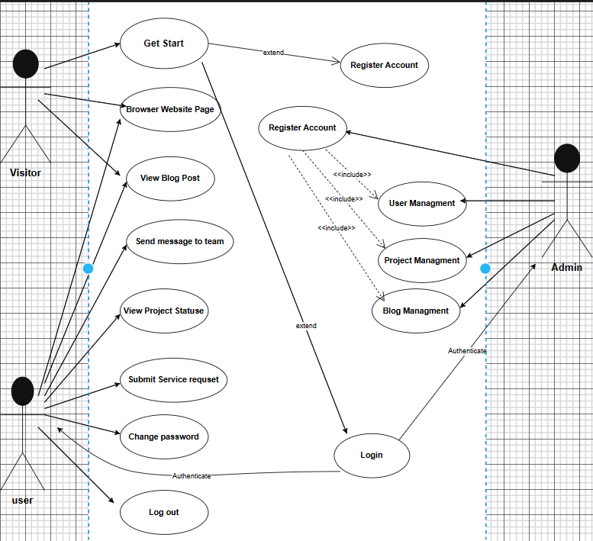

Appendix B:Description of the use case
NO | UC ID | UC Name | UC Description
1 | UC-01 | Get Start | This use case allows the visitor to start using the system and access initial features.
2 | UC-02 | Browse Website Page | This use case allows the visitor to browse and view website pages.
3 | UC-03 | View Blog Post | This use case allows the visitor or user to read blog posts available on the system.
4 | UC-04 | Send Message to Team | This use case allows the user to send messages or inquiries to the team.
5 | UC-05 | View Project Status | This use case allows the user to check the current status of projects.
6 | UC-06 | Submit Service Request | This use case allows the user to submit a service request to the system.
7 | UC-07 | Register Account | This use case allows a visitor to create a new account in the system.
8 | UC-08 | Login | This use case allows users and admins to log in to the system using valid credentials.
9 | UC-09 | Logout | This use case allows users to log out from the system securely.
10 | UC-10 | Change Password | This use case allows users to change their account password after authentication.
11 | UC-11 | User Management | This use case allows the admin to manage user accounts (add, update, delete users).
12 | UC-12 | Project Management | This use case allows the admin to manage projects and project details.
13 | UC-13 | Blog Management | This use case allows the admin to create, update, and delete blog posts.

Appendix C: Project Screenshots
We were working on the development of the core web platform of the company during our tenure, which was a complex system to manage the services to clients, data concerning the users, and administrative functions in the company. The platform is the main point of all the operations of the company, and it includes separate dashboards of end-users and administrators. The project was divided into two key parts, the front of the site, where SEO was implemented, and the back-end, which is a private and feature-filled portal with two User and Admin dashboards.
The User Dashboard was meant to transform the client experience making it to be a central point of contact of any interaction with the company. It will enable the clients to place new orders in terms of projects and services, monitor the current status of the ongoing projects in real time, send direct messages to the development team through an in-built messaging system, as well as to give feedback about the work done through a star rating system.
Admin Dashboard is the control center of Hawi Software Solution team. It offers administrators with the tools of user and team management, project management in all its aspects, content management of the company blog and a system of managing all of the incoming client requests. It has also an analytics review to track user statistics and project statistics. The backend of the platform was developed using a particular collection of current software technologies.
- To develop the main server-side application, we used PHP and Laravel, developing a secure and maintainable codebase.
- MySQL was our relational database to manage the data of the application and we
designed the schema and handled data flow with Eleloquent ORM of Laravel.
- To ensure that the front end and the back end can work together, we created and
developed a RESTful API, which was the main medium of communication of all data.
- In order to protect data privacy and controlled access, we have adopted a strong
authentication and authorization system which is based on Larval Sanctum.
- The following are the primary functions that we created in the backend:
• Registration of users, their log-in and role-based access control (Admin vs. User).
• Endpoints to create, retrieve, update and delete service requests, via API.
• Project management information database logic.
• Admin dashboard with back-end user and web page management functionality.
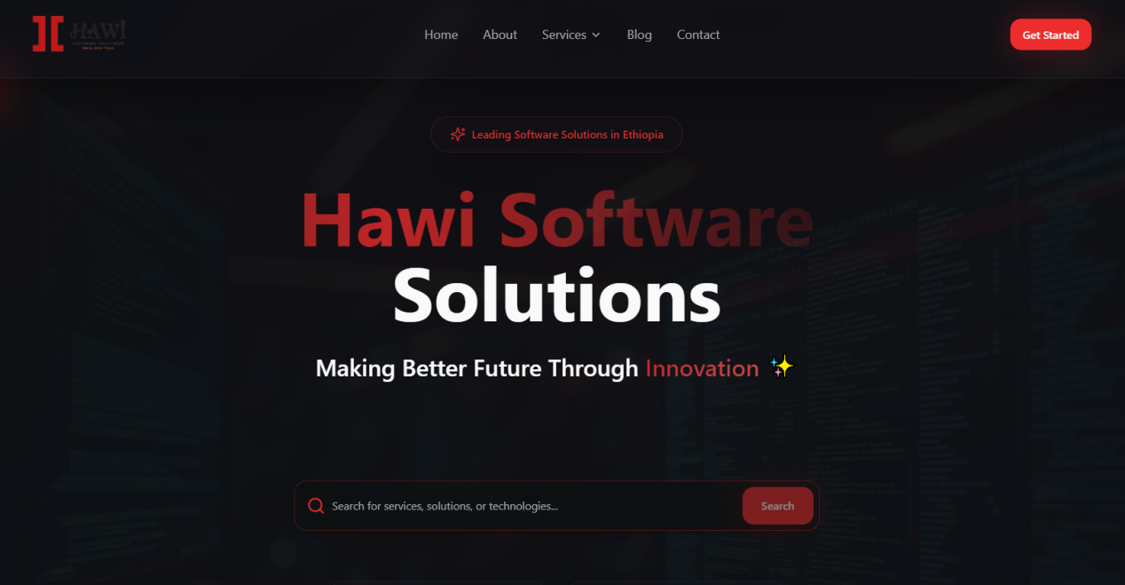
Figure 2.1: main page
Home Page: Showcases main sections and user engagement elements.
About Page: Provides information about the company and its values.
Services Page: Details the services offered by Hawi Software Solutions
Contact Page: Features an inquiry form and Google Map integration for location.
Authentication: Users can log in or sign up using email/password or social media accounts, enhancing accessibility.
Public Blog Page: Displays a list of articles and categories to engage users.
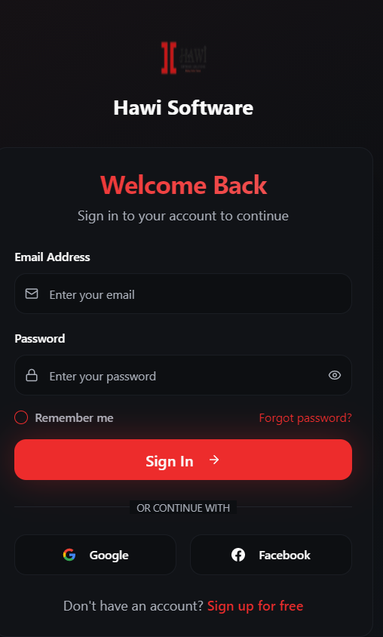
Figure 2.2: Login page
- Admin Dashboard
User Management: Tools for admins to manage user accounts and permissions.
Project progress Management: Admin oversight of all projects and service requests.
Service Requests Management: Ability to view and respond to user service requests.
Blog Management: Control over blog content, including creation and editing of posts.
Message Management: Ability to view and respond to user messages.
Team Management: comprehensive team member management with bulk actions.
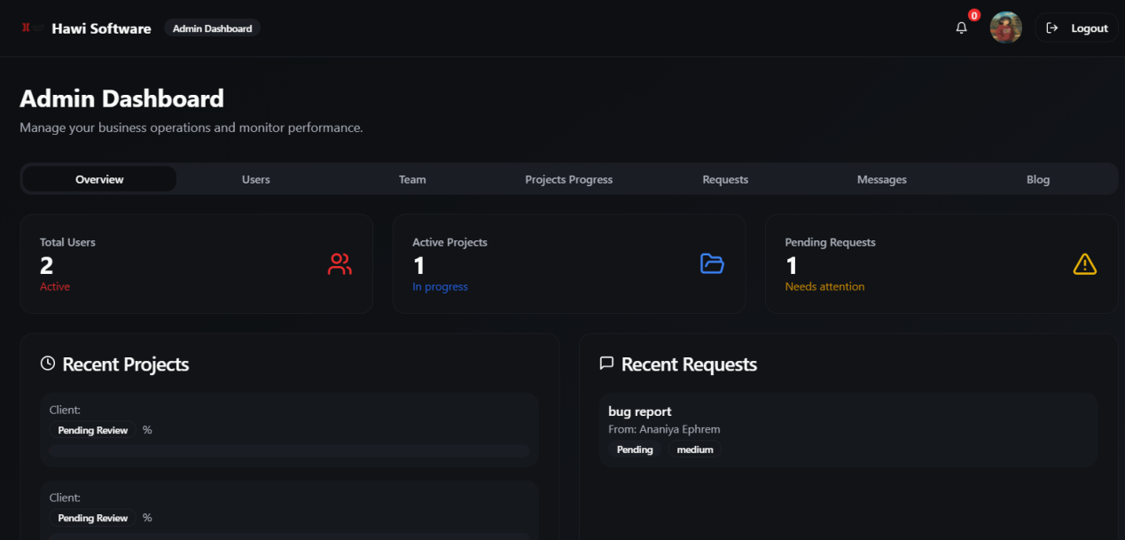
Figure 2.3: Admin Dashboard

User Dashboard
• Personal Dashboard: Displays an overview of project statuses and feedback metrics.
• Project Management: Users can create, view, and manage their projects effectively.
• Service Requests: Functionality to submit and track service requests.
• Messaging: Options for starting and viewing conversations with support or team
members.
• Profile Management: Ability to edit personal profiles and submit feedback.
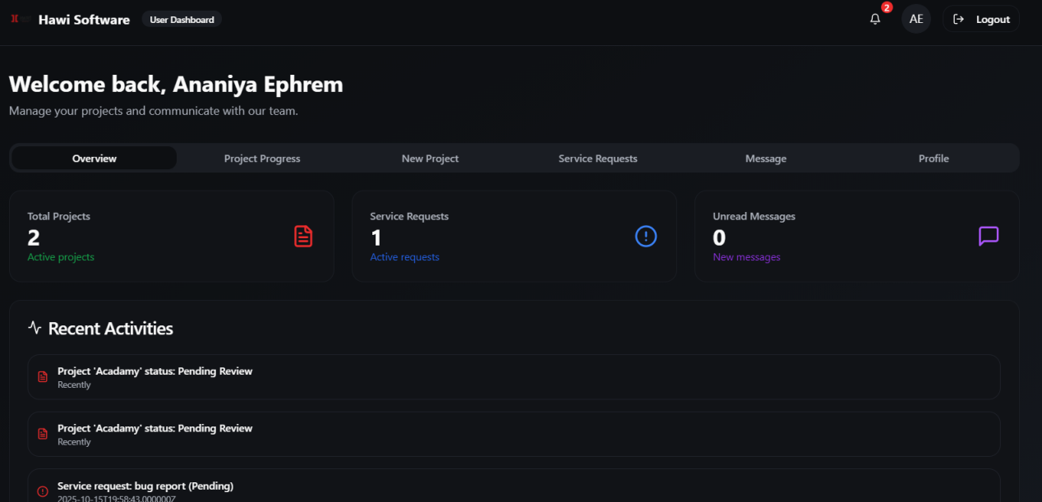Figure 2.4: User Dashboard

REFERENCE
- Official Website of Hawi Software Solutions : https://www.hawisoftware.com/
- Internship Guidelines for interns
- Old practical attachments

