1. Go to Anaconda website: <https://www.anaconda.com/distribution/>

Download Anaconda Python

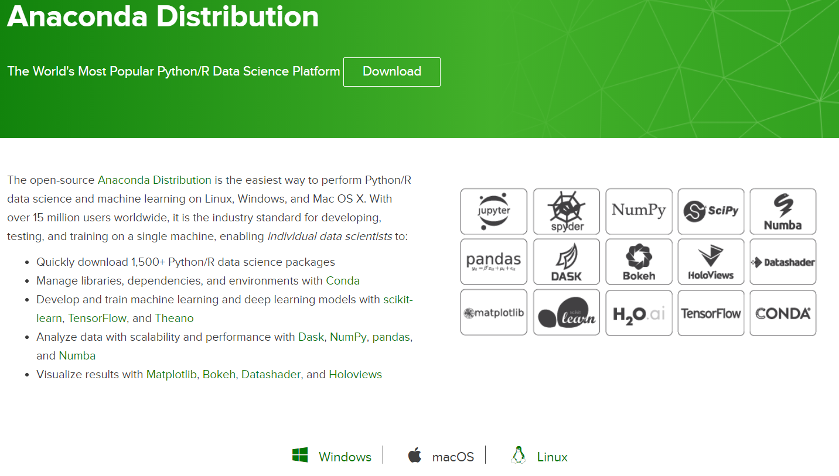

1. Go to GitHub, get the repo: <https://github.com/gecko17k/MachineLearningWorkflow>

Clone or download the files shown below

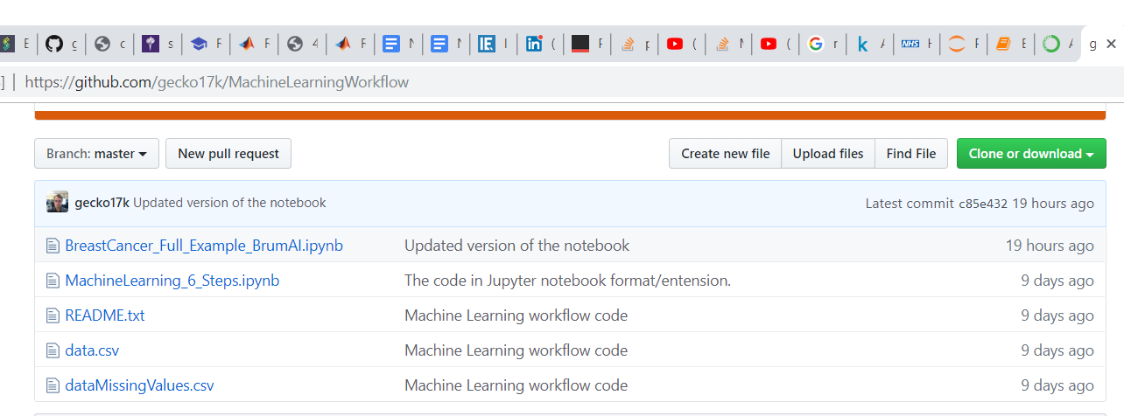

1. Place in a single folder on your laptop, e.g. C:\Users\Name\Projects\BreastCancer or a folder called “BreastCancer”.
2. Open Anaconda Navigator  
   Launch Jupyter Notebook

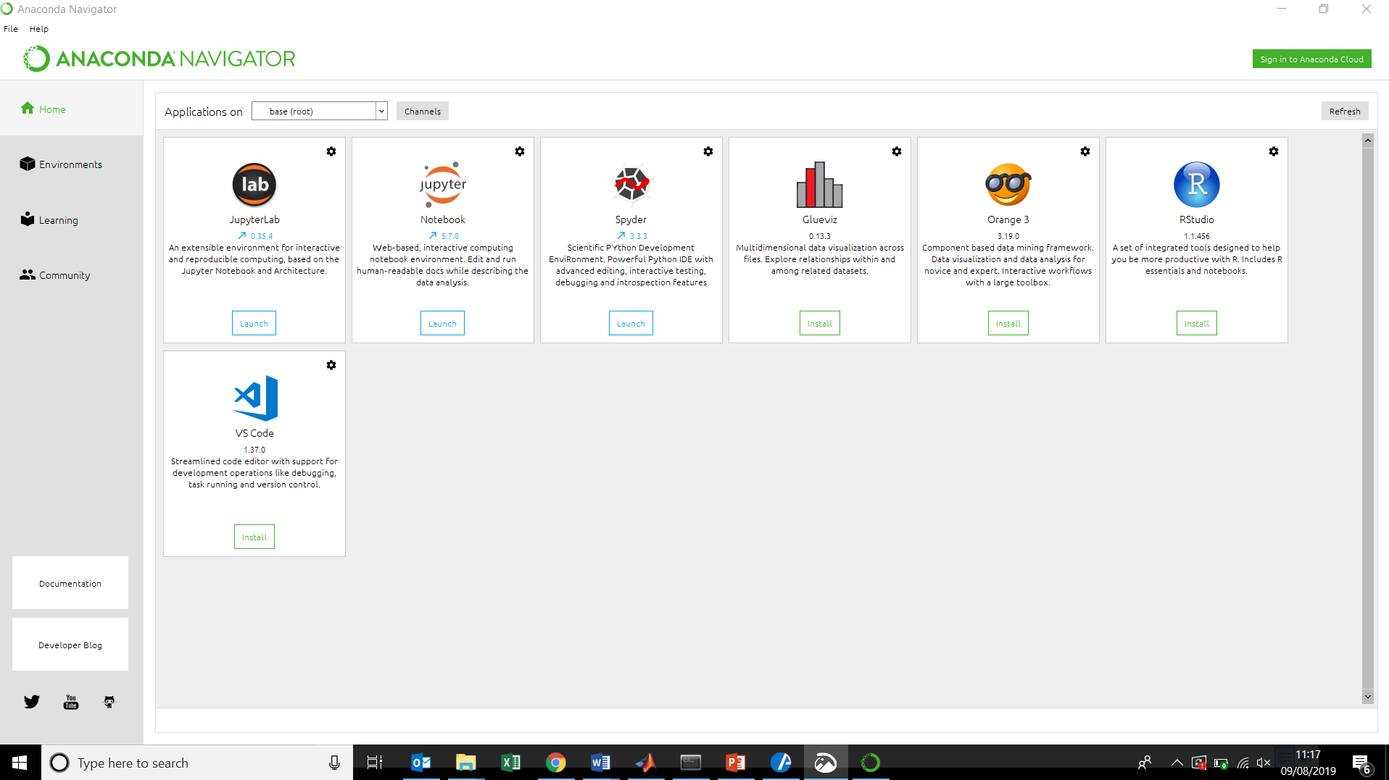

1. Jupyter opens in your browser.

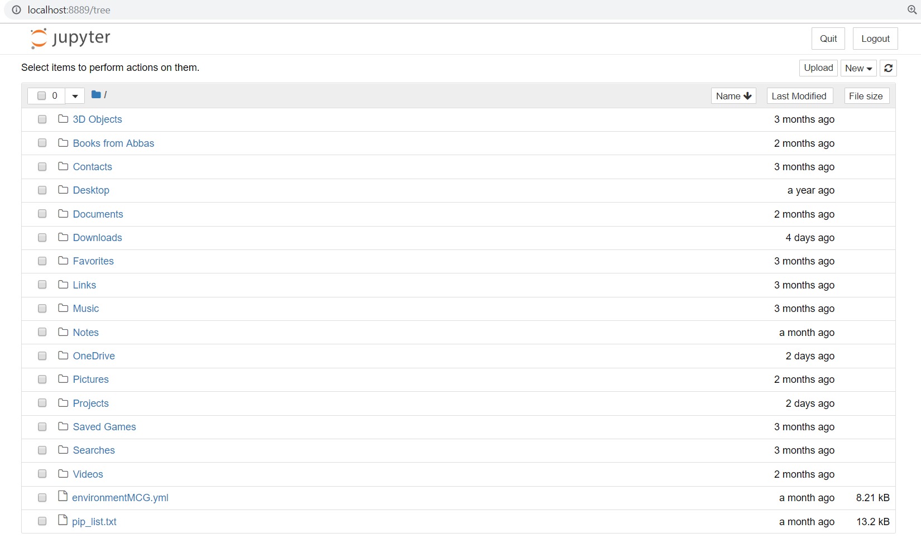

1. Navigate to where you put the files from GitHub and open up “-MachineLearning_6_Steps.ipynb”.

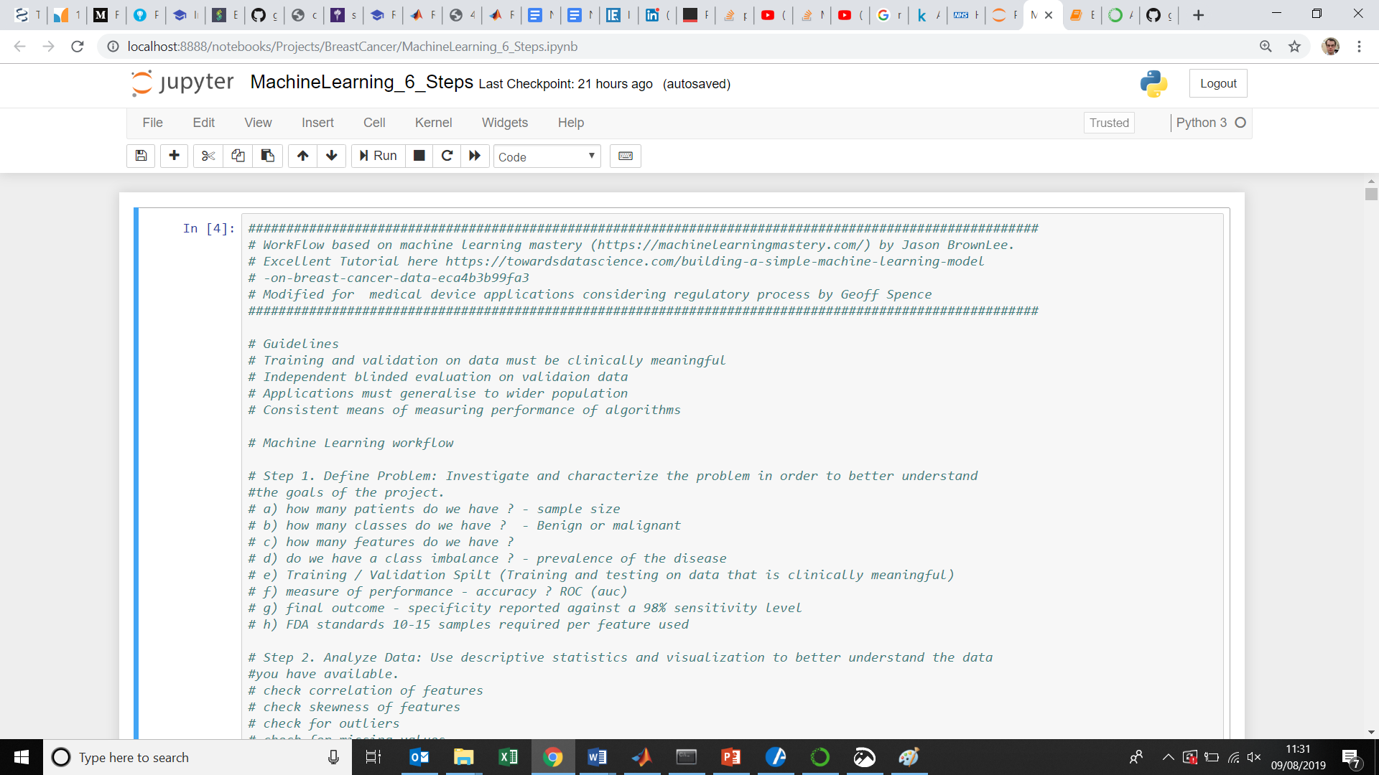

We are now ready to start.