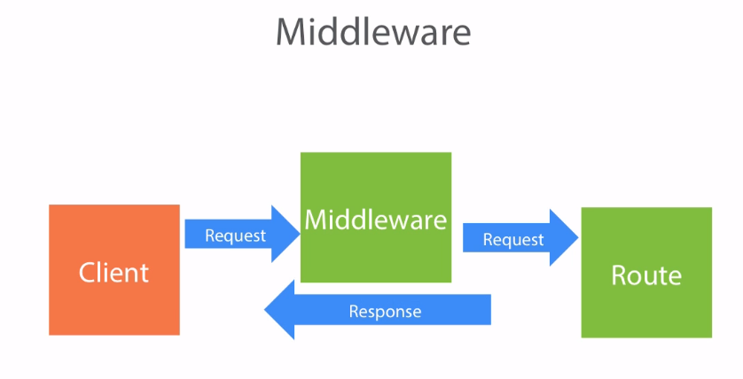
This the first time I saw it didn't make sense. But somehow, like concepts in programming seem to happen, it has seeped in a bit.

So traditional understanding: the client makes a request to server, server sends a response.

We have been working with Router objects which are given to us by express.
var bookRouter = express.Router()
bookRouter.route('/')
.post(function(req,res){
…
})
.get(function(req,res){
…
})

At first it seemed to me that these Router objects were interceptors to both the incoming request and outgoing response. We can intercept params on the incoming request and do stuff with them (like update a database with an incoming JSON object) and also intercept response to add data to it (like adding a JSON representation of a book that a user requested).

bookRouter.route('/:bookId')
.get(function(req, res){
var param = req.params.bookId; //get param=bookId from request
Book.findById(param, function(err, book){ //mongoose findbyId method
if(err)
res.status(500).send(err);
else
res.json(book);
})
})

But now I realize something silly. The route is not the interceptor to the server, the Route object is the server. We are making the Restful API on the server (this is what the Restful API is!). We are the ones handling what happens on the server when a route is called from the client-- we are handling the requests and sending responses!

So, the real interceptors are these guys called middleware. The make our code have to repeat less. Yay!
At least from the first example, what they are going to do is intercept params and stuff from the incoming request, bundle them up into variables, then loop through all our HTTP methods (.post, .get, .put, .patch, etc.) and pass them to the appropriate method.

Look at this code-- lots of repeated functions here!
bookRouter.route('/:bookId')
.get(function(req, res){
Book.findById(req.params.bookId, function(err, book){ //Note new method: findbyId
if(err)
res.status(500).send(err);
else
res.json(book);
})
})

.put(function(req,res){
Book.findById(req.params.bookId, function(err, book){ //Note new method: findbyId
if(err){
res.status(500).send(err);
}else{
//do some stuff with book
res.json(book);
}
})
})
.patch(function(req, res){
Book.findById(req.params.bookId, function(err, book){
if(err){
res.status(500).send(err);
}else{
//patch some stuff on book
res.json(book);
}
})
})

See how these methods are repeated? We can solve this with middleware!
Before we get to our GET, POST, PUT, etc methods. Lets intercept the request, do whatever data querying we need to do, and then add that data to the request. That way we don't have to repeated code for querying for a data item for each GET, POST, PUT, etc method.

bookRouter.use('/:bookId', function(req, res, next){
var param = req.params.bookId;

Book.findById(param, function(err, book){ //findById method comes from mongoose
if (err)
res.status(500).send(err)
else if (book) {
req.book = book; //add the JSON book directly to incoming req
next(); //call any HTTP methods assigned to this bookRouter
}
else{
res.status(404).send(err); //resource was not found
}
})
});

Now the code is simplified. See how the findById method is only used once? And now that we have the data that we need from that method (book), we can just add the book (represented as a JSON object) to the request, and send the request on to its appropriate HTTP method using the next() method. Q: Where does this next() method come from? Is this an iterator?

bookRouter.route('/:bookId')
.get(function(req, res){
res.json(req.book);
})

.put(function(req,res){
req.book.author = req.body.author;
req.book.title = req.body.title;
req.book.genre = req.body.genre;
req.book.read = req.body.read;
req.book.save();
res.json(book);
})
.patch(function(req, res){
if (req.body._id)
delete req.body._id;

for (var p in req.body){
req.book[p] = req.body[p];
}
req.book.save();
res.json(req.book);
});

return bookRouter;
};

Notice anything asynchronous about this? I definitely did not at first. But the speaker points out that our req.book.save() methods are asynchronous. And after the fact, I can see that. I am not sure a good way to have a red flag go off to indicate to me that a function should be asynchronous. I guess I can safely say that anything updating the database should definitely be asynchronous (otherwise you could potentially be updating data that was already outdated...). Should all functions just be asynchronous?

REVIEW OF WHAT WE HAVE DONE/LEARNED THUS FAR
► Always use the --save modifier when installing new packages. This will automatically include the dependency in your package.json.
npm install express -- save

package.json
"dependencies": {
"body-parser": "^1.13.3",
"express": "^4.13.3",
"gulp": "^3.9.0",
"gulp-nodemon": "^2.0.3",
"mongoose": "^4.1.1"
}
If anyone downloads your project, npm will know to go out and download these APIs and find versions compatible with the project.

► Installed gulp with a -g modifier so that we can run it from the command-line. I had to run the 2nd command as sudo
npm install gulp -- save
sudo npm install gulp -- g

► Gulp
“Gulp is a task/build runner for development”.
Remember –> A build is the process of creating the actual binaries. Turning source code into something the computer can understand. A build utility needs to compile and link all the various files necessary to run the application, and in the correct order (think ant, maven, etc.)

►Nodemon
Gulp is the task runner, nodemon is what makes the server actually restart as we modify files.

►Gulpfile.js –-- the config file that gulp will look for when it starts up. Gulp builds our code (compiles the C++ and makes it run?)

►Mongo – A noSQL, OODBMS (Object Oriented Database Management System) or DOD (Document Oriented Database). A DB system that uses the native data structure to the programming language (.i.e JSON) to make modeling easier.

►Mongoose --- npm package that allows us to talk to the database. Jonathon Mills says this is like an ORM**. It is like a sophisticated translator that wraps data accessing functions into a nice API where we can use methods like findById() or save() or remove(). http://mongoosejs.com/docs/2.8.x/docs/api.html

**Object Relational Mapping. “A technique for converting data between incompatible type systems in object oriented programming languages”. In ORM, a 3rd virtual object database is created so the 2 incompatiable languages can talk to this 3rd party.

►Getting data
Filtering with the query string and the req.query method
- localhost:8000/api/book?genre=Fiction
the request object has a JSON object property 'query', so req.query returns a JSON object that we can pass to the mongoose method {Model}.find(req.query, callback)

Getting a resource by ID, directly
- localhost:800/api/book/:something
- not reading param, just reading a string after route
-use a route → bookRouter.route('Books/:bookId).get(function(req,res){}; *remember bookRouter is our express.Router() returned object and route is an express method.*

►Posting data
Using Body Parser
“Piece of middleware that allows express to read the body and parse that into a JSON object that we can understand” aka it parses the body =)
- This requires an npm install (npm install body-parser - - save)
- Because this is a middleware, we need an app.use(bodyParser.json()) to load the body parser
- The body-parser is going to look at the body and see if it has any JSON objects in in it and, if so, going to add it to the body of the request ---> When the user posts JSON objects on the request body, now we are able to get that object. Once we get that JSON object, we can pass it to the model, create a new book and save it to the DB.

►Updating data
- PUT, PATCH, REMOVE -
- Middleware – app.use(some_router/some_middleware_like_body_parser)
- see above notes
- next()

►HTTP STATUSES
http://www.w3.org/Protocols/rfc2616/rfc2616-sec10.html
201-- Request fulfilled, something created
404 – Not found Error
500 – Internal Server error
204 – No content (something deleted, not sending anything back)

►Module exports
What did you learn from learnyounode, what did we use here?

►Mocha
npm install gulp-mocha should sinon
BDD (behavior driven development)
should-assertion framework
sinon-mocking framework

