**Phenotype Cloud for One Point in LALIspace**

* The variation intrinsic to one point in LALItype space can be described by the cloud of phenotypes that result from 100 patterns randomly generated by that point in space. Here we show the phenotype cloud for points in LALIspace that are likely to generate the phenotype of gecko #682, for the linear and FHN models. The most likely variation (50% most likely) is indicated with darker points.

|  |  |
| --- | --- |
| Linear model | FitzHugh Nagumo Model |
|  |  |

Note this looks even better defined for a cloud of 1000 images, so perhaps Tilmann you could generate 800 more for gecko 682?

a cloud of 1000 points for the linear model: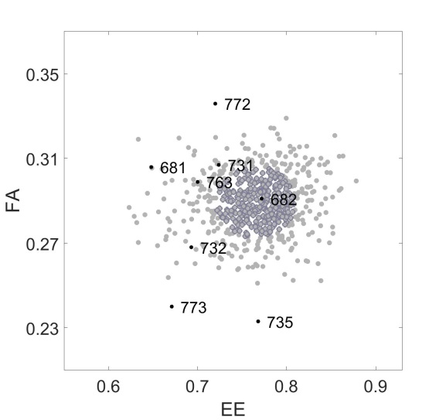

**Observed Variation Among 8 Geckos is Greater then Random Variation**

|  |  |
| --- | --- |
| Linear model | FitzHugh Nagumo Model |
|  |  |

* The variation within the cloud indicates that this point in LALIspace would also be likely to generate the phenotypes of geckos #731 and #763, but very unlikely to randomly generate phenotypes for #772, 773 and 775. Likewise, the cloud associated with a point in LALIspce that is likely to generate phenotypes like gecko pattern #772 is likely to reproduce the closest phenotypes but not 773 or 735. This indicates that the range of phenotypes found in the 8 geckos are not predicted to be due to random variation alone, but generating all the observed variation requires different starting points in LALIspace.
* Showing the clouds of 8 points in LALIspace (one for every gecko pattern) is very messy, but showing the most likely variation of each cloud (50% most likely variation) gives a tighter picture. This shows, for example, no point in space is likely to generate all the phenotypes we observed.

|  |  |
| --- | --- |
| Linear model | FitzHugh Nagumo Model |
|  |  |

**Extent of Variation Depends on the Regions in Lalispace**

* The amount of variation is not uniform. The region of phenotype space covered by random variation is much larger for some points in LALIspace than others. For example, the likely variation for the cloud associated with pattern of the gecko #735 is much larger than than for #772. This could be an additional selection pressure on the phenotypes, beyond the modal

Next: show most similar generated phenotypes for each gecko for each model. Hopefully there won’t be too many annuli popping up!