|  |  |  |  |
| --- | --- | --- | --- |
| 772 |  |  |  |
| 681 |  |  |  |
| 763 |  |  |  |
| 731 |  |  |  |
| 682 |  |  |  |
| 732 |  |  |  |
| 773 |  |  |  |
| 735 |  |  |  |

**Figure 1: Automated disk-shaped pattern selection of parietal, post-orbital head region of 8 geckos at 13 weeks.** For each Gecko ID; **Left**: Images of the eight gecko heads at 13 weeks; **Middle**: the disk-shaped parietal, post-orbital (DSPPO) region that was selected for pattern analysis, also showing their relative sizes; **Right:** the final binarized pattern when the threshold was applied with the skeletonization pattern overlaid. Horizontal bars indicate 0.5 cm. Geckos are ordered by decreasing fractional spot area of their DSPPO pattern.

* The third column isn’t essential but it seems to make it more cleat regarding the processing we did.

A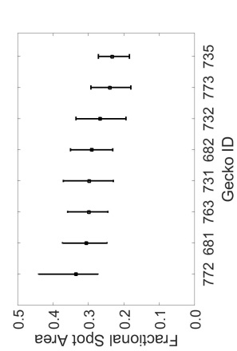B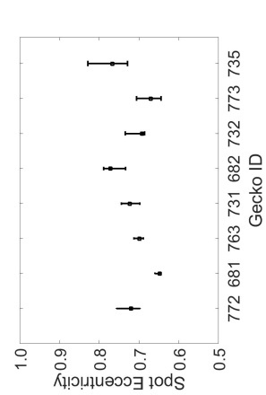

C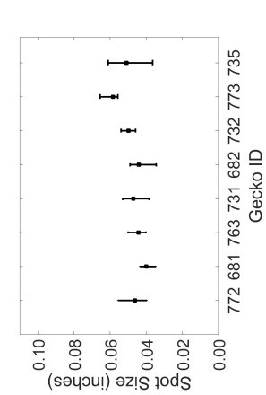D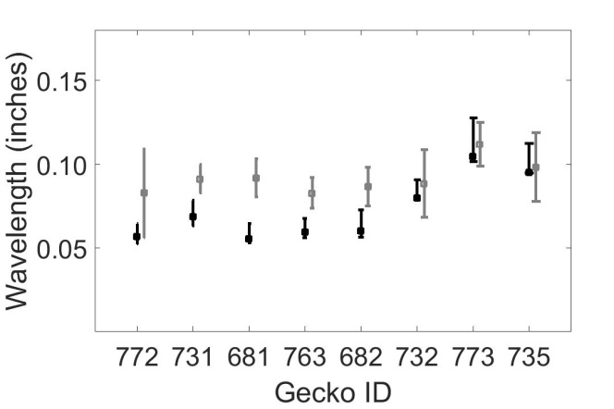

**Figure 2: Spot statistics versus Gecko ID.** For each binarized image of spot patterning, A) fractional spot area, B) mean spot eccentricity, C) mean spot size and D) wavelength calculated by peak length (black) and Fourier (gray) methods were calculated. Geckos are ordered by decreasing fractional area. Error bars show the minimum and maximum measures of these measures as the threshold for binarization was varied by 0.25σi where σi is the standard deviation of the image pixel intensity. For the following analyses, the binarization was fixed at xx.

* These are currently in inches, reminding me to go back and check my conversion to cm. I assume we want the numbers in cm.

|  |  |  |  |  |  |  |  |
| --- | --- | --- | --- | --- | --- | --- | --- |
| 772 | 681 | 763 | 731 | 682 | 732 | 773 | 735 |
|  |  |  |  |  |  |  |  |
|  |  |  |  |  |  |  |  |

**Figure 3A Supplemental Methods:** Determination of characteristic peak length. For each 13 week old gecko the a) original pattern and the b) skeletonization are shown. (This is redundant with Figure 1).

rect_c731_w9_200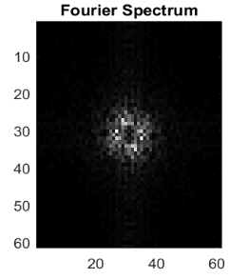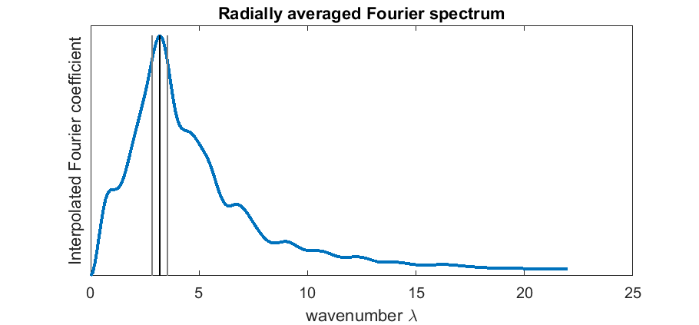

A B C

**Figure 3B Supplemental Methods:** Determination of Fourier wavelength. A: rectangular section of the pattern for Gecko ID 731. B: corresponding centered Fourier spectrum. Low-frequency components are shown in the center of the image, high-frequency components on the edges. Lighter colors indicate larger values. C: plot of radially averaged interpolated absolute Fourier coefficient as a function of radius . The vertical lines indicate the location of the wavenumber correponsing to the maximum interpolated Fourier coefficient, as well as the interval in which its value is within 90% of the maximum.

A 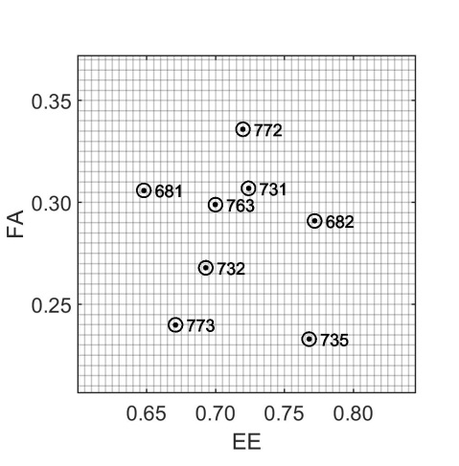B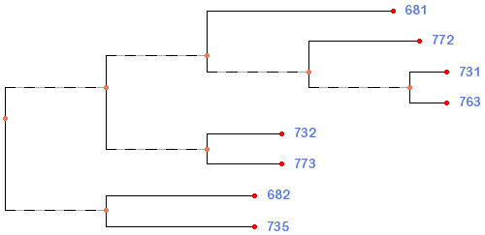

**Figure 3:** **Location of the Eight Gecko DSPPO Patterns in FA-EE Phenotype Space.** The distribution of the eight patterns in $\left[FA,EE\right]$ phenotype space (Panel A) and a diagrammatic result of *k*-means clustering of the measured statistics (Panel B).

* A phenotype space is n-dimensional, where n corresponds to the number of measured parameters. We focus on a 2-dimensional FA-EE projection since this lower-dimensional space is sufficient to characterize the patterning and variation of the 8 DSPPO patterns.
* In our analyses, we measured along 4 parameters: fractional area, eccentricity, spot size and wavelength. However, the spot size is an arbitrary parameter in simulations since the scale of a pixel may be arbitrarily chosen and the wavelength is not independent of the fractional area and spot size.

|  |  |
| --- | --- |
|  | Tilmann, could you generate a tree like the one in Figure 3D corresponding to the locations of the eight points in LALIspace?  Gecko fu ft  681.0000 0.8110 1.1951  682.0000 0.8260 1.4157  732.0000 0.8170 1.4747  735.0000 0.8320 1.5700  772.0000 0.8180 1.1607  773.0000 0.8150 1.6220  731.0000 0.8190 1.3033  763.0000 0.8170 1.3133 |

**Figure 4:** **Location of the Eight DSPPO Gecko Patterns in T-fu LALI-space.** For each of the eight DSPPO gecko patterns, we identified the neutral match region in $\left[T,fu\right]$ LALI-space. A point in LALI-space is defined as generating a “match” to a DSPPO pattern if the DSPPO pattern is a ‘likely’ outcome of that point in LALIspace (within the 50% likely radius – see Methods). The neutral match regions of gecko DSPPO patterns #682 and #735 continue indefinitely as the activation rate is increased. The numbered white circles show the point in LALI-space that are used to generate the phenotype clouds in Figure 5. The labeled stars are the points in LALI-space that are used to generate “Praeter Naturam” patterns in Figure 7.

* Specifically, for each considered point in LALIspace, we simulate 100 patterns. The 100 patterns create a cloud in FA-EE phenotype space (see Figure 5). The center of the phenotype cloud is calculated as the average fractional area and the average eccentricty. we define the 50% likely radius as the radius of a disk centered at center of the phenotype cloud that would contain 50% of the random variation. A pattern with a phenotype within this radius would thus not be an outlier.

|  |  |  |  |  |  |
| --- | --- | --- | --- | --- | --- |
|  | |  |  | | --- | --- | |  |  | |  |  | |

**Figure 5: Random Phenotype Variation for a Given Point in LALIspace** A) Examples of eight phenotype clouds corresponding to eight genotypes chosen from within the neutral match region of each of the 8 DSPPO gecko patterns. The labeled circles show the actual location of each of the DSPPO patterns in phenotype space. B) The DSPPO pattern isolated from the image of Gecko #682 and three simulation-generated “clones”. These three clones have the same LALItype (this point in LALIspace chosen from within the neutral match space of 682) and thus these three simulation-generated images show the predicted phenotypic variation due to random variation of the LALI model.

|  |  |  |  |  |  |  |  |
| --- | --- | --- | --- | --- | --- | --- | --- |
| 772 | 731 | 681 | 763 | 682 | 732 | 773 | 735 |
|  |  |  |  |  |  |  |  |
|  |  |  |  |  |  |  |  |
|  |  |  |  |  |  |  |  |

**Figure 6:** Within the neutral match regions, the LALI model captures the salient pattern characteristics of each of the eight DSPPO gecko patterns. The top row shows each of the original DSPPO gecko pattern. Among 100 generated phenotypes, the phenotype are shown that most closely matches that of the DSPPO gecko pattern. The phenotypes were generated from a point in the neutral match region of LALIspace using the linear LALI model (middle row) or the non-linear LALI model (bottom row).

* Would it make sense to place these in Figure 1, perhaps instead of the skeletonization images?

|  |
| --- |
| A |
| B |
| C |
| D |

Figure 7: The LALI framework can be used to generate patterns that are “nearby” in LALIspace, possibly corresponding to the patterns that could be reached by evolutionary change. For each of the ‘starred’ locations in LALIspace indicated in Figure 5, we show three random phwnotype variations corresponding to that point in LALIspace.

A: 0.806 1.75

B: 0.805 1.1

C: 0.840 1.7

D: 0.835 0.9