Introduction

The Microsporidia

Microsporidia is a group of obligate intracellular parasites that infect a broad range of species from vertebrates to invertebrates. They are now classified as sister group of fungi. Microsporidia species have genome sizes from 2,3MB to 19,5MB. Most of these parasites have a very small number of genes, from 2000 to 4000 genes, which are thought to be very essential that cannot be lost or they are specific genes of Microsporidia. The understanding of the evolution of Microsporidia is still unclear and there are many question about the reducing process in their genomes, such as when they lost their genes, if the losing process happened once or many times, if those genes lost forever or just temporarily...

In order to find the answer for those questions, the proteins sets of the Microsporidia last common ancestor (LCA) will be inferred using hierarchical orthology inference approach. The distribution of these proteins will be then analyzed to find their origins and to get an overview how common they are in the living organisms. Moreover, we try to investigate the functionality of these Microsporidia LCA proteins and identify their roles to understand how they can work together with their hosts' metabolic pathways.

The estimation of the Microsporidia last common ancestor protein set

Introduction

Methods

Starting from 11 extant Microsporidia species (Table A‑1), we used OrthoMCL (Li et al. 2003) to search for homologous proteins in those 11 Microsporidia species. OrthoMCL performed all-against-all BLASTP comparisons for all input data set and clustered homologous groups using Markov Cluster algorithm MCL (van Dongen 2000).

The initial homologous groups were then extended by using HaMStR (Ebersberger et al. 2009) to search for orthologs in other 24 search taxa (Table A‑2). The Hidden Markov Model (HMM) profiles for the initial homologous groups (seed sequences) crated by HaMStR were used to search in the search taxa. The obtained hits were confirmed by re-BLAST search against the protein sets of seed sequences. We took into account here also the co-orthologs for re-BLAST and we limited the HMM hits up to only the best 10 hits.

We identified a core gene set, where we found orthologs in all taxa and each taxon has exactly one orthologous protein. Using the core gene set, we reconstructed a maximum likelihood species tree for those 35 taxa. Firstly, we created a super-alignment by concatenating the alignments of all core genes. To exclude the alignment columns that are uninformative, we removed columns that have at least 50% gaps. We used ProtTest (Abascal et al. 2005) to find the best fitting model for the tree reconstruction procedure. With the best model parameters obtained from ProtTest, we used RAxML (Stamatakis 2014) to build the maximum likelihood species tree with 100 bootstrap replicates.

Using the principle of minimum evolution (Edwards 1996), we filtered the orthologous group to obtain the final protein set representing the Microsporidia last common ancestor. Those final orthologous groups have to have either (1) at least one ortholog from N.parisii (the earliest branch of the Microsporidia clade), or (2) at least two orthologs from Microsporidia species different than N.parisii and one or more orthologs from non-Microsporidia taxa.

Results

OrthoMCL gave 2904 initial homologous groups for 11 Microsporidia protein sets. Out of 2904 extended groups, we found 80 groups, where all 11 Microsporidia and 24 non-Microsporidia taxa are present and each taxon has one representative ortholog. Those 80 groups serve as out core get set for the species tree reconstruction. The super-alignment after de-gapping has a length from 36.616 amino acids. The best model obtained from ProtTest was LG substitution model (Le & Gascuel 2008), GAMMA distribution G , including proportion of invariable sites estimation I & empirical base frequencies F. The input model parameter for RAxML was PROTGAMMAILGF. The reconstructed species tree with bootstrap support values is shown in the Figure A‑1 below.

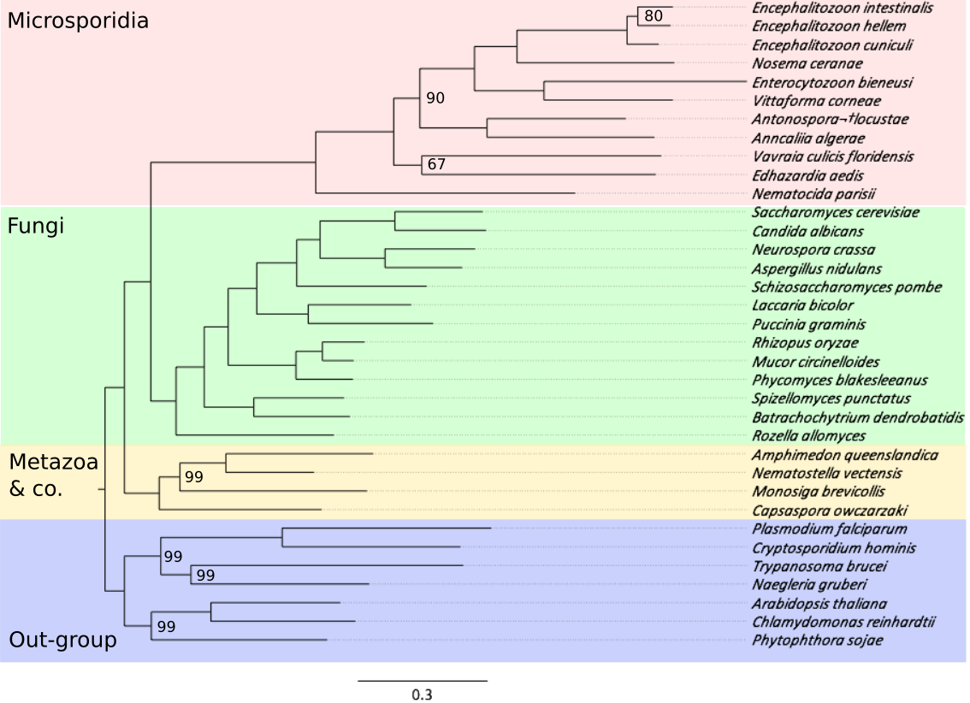

Figure A‑1: Maximum likelihood tree over 35 species. The 11 Microsporidia taxa are highlighted in red. Other non-Microsporidia taxa include 13 Fungi (green), 2 Metazoa and M.brevicollis, C.owczarzaki (yellow) and 7 out-group species (purple). Node labels denote the bootstrap support and only values <100 are shown. The tree topology is congruent with the known species tree.

Filtered the HaMStR result that did not match the parsimony criteria, we got at the end 1605 final orthologous groups. They present the set of Microsporidia last common ancestor proteins.

Discussion

Figure A‑2 shows the fractions of non-orthologous and orthologous proteins in 11 Microsporidia species. The Encephalitozoon group is the best example for the compact genome of Microsporidia. Where almost 98% of their proteome are orthologous proteins that are shared in other Microsporidia species. Only 2% of genes are lineage specific proteins.

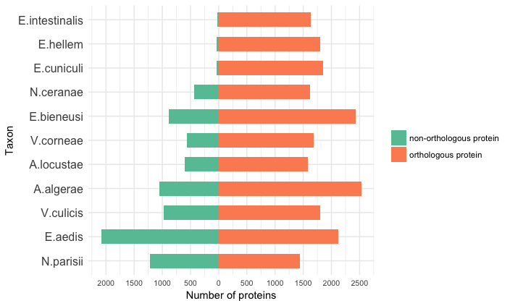

Figure A‑2: Fractions of non-orthologous (orange) and orthologous (green) proteins in different Microsporidia species.

Other taxa still have orphan proteins (21% in N.ceranae up to 49% in E.aedis). We have some hypotheses for those orphan proteins.

(1) Wrong gene assignment: length of orphan proteins would be shorter than orthologous proteins.

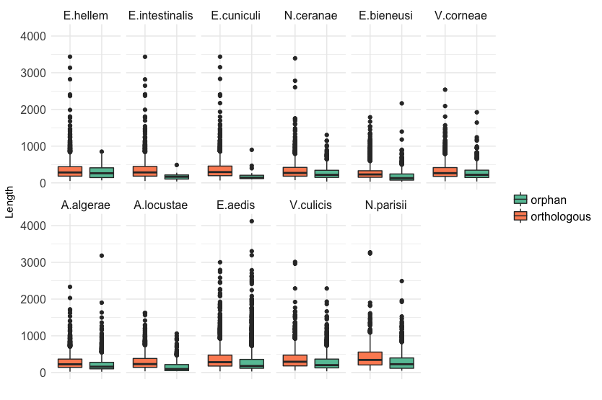

Figure A‑3: Length distribution of orthologous proteins (orange) and orphan proteins (green) in different Microsporidia taxa.

Figure A‑3 shows the length distribution of orthologous and orphan proteins in 11 Microsporidia taxa. We use Wilcoxon-Mann-Whitney U-Test to compare the two length categories. We found that the lengths of orphan proteins are significantly different (smaller) to the one of orthologous proteins with the significant level of 5%. Only for E.hellem the p-value is 0,20>0,05. But this p-value makes no sense since the number of orphan proteins in E.hellem is too small to make the comparison meaningful.

(2) New invented genes (which have no PFAM annotations), or genes from horizontal gene transfer events (which have new PFAM annotation, which are not found in orthologous proteins), or they cannot be detectable as orthologs (which have the same PFAM annotations as orthologous proteins).

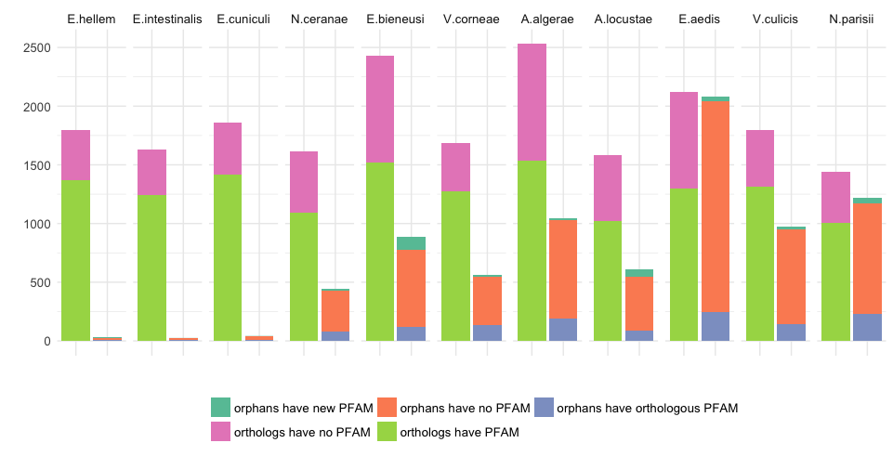

Figure A‑4: Fractions of orthologous and orphan proteins that have and do not have PFAM annotations. The left columns show the number of orthologous proteins that have PFAM annotations (light green) and do not have PFAM annotations (pink). The right columns show the proportion of orphan proteins that have new PFAM annotations that are not found in orthologous proteins (dark green), do not have any PFAM annotation (orange) and orphans that have the same PFAM annotations as orthologous proteins (purple).

A large fraction of orphan Microsporidia proteins do not have any PFAM annotation as been shown in Figure A‑4 suggests that most of the orphan proteins are new invented genes after the speciation event that split fungi out of the Microsporidia clade.

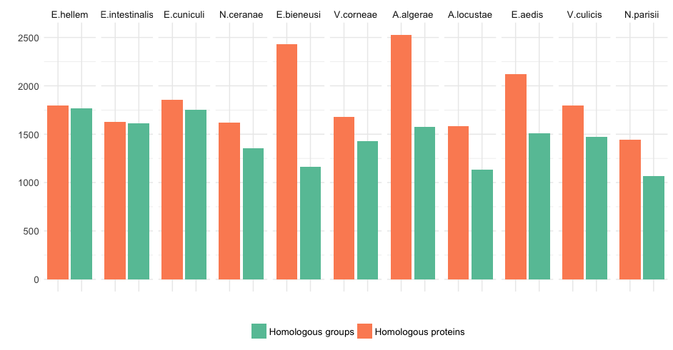

Figure A‑5: The distribution of number of homologous proteins (orange) and number of homologous groups (green) in each Microsporidia taxon.

Figure A‑5 shows the relative number of homologous proteins and number of homologous groups in each Microsporidia species. In some species, such as E.bieneusi or A.algerae, the number of homologous genes is substantially higher than the number of corresponding homologous groups. We check the number of in-paralogs for each Microsporidia taxon in the homologous group. The result in Figure A‑6 shows that there is no evidence for whole genome duplication in any species. But there are some instances where the homologous groups contain more than 10 co-orthologs for one Microsporidia species showing the effect of gene dosage (Kondrashov & Koonin 2004).

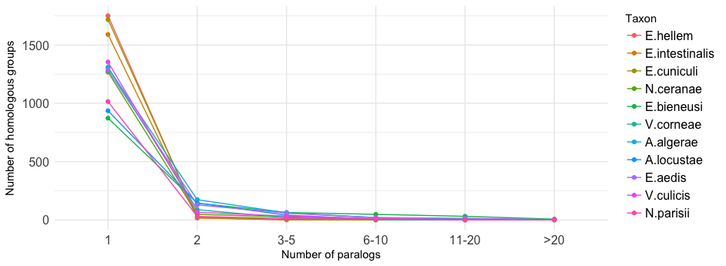

Figure A‑6: The distribution of number of homologous groups as a function of number of in-paralogs. Colors denote different Microsporidia taxa.

The reconstructed species tree shows a stable signal for placing the Microsporidia group as the earliest clade of the fungi, which are supported by the recent phylogenetic study of the taxonomy of Microsporidia that hypothesis that Microsporidia is the sister clade of fungi.

Conclusion

The estimation of Microsporidia last common ancestor proteins is the basic step for the whole downstream study. The orthology assignment result agreed with other studies about the fraction of microsporidia only proteins. The length distribution and PFAM annotation analysis indicate that most of the orphan Microsporidia proteins are either resulting by wrong gene assignment or they are new invented genes in the Microsporidia clade. The good resolved species tree can serve as a fundamental phylogenetic background for filtering the orthology assignment and estimating the set of 1605 proteins for the last common ancestor of Microsporidia.

Distribution analysis of the Microsporidia last common ancestor proteins

Introduction

To answer the question "How old are the Microsporidia last common ancestor proteins"

Methods

We used HaMStR to search orthologs for 1605 Microsporidia last common ancestor proteins in 480 taxa across the tree of life including bacteria, archaea and eukaryote, which are grouped into 44 super taxa as you can see in this schematic species tree in the Figure A‑7. The list of all the taxa under this analysis is written in the Table A‑4. The options we used for HaMStR search are -strict, -checkCoorthologsRef, -hit_limit=10 and -representative.

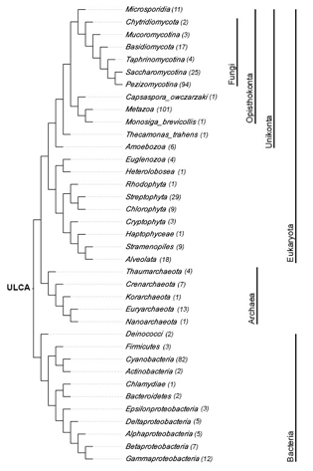

Figure A‑7: A cladogram depicts a species tree for all taxa used in the distribution analysis of Microsporidia last common ancestor proteins. The number in parenthesis next to the taxon names denotes the number of species in each supertaxon.

For a comprehensive analysis and to complement the orthology assignment, we calculated the feature architecture similarity (Koestler et al. 2010) scores (FAS scores) for all pair Microsporidia seed proteins and non-Microsporidia orthologs. Feature architecture of a protein is the arrangement of different types of protein domains such as PFAM (Finn et al. 2014) or SMART (Letunic et al. 2012) domains, transmembrane domains, low complexity regions, secondary structures, etc. Comparison of feature architecture between two proteins gives a FAS score between 0 and 1. The higher the FAS score, the more similar those 2 proteins are in term of functional equivalence.

To visualize the phylogenetic profiles of 1605 Microsporidia last common ancestor proteins, we developed a tool named PhyloProfile. This tool is written in R (R Development Core Team 2011) using the Shiny library (https://CRAN.R-project.org/package=shiny). Beside the presence / absence pattern of genes across species, PhyloProfile is able to display two additional layers of information. In particularly, PhyloProfile enables the visualization and exploration of phylogenetic profiles together with the protein feature architectures in an informative and interactive way. Implemented with the dynamic filtering option, PhyloProfile can offer a reliable analysis of phylogenetic profiles with its analysis functions.

Results

PhyloProfile appears to be vey handy for exploring the informative phylogenetic profile with complementary information.



Figure A‑8: The distribution of FAS scores for all orthologs of 1605 Microsporidia last common ancestor proteins.

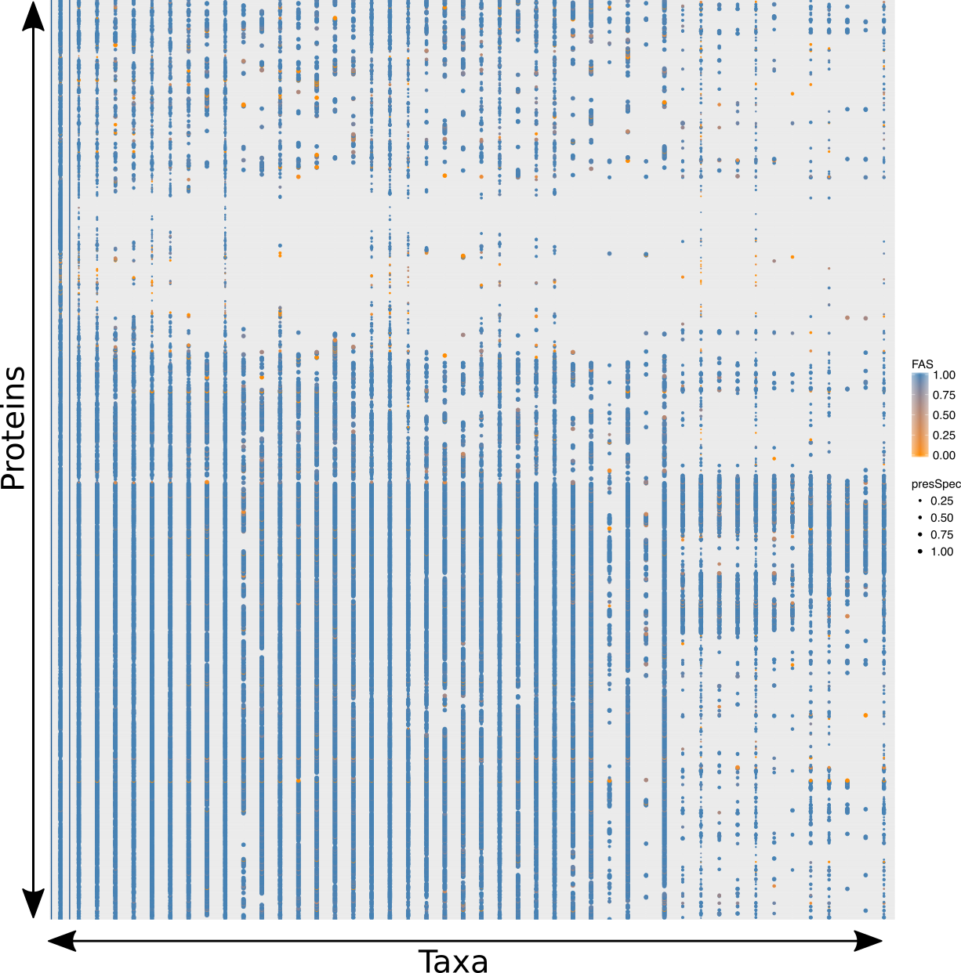

Figure A‑9: The full phylogenetic profile of 1605 Microsporidia last common ancestor protein across 491 taxa grouped in phylum level. The color of the points denotes the FAS score between Microsporidia and non-Microsporidia protein. The size of the points depicts the percentage of species that have orthologs in each phylum.



Figure A‑10: Gene age estimation of 1605 Microsporidia last common ancestor proteins. The fraction and corresponding absolute number of proteins for each estimated phylogenetic age are written in each block. The colors denote the estimated ages for query proteins.

Discussion

Conclusion

Functional annotation

Introduction

Methods

Results

Discussion

Conclusion

Metabolic pathway analysis

Introduction

Methods

Results

Discussion

Conclusion

# Appendix

Tables

Table A‑1: Eleven extant Microsporidia species

|  |  |  |  |  |
| --- | --- | --- | --- | --- |
| No. | Name | Source | Strain | Number of proteins |
| 1 | *Encephalitozoon hellem* | JGI | ATCC 50504 | 1827 |
| 2 | *Encephalitozoon intestinalis* | Broad Inst | ATCC 50506 | 1657 |
| 3 | *Encephalitozoon cuniculi* | Broad Inst | GB-M1 | 1896 |
| 4 | *Nosema ceranae* | Broad Inst | BRL01 | 2057 |
| 5 | *Enterocytozoon bieneusi* | JGI | H348 | 3312 |
| 6 | *Vittaforma corneae* | Broad Inst | ATCC 50505 | 2243 |
| 7 | *Anncaliia algerae* | Broad Inst | PRA339 | 3576 |
| 8 | *Antonospora locustae* | JGI | HM-2013 | 2191 |
| 9 | *Edhazardia aedis* | Broad Inst | USNM 41457 | 4208 |
| 10 | *Vavraia culicis* subsp. floridensis | Broad Inst |  | 2775 |
| 11 | *Nematocida parisii* | Broad Inst | ERTm1 | 2659 |

Table A‑2: 24 taxa used for extent the initial homologous groups

|  |  |  |  |
| --- | --- | --- | --- |
| No. | Name | No. | Name |
| 1 | *S.pombe* | 14 | *M.brevicollis* |
| 2 | *C.albicans* | 15 | *N.vectensis* |
| 3 | *S.cerevisiae* | 16 | *A.queenslandica* |
| 4 | *N.crassa* | 17 | *C.owczarzaki* |
| 5 | *A.nidulans* | 18 | *T.brucei* |
| 6 | *L.bicolor* | 19 | *N.gruberi* |
| 7 | *P.graminis* | 20 | *A.thaliana* |
| 8 | *M.circinelloides* | 21 | *C.reinharditii* |
| 9 | *R.oryzae* | 22 | *P.sojae* |
| 10 | *P.blakesleeanus* | 23 | *C.hominis* |
| 11 | *B.dendrobatidis* | 24 | *P.falciparum* |
| 12 | *S.punctatus* |  |  |
| 13 | *R.allomyces* |  |  |

Table A‑3: Mean length of orthologous and orphan proteins in 11 Microsporidia. We used Wilcoxon-Mann-Whitney U-Test to compare the length of those two protein groups. P-value is less then 0.05 meaning that the length of orthologous proteins are significant different to the one of orphan proteins.

|  |  |  |  |
| --- | --- | --- | --- |
| Taxon | Mean length of orthologous proteins | Mean length of orphans | P_value |
| *E.hellem* | 358,507 | 305,250 | 0,1966 |
| E.intestinallis | 358,931 | 174,630 | 9,11E-07 |
| E.cuniculi | 368,688 | 187,100 | 1,14E-10 |
| N.ceranae | 339,184 | 279,514 | 2,32E-09 |
| E.bieneusi | 274,151 | 182,634 | p < 2,2E-16 |
| V.corneae | 330,872 | 283,743 | 5,05E-08 |
| A.algerae | 284,651 | 223,355 | p < 2,2E-16 |
| A.locustae | 295,033 | 157,594 | p < 2,2E-16 |
| E.aedis | 380,879 | 319,525 | p < 2,2E-16 |
| V.culicis | 370,504 | 294,433 | p < 2,2E-16 |
| N.parisii | 421,400 | 302,794 | p < 2,2E-16 |

Table A‑4: List of species we used for the distribution analysis of Microsporidia last common ancestor proteins.

|  |  |  |  |
| --- | --- | --- | --- |
| No. | Full name | supertaxa | group |
| 1 | Ashbya gossypii | Saccharomycotina | fungi |
| 2 | Candida albicans | Saccharomycotina | fungi |
| 3 | Candida dubliniensis CD36 | Saccharomycotina | fungi |
| 4 | Candida glabrata | Saccharomycotina | fungi |
| 5 | Candida parapsilosis | Saccharomycotina | fungi |
| 6 | Candida tropicalis | Saccharomycotina | fungi |
| 7 | Clavispora lusitaniae | Saccharomycotina | fungi |
| 8 | Debaryomyces hansenii CBS767 | Saccharomycotina | fungi |
| 9 | Kluyveromyces lactis | Saccharomycotina | fungi |
| 10 | Kluyveromyces thermotolerans | Saccharomycotina | fungi |
| 11 | Kluyveromyces waltii | Saccharomycotina | fungi |
| 12 | Lodderomyces elongisporus NRRL YB-4239 | Saccharomycotina | fungi |
| 13 | Pichia guilliermondii | Saccharomycotina | fungi |
| 14 | Pichia pastoris GS115 | Saccharomycotina | fungi |
| 15 | Pichia stipitis CBS 6054 | Saccharomycotina | fungi |
| 16 | Saccharomyces bayanus 623-6C | Saccharomycotina | fungi |
| 17 | Saccharomyces castelli | Saccharomycotina | fungi |
| 18 | Saccharomyces cerevisiae | Saccharomycotina | fungi |
| 19 | Saccharomyces kluyveri | Saccharomycotina | fungi |
| 20 | Saccharomyces kudriavzevii | Saccharomycotina | fungi |
| 21 | Saccharomyces mikatae | Saccharomycotina | fungi |
| 22 | Saccharomyces paradoxus | Saccharomycotina | fungi |
| 23 | Vanderwaltozyma polyspora | Saccharomycotina | fungi |
| 24 | Yarrowia lipolytica | Saccharomycotina | fungi |
| 25 | Zygosaccharomyces rouxii | Saccharomycotina | fungi |
| 26 | Acidomyces richmondensis | Pezizomycotina | fungi |
| 27 | Aulographum hederae | Pezizomycotina | fungi |
| 28 | Baudoinia compniacensis uamh 10762 | Pezizomycotina | fungi |
| 29 | Botryosphaeria dothidea | Pezizomycotina | fungi |
| 30 | Cenococcum geophilum 1.58 | Pezizomycotina | fungi |
| 31 | Cladonia grayi | Pezizomycotina | fungi |
| 32 | Cochliobolus carbonum 26-r-13 | Pezizomycotina | fungi |
| 33 | Cochliobolus heterostrophus c5 3332 | Pezizomycotina | fungi |
| 34 | Cochliobolus heterostrophus c5 5759 | Pezizomycotina | fungi |
| 35 | Cochliobolus lunatus m118 | Pezizomycotina | fungi |
| 36 | Cochliobolus miyabeanus atcc 44560 | Pezizomycotina | fungi |
| 37 | Cochliobolus victoriae fi3 | Pezizomycotina | fungi |
| 38 | Cucurbitaria berberidis cbs 394.84 | Pezizomycotina | fungi |
| 39 | Dissoconium aciculare | Pezizomycotina | fungi |
| 40 | Dothistroma septosporum nze10 | Pezizomycotina | fungi |
| 41 | Dothidotthia symphoricarpi | Pezizomycotina | fungi |
| 42 | Hysterium pulicare | Pezizomycotina | fungi |
| 43 | Leptosphaeria maculans | Pezizomycotina | fungi |
| 44 | Lepidopterella palustris | Pezizomycotina | fungi |
| 45 | Lophiostoma macrostomum | Pezizomycotina | fungi |
| 46 | Macrophomina phaseolina ms6 | Pezizomycotina | fungi |
| 47 | Melanomma pulvis-pyrius | Pezizomycotina | fungi |
| 48 | Myriangium duriaei cbs 260.36 | Pezizomycotina | fungi |
| 49 | Neofusicoccum parvum ucrnp2 | Pezizomycotina | fungi |
| 50 | Piedraia hortae | Pezizomycotina | fungi |
| 51 | Pleomassaria siparia | Pezizomycotina | fungi |
| 52 | Pyrenophora teres f. teres | Pezizomycotina | fungi |
| 53 | Pyrenophora tritici-repentis pt-1c-bfp 3136 | Pezizomycotina | fungi |
| 54 | Pyrenophora tritici-repentis pt-1c-bfp 5809 | Pezizomycotina | fungi |
| 55 | Rhytidhysteron rufulum | Pezizomycotina | fungi |
| 56 | Septoria musiva so2202 | Pezizomycotina | fungi |
| 57 | Septoria populicola | Pezizomycotina | fungi |
| 58 | Thermomyces stellatus cbs 241.64 | Pezizomycotina | fungi |
| 59 | Trypethelium eluteriae | Pezizomycotina | fungi |
| 60 | Zasmidium cellare atcc 36951 | Pezizomycotina | fungi |
| 61 | Zopfia rhizophila | Pezizomycotina | fungi |
| 62 | Cladosporium fulvum | Pezizomycotina | fungi |
| 63 | Cochliobolus sativus nd90pr | Pezizomycotina | fungi |
| 64 | Didymella exigua cbs 183.55 | Pezizomycotina | fungi |
| 65 | Lentithecium fluviatile | Pezizomycotina | fungi |
| 66 | Patellaria atrata | Pezizomycotina | fungi |
| 67 | Polychaeton citri | Pezizomycotina | fungi |
| 68 | Setosphaeria turcica et28a | Pezizomycotina | fungi |
| 69 | Sporormia fimetaria | Pezizomycotina | fungi |
| 70 | Xanthoria parietina | Pezizomycotina | fungi |
| 71 | Ajellomyces capsulatus NAmI WU24 | Pezizomycotina | fungi |
| 72 | Ajellomyces dermatitidis ER-3 | Pezizomycotina | fungi |
| 73 | Alternaria brassicicola | Pezizomycotina | fungi |
| 74 | Ascosphaera apis | Pezizomycotina | fungi |
| 75 | Aspergillus clavatus | Pezizomycotina | fungi |
| 76 | Aspergillus fischeri | Pezizomycotina | fungi |
| 77 | Aspergillus flavus | Pezizomycotina | fungi |
| 78 | Aspergillus fumigatus | Pezizomycotina | fungi |
| 79 | Aspergillus kawachii | Pezizomycotina | fungi |
| 80 | Aspergillus nidulans 2095 | Pezizomycotina | fungi |
| 81 | Aspergillus nidulans 1855 | Pezizomycotina | fungi |
| 82 | Aspergillus oryzae | Pezizomycotina | fungi |
| 83 | Aspergillus terreus | Pezizomycotina | fungi |
| 84 | Botrytis cinerea | Pezizomycotina | fungi |
| 85 | Chaetomium globosum | Pezizomycotina | fungi |
| 86 | Coccidioides immitis RS | Pezizomycotina | fungi |
| 87 | Coccidioides posadasii RMSCC_3488 | Pezizomycotina | fungi |
| 88 | Cryphonectria parasitica 3352 | Pezizomycotina | fungi |
| 89 | Cryphonectria parasitica 4119 | Pezizomycotina | fungi |
| 90 | Fusarium graminearum ph1 | Pezizomycotina | fungi |
| 91 | Fusarium oxysporum lycopersici | Pezizomycotina | fungi |
| 92 | Fusarium verticillioides | Pezizomycotina | fungi |
| 93 | Magnaporthe grisea | Pezizomycotina | fungi |
| 94 | Microsporum canis CBS 113480 | Pezizomycotina | fungi |
| 95 | Microsporum gypseum CBS 118893 | Pezizomycotina | fungi |
| 96 | Mycosphaerella fijiensis | Pezizomycotina | fungi |
| 97 | Mycosphaerella graminicola | Pezizomycotina | fungi |
| 98 | Nectria haematococca MPVI | Pezizomycotina | fungi |
| 99 | Neurospora crassa | Pezizomycotina | fungi |
| 100 | Neurospora discreta FGSC 8579 mat A | Pezizomycotina | fungi |
| 101 | Neurospora tetrasperma FGSC 2508 mat A | Pezizomycotina | fungi |
| 102 | Paracoccidioides brasiliensis Pb03 | Pezizomycotina | fungi |
| 103 | Penicillium chrysogenum | Pezizomycotina | fungi |
| 104 | Penicillium marneffei ATCC 18224 | Pezizomycotina | fungi |
| 105 | Podospora anserina | Pezizomycotina | fungi |
| 106 | Sclerotinia sclerotiorum | Pezizomycotina | fungi |
| 107 | Stagonospora nodorum | Pezizomycotina | fungi |
| 108 | Talaromyces stipitatus | Pezizomycotina | fungi |
| 109 | Thielavia terrestris | Pezizomycotina | fungi |
| 110 | Trichoderma atroviride | Pezizomycotina | fungi |
| 111 | Trichophyton equinum CBS127.97 | Pezizomycotina | fungi |
| 112 | Trichoderma reesei | Pezizomycotina | fungi |
| 113 | Trichoderma virens Gv29-8 | Pezizomycotina | fungi |
| 114 | Tuber melanosporum | Pezizomycotina | fungi |
| 115 | Uncinocarpus reesii 5820 | Pezizomycotina | fungi |
| 116 | Uncinocarpus reesii 2939 | Pezizomycotina | fungi |
| 117 | Verticillium albo-atrum VaMs.102 | Pezizomycotina | fungi |
| 118 | Verticillium dahliae VdLs.17 | Pezizomycotina | fungi |
| 119 | Phaeosphaeria nodorum SN15 | Pezizomycotina | fungi |
| 120 | Schizosaccharomyces japonicus | Taphrinomycotina | fungi |
| 121 | Schizosaccharomyce octosporus | Taphrinomycotina | fungi |
| 122 | Schizosaccharomyces pombe | Taphrinomycotina | fungi |
| 123 | Schizosaccharomyces sp. OY26 | Taphrinomycotina | fungi |
| 124 | Coprinopsis cinerea | Basidiomycota | fungi |
| 125 | Cryptococcus neoformans JEC21 | Basidiomycota | fungi |
| 126 | Gelatoporia subvermispora | Basidiomycota | fungi |
| 127 | Heterobasidion annosum | Basidiomycota | fungi |
| 128 | Laccaria bicolor | Basidiomycota | fungi |
| 129 | Malassezia globosa CBS 7966 | Basidiomycota | fungi |
| 130 | Melampsora laricis-populina | Basidiomycota | fungi |
| 131 | Moniliophthora perniciosa FA553 | Basidiomycota | fungi |
| 132 | Phanerochaete chrysosporium P-78 | Basidiomycota | fungi |
| 133 | Pleurotus ostreatus PC15 | Basidiomycota | fungi |
| 134 | Postia placenta | Basidiomycota | fungi |
| 135 | Puccinia graminis | Basidiomycota | fungi |
| 136 | Schizophyllum commune | Basidiomycota | fungi |
| 137 | Serpula lacrymans S7_3 | Basidiomycota | fungi |
| 138 | Sporobolomyces roseus | Basidiomycota | fungi |
| 139 | Tremella mesenterica Fries | Basidiomycota | fungi |
| 140 | Ustilago maydis | Basidiomycota | fungi |
| 141 | Mucor circinelloides | Mucoromycotina | fungi |
| 142 | Phycomyces blakesleeanus | Mucoromycotina | fungi |
| 143 | Rhizopus oryzae | Mucoromycotina | fungi |
| 144 | Batrachochytrium dendrobatidis | Chytridiomycota | fungi |
| 145 | Spizellomyces punctatus | Chytridiomycota | fungi |
| 146 | Encephalitozoon hellem | Microsporidia | microsporidia |
| 147 | Encephalitozoon intestinalis | Microsporidia | microsporidia |
| 148 | Encephalitozoon cuniculi | Microsporidia | microsporidia |
| 149 | Nosema ceranae | Microsporidia | microsporidia |
| 150 | Enterocytozoon bieneusi | Microsporidia | microsporidia |
| 151 | Antonospora locustae | Microsporidia | microsporidia |
| 152 | Edhazardia aedis | Microsporidia | microsporidia |
| 153 | Vavraia culicis floridensis | Microsporidia | microsporidia |
| 154 | Nematocida parisii | Microsporidia | microsporidia |
| 155 | Anncaliia algerae PRA339 | Microsporidia | microsporidia |
| 156 | Vittaforma corneae | Microsporidia | microsporidia |
| 157 | Anas platyrhynchos | Metazoa | unikonta |
| 158 | Latimeria chalumnae | Metazoa | unikonta |
| 159 | mustela putorius furo | Metazoa | unikonta |
| 160 | Linepithema humile | Metazoa | unikonta |
| 161 | Pelodiscus sinensis | Metazoa | unikonta |
| 162 | Acropora digitifera | Metazoa | unikonta |
| 163 | Acyrthosiphon pisum | Metazoa | unikonta |
| 164 | Aedes aegypti | Metazoa | unikonta |
| 165 | Ailuropoda melanoleuca | Metazoa | unikonta |
| 166 | Amphimedon queenslandica | Metazoa | unikonta |
| 167 | Anolis carolinensis | Metazoa | unikonta |
| 168 | Anopheles gambiae | Metazoa | unikonta |
| 169 | Apis mellifera | Metazoa | unikonta |
| 170 | Bombyx mori | Metazoa | unikonta |
| 171 | Bos taurus | Metazoa | unikonta |
| 172 | Branchiostoma floridae | Metazoa | unikonta |
| 173 | Caenorhabditis brenneri 2851 | Metazoa | unikonta |
| 174 | Caenorhabditis brenneri 70 | Metazoa | unikonta |
| 175 | Caenorhabditis elegans | Metazoa | unikonta |
| 176 | Caenorhabditis japonica | Metazoa | unikonta |
| 177 | Caenorhabditis remanei | Metazoa | unikonta |
| 178 | Callithrix jacchus | Metazoa | unikonta |
| 179 | Canis familiaris | Metazoa | unikonta |
| 180 | Capitella capitata | Metazoa | unikonta |
| 181 | Cavia porcellus | Metazoa | unikonta |
| 182 | Choloepus hoffmanni | Metazoa | unikonta |
| 183 | Ciona intestinalis | Metazoa | unikonta |
| 184 | Ciona savignyi | Metazoa | unikonta |
| 185 | Culex pipiens quinquefasciatus | Metazoa | unikonta |
| 186 | Danio rerio | Metazoa | unikonta |
| 187 | Daphnia pulex | Metazoa | unikonta |
| 188 | Dasypus novemcinctus | Metazoa | unikonta |
| 189 | Dipodomys ordii | Metazoa | unikonta |
| 190 | Drosophila ananassae | Metazoa | unikonta |
| 191 | Drosophila erecta | Metazoa | unikonta |
| 192 | Drosophila grimshawi | Metazoa | unikonta |
| 193 | Drosophila melanogaster | Metazoa | unikonta |
| 194 | Drosophila mojavensis | Metazoa | unikonta |
| 195 | Drosophila persimilis | Metazoa | unikonta |
| 196 | Drosophila pseudoobscura | Metazoa | unikonta |
| 197 | Drosophila sechellia | Metazoa | unikonta |
| 198 | Drosophila simulans | Metazoa | unikonta |
| 199 | Drosophila virilis | Metazoa | unikonta |
| 200 | Drosophila willistoni | Metazoa | unikonta |
| 201 | Drosophila yakuba | Metazoa | unikonta |
| 202 | Echinops telfairi | Metazoa | unikonta |
| 203 | Equus caballus | Metazoa | unikonta |
| 204 | Erinaceus europaeus | Metazoa | unikonta |
| 205 | Felis catus | Metazoa | unikonta |
| 206 | Takifugu rubripes | Metazoa | unikonta |
| 207 | Gadus morhua | Metazoa | unikonta |
| 208 | Gallus gallus | Metazoa | unikonta |
| 209 | Gasterosteus aculeatus | Metazoa | unikonta |
| 210 | Gorilla gorilla | Metazoa | unikonta |
| 211 | Helobdella robusta | Metazoa | unikonta |
| 212 | Homo sapiens | Metazoa | unikonta |
| 213 | Hydra magnipapillata | Metazoa | unikonta |
| 214 | Ixodes scapularis | Metazoa | unikonta |
| 215 | Lama pacos | Metazoa | unikonta |
| 216 | Lepisosteus oculatus | Metazoa | unikonta |
| 217 | Loa loa | Metazoa | unikonta |
| 218 | Lottia gigantea | Metazoa | unikonta |
| 219 | Loxodonta africana | Metazoa | unikonta |
| 220 | Macropus eugenii | Metazoa | unikonta |
| 221 | Macaca mulatta | Metazoa | unikonta |
| 222 | Microcebus murinus | Metazoa | unikonta |
| 223 | Monodelphis domestica | Metazoa | unikonta |
| 224 | Mus musculus | Metazoa | unikonta |
| 225 | Myotis lucifugus | Metazoa | unikonta |
| 226 | Nasonia vitripennis | Metazoa | unikonta |
| 227 | Nematostella vectensis | Metazoa | unikonta |
| 228 | Nomascus leucogenys | Metazoa | unikonta |
| 229 | Ochotona princeps | Metazoa | unikonta |
| 230 | Ornithorhynchus anatinus | Metazoa | unikonta |
| 231 | Oryctolagus cuniculus | Metazoa | unikonta |
| 232 | Oryzias latipes | Metazoa | unikonta |
| 233 | Otolemur garnettii | Metazoa | unikonta |
| 234 | Pan troglodytes | Metazoa | unikonta |
| 235 | Pediculus humanus | Metazoa | unikonta |
| 236 | Petromyzon marinus | Metazoa | unikonta |
| 237 | Pongo pygmaeus | Metazoa | unikonta |
| 238 | Pristionchus pacificus | Metazoa | unikonta |
| 239 | Procavia capensis | Metazoa | unikonta |
| 240 | Pteropus vampyrus | Metazoa | unikonta |
| 241 | Rattus norvegicus | Metazoa | unikonta |
| 242 | Sarcophilus_harrisii | Metazoa | unikonta |
| 243 | Schistosoma mansoni | Metazoa | unikonta |
| 244 | Sorex araneus | Metazoa | unikonta |
| 245 | Spermophilus tridecemlineatus | Metazoa | unikonta |
| 246 | Strongylocentrotus purpuratus | Metazoa | unikonta |
| 247 | Sus scrofa | Metazoa | unikonta |
| 248 | Taeniopygia guttata | Metazoa | unikonta |
| 249 | Tarsius syrichta | Metazoa | unikonta |
| 250 | Tetraodon nigroviridis | Metazoa | unikonta |
| 251 | Trichoplax adhaerens | Metazoa | unikonta |
| 252 | Tribolium castaneum | Metazoa | unikonta |
| 253 | Tupaia belangeri | Metazoa | unikonta |
| 254 | Tursiops truncatus | Metazoa | unikonta |
| 255 | Wuchereria bancrofti | Metazoa | unikonta |
| 256 | Xenopus tropicalis | Metazoa | unikonta |
| 257 | Callorhinchus milii | Metazoa | unikonta |
| 258 | Monosiga brevicollis | Monosiga_brevicollis | unikonta |
| 259 | Capsaspora owczarzaki | Capsaspora_owczarzaki | unikonta |
| 260 | Thecamonas trahens | Thecamonas_trahens | unikonta |
| 261 | Bigelowiella natans | Amoebozoa | unikonta |
| 262 | Dictyostelium discoideum AX4 | Amoebozoa | unikonta |
| 263 | Dictyostelium purpureum QSDP1 | Amoebozoa | unikonta |
| 264 | Entamoeba dispar SAW760 | Amoebozoa | unikonta |
| 265 | Entamoeba histolytica | Amoebozoa | unikonta |
| 266 | Polysphondylium pallidum | Amoebozoa | unikonta |
| 267 | Leishmania braziliensis | Euglenozoa | eukaryota |
| 268 | Leishmania infantum | Euglenozoa | eukaryota |
| 269 | Leishmania major strain Friedlin | Euglenozoa | eukaryota |
| 270 | Trypanosoma brucei | Euglenozoa | eukaryota |
| 271 | Naegleria gruberi | Heterolobosea | eukaryota |
| 272 | Aquilegia coerulea | Streptophyta | eukaryota |
| 273 | Arabidopsis lyrata | Streptophyta | eukaryota |
| 274 | Arabidopsis thaliana | Streptophyta | eukaryota |
| 275 | Brachypodium distachyon | Streptophyta | eukaryota |
| 276 | Brassica rapa | Streptophyta | eukaryota |
| 277 | Capsella rubella | Streptophyta | eukaryota |
| 278 | Citrus clementina | Streptophyta | eukaryota |
| 279 | Citrus sinensis | Streptophyta | eukaryota |
| 280 | Cucumis sativus | Streptophyta | eukaryota |
| 281 | Eucalyptus grandis | Streptophyta | eukaryota |
| 282 | Glycine max | Streptophyta | eukaryota |
| 283 | Linum usitatissimum | Streptophyta | eukaryota |
| 284 | Malus x domestica | Streptophyta | eukaryota |
| 285 | Manihot esculenta | Streptophyta | eukaryota |
| 286 | Medicago truncatula | Streptophyta | eukaryota |
| 287 | Mimulus guttatus | Streptophyta | eukaryota |
| 288 | Oryza sativa sp. japonica | Streptophyta | eukaryota |
| 289 | Phaseolus vulgaris | Streptophyta | eukaryota |
| 290 | Physcomitrella patens sp. patens | Streptophyta | eukaryota |
| 291 | Populus trichocarpa | Streptophyta | eukaryota |
| 292 | Prunus persica | Streptophyta | eukaryota |
| 293 | Ricinus communis | Streptophyta | eukaryota |
| 294 | Selaginella moellendorffii | Streptophyta | eukaryota |
| 295 | Setaria italica | Streptophyta | eukaryota |
| 296 | Solanum lycopersicum | Streptophyta | eukaryota |
| 297 | Sorghum bicolor | Streptophyta | eukaryota |
| 298 | Vitis vinifera | Streptophyta | eukaryota |
| 299 | Zea mays | Streptophyta | eukaryota |
| 300 | Thellungiella halophila | Streptophyta | eukaryota |
| 301 | Chlorella sp. NC64A | Chlorophyta | eukaryota |
| 302 | Chlamydomonas reinhardtii | Chlorophyta | eukaryota |
| 303 | Micromonas sp. CCMP490 | Chlorophyta | eukaryota |
| 304 | Micromonas pusilla sp. RCC299 | Chlorophyta | eukaryota |
| 305 | Ostreococcus lucimarinus | Chlorophyta | eukaryota |
| 306 | Ostreococcus sp. RCC809 | Chlorophyta | eukaryota |
| 307 | Ostreococcus tauri | Chlorophyta | eukaryota |
| 308 | Volvox carteri f. nagariensis | Chlorophyta | eukaryota |
| 309 | Coccomyxa subellipsoidea | Chlorophyta | eukaryota |
| 310 | Cyanidioschyzon merolae | Rhodophyta | eukaryota |
| 311 | Aureococcus anophagefferens | Stramenopiles | eukaryota |
| 312 | Ectocarpus siliculosus | Stramenopiles | eukaryota |
| 313 | Fragilariopsis cylindrus CCMP 1102 | Stramenopiles | eukaryota |
| 314 | Phaeodactylum tricornutum | Stramenopiles | eukaryota |
| 315 | Phytophthora infestans | Stramenopiles | eukaryota |
| 316 | Phytophthora ramorum | Stramenopiles | eukaryota |
| 317 | Phytophthora sojae | Stramenopiles | eukaryota |
| 318 | Saprolegnia parasitica | Stramenopiles | eukaryota |
| 319 | Thalassiosira pseudonana | Stramenopiles | eukaryota |
| 320 | Babesia bovis | Alveolata | eukaryota |
| 321 | Cryptosporidium hominis ATCC BAA-381 | Alveolata | eukaryota |
| 322 | Eimeria tenella | Alveolata | eukaryota |
| 323 | Neospora caninum | Alveolata | eukaryota |
| 324 | Paramecium tetraurelia | Alveolata | eukaryota |
| 325 | Perkinsus marinus | Alveolata | eukaryota |
| 326 | Plasmodium berghei | Alveolata | eukaryota |
| 327 | Plasmodium chabaudi | Alveolata | eukaryota |
| 328 | Plasmodium falciparum | Alveolata | eukaryota |
| 329 | Plasmodium gallinaceum | Alveolata | eukaryota |
| 330 | Plasmodium knowlesi | Alveolata | eukaryota |
| 331 | Plasmodium reichenowi | Alveolata | eukaryota |
| 332 | Plasmodium vivax | Alveolata | eukaryota |
| 333 | Plasmodium yoelii | Alveolata | eukaryota |
| 334 | Tetrahymena thermophila | Alveolata | eukaryota |
| 335 | Theileria annulata | Alveolata | eukaryota |
| 336 | Theileria parva | Alveolata | eukaryota |
| 337 | Toxoplasma gondii | Alveolata | eukaryota |
| 338 | Emiliania huxleyi CCMP1516 | Haptophyceae | eukaryota |
| 339 | Hemiselmis andersenii | Cryptophyta | eukaryota |
| 340 | Guillardia theta | Cryptophyta | eukaryota |
| 341 | Hemiselmis andersenii | Cryptophyta | eukaryota |
| 342 | Archaeoglobus fulgidus | Euryarchaeota | archaea |
| 343 | Methanococcoides burtonii | Euryarchaeota | archaea |
| 344 | Methanopyrus kandleri | Euryarchaeota | archaea |
| 345 | Methanocorpusculum labreanum | Euryarchaeota | archaea |
| 346 | Natronomonas pharaonis | Euryarchaeota | archaea |
| 347 | Haloferax volcanii DS2 | Euryarchaeota | archaea |
| 348 | Methanosarcina barkeri str. Fusaro | Euryarchaeota | archaea |
| 349 | Methanocaldococcus jannaschii DSM 2661 | Euryarchaeota | archaea |
| 350 | Methanothermobacter thermautotrophicus str. Delta H | Euryarchaeota | archaea |
| 351 | Picrophilus torridus DSM 9790 | Euryarchaeota | archaea |
| 352 | Pyrococcus horikoshii | Euryarchaeota | archaea |
| 353 | Thermoplasma acidophilum DSM 1728 | Euryarchaeota | archaea |
| 354 | Thermococcus kodakarensis KOD1 | Euryarchaeota | archaea |
| 355 | Nanoarchaeum equitans | Nanoarchaeota | archaea |
| 356 | Candidatus Korarchaeum cryptofilum OPF8 | Korarchaeota | archaea |
| 357 | Aeropyrum pernix K1 | Crenarchaeota | archaea |
| 358 | Ignicoccus hospitalis | Crenarchaeota | archaea |
| 359 | Metallosphaera sedula | Crenarchaeota | archaea |
| 360 | Pyrobaculum neutrophilum | Crenarchaeota | archaea |
| 361 | Thermofilum pendens | Crenarchaeota | archaea |
| 362 | Caldivirga maquilingensis | Crenarchaeota | archaea |
| 363 | Sulfolobus solfataricus P2 | Crenarchaeota | archaea |
| 364 | Candidatus Caldiarchaeum subterraneum | Thaumarchaeota | archaea |
| 365 | Cenarchaeum symbiosum | Thaumarchaeota | archaea |
| 366 | Nitrosopumilus maritimus | Thaumarchaeota | archaea |
| 367 | Candidatus Nitrososphaera gargensis Ga9.2 | Thaumarchaeota | archaea |
| 368 | Deinococcus proteolyticus MRP | Deinococci | bacteria |
| 369 | Marinithermus hydrothermalis DSM 14884 | Deinococci | bacteria |
| 370 | Clostridium tetani E88 | Firmicutes | bacteria |
| 371 | Coprothermobacter proteolyticus DSM 5265 | Firmicutes | bacteria |
| 372 | Desulfotomaculum acetoxidans DSM 771 | Firmicutes | bacteria |
| 373 | Acaryochloris marina | Cyanobacteria | bacteria |
| 374 | Acaryochloris marina | Cyanobacteria | bacteria |
| 375 | Anabaena cylindrica | Cyanobacteria | bacteria |
| 376 | Anabaena sp. | Cyanobacteria | bacteria |
| 377 | Anabaena variabilis ATCC 29413 | Cyanobacteria | bacteria |
| 378 | Arthrospira platensis | Cyanobacteria | bacteria |
| 379 | Calothrix sp. 5685 | Cyanobacteria | bacteria |
| 380 | Calothrix sp. 5686 | Cyanobacteria | bacteria |
| 381 | Chamaesiphon minutus | Cyanobacteria | bacteria |
| 382 | Chlorogloeopsis fritschii | Cyanobacteria | bacteria |
| 383 | Chlorogloeopsis sp. | Cyanobacteria | bacteria |
| 384 | Chroococcidiopsis thermalis | Cyanobacteria | bacteria |
| 385 | Crinalium epipsammum | Cyanobacteria | bacteria |
| 386 | Cyanobacterium aponinum | Cyanobacteria | bacteria |
| 387 | Cyanothece ATCC 51142 | Cyanobacteria | bacteria |
| 388 | Cyanobium gracile | Cyanobacteria | bacteria |
| 389 | Cyanothece sp. 5693 | Cyanobacteria | bacteria |
| 390 | Cyanothece sp. 5694 | Cyanobacteria | bacteria |
| 391 | Cyanothece sp. 5695 | Cyanobacteria | bacteria |
| 392 | Cyanothece sp. 5696 | Cyanobacteria | bacteria |
| 393 | Cyanothece sp. 5697 | Cyanobacteria | bacteria |
| 394 | Cyanothece sp. 5698 | Cyanobacteria | bacteria |
| 395 | Cyanobacterium stanieri | Cyanobacteria | bacteria |
| 396 | Cyanobacterium UCYN-A | Cyanobacteria | bacteria |
| 397 | Cylindrospermum stagnale | Cyanobacteria | bacteria |
| 398 | Dactylococcopsis salina | Cyanobacteria | bacteria |
| 399 | Fischerella muscicola 5744 | Cyanobacteria | bacteria |
| 400 | Fischerella muscicola 5745 | Cyanobacteria | bacteria |
| 401 | Fischerella sp. | Cyanobacteria | bacteria |
| 402 | Geitlerinema sp. | Cyanobacteria | bacteria |
| 403 | Gloeocapsa sp. | Cyanobacteria | bacteria |
| 404 | Gloeobacter violaceus 4698 | Cyanobacteria | bacteria |
| 405 | Gloeobacter violaceus 5702 | Cyanobacteria | bacteria |
| 406 | Halothece sp. | Cyanobacteria | bacteria |
| 407 | Leptolyngbya sp. | Cyanobacteria | bacteria |
| 408 | Microcystis aeruginosa NIES 843 | Cyanobacteria | bacteria |
| 409 | Microcoleus sp. | Cyanobacteria | bacteria |
| 410 | Nostoc azollae 0708 | Cyanobacteria | bacteria |
| 411 | Nostoc punctiforme PCC 73102 | Cyanobacteria | bacteria |
| 412 | Nostoc sp. 5707 | Cyanobacteria | bacteria |
| 413 | Nostoc sp. 5708 | Cyanobacteria | bacteria |
| 414 | Nostoc sp. 5709 | Cyanobacteria | bacteria |
| 415 | Oscillatoria acuminata | Cyanobacteria | bacteria |
| 416 | Oscillatoria nigro-viridis | Cyanobacteria | bacteria |
| 417 | Pleurocapsa sp. | Cyanobacteria | bacteria |
| 418 | Prochlorococcus marinus AS9601 4702 | Cyanobacteria | bacteria |
| 419 | Prochlorococcus marinus AS9601 5713 | Cyanobacteria | bacteria |
| 420 | Prochlorococcus marinus AS9601 5714 | Cyanobacteria | bacteria |
| 421 | Prochlorococcus marinus AS9601 5715 | Cyanobacteria | bacteria |
| 422 | Prochlorococcus marinus AS9601 5716 | Cyanobacteria | bacteria |
| 423 | Prochlorococcus marinus AS9601 5717 | Cyanobacteria | bacteria |
| 424 | Prochlorococcus marinus AS9601 5718 | Cyanobacteria | bacteria |
| 425 | Prochlorococcus marinus AS9601 5719 | Cyanobacteria | bacteria |
| 426 | Prochlorococcus marinus AS9601 5720 | Cyanobacteria | bacteria |
| 427 | Prochlorococcus marinus AS9601 5721 | Cyanobacteria | bacteria |
| 428 | Prochlorococcus marinus AS9601 5722 | Cyanobacteria | bacteria |
| 429 | Prochlorococcus marinus AS9601 5723 | Cyanobacteria | bacteria |
| 430 | Prochlorococcus marinus AS9601 5724 | Cyanobacteria | bacteria |
| 431 | Pseudanabaena sp. | Cyanobacteria | bacteria |
| 432 | Rivularia sp. | Cyanobacteria | bacteria |
| 433 | Scytonema hofmanni | Cyanobacteria | bacteria |
| 434 | Stanieria cyanosphaera | Cyanobacteria | bacteria |
| 435 | Synechococcus elongatus PCC 7942 4703 | Cyanobacteria | bacteria |
| 436 | Synechococcus elongatus PCC 7942 4704 | Cyanobacteria | bacteria |
| 437 | Synechococcus_sp_JA-2-3Ba_2-13 4694 | Cyanobacteria | bacteria |
| 438 | Synechococcus_sp_JA-2-3Ba_2-13 4695 | Cyanobacteria | bacteria |
| 439 | Synechocystis sp. 5728 | Cyanobacteria | bacteria |
| 440 | Synechocystis sp. 5729 | Cyanobacteria | bacteria |
| 441 | Synechocystis sp. 5730 | Cyanobacteria | bacteria |
| 442 | Synechocystis sp. 5731 | Cyanobacteria | bacteria |
| 443 | Synechocystis sp. 5731 | Cyanobacteria | bacteria |
| 444 | Synechocystis sp. 5733 | Cyanobacteria | bacteria |
| 445 | Synechocystis sp. 5734 | Cyanobacteria | bacteria |
| 446 | Synechocystis sp. 5735 | Cyanobacteria | bacteria |
| 447 | Synechocystis sp. 5736 | Cyanobacteria | bacteria |
| 448 | Synechocystis sp. 5737 | Cyanobacteria | bacteria |
| 449 | Synechocystis sp. 5738 | Cyanobacteria | bacteria |
| 450 | Synechocystis sp. 5739 | Cyanobacteria | bacteria |
| 451 | Synechocystis sp. 5740 | Cyanobacteria | bacteria |
| 452 | Thermosynechococcus elongatus 4705 | Cyanobacteria | bacteria |
| 453 | Thermosynechococcus elongatus 5741 | Cyanobacteria | bacteria |
| 454 | Trichodesmium erythraeum IMS101 | Cyanobacteria | bacteria |
| 455 | Clavibacter michiganensis subsp. michiganensis NCPPB 382 | Actinobacteria | bacteria |
| 456 | Conexibacter woesei DSM 14684 | Actinobacteria | bacteria |
| 457 | Chlamydophila psittaci 6BC | Chlamydiae | bacteria |
| 458 | Candidatus Azobacteroides pseudotrichonymphae genomovar. CFP2 | Bacteroidetes | bacteria |
| 459 | Candidatus Sulcia muelleri DMIN | Bacteroidetes | bacteria |
| 460 | Campylobacter curvus 525.92 | Epsilonproteobacteria | bacteria |
| 461 | Nitratiruptor sp. SB155-2 | Epsilonproteobacteria | bacteria |
| 462 | Sulfurovum sp. NBC37-1 | Epsilonproteobacteria | bacteria |
| 463 | Bdellovibrio bacteriovorus HD100 | Deltaproteobacteria | bacteria |
| 464 | Desulfovibrio vulgaris DP4 | Deltaproteobacteria | bacteria |
| 465 | Geobacter sulfurreducens PCA | Deltaproteobacteria | bacteria |
| 466 | Sorangium cellulosum So ce 56 | Deltaproteobacteria | bacteria |
| 467 | Syntrophus aciditrophicus SB | Deltaproteobacteria | bacteria |
| 468 | Agrobacterium fabrum | Alphaproteobacteria | bacteria |
| 469 | Caulobacter crescentus CB15 | Alphaproteobacteria | bacteria |
| 470 | Ehrlichia canis str. Jake | Alphaproteobacteria | bacteria |
| 471 | Maricaulis maris MCS10 | Alphaproteobacteria | bacteria |
| 472 | Zymomonas mobilis subsp. mobilis ZM4 | Alphaproteobacteria | bacteria |
| 473 | Bordetella petrii DSM 12804 | Betaproteobacteria | bacteria |
| 474 | Chlamydia trachomatis G/9301 | Betaproteobacteria | bacteria |
| 475 | Dechloromonas aromatica RCB | Betaproteobacteria | bacteria |
| 476 | Methylobacillus flagellatus KT | Betaproteobacteria | bacteria |
| 477 | Neisseria gonorrhoeae FA 1090 | Betaproteobacteria | bacteria |
| 478 | Nitrosomonas europaea ATCC 19718 | Betaproteobacteria | bacteria |
| 479 | Thiobacillus denitrificans ATCC 25259 | Betaproteobacteria | bacteria |
| 480 | Aeromonas hydrophila subsp. hydrophila ATCC 7966 | Gammaproteobacteria | bacteria |
| 481 | Baumannia cicadellinicola str. Hc (Homalodisca coagulata) | Gammaproteobacteria | bacteria |
| 482 | Candidatus Carsonella ruddii PV | Gammaproteobacteria | bacteria |
| 483 | Coxiella burnetii RSA 331 | Gammaproteobacteria | bacteria |
| 484 | Dichelobacter nodosus VCS1703A | Gammaproteobacteria | bacteria |
| 485 | Escherichia coli str. K-12 substr. MG1655 | Gammaproteobacteria | bacteria |
| 486 | Haemophilus influenzae 10810 | Gammaproteobacteria | bacteria |
| 487 | Marinomonas mediterranea MMB-1 | Gammaproteobacteria | bacteria |
| 488 | Methylococcus capsulatus str. Bath | Gammaproteobacteria | bacteria |
| 489 | Nitrosococcus oceani ATCC 19707 | Gammaproteobacteria | bacteria |
| 490 | Pseudomonas putida F1 | Gammaproteobacteria | bacteria |
| 491 | Candidatus Ruthia magnifica str. Cm (Calyptogena magnifica) | Gammaproteobacteria | bacteria |