**SQA Phase 3**

|  |  |
| --- | --- |
| **ID** | **Name** |
| 172739 | Omar Atef |
| 177372 | Ahmed Sayed |
| 178900 | Youssef Nagy |

* **Webdriver**

**Omar:**

Edit Profile Info:

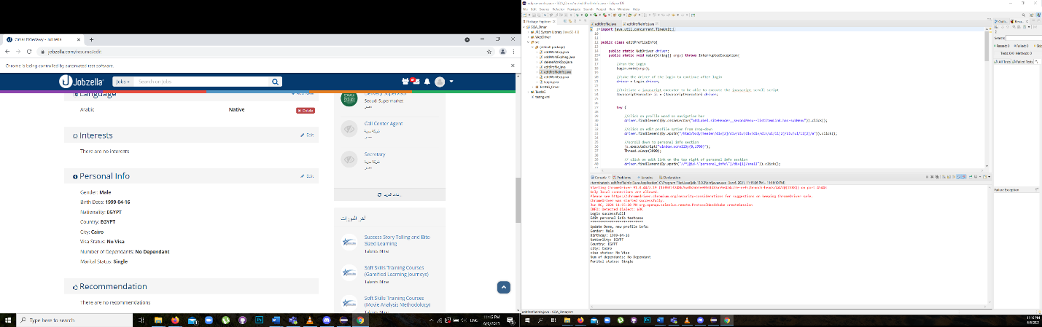

Add Work Exp:

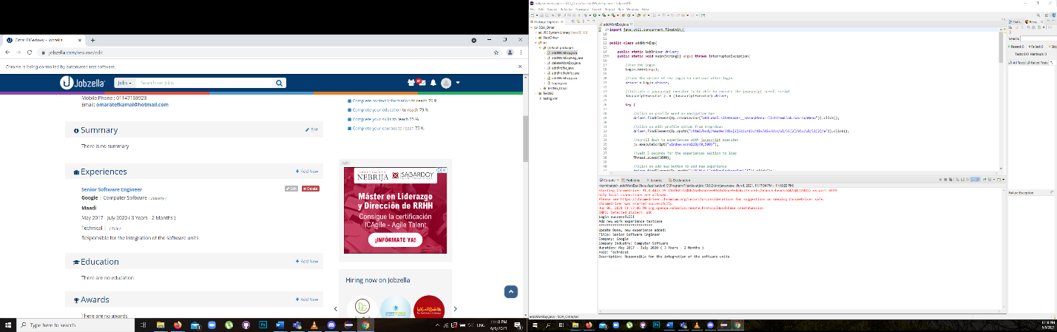

Edit Work Exp:

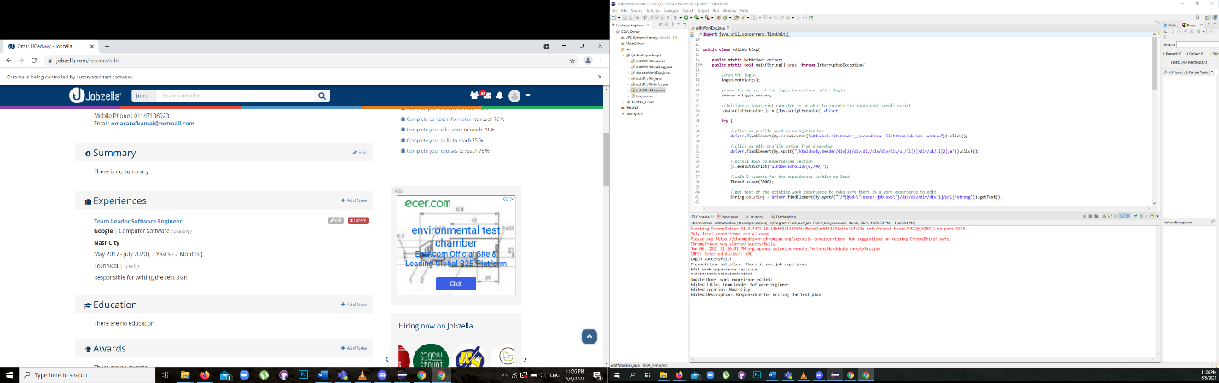

Delete Work Exp:

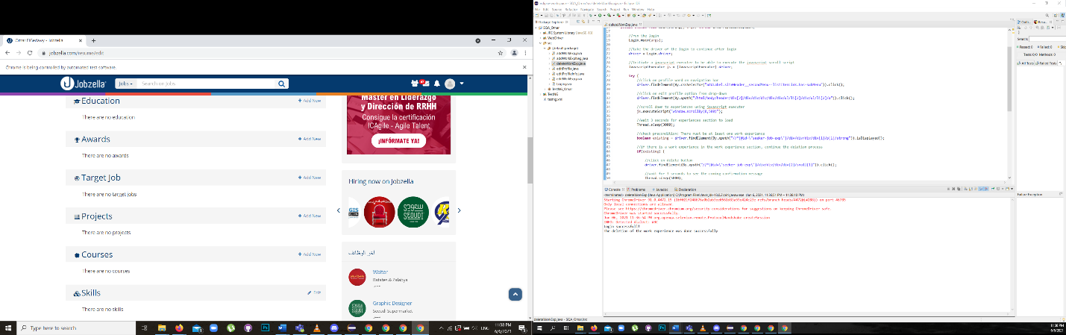

Add Work Exp Neg:

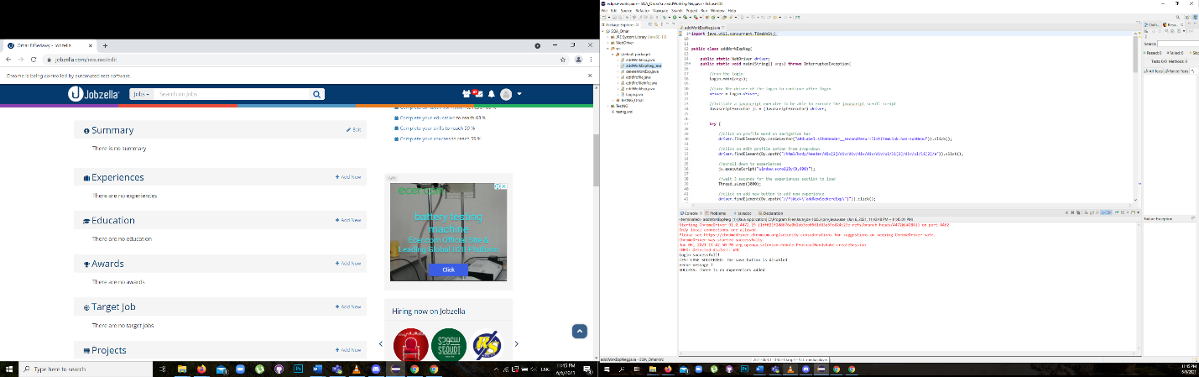

Test Suite:

* **Selenium IDE**

Edit Profile Info:

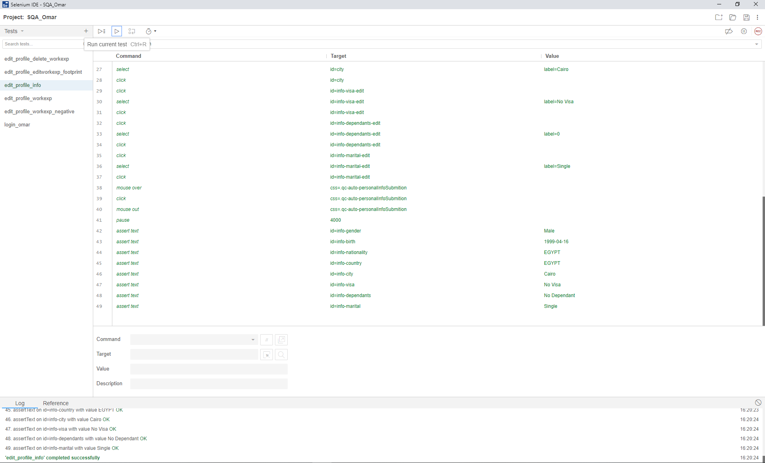

Add Work Experience:

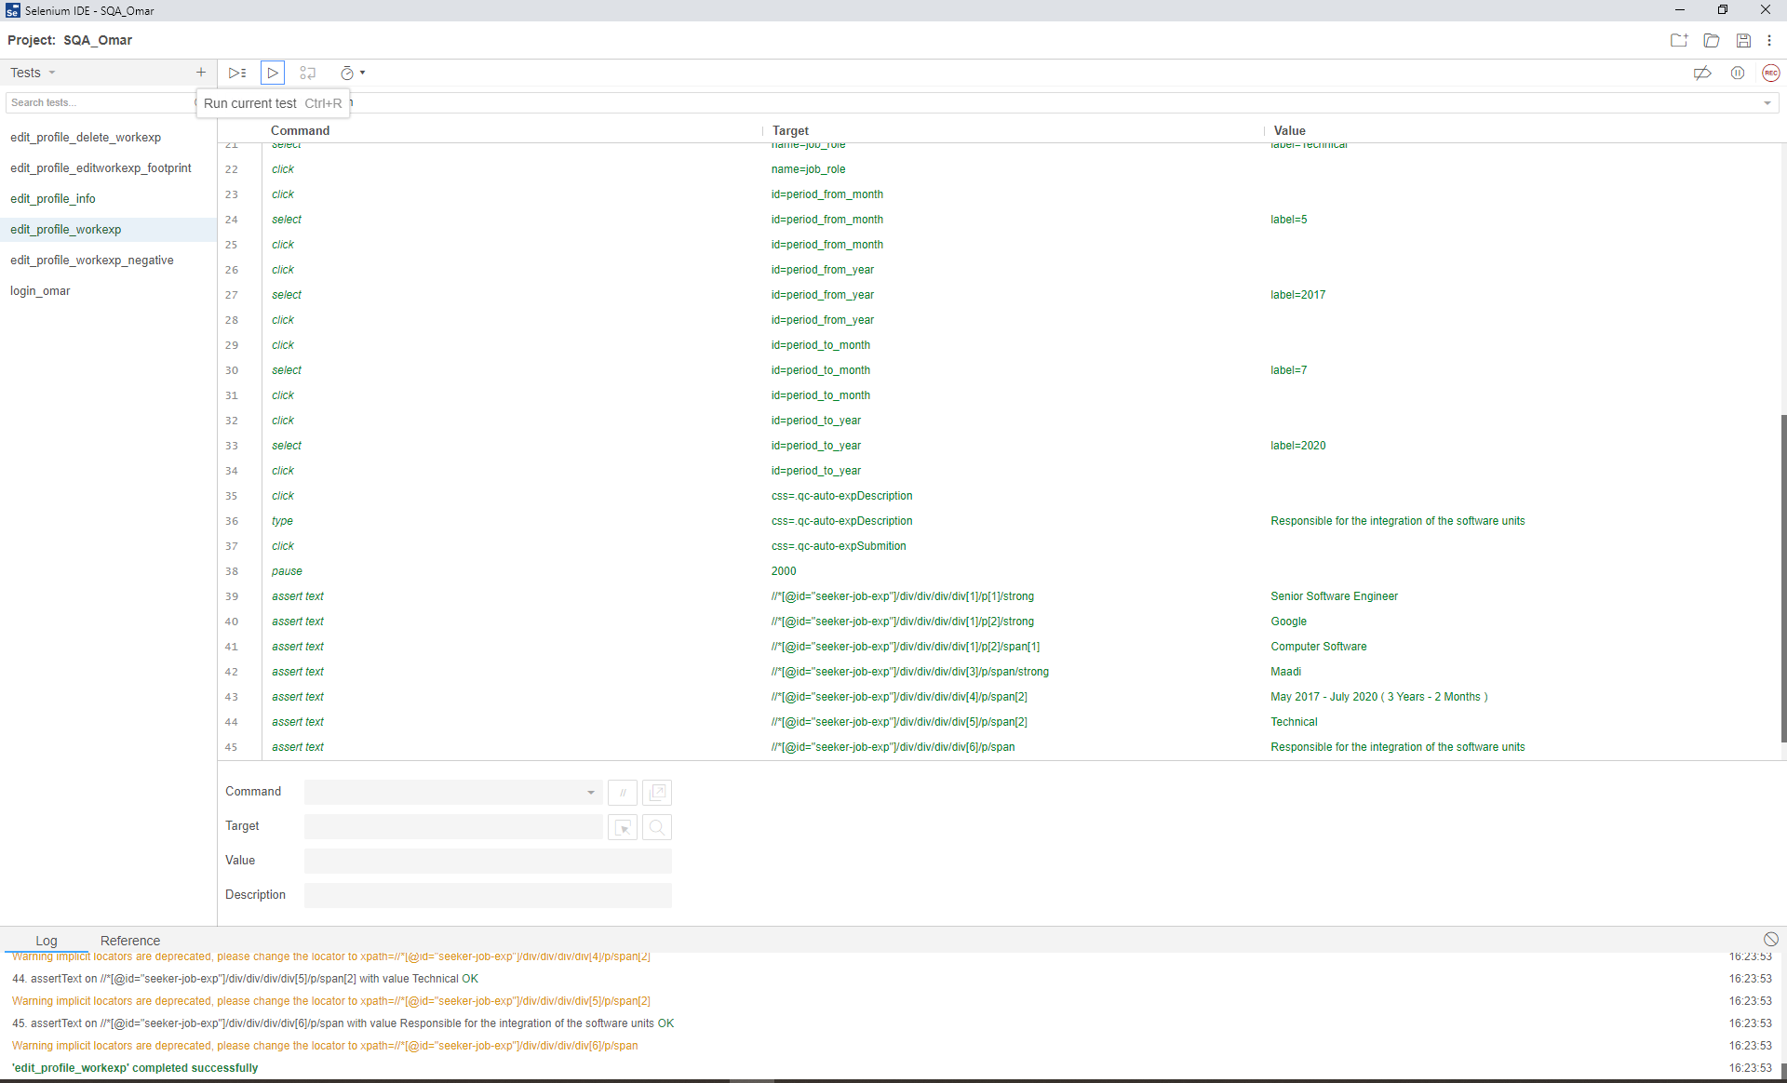

Edit Work Experience:

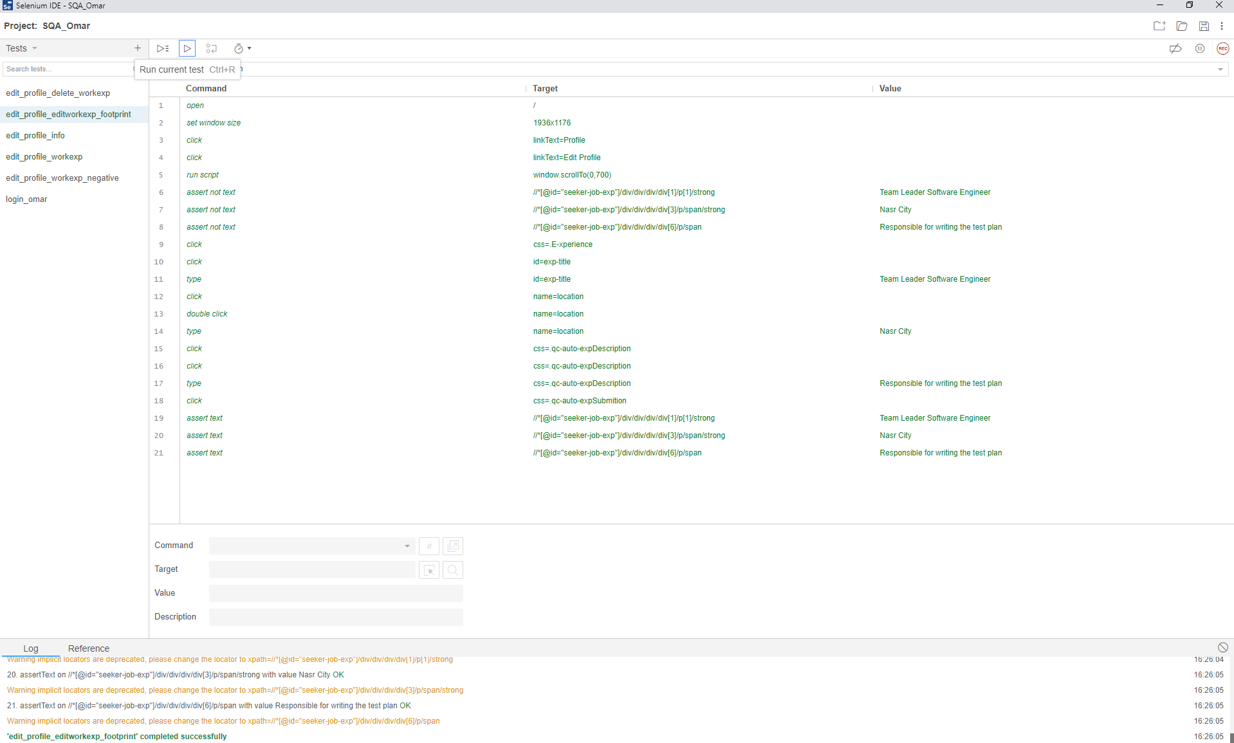

Delete Work Experience:

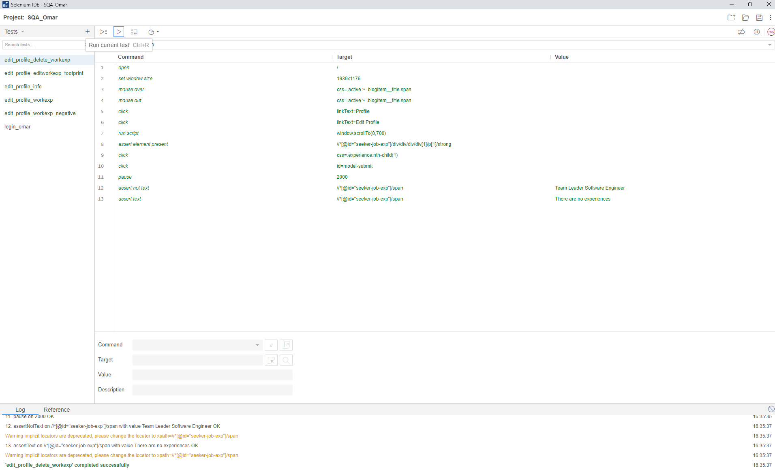

Add Work Experience Negative:

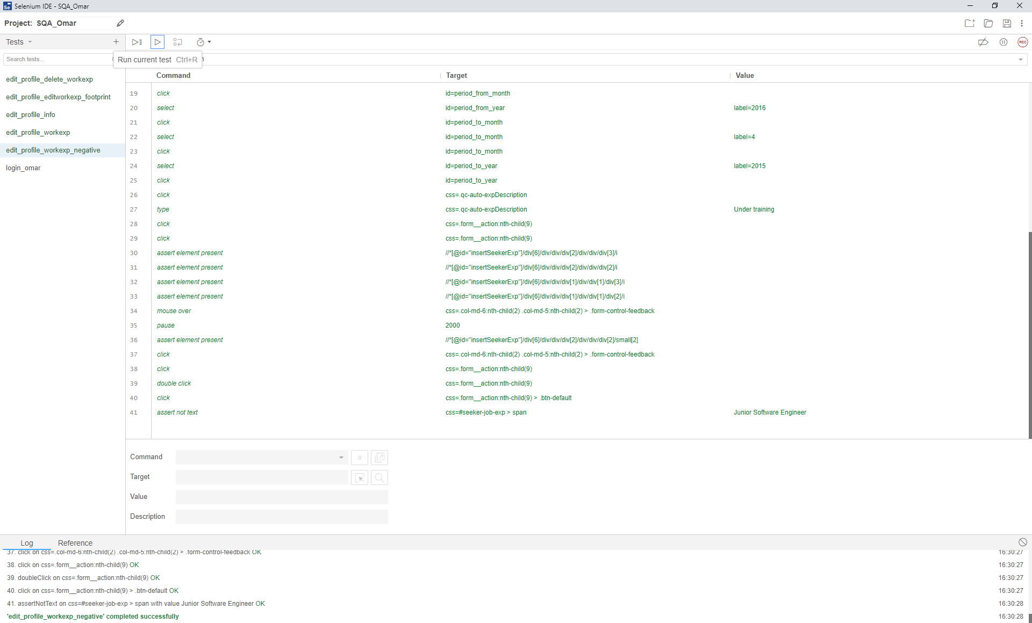

* **TestNG**

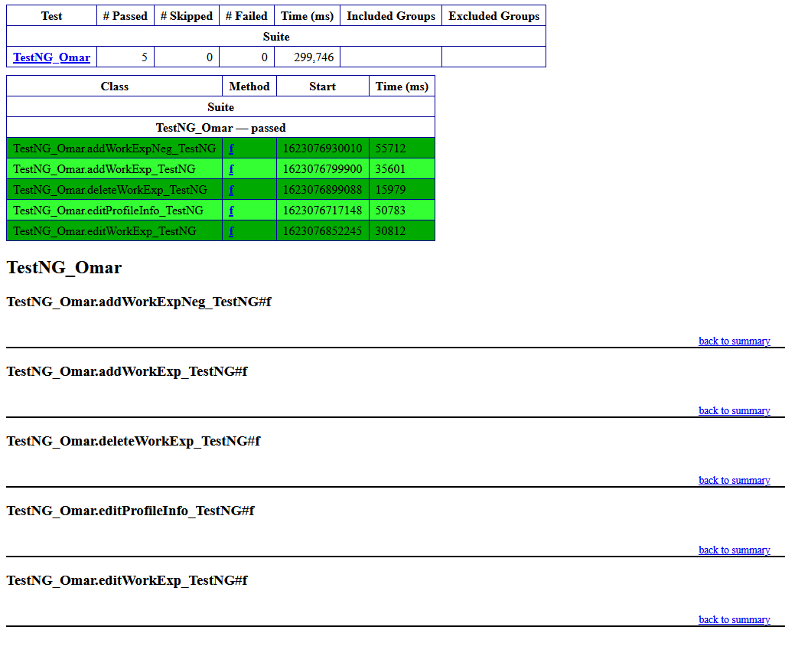

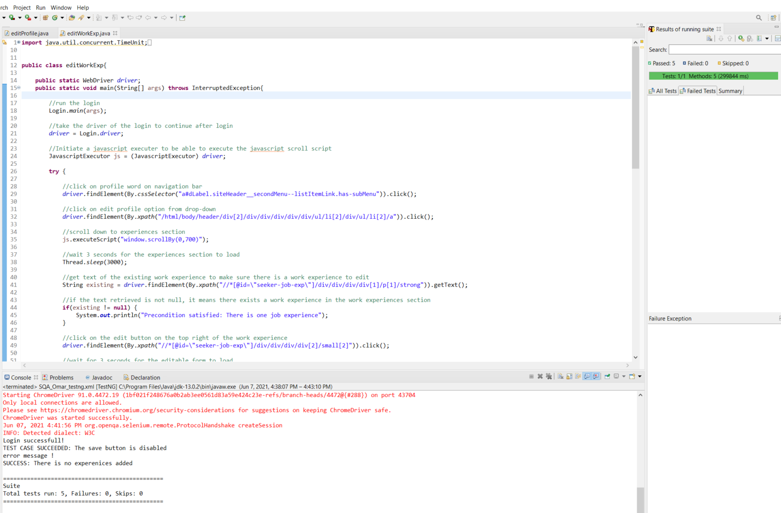

Ahmed:

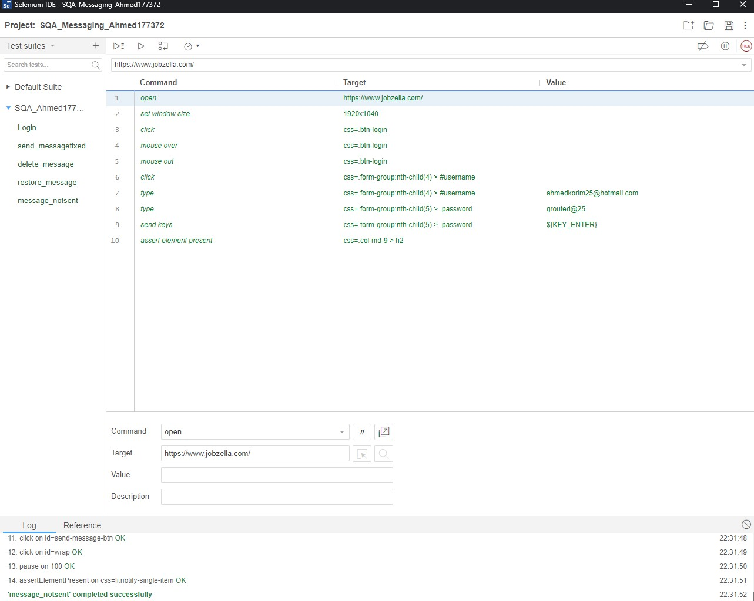

Youssef:

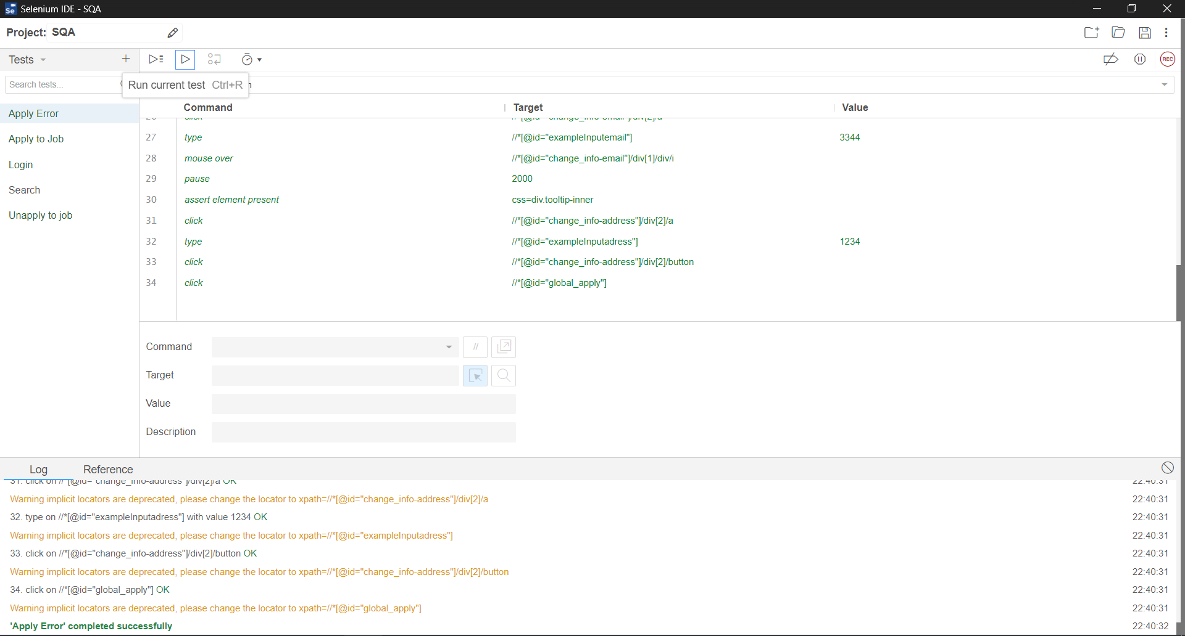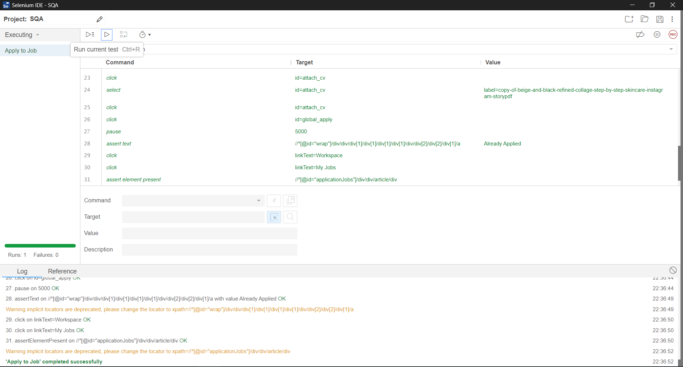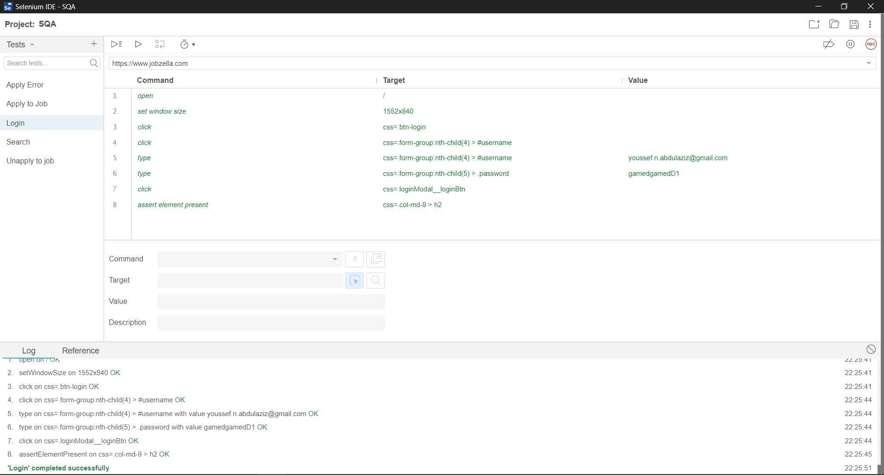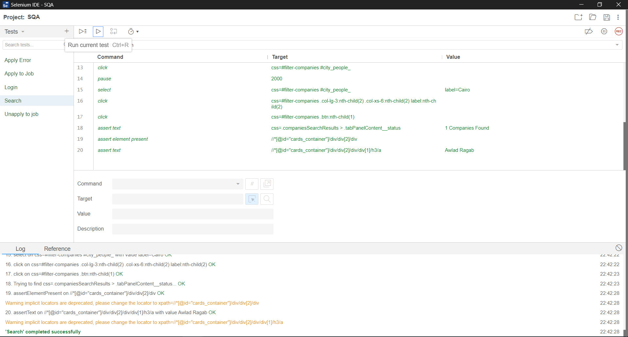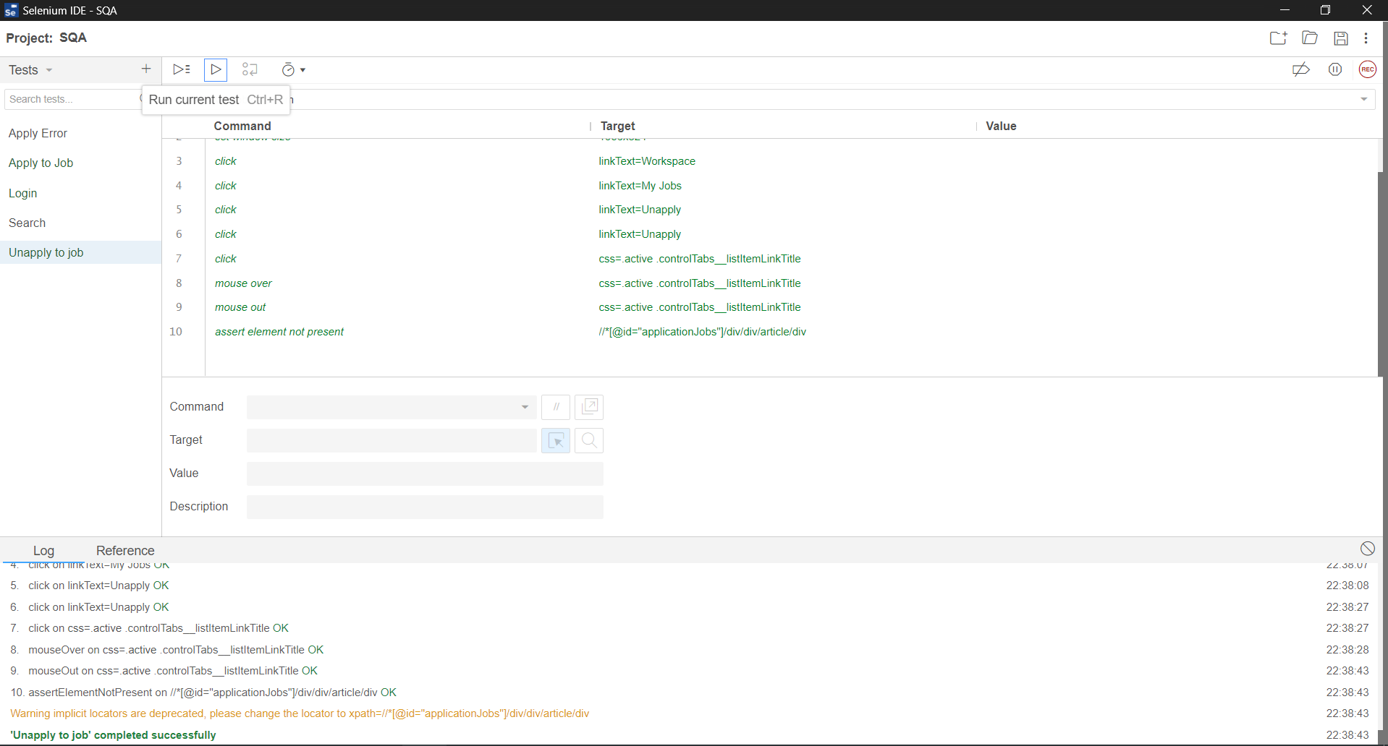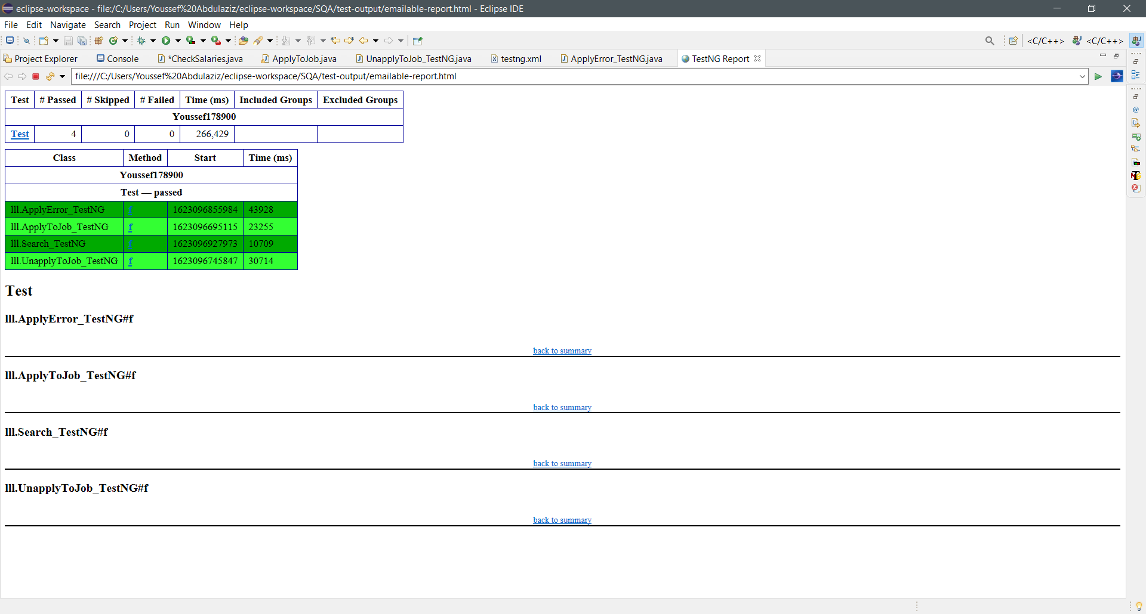

**Jmeter:**

**Summary Report:**

|  |  |
| --- | --- |
| ID | Jobzella-1 |
| Test Case | Login page load |
| Name | Login page load |
| Objective | Verifies the peak load of 1000 users access the login page |
| Test Scenario | 1.Create Thread Group  2.Enter 1000 for number of threads  3.Enter 4 for ramp-up period  4.Create HTTP Request Sampler  5.Create Summary Report |
| Input | **Number of threads (users):** 1000  **Ramp-up period:** 4  **Server URL/Path:** <https://www.jobzella.com/login>  **Loop count:** 7 |
| Expected output | The accessing of the login page of all 1000 threads/users at the same time with 4 seconds between each user and with 7 requests done by each user. |
| Actual Output | The accessing of the login page of all 1000 threads/users at the same time with 4 seconds between each user and with 7 requests done by each user and with a delay of 4/1000 seconds. |
| Pass/Fail | Pass |

**Comment:**

7000 sample requests have been sent to the server and the minimum time for a request was 170 ms and the highest is 106144 ms, The throughput is 35.4/sec which means that server can handle 35.4 requests in a second, the average time for a request is 16847 ms and this is subject to increasing by a std deviation of 22826.49.

**Graph Results:**

|  |  |
| --- | --- |
| ID | Jobzella-2 |
| Test Case | About page load |
| Name | About page load |
| Objective | Verifies the ability of Jobzella to handle a load of 100 users accessing the about page. |
| Test Scenario | 1.Create Thread Group  2.Enter 100 for number of threads  3.Enter 1 for ramp-up period  4.Create HTTP Request Sampler  5.Create Graph Results |
| Input | **Number of threads (users):** 100  **Ramp-up period:** 1  **Server URL/Path:** https://www.jobzella.com/about  **Loop count:** 1 |
| Expected output | The accessing of the about page by 100 threads/users at the same time. |
| Actual Output | The accessing of the about page by 100 threads/users at the same time. |
| Pass/Fail | Pass |

**Comment:**

100 sample requests have been sent to the server and the average time for a request was 7383 ms subject to std deviation of 897 ms and the throughput is 615.574/min.

**View Results Tree:**

|  |  |
| --- | --- |
| ID | Jobzella-3 |
| Test Case | Support page load |
| Name | Support page load |
| Objective | Verifies the ability of Jobzella to handle a load of 110 users accessing the support page. |
| Test Scenario | 1.Create Thread Group  2.Enter 100 for number of threads  3.Enter 1 for ramp-up period  4.Create HTTP Request Sampler  5.Create Results Tree |
| Input | **Number of threads (users):** 110  **Ramp-up period:** 2  **Server URL/Path:** https://www.jobzella.com/support  **Loop count:** 1 |
| Expected output | The accessing of the support page by 110 threads/users at the same time. |
| Actual Output | The accessing of the support page by 110 threads/users at the same time. |
| Pass/Fail | Pass |

**Comment:**

110 sample requests were sent to the server and the server replied with response code: 200 or OK to indicate a successful process of request and response.

**View Results in Table:**

|  |  |
| --- | --- |
| ID | Jobzella-4 |
| Test Case | Search page load |
| Name | Search page load |
| Objective | Verifies the ability of Jobzella to handle a load of 1000 users accessing the same search results page. |
| Test Scenario | 1.Create Thread Group  2.Enter 100 for number of threads  3.Enter 1 for ramp-up period  4.Create HTTP Request Sampler  5.Create View Results in Table |
| Input | **Number of threads (users):** 1000  **Ramp-up period:** 10  **Server URL/Path:** https://www.jobzella.com/ /search/#?type=companies&sortby=relevance&filterSearch=any&keywordtype=any  **Loop count:** 4 |
| Expected output | The accessing of the specific search page by 1000 threads/users at the same time, each sending 4 requests. |
| Actual Output | The accessing of the specific search page by 1000 threads/users at the same time, each sending 4 requests. |
| Pass/Fail | Pass |

**Issues and** **difficulties:**

**In selenium IDE:**

* The many steps done by record process of the selenium IDE caused the testing to lag (fixed by removing redundant record steps).
* Failure of test when the browser takes actions before the load of elements. (Fixed by adding pause for few seconds).
* In ability of selenium IDE to identify some elements (fixed by using the cursor in the tool that gets the css selector of the element).
* The fast showing and disappearing elements (fixed by hovering by the tool in a position near to the location of the fast-disappearing element).
* The slow internet connection.

**In selenium Webdriver:**

* **The lack of informative error messages (fixed by encapsulating code in try and catch and printing the error inside the catch).**
* **The new functions not included in the lab (fixed by doing some search).**
* **Not detecting elements due to their late appearance (fixed by adding waits).**
* **Slow internet connection.**

**In testNg:**

* **The xml file for test suite was not running (fixed by removing the xml doctype)**

**In Jmeter: None.**