**1. What is normalization? Explain its types.**

**Ans: Normalization is a process of dividing larger tables into number of small tables and links them using relationships.**

**It is the systematic approach of decomposing tables to eliminate data redudancy.(duplication)**

**The types of Normalizatioin are:**

* **Unnormalized Form (UNF)**
* **First Normal Form (1NF)**

**For Table to be in the 1NF**

* **It should have only atomic values.**
* **Value stored in a column sholud be of same data type**
* **All column should be unique**
* **The order in which data is stored doesn't mattles.**
* **Second Normal Form (2NF)**

**For able to be in 2NF**

* **It should be in 1NF.**
* **It shouldn’t have partial Dependency on Only a portion of Primary key.**
* **Third Normal Form (3NF)**

**The table is said to be in 3NF if**

* **It should be in 2NF**
* **It should not transitive dependency.**
* **Boyce and Codd Normal Form (BCNF)**
  + - **It is higher version of 3NF**
    - **For a table to be in BCNF**
    1. **It must be in 3NF**
    2. **For each functional dependencies (X---🡪4)  
       X- should be super Key.**
* **Fourth Normal Form (4NF)**

**For table to be in 4NF**

* + - **It should be in BCNF**
    - **Shouldn’t have Multi valued Dependency.**
* **Fifth Normal Form (5NF)**
  + - **5Nf is generally not implemented in real life database design.**
* **Domain Key Normal Form(DkNF)**
  + - **BCNF, 4NF, 5NF are example of such forms**
    - **It requires the database to contain no constraints other than domain and key constrains.**

**2. Define all DDL and DML commands with syntax.**

**Ans:**

**DDL (Data Definition Language)**

**• DDL and SQL command that defines database table and schemas.**

**• It is used to create and modify the structure of database objects in the databases.**

**Commands**

* **CREATE:**

**To create database and its objects (like, table, view, trigger)**

* **DROP:   
  It is used to delete object from the databases.**
* **ALTER:  
   It is used to alter the structure of databases.**
* **TRUNCATE:   
  To delete table data.**
* **RENAME:   
  To rename database**
* **Create a database:  
  Syntax: Create DATABASE db-name;  
  Eg: CREATE DATABASE student;**
* **Delete a database:  
  Syntax: DROP DATABASE database-name;  
  Eg: DROP DATABASE student;**
* **SELECT a database:  
  Syntax: USE database-name;  
  Eg: USE students;**
* **CREATE a table:  
  Syntax: CREATE TABLE table-name (column1 datatype, column2 datatype, column3 datatype ------ integrity constrains>);  
  Eg: CREATE TABLE details (name varchar(30),id int, section varchar(1), Mobile-no int);**

**DML (Data Manipulation Language)**

**• DML is a language that allows user to access and manipulate data in a database.**

**• It is also known as query language.**

**• Data Manipulation includes**

**- Retrival of stored information from databases.**

**- Insertion of new information in database.**

**- Detection of information for the database.**

**- Modification of information stored in the database.**

**Commands**

* **INSERT:   
  To inserts records into the table.  
  Syntax: INSERT INTO table_name (column1, column2, column3,-----) values(values1, values2, values3,--------);**
* **SELECT:   
  To read records from the table.  
  Syntax: SELECT * from table_name;  
  Eg: SELECT * from emp;**
* **UPDATE:   
  To update data in the table.  
  UPDATE table_name SET column_name = value WHERE conditions;**
* **DELETE:   
  To delete records from the table.  
  DELETE from table_name WHERE condition;**

**3. Define OSI reference model. Explain each layer.**

**Ans:**

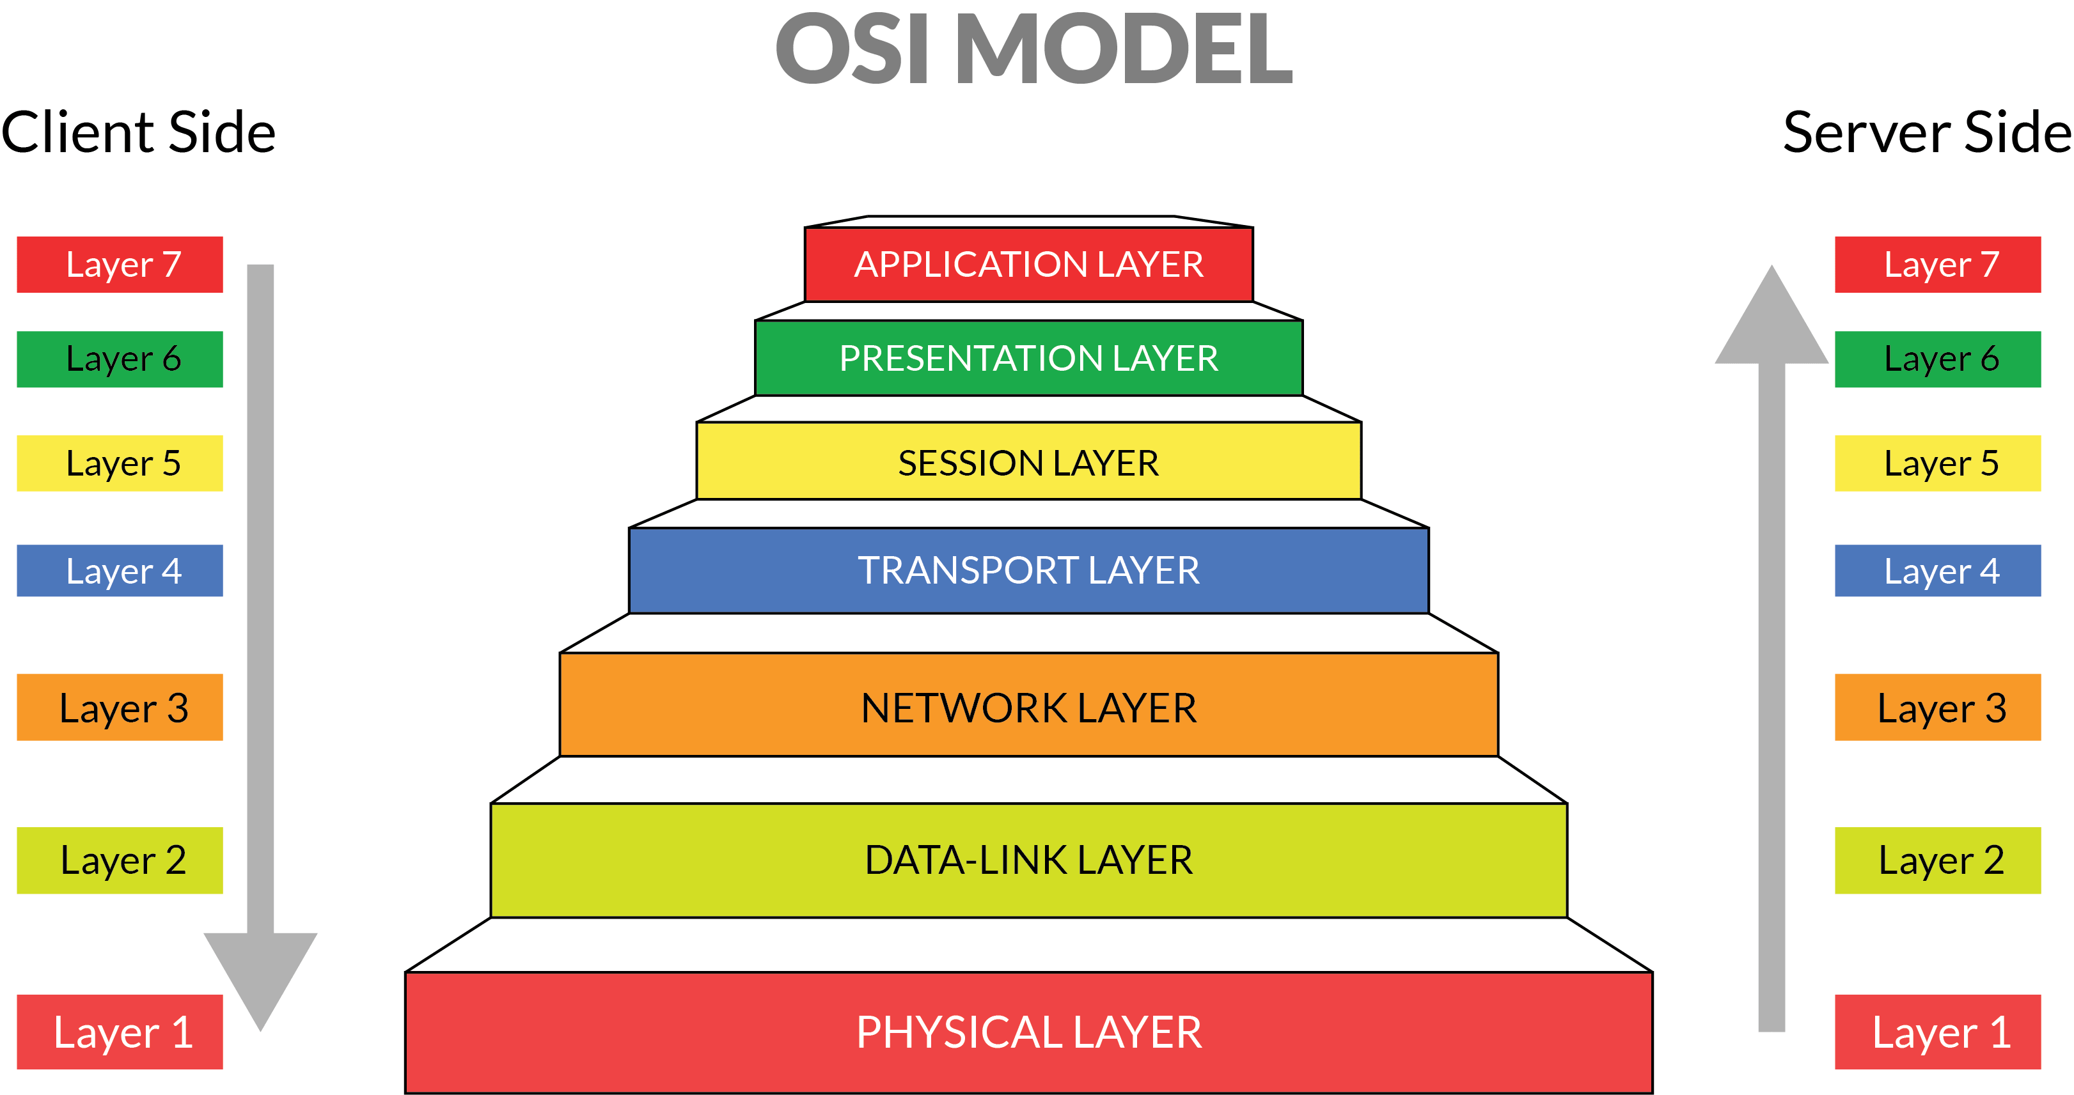

**Physical Layer (Layer 1) : The lowest layer of the OSI reference model is the physical layer. It is responsible for the actual physical connection between the devices.**

**Data Link Layer (DLL) (Layer 2) : The data link layer is responsible for the node to node delivery of the message.**

**Network Layer (Layer 3) : Network layer works for the transmission of data from one host to the other located in different networks.**

**Transport Layer (Layer 4) : Transport layer provides services to application layer and takes services from network layer. The data in the transport layer is referred to as Segments.**

**Session Layer (Layer 5) : This layer is responsible for establishment of connection, maintenance of sessions, authentication and also ensures security.**

**Presentation Layer (Layer 6) : Presentation layer is also called the Translation layer .The data from the application layer is extracted here and manipulated as per the required format ...**

**Application Layer (Layer 7) : At the very top of the OSI Reference Model stack of layers, we find Application layer which is implemented by the network applications.**

**4. Define any four LAN topologies with figure, advantages and disadvantages each.**

**Ans:**

**LAN (Local Area Network) Topology**

**Topology is defined as the pattern of interconnection between the nodes of the network. The three basic topologies of LAN are**

* **Star Topology**
* **Ring Topology**
* **Bus Topology**

**Star Topology**

**In this network, all the nodes are connected to Central Node. The devices are not connected to each other and transmits the messages to the Central Node. The central node is responsible for transmitting the message to the required destination. It is the most widely used topology for LAN’s.**

**Ring Topology**

**In this network, the nodes are interconnected to make a closed loop. Each node communicates with the nodes on its either side with the help of Token (information passing). The nodes with Token are allowed to transmit data. This topology eliminates the connection of nodes with the central node i.e. there is no need of Network Server to control other devices.**

**Bus Topology**

**In this network, all the nodes including computers and servers are connected to a single cable termed as Bus. This network is easier compared to other networks and is economical. Source node transmits a signal which is broadcast to all the other nodes via Bus cable. Though the message is broadcast, the intended recipient receives the signal. The recipient can accept the signal if its MAC Address or IP Address matches and data transmission occurs in a single direction.**

**5. Explain guided and unguided media along its types.**

**Ans: Guided transmission media are more commonly known as the wired communication or bounded transmission media. The electromagnetic signals travel between the communicating devices through a physical medium/conductor.** **The guided media is categorized further into three categories that are twisted-pair cable, coaxial cable and fiber-optic cable.**

**The unguided media is also called wireless communication. It does not require any physical medium to transmit electromagnetic signals. In unguided media, the electromagnetic signals are broadcasted through air to everyone.** **The unguided media is categorized into radio waves, microwaves and infrared waves.**

**6. Define keys in DBMS with example.  
Ans: Key is an attribute or set of attributes which uniquely identifies each rows (records) of the table.**

**Types:**

* **Super key: A super key is a group of single or multiple keys which identifies rows in a table.**
* **Candidate keys: Candidate key is a set of minimal super key that uniquely identifies each record in all the table.**
* **Primary key: A primary key is a candidate key that is choosen by database designer which uniquely identifies each rows of the table.**
* **Foreign key: Primary key of one table if present in another table is known as foreign key.**