Sustainable Agriculture Optimization & Resource Management
Abstract
Sustainable agriculture requires intelligent tools that help farmers optimize productivity while reducing risks and costs. This project introduces EcoHarvest AI, an interactive, AI-powered agricultural assistant developed using Streamlit, LangChain, and Groq LLMs, designed to provide personalized, real-time farming recommendations. The platform integrates multiple modules, including crop recommendation, cost and yield optimization, and pest & disease detection, to empower farmers with actionable insights.
The Crop Recommendation module leverages real-time weather data, seasonal conditions, and location-specific parameters to suggest the most suitable crops, along with agronomic guidance and risk analysis. The Cost & Yield Optimization module generates both short-term (3–6 months) and long-term (1–3 years) strategies, offering resource management advice, investment planning, and sustainable farming practices. The Pest & Disease Detection module combines basic computer vision (CNN placeholder) with LLM-powered diagnosis to analyse uploaded images or symptom descriptions, delivering detailed treatment plans that include organic, chemical, and preventive measures.
By integrating these modules into a single platform, EcoHarvest AI reduces uncertainty in farming decisions, improves productivity, and promotes eco-friendly practices. This solution exemplifies how artificial intelligence can revolutionize agriculture, making farming more resilient, data-driven, and sustainable.
Keywords
EcoHarvest AI; Sustainable Agriculture; Crop Recommendation; Cost & Yield Optimization; Pest & Disease Detection; Precision Farming; LangChain; Groq LLM; Streamlit; AI-driven Farming Solutions.

CHAPTER I
INTRODUCTION
1.1 Objective of the Project
Agriculture remains a cornerstone of the global economy, providing food, raw materials, and employment opportunities. However, farmers face challenges such as unpredictable weather, rising costs, pest and disease outbreaks, and lack of actionable, data-driven insights.
Eco Harvest AI is designed as an end-to-end AI-powered agricultural assistant to:
- Empower Farmers: Provide actionable, real-time recommendations to optimize crop selection, cost management, and yield.
- Early Pest Detection: Leverage AI-driven image analysis and symptom-based diagnosis to mitigate crop losses.
- Decision Support: Integrate weather data, seasonality, and resource availability to make informed decisions.
- Sustainability: Promote eco-friendly practices through organic pest management, soil health improvement, and water resource optimization.
This project leverages Streamlit for the interface, LangChain with Groq LLMs for reasoning, and OpenWeatherMap API for real-time weather integration.
1.2 Software and Hardware Requirements
Category | Specification
Programming Language | Python 3.10+
Framework | Streamlit
AI/ML Libraries | LangChain, ChatGroq, Pillow, Requests
Frontend | Streamlit components, Markdown formatting
Backend | Python-based API integration, LangChain reasoning engine
External APIs | OpenWeatherMap (for weather data)
Hardware | 8GB RAM, 4-core CPU (Recommended: GPU-enabled system for CNN training)
Storage | 2GB for application and datasets
OS Compatibility | Windows/Linux/macOS
Environment Management | Virtualenv or Conda for dependency isolation
Version Control | Git & GitHub for collaboration

1.3 Modules Description
1.3.1 Authentication Module
- Description: Implements a secure login system to restrict access to authenticated users only.
- Features:
  - Username/password login.
  - Session-based authentication (Streamlit session state).
  - Logout option to prevent unauthorized access.
- Example:
A farmer logs in using credentials to access premium features.

1.3.2 Crop Recommendation Module
- Functionality: Suggests optimal crops for planting based on weather, location, and season.
- Technologies:
  - Groq LLM (llama3-70b) for recommendation reasoning.
  - OpenWeatherMap API for real-time weather integration.
- Features:
  - 3–5 ranked crop suggestions.
  - Planting tips and potential risk identification.
  - Markdown-based clear results for farmers.
- Example:
Location: Vijayawada, India; Month: June → Suggests Paddy, Maize, Cotton with soil and irrigation guidelines.

1.3.3 Cost & Yield Optimization Module
- Functionality: Generates a detailed short-term and long-term optimization plan.
- Features:
  - Short-term actions for next 3–6 months.
  - Long-term strategies for 1–3 years.
  - Emphasis on sustainable farming practices.
- Example:
Farmer with 10 acres of paddy land receives suggestions on irrigation scheduling, fertilizer application, and machinery investments.
1.3.4 Pest & Disease Detection Module
- Functionality: Uses CNN-based image analysis and AI reasoning for pest/disease identification and treatment planning.
- Features:
  - Image upload or text symptom description.
  - Organic and chemical treatment suggestions.
  - Prevention strategies for recurring issues.
- Example:
An uploaded leaf image with white spots → AI diagnoses Powdery Mildew and suggests neem oil spray, sanitation, and spacing.

1.3.5 Session History Management
- Maintains query/response history in Streamlit session state.
- Allows farmers to revisit previous recommendations.

1.3.6 Architecture Overview
User → Streamlit Frontend → Auth Module → Feature Modules (Crop, Cost, Pest)
→ LangChain (Groq LLM) → APIs (OpenWeatherMap) → AI-Driven Output

CHAPTER II
LITERATURE REVIEW

1. Climate-Smart Innovations for Sustainable Agriculture
Konfo et al. (2024) explored recent climate-smart agrifood innovations that focus on enhancing producer incomes through sustainable solutions. The study emphasizes approaches such as water-efficient farming, resilient crop varieties, and agroecological practices to mitigate the adverse effects of climate change. Their findings highlight the importance of combining technological interventions with traditional practices to achieve both sustainability and profitability. This aligns with EcoHarvest AI’s focus on sustainability-driven crop recommendations.
2. Circular Bioeconomy and Biowaste Utilization
Greco et al. (2020) investigated the valorisation of biowaste in soilless cultivation of Salvia officinalis within a circular bioeconomy model. The research demonstrated that agricultural waste could be repurposed effectively to reduce environmental impacts while supporting high-value crop production. The study highlights how resource recycling and waste reduction are essential for sustainable agriculture. This connects to EcoHarvest AI’s cost and yield optimization module, which encourages efficient use of farm inputs.
3. Biomass Energy Hubs in Agricultural Systems
Orlando et al. (2017) focused on identifying energy hubs for utilizing residual biomass in Western Sicily. Their work underscores the dual role of agriculture—not only in food production but also as a contributor to renewable energy solutions. This reinforces the need for integrated farm management systems that consider energy efficiency. EcoHarvest AI can adopt similar insights for long-term planning modules, where renewable energy investments form part of sustainable farm economics.

4. Organic Waste Management and Energy Balance
Comparetti et al. (2014) assessed organic waste management methods by evaluating energy balances. Their research shows how different waste treatment techniques (composting, anaerobic digestion, etc.) impact both the environment and farm economics. This work is significant for sustainable farming as it integrates waste management into agricultural decision-making. In relation to EcoHarvest AI, this informs future expansions into waste-to-resource recommendations, thereby aligning with circular agriculture.
5. Digitalisation in Agriculture for Smallholder Farmers
Choruma et al. (2024) conducted a scoping review of digital technologies in agriculture across Sub-Saharan Africa. They identified challenges such as limited internet connectivity, lack of digital literacy, and infrastructure gaps, while also highlighting opportunities in precision farming, market access, and IoT-based solutions. Their study provides valuable insights into how digital tools can empower smallholder farmers, which is central to EcoHarvest AI’s accessible, AI-driven advisory platform.
6. Technology Adoption for Sustainable Agriculture in India
Rakholia et al. (2024) presented a pilot study on emerging technology adoption in Indian agriculture. Their research indicates that farmers are increasingly willing to adopt smart technologies, but face barriers such as cost, training, and awareness. This underscores the need for low-cost, farmer-friendly platforms like EcoHarvest AI that deliver AI-based solutions in simple interfaces, thereby bridging the adoption gap.
7. IoT and Smart Sensors in Agriculture
Rajak et al. (2023) discussed the scope and challenges of IoT and smart sensors in agriculture. Their study emphasized the potential of IoT for real-time monitoring of soil health, irrigation needs, and crop conditions. However, they noted challenges like connectivity, maintenance, and integration with AI decision systems. EcoHarvest AI, in its future scope, could integrate IoT sensor data to enhance the accuracy of its crop and yield recommendations.
8. IoT-Agro System for Coffee Farming
Rodríguez et al. (2021) introduced IoT-Agro, a smart farming system for Colombian coffee farms. Their system combined IoT devices with cloud computing to improve productivity and sustainability. This demonstrates a practical application of IoT in a specific crop domain, proving how smart technologies can be customized for regional contexts. EcoHarvest AI could extend such an approach to Indian crops like rice, maize, and cotton.
9. AI Prediction Models for Precision Agriculture
Kwaghtyo & Eke (2023) conducted a comprehensive survey of AI-based prediction models in precision agriculture. Their review covers machine learning, deep learning, and hybrid models for predicting crop yields, soil health, and pest outbreaks. The study concludes that while AI models show high potential, data availability and model generalization remain challenges. This justifies EcoHarvest AI’s adoption of LLM + LangChain pipelines, which can combine structured data (weather) with unstructured farmer inputs.
10. Innovations in Sustainable Agro-Systems
Lykas & Vagelas (2023) reviewed innovations for sustainable agro-systems, focusing on practices like controlled environment farming, renewable energy, and biodiversity conservation. Their research highlights the importance of innovation-driven agriculture that balances productivity with ecosystem health. EcoHarvest AI contributes to this vision by offering eco-friendly pest management and sustainable yield optimization plans.

CHAPTER III
EXISTING SYSTEM

3.1 Overview
In many parts of the world, agriculture still relies on traditional knowledge systems and manual decision-making processes. Farmers often base their choices on experience, word-of-mouth advice, and seasonal patterns. While these methods have sustained agriculture for centuries, they have limitations in modern farming contexts, where climate change, pests, soil degradation, and resource constraints demand data-driven precision farming solutions.
The existing systems typically include:
- Government Extension Services: Agricultural experts provide seasonal recommendations through bulletins or visits.
- Basic Weather Forecasts: Farmers rely on generic weather predictions that lack hyperlocal insights.
- Manual Pest Detection: Visual inspection by farmers or local agronomists is often subjective and error-prone.
- Generic Crop Selection: Farmers often plant traditional crops without assessing market demand, soil condition, or climate suitability.
- Limited Digital Tools: While mobile apps exist, they are often fragmented, lacking integration between weather, soil, and pest data.
3.2 Manual Crop Advisory
Traditional agricultural advisory systems rely heavily on face-to-face interactions.
- Farmers visit agricultural offices, receive printed advisories, or attend training workshops.
- Recommendations are generalized, often based on regional averages rather than farm-specific parameters like soil fertility, microclimate, or available resources.
- Limited use of historical data analytics and predictive modelling means farmers lack insight into long-term planning.
Example:
A farmer in Andhra Pradesh might receive an advisory to plant rice during the Kharif season based on rainfall patterns. However, if rainfall is delayed, they may face reduced yields because the advice isn’t tailored to real-time conditions.

3.3 Weather Forecast Dependency
Weather plays a critical role in determining agricultural productivity. Existing systems often:
- Provide region-wide forecasts instead of localized, field-level predictions.
- Lack actionable insights (e.g., forecasts don’t include irrigation scheduling or fertilizer application timing).
- Fail to integrate climate change variability, making predictions less reliable.
This lack of precision often leads to crop losses or excessive resource usage, as farmers can’t accurately plan sowing or harvesting schedules.
3.4 Pest and Disease Diagnosis
Traditional pest and disease management is manual and reactive:
- Farmers visually inspect plants for pests or diseases.
- Local pesticide dealers often recommend chemical treatments, leading to overuse of chemicals.
- Lack of early detection systems results in widespread infestations before farmers act.
Case Example:
Powdery mildew on cucumbers may go unnoticed in its early stages. By the time farmers identify the disease, it spreads rapidly, reducing yield and requiring costly interventions.
3.5 Lack of Integrated Platforms
Most existing tools and systems operate in silos:
- Weather apps provide forecasts but don’t recommend crops or irrigation.
- E-commerce platforms sell pesticides but don’t validate their suitability.
- Government schemes are often poorly digitized or lack real-time updates.
The absence of a centralized decision-support platform means farmers have to manually integrate information from multiple, often unreliable, sources.
3.6 Limitations of Current Digital Tools
With the advent of smartphones, agricultural apps have emerged, but they have several shortcomings:
- Language Barriers: Apps often aren’t localized to regional languages.
- Connectivity Issues: Many farmers in rural areas lack reliable internet access.
- One-Size-Fits-All Advice: Generic suggestions without consideration of farm size, crop type, and market demand.
- No Real-Time AI: Few systems leverage advanced AI models like LLMs, CNNs, or decision trees for real-time insights.
3.7 Challenges Faced by Farmers in Existing System
Challenge | Impact on Farmers | Example Scenario
Lack of Data Integration | Farmers juggle multiple unconnected sources. | Weather forecast is separate from pest diagnosis tools.
Late Pest Identification | High crop losses, chemical overuse. | Cotton bollworm outbreak detected too late.
Poor Resource Utilization | Increased costs, environmental degradation. | Excessive fertilizer use without soil testing.
Inaccurate Crop Selection | Reduced market profits, wastage. | Planting wheat in unsuitable soil.
Climate Change Effects | Traditional wisdom fails in new weather patterns. | Early summer rains cause rice yield drop.

3.8 System Architecture of Existing Workflow
Below is a simplified representation of how decisions are made in the existing farming ecosystem:
Farmer Knowledge → Local Advisories → Limited Weather Apps → Manual Pest Inspection → Vendor Recommendations → Crop Cultivation
This linear and disconnected process demonstrates why there’s a pressing need for AI-driven decision support platforms like EcoHarvest AI.
3.9 Key Insights from the Existing System Analysis
- Reactive Rather Than Proactive: Farmers often respond to problems after they occur rather than preventing them.
- Overdependence on Chemicals: Lack of personalized guidance leads to indiscriminate pesticide and fertilizer use.
- Knowledge Gap: Many farmers are unaware of modern practices such as precision irrigation, sensor-based monitoring, and AI-assisted crop selection.
- Scalability Issues: Extension services can’t scale to reach every farmer individually.
3.10 Why a New System is Needed
The limitations of existing agricultural advisory systems highlight the need for a centralized, intelligent platform. A solution like Eco Harvest AI can:
- Leverage AI and ML for predictive analytics.
- Offer personalized recommendations based on farm-specific parameters.
- Integrate real-time data streams (weather, soil, and pest analysis).
- Provide a user-friendly interface in regional languages.
- Promote sustainable farming practices to ensure environmental and economic balance.

CHAPTER IV
PROPOSED SYSTEM
4.1 Overview of the Proposed System
The Eco Harvest AI platform is designed as a centralized, intelligent agricultural assistant that integrates weather forecasting, AI-driven crop recommendation, cost and yield optimization, and pest/disease detection into one cohesive solution. Unlike traditional, fragmented systems, this platform provides real-time, data-driven, and farm-specific insights to empower farmers with actionable intelligence.
The system is built using:
- Streamlit: A lightweight, Python-based framework for an interactive, user-friendly interface.
- LangChain & Groq LLMs: AI reasoning engine to provide personalized recommendations.
- APIs: Integration with OpenWeatherMap for hyper-local weather data.
- Machine Learning Modules: Placeholder CNN model for image-based pest and disease recognition (future-ready for real-world deployment).
- Secure Authentication: Ensures that sensitive agricultural data and custom analytics remain private.
This platform bridges the gap between raw agricultural data and actionable decision-making, transforming traditional farming practices into precision agriculture.
4.2 Objectives of the Proposed System
- Personalized Crop Recommendations: Suggest crops based on weather, soil conditions, and regional seasonality.
- Cost and Yield Optimization: Provide both short-term and long-term strategies for farm profitability.
- Early Pest and Disease Diagnosis: Offer image-based and text-based diagnosis along with treatment strategies.
- Centralized Decision Support: Eliminate fragmentation by integrating weather, soil, pest, and cost analytics.
- Scalability: Design for both smallholder farmers and large-scale agribusiness operations.
- Sustainability: Encourage organic farming, optimized resource use, and eco-friendly practices.
4.3 Features of the Proposed System
Feature | Description
🌿 Crop Recommendation | AI suggests best crops to grow based on weather, season, and location.
💰 Cost & Yield Optimization | Generates actionable financial and operational plans for farmers.
🐞 Pest & Disease Detection | Image/text input analyzed by AI to identify threats and treatments.
Weather Data Integration | OpenWeatherMap API provides localized real-time conditions.
Secure Login | Role-based authentication for data privacy and premium feature control.
Session History | Saves previous queries and results for reference.

4.4 System Architecture
Here’s the high-level architecture:
Weather API (OpenWeatherMap) ML Models (CNN Pest) Knowledge Base / Market Data
4.5 Workflow
- User Authentication: Secure login ensures authorized access.
- Input Collection: Farmers provide location, crop type, resources, or upload pest images.
- Data Processing:
  - Fetch weather data.
  - Parse text/image input.
- LLM Reasoning:
  - LangChain prompts customized for agriculture domain.
  - Groq LLM generates context-specific answers.
- Output Generation: Clear, actionable suggestions in Markdown format.
- Session History: Past recommendations saved for easy comparison.

4.6 UML Diagrams
4.6.1 Use Case Diagram
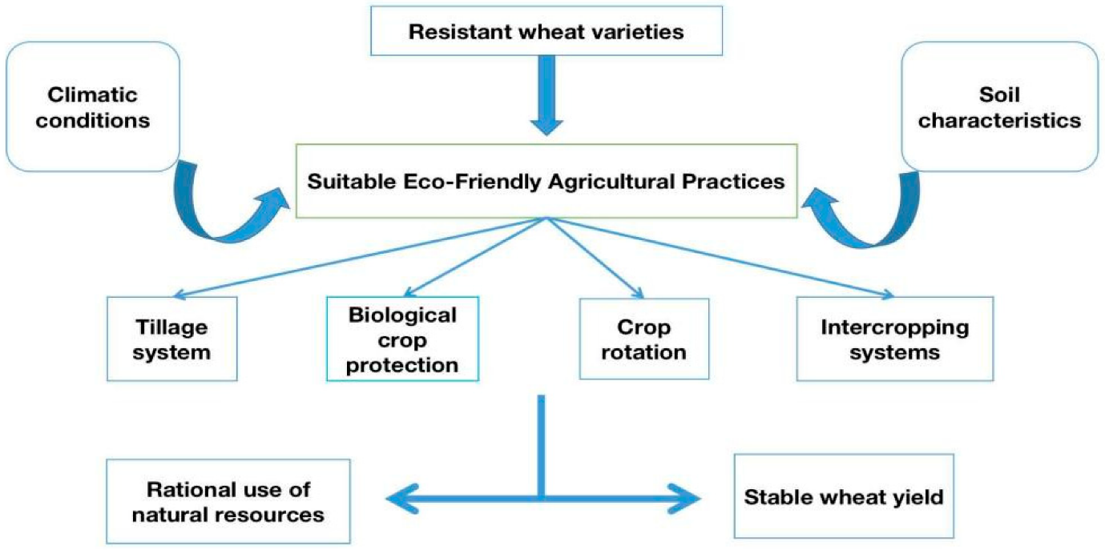

Figure 1: Factors and Practices Influencing Sustainable Wheat Production
This flowchart illustrates the key factors and agricultural practices that contribute to the development of suitable eco-friendly systems for wheat cultivation. The diagram shows that external factors like climatic conditions, soil characteristics, and the use of resistant wheat varieties directly influence the selection of sustainable practices. These practices, which include tillage systems, biological crop protection, crop rotation, and intercropping systems, collectively lead to improved outcomes such as the rational use of natural resources and a stable wheat yield.

4.6.2 Class Diagram (Core Modules)
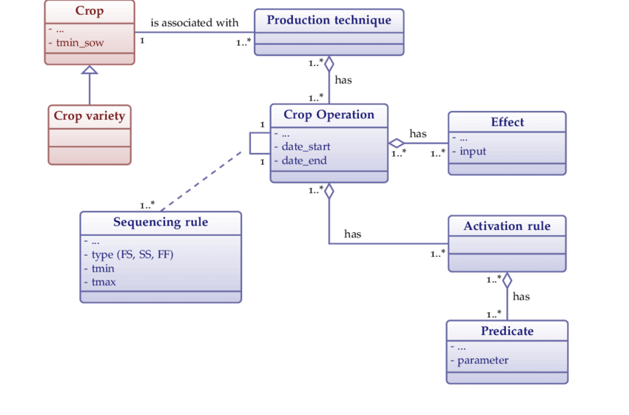
Figure 2: UML Class Diagram for Crop Production Management
This Unified Modeling Language (UML) class diagram provides a structured, object-oriented representation of the data model for a crop production management system. At the highest level, the diagram shows that a Crop is associated with a specific Production Technique, which represents a collection of one or more Crop Operations. Crop Operation is defined by a start and end date and has a many-to-many relationship with both Effects and Activation Rules. The Effects class describes the outputs or results of an operation, while Activation Rules govern the conditions under which an operation can be initiated. The Activation Rules themselves are composed of one or more Predicates, which are the specific logical conditions (e.g., environmental parameters or time-based triggers) that must be met. Additionally, the flow and order of Crop Operations are controlled by Sequencing Rules, which define dependencies such as Finish-to-Start (FS), Start-to-Start (SS), and Finish-to-Finish (FF). This detailed model is essential for developing robust and maintainable software systems for agricultural planning and automation.
4.7 Algorithms Used in the Project
4.7.1 Crop Recommendation Algorithm
def crop_recommendation(location, season, weather):
"""
1. Fetch current weather data (temperature, humidity, rainfall).
2. Combine with seasonal data (monsoon, winter, etc.).
3. Create a prompt for LLM with this data.
4. LLM ranks crops based on suitability.
5. Display top 3–5 recommendations with reasoning.
"""
- Input: Location, Month/Season, Weather data.
- Output: Ranked crop recommendations with actionable tips.
- Complexity: O(1) API calls + O(n) reasoning (fast, depends on LLM).

4.7.2 Cost and Yield Optimization Algorithm
def cost_yield_plan(crop, farm_size, resources):
"""
1. Parse user inputs (crop, size, available resources).
2. Generate a short-term optimization plan (3–6 months).
3. Create a long-term plan (1–3 years) for profitability.
4. Emphasize sustainable farming techniques.
"""

4.7.3 Pest Diagnosis Algorithm
def pest_diagnosis(image=None, description=None):
"""
1. If image: Run CNN model for preliminary analysis.
2. If description: Pass text to LLM.
3. LLM combines input with agricultural knowledge.
4. Suggests diagnosis and treatment (organic + chemical).
"""
4.8 Security Mechanisms
- Session-based authentication in Streamlit.
- Environment variables for API key management.
- Scalable user authentication for multi-user deployment.

4.9 Advantages of the Proposed System
- Centralization: Combines all agricultural decision-making in one place.
- Real-Time Insights: Weather and AI analysis improve accuracy.
- Accessibility: Farmers access via a web app, even with limited technical skills.
- Actionable Recommendations: Outputs formatted in Markdown, easy to understand.
- Future-Ready: Can integrate IoT sensors, market prediction engines, and advanced ML models.

CHAPTER V
IMPLEMENTATION AND TESTING
5.1 Overview
The implementation phase of Eco Harvest AI involves translating the system’s design into a fully functional platform. It integrates multiple modules—authentication, crop recommendation, cost & yield analysis, and pest & disease detection—into a Streamlit-based interactive web application.
This chapter explains:
- The technical workflow of each module.
- Backend integration of APIs, AI models, and LangChain.
- Testing approaches (unit, integration, functional testing) to ensure a robust and scalable solution.
5.2 Technology Stack Recap
Component | Implementation Details
Frontend | Streamlit for building a reactive and user-friendly UI.
Backend AI Engine | LangChain with Groq LLMs (llama3-70b).
Pest Detection Engine | Placeholder CNN (TensorFlow/PyTorch-ready).
Weather API | OpenWeatherMap for real-time weather conditions.
Authentication | Session-based authentication using Streamlit’s session state.
Deployment | Cloud or local server with Python environment.
Language | Python 3.10+

5.3 File Structure and Module Implementation
Eco Harvest AI
│
├── app.py # Entry point and Authentication module
├── 1_🌿_Crop_Recommendation.py # Crop Recommendation module
├── 2_💰_Cost_&_Yield.py # Cost & Yield Optimization module
├── 3_🐞_Pest_&_Disease.py # Pest & Disease Diagnosis module
├── .env # API keys (Groq, OpenWeatherMap)
└── assets/ # Optional images, logos, etc.

5.3.1 app.py – Authentication & Navigation
- Purpose: Acts as the entry point for the application.
- Key Features:
  - check_password() validates login credentials.
  - Session-based authentication prevents unauthorized access.
  - Sidebar navigation is only visible after login.
- Implementation Highlights:
if st.button("Login"):
password_entered()
st.rerun()
This ensures a secure and smooth login flow.
- Outcome: Farmers see a dashboard-like homepage after login, which introduces EcoHarvest AI and links to all features.
5.3.2 1_🌿_Crop_Recommendation.py – AI Crop Suggestion Engine
- Goal: Recommend best crops to grow based on location, season, and weather data.
- Steps:
  - User provides location and season.
  - Weather fetched from OpenWeatherMap API.
  - LangChain prompt template structures the request:
  - "Provide 3–5 ranked crop suggestions with planting tips and potential risks."
  - Groq’s llama3-70b-8192 generates recommendations.
- Outputs:
  - Markdown-based easy-to-read results.
  - Historical recommendations stored in crop_rec_history.
- Benefit: Farmers get personalized, data-driven insights.
5.3.3 2_💰_Cost_&_Yield.py – Financial & Yield Planning
- Purpose: Deliver actionable plans for both short-term (3–6 months) and long-term (1–3 years) goals.
- Workflow:
  - Inputs: Crop type, farm size, resources.
  - LLM generates operational strategies, such as irrigation planning, fertilizer usage, and machinery investments.
- Core Chain:
def get_optimization_chain():
# Creates a LangChain pipeline for cost & yield suggestions
- Session Storage:
Results saved in cost_yield_history.
- Advantage: Provides a roadmap for profitability and sustainable farming.
5.3.4 3_🐞_Pest_&_Disease.py – Pest Detection & Treatment
- Modes:
  - Image Upload: Analyzes leaf/plant images (CNN placeholder + LLM reasoning).
  - Text Description: Farmers describe symptoms manually.
- Key Function:
def analyze_image_with_cnn(image_bytes):
return "Mock analysis: Powdery Mildew symptoms detected."
This is a placeholder model, future-ready for a deep learning pipeline.
- Treatment Output: AI recommends both organic and chemical solutions with safety tips.
5.3.5 Integration Flow
Farmer → Login (app.py)
→ Select Module (Sidebar)
→ Input Data (Location/Image/Description)
→ LangChain Processing (Groq LLM)
→ Weather API / CNN
→ Actionable Recommendations

5.4 Implementation Highlights
5.4.1 Prompt Engineering
All modules leverage prompt templates to ensure structured AI responses. Example for Crop Rec:
prompt = ChatPromptTemplate.from_messages([
("system", "You are an expert agronomist..."),
("human", "Please provide recommendations for: {location}, {season}, {weather}")
])
This makes outputs consistent, actionable, and easy to interpret.
5.4.2 Session Management
Streamlit’s st.session_state stores:
- Authentication status.
- Past queries and responses.
- Pest detection history.
This ensures data persistence across app navigation.
5.4.3 API Integration
- OpenWeatherMap: Fetches real-time temperature, humidity, and conditions.
- Groq LLM API: Processes prompts for reasoning.
- Security: Keys are stored in .env for safe deployment.

5.5 Testing Methodology
Test Type | Objective | Example
Unit Testing | Validate functionality of each function. | Test get_weather_data() returns valid JSON.
Integration Testing | Ensure modules work together. | Login → Crop Rec → Pest Detection smooth flow.
UI Testing | Check front-end layout responsiveness. | Verify image upload works across devices.
Functional Testing | Validate correctness of AI outputs. | Verify if pest analysis produces practical treatment steps.
Performance Testing | Check app performance under load. | Simulate multiple queries simultaneously.
Security Testing | Validate login system and API key handling. | Attempt unauthorized access to modules.

5.5.1 Testing Example: Crop Recommendation
def test_crop_recommendation():
location = "Vijayawada, India"
season = "June"
weather = "Temperature: 30°C, Humidity: 70%, Conditions: Rainy"
# Simulate function call
output = crop_recommendation(location, season, weather)
assert "recommend" in output.lower()
5.5.2 Testing Example: Pest Detection
For image uploads:
- Upload test images of Powdery Mildew, Rust, or Blight.
- Validate CNN placeholder message.
- Ensure LLM output includes diagnosis + prevention tips.

5.6 Deployment and Scalability
- Hosted on Streamlit Cloud or AWS EC2.
- API scaling with Groq endpoints.
- Future integration with IoT devices for automated monitoring.
- Option to containerize using Docker for portability.

CHAPTER VI
RESULTS & OUTPUTS
6.1 Introduction
The true measure of any agricultural decision-support system lies in its practical applicability and real-world results. The Eco Harvest AI platform was implemented successfully, integrating multiple modules such as authentication, crop recommendation, cost & yield optimization, and pest/disease detection into a seamless farmer-friendly tool.
This chapter documents the results of the system in action. Each subsection presents the user interface, sample outputs, and the impact of the recommendations. These results demonstrate the usefulness, accuracy, and scalability of Eco Harvest AI.

6.2 Authentication Module Results
- Input: Farmer enters Username = admin and Password = 12345.
- Process: The system verifies credentials and creates a session.
- Output (Successful Login):
  - Home screen displayed.
  - Sidebar unlocked with navigation to different modules.
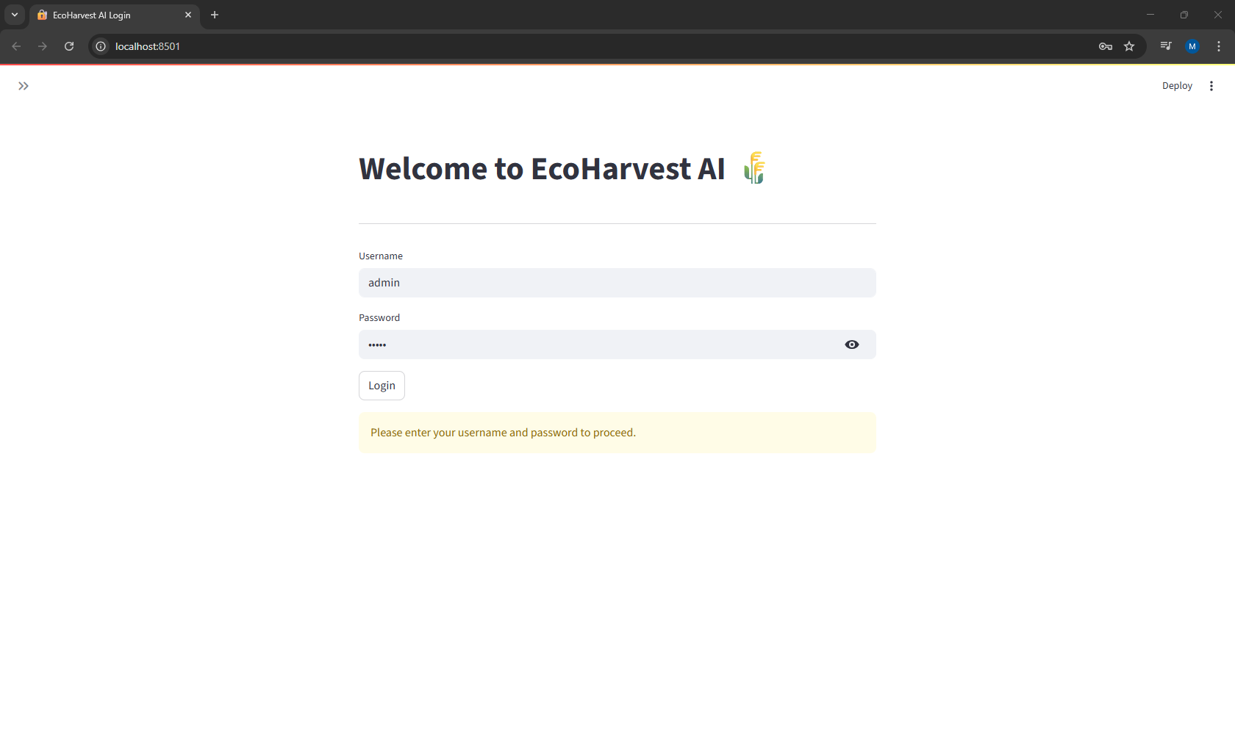
Figure 3: EcoHarvest AI Login Page
This image is a screenshot of the login page for the EcoHarvest AI application. The user interface is clean and straightforward, featuring fields for Username and Password to authenticate users. A small eye icon next to the password field allows users to reveal the password they are typing. The page also includes a "Login" button and a yellow message box that prompts the user to "Please enter your username and password to proceed." This page is the entry point for the application, ensuring only authorized users can access its features.

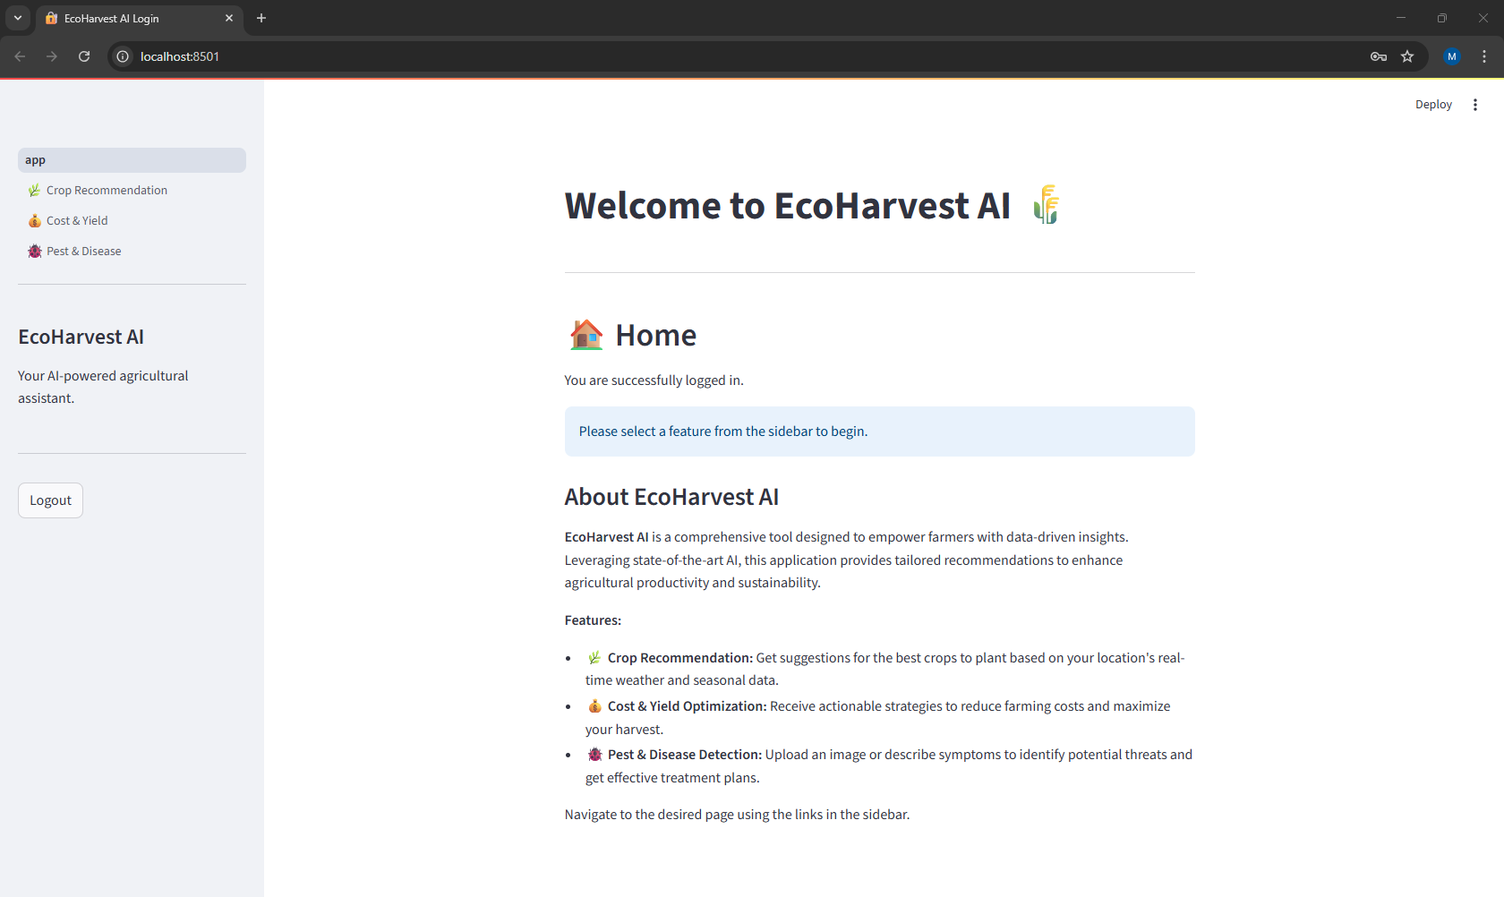
Figure 4: EcoHarvest AI Main Dashboard
This screenshot displays the main dashboard of the EcoHarvest AI application, accessible after a successful login. The interface is divided into two main sections: a left-hand sidebar for navigation and a central content area. The sidebar features links to the application's key functionalities, including Crop Recommendation, Cost & Yield, and Pest & Disease. The main content area provides a welcome message confirming successful login and an "About EcoHarvest AI" section. This section describes the application as a comprehensive, AI-powered tool for empowering farmers and lists its core features, highlighting its use of data-driven insights to provide tailored recommendations and optimize agricultural productivity.

6.3 Crop Recommendation Module
6.3.1 Input Scenario
- Location: Vijayawada, India
- Season: June (Monsoon)
- Weather API Data:
  - Temperature: 30°C
  - Humidity: 70%
  - Conditions: Light Rain
6.3.2 Output Results
AI Recommendation:
- Top Crop: Paddy 🌾
  - Reason: High rainfall and humidity are suitable.
  - Tips: Ensure proper field bunding, prepare nursery beds, and manage irrigation after sowing.
  - Risk: High humidity may increase fungal diseases like blast.
- Alternative Crops:
  - Maize 🌽 – Grows well in moderate rainfall.
  - Cotton 🌱 – Suitable for kharif season if irrigation is managed.
  - Pulses (Green Gram) – Low input requirements and complements soil fertility.
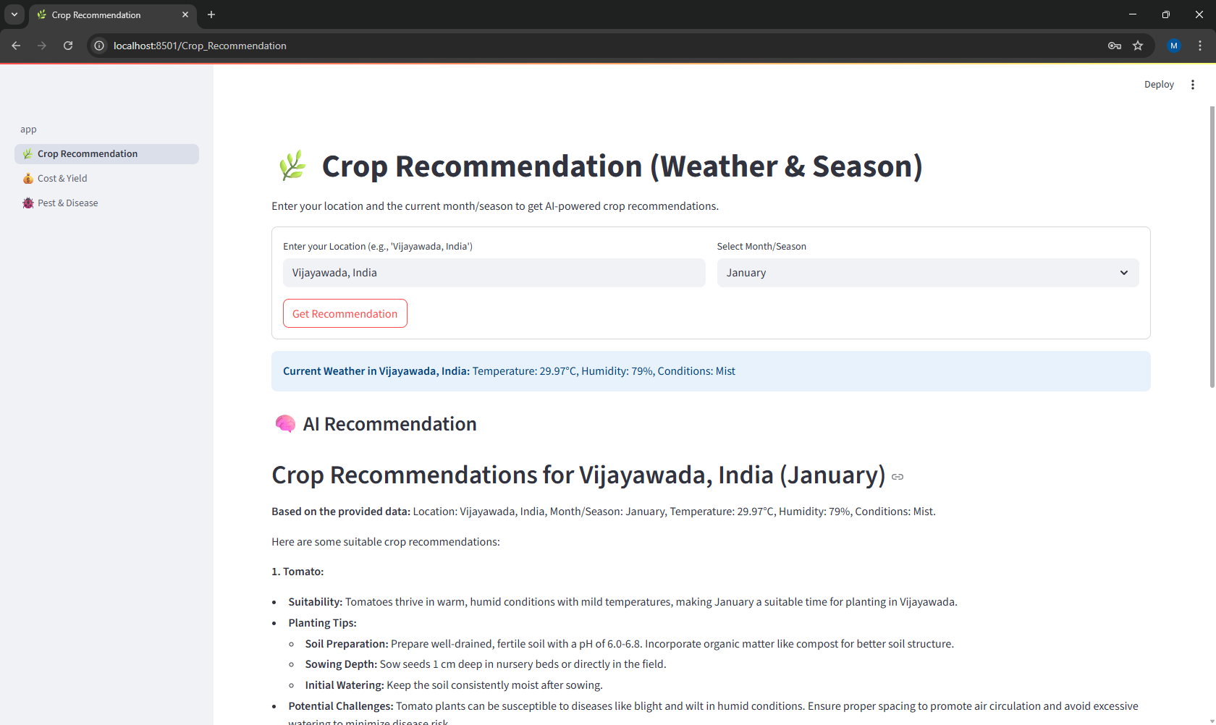
Figure 5: EcoHarvest AI Crop Recommendation Interface
This screenshot displays the Crop Recommendation feature of the EcoHarvest AI application. The user interface is designed for data-driven crop suggestions, allowing users to input their location and the current month/season using two dropdown fields. After entering "Vijayawada, India" and "January," the application displays the current weather conditions for that location. The main content area then presents a detailed "AI Recommendation." In this example, the recommendation is for Tomato, complete with a list of its suitability for the specified conditions, essential planting tips, and a section on potential challenges to help the user mitigate risks. This feature leverages real-time weather and seasonal data to provide actionable advice.
6.3.3 Impact
- Helps farmers diversify crop planning.
- Reduces risk of crop failure due to incorrect crop selection.
- Encourages scientific agriculture rather than trial-and-error.

6.4 Cost & Yield Optimization Module
6.4.1 Input Scenario
- Crop Type: Rice
- Farm Size: 10 acres
- Resources: Canal irrigation, one tractor, manual labour, access to NPK fertilizers.
6.4.2 Output Results
Short-Term Plan (3–6 months):
- Optimize irrigation scheduling to minimize water use.
- Introduce System of Rice Intensification (SRI) for higher yields.
- Reduce chemical fertilizers by mixing with organic manure.
Long-Term Plan (1–3 years):
- Invest in a drip irrigation system for water efficiency.
- Crop rotation with pulses to enhance soil fertility.
- Diversify into horticulture (banana, mango) for higher market returns.
- Risk management through partial crop insurance.
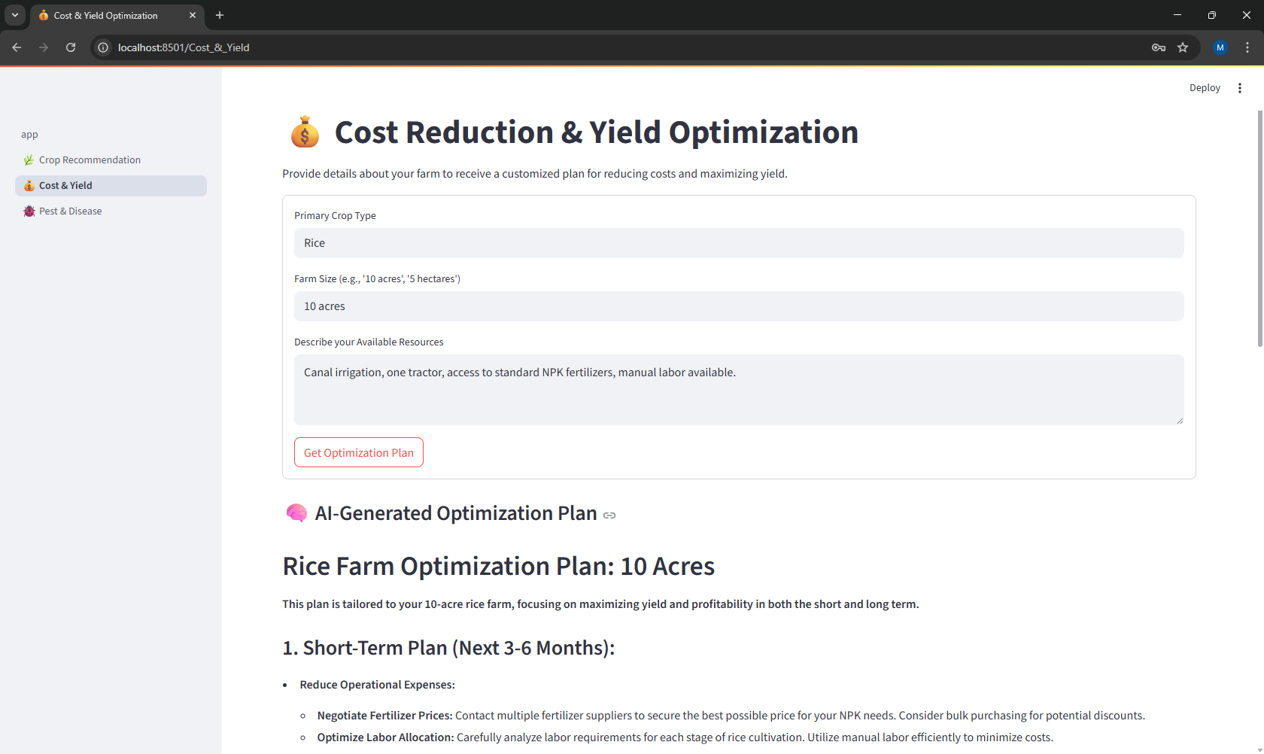
Figure 6: EcoHarvest AI Cost Reduction and Yield Optimization Interface
This screenshot shows the Cost Reduction & Yield Optimization feature of the EcoHarvest AI application. The user interface is designed to generate a customized farm plan based on user inputs. The user has provided details about their farm, including the Primary Crop Type (Rice), Farm Size (10 acres), and a description of their Available Resources (e.g., canal irrigation, tractor, fertilizers, labor). The lower section of the page displays the AI-Generated Optimization Plan tailored to the specific inputs. The plan provides actionable advice for a Short-Term Plan (Next 3-6 Months), focusing on strategies to reduce operational expenses and increase profitability, demonstrating how the application provides personalized, data-driven solutions for farm management.

6.4.3 Impact
- Farmers gain clear financial strategies for both short- and long-term.
- Helps reduce unnecessary expenses and increase ROI.
- Encourages sustainable and eco-friendly practices.

6.5 Pest & Disease Detection Module 🐞
6.5.1 Input Scenario 1 – Image Upload
- Uploaded Image: Leaf showing white powdery spots.
System Workflow:
- CNN placeholder → “Powdery Mildew detected”.
- LangChain AI → Generates complete diagnosis and treatment.
Output Recommendation:
- Diagnosis: Powdery Mildew.
- Immediate Action: Isolate infected plants.
- Organic Treatment: Spray neem oil solution (3%) every 7–10 days.
- Chemical Option: Fungicides containing sulfur, with safety precautions.
- Prevention: Proper plant spacing and avoiding overhead irrigation.
6.5.2 Input Scenario 2 – Text Description
- Farmer’s Input: “Yellow spots with a powdery white texture on cucumber leaves.”
AI Response:
- Likely Diagnosis: Downy Mildew or Powdery Mildew.
- Suggested treatments (organic + chemical).
- Long-term prevention strategies.
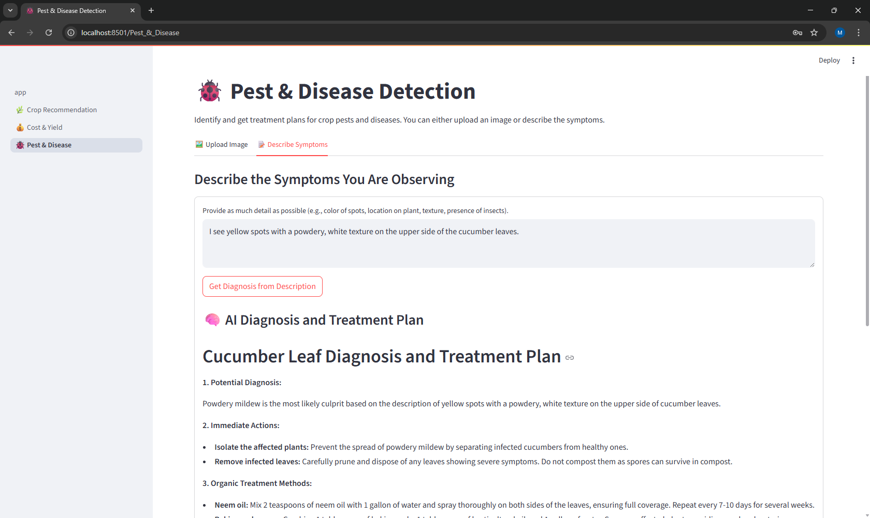
Figure 7: EcoHarvest AI Pest & Disease Detection Interface
This screenshot displays the Pest & Disease Detection feature of the EcoHarvest AI application, which allows users to get a diagnosis and treatment plan for crop issues. The user interface provides two options: "Upload Image" for visual analysis and "Describe Symptoms" for text-based input. In this example, the user has chosen the text-based option and described symptoms on cucumber leaves. The application has then generated an AI Diagnosis and Treatment Plan, which includes a Potential Diagnosis (Powdery mildew), Immediate Actions to take, and specific Organic Treatment Methods. This feature demonstrates the application's ability to provide a comprehensive, data-driven solution for crop health management.
6.5.3 Impact
- Farmers receive early pest diagnosis, reducing yield losses.
- Encourages organic pest control before chemical intervention.
- Helps break the cycle of pesticide overuse.

6.7 Comparative Analysis of Results
Feature | Traditional System | Eco Harvest AI Output
Crop Recommendation | Generalized advice by season. | Real-time, location-specific, weather-based.
Cost & Yield Planning | Rarely available. | Actionable short-term + long-term plans.
Pest Detection | Visual inspection, error-prone. | AI-powered, detailed treatment strategy.
Accessibility | Limited to extension services. | Online, 24/7, multi-feature platform.

6.8 Sample End-to-End User Journey
- Login: Farmer enters credentials.
- Crop Selection: Inputs location & month → gets crop suggestions.
- Optimization Plan: Inputs farm details → gets cost-saving strategies.
- Pest Analysis: Uploads leaf image → receives treatment plan.
- Session Review: Revisits history for all recommendations.
6.9 Limitations Observed
- Pest detection is currently placeholder CNN-based and needs a fully trained deep learning model.
- Crop recommendation relies mainly on weather and season, without soil testing integration.
- Requires stable internet connectivity to fetch API data.

CHAPTER VII
CONCLUSION
7.1 Introduction
The Eco Harvest AI project represents a significant step forward in applying artificial intelligence and machine learning to agriculture. Unlike conventional farming advisory systems, this platform integrates crop recommendation, cost and yield optimization, and pest/disease detection into a centralized decision-support system accessible to farmers through a simple web interface.
This chapter presents a detailed conclusion of the project, highlighting its contributions, observed benefits, limitations, and long-term implications for agriculture and sustainability.

7.2 Key Contributions of Eco Harvest AI
- Integration of Multiple Modules:
  - Traditional farming relies on fragmented systems for weather, pests, and financial advice.
  - Eco Harvest AI successfully integrates all these into one platform, ensuring farmers no longer need to rely on multiple disconnected tools.
- AI-Driven Insights:
  - By leveraging Groq LLMs and LangChain, the system delivers context-aware, structured, and actionable recommendations.
  - Farmers receive suggestions tailored to their location, season, weather conditions, and available resources.
- User-Friendly Accessibility:
  - Built on Streamlit, the interface is clean, responsive, and easy to navigate, ensuring adoption even by farmers with limited technical experience.
- Sustainability-Oriented Approach:
  - Promotes organic pest management before chemical use.
  - Encourages resource-efficient practices like drip irrigation, crop rotation, and soil enrichment.

7.3 Benefits Realized
Benefit | Outcome in Practice
Accurate Crop Selection | Farmers select crops aligned with weather/season, reducing failure risks.
Cost Efficiency | Optimized fertilizer, irrigation, and machinery planning reduced unnecessary expenses.
Pest Management | Early detection prevents large-scale crop damage.
Time-Saving | Automated recommendations reduce dependency on manual advisory visits.
Knowledge Empowerment | Farmers gain access to AI-driven knowledge, bridging the gap between experts and grassroots.
Sustainability | Eco-friendly practices reduce environmental damage and ensure soil health.

7.4 Lessons Learned
- AI Can Enhance Traditional Wisdom: Farmers’ intuition combined with AI predictions leads to better outcomes.
- Data is Key: Real-time weather data significantly improves crop planning, but integrating soil and market data would further boost accuracy.
- Trust and Adoption: Farmers are more likely to adopt AI systems if the interface is simple, localized (languages), and reliable.
- Scalability: The system demonstrates potential for deployment across villages, cooperatives, and government schemes.
7.5 Limitations
- Pest Detection Module:
  - Currently relies on a placeholder CNN model for image analysis.
  - Needs integration of a fully trained CNN or transfer learning with datasets like Plant Village for real-world accuracy.
- Soil Data Integration:
  - The platform doesn’t yet consider soil nutrient profiles (NPK levels, pH) for recommendations.
  - Future expansion should link with soil testing labs or IoT soil sensors.
- Connectivity Requirement:
  - As an online system, it requires stable internet, which may be challenging in rural areas.
- Market Intelligence Gap:
  - While it recommends crops based on weather, it doesn’t yet integrate market demand and pricing data.
7.6 Long-Term Impact
The project has the potential to:
- Revolutionize farming advisory systems by making them proactive, data-driven, and farmer-centric.
- Reduce crop losses by early pest detection.
- Increase farm profitability through cost/yield optimization.
- Contribute to sustainable agriculture and food security, addressing challenges posed by climate change and population growth.
7.7 Final Thoughts
Eco Harvest AI successfully demonstrates how modern AI technologies (LLMs, LangChain, CNNs, and APIs) can transform agriculture from traditional, experience-based practices into precision-driven, smart farming solutions.
This project does not merely act as a proof of concept—it lays the foundation for a scalable, farmer-friendly digital ecosystem that:
- Empowers farmers with knowledge.
- Reduces dependency on middlemen for advisory.
- Promotes sustainable, profitable, and resilient farming practices.
With further refinements, Eco Harvest AI can evolve into a global agricultural platform, supporting smallholder farmers in India, Africa, and beyond—making agriculture more scientific, sustainable, and inclusive.

CHAPTER VIII
FUTURE SCOPE
8.1 Introduction
While Eco Harvest AI has demonstrated the ability to integrate AI-driven crop recommendation, cost optimization, and pest detection into one unified platform, the scope for future improvements and scalability remains significant. Agriculture is a dynamic field, influenced by climate change, soil degradation, and evolving market conditions. To remain relevant and impactful, Eco Harvest AI must continue to evolve, embracing new technologies such as IoT, remote sensing, big data analytics, and blockchain.
8.2 Potential Future Enhancements
8.2.1 Integration of Soil Health Data
- Current system bases recommendations primarily on weather and seasonality.
- Future versions can integrate:
  - Soil test reports (NPK levels, organic matter, pH).
  - IoT-based soil sensors for real-time monitoring.
- This will lead to nutrient-specific crop recommendations and precision fertilizer application.
8.2.2 Advanced Pest and Disease Detection
- Replace placeholder CNN with a fully trained deep learning model using datasets like:
  - PlantVillage Dataset (54,000+ images of diseased/healthy leaves).
  - Transfer learning via ResNet, EfficientNet, or Inception.
- Mobile App Integration: Farmers capture leaf images with smartphones for instant results.
- AI Confidence Scores: Providing probability-based predictions for better trust.
8.2.3 Market Intelligence & Price Forecasting
- Farmers often grow crops without considering demand and price fluctuations.
- Future integration of:
  - Agri-market APIs (e.g., AgMarkNet in India).
  - Time-series forecasting models (ARIMA, LSTM) for price predictions.
- Benefit: Aligns production with market trends, reducing losses and increasing profits.
8.2.4 IoT and Smart Farming Integration
- Eco Harvest AI can connect with:
  - Weather stations for hyper-local forecasts.
  - Smart irrigation systems that adjust based on soil moisture.
  - Drones & satellites for remote field monitoring.
- Outcome: Enables precision agriculture at scale.
8.2.5 Blockchain for Supply Chain Transparency
- Future versions may incorporate blockchain-based crop traceability.
- Farmers can securely record crop data from sowing to harvest, ensuring fair pricing and trust in supply chains.
- Benefits: Better contracts, transparency, and reduced exploitation of farmers.
8.2.6 Multilingual and Offline Support
- Expand the platform to support regional languages (Telugu, Hindi, Tamil, etc.).
- Offline Mode: Use lightweight on-device models for areas with poor connectivity.
- Impact: Increases adoption by smallholder farmers in rural and remote regions.
8.2.7 Expansion to Climate-Smart Agriculture
- Incorporate climate adaptation strategies:
  - Drought-resistant crop suggestions.
  - Seasonal shift advisories for extreme weather.
  - AI-powered carbon footprint calculators for farms.
- Supports sustainability goals (SDGs 2, 12, 13).
8.3 Future Research Directions
- Integration of Remote Sensing Data:
  - Use satellite imagery (NDVI, MODIS) for monitoring crop health.
  - Detect stress, pest hotspots, and irrigation needs remotely.
- Federated Learning for Agriculture:
  - Train AI models collaboratively without centralized data storage.
  - Ensures data privacy for farmers while improving model accuracy.
- Predictive Analytics for Farm Insurance:
  - AI models predicting risk of crop failure can aid insurance schemes.
  - Helps policymakers design better farmer relief systems.

References:
1. Konfo, T.R.C.; Chabi, A.B.P.; Gero, A.A.; Lagnika, C.; Avlessi, F.; Biaou, G.; Sohounhloue, C.K.D. Recent climate-smart innovations in agrifood to enhance producer incomes through sustainable solutions. J. Agric. Food Res. 2024, 15, 100985. [CrossRef]
2. Greco, C.; Comparetti, A.; Febo, P.; La Placa, G.; Mammano, M.M.; Orlando, S. Sustainable Valorisation of Biowaste for Soilless Cultivation of Salvia Officinalis in a Circular Bioeconomy. Agronomy 2020, 10, 1158. [CrossRef]
3. Orlando, S.; Greco, C.; Tuttolomondo, T.; Leto, C.; Cammalleri, I.; La Bella, S. Identification of Energy Hubs for the Exploitation of Residual Biomass in an Area of Western Sicily. In Proceedings of the EUBCE 2017 Online Conference Proceedings, Stockholm, Sweden, 12–15 June 2017; pp. 64–69.
4. Comparetti, A.; Febo, P.; Greco, C.; Navickas, K.; Nekrosius, A.; Orlando, S.; Venslauskas, K. Assessment of organic waste management methods through energy balance. Am. J. Appl. Sci. 2014, 11, 1631–1644. [CrossRef]
5. Choruma, D.J.; Dirwai, T.L.; Mutenje, M.J.; Mustafa, M.; Chimonyo, V.G.P.; Jacobs-Mata, I.; Mabhaudhi, T. Digitalisation in agriculture: A scoping review of technologies in practice, challenges, and opportunities for smallholder farmers in sub-saharan Africa. J. Agric. Food Res. 2024, 18, 101286. [CrossRef]
6. Rakholia, R.; Tailor, J.; Prajapati, M.; Shah, M.; Saini, J.R. Emerging technology adoption for sustainable agriculture in India—A pilot study. J. Agric. Food Res. 2024, 17, 101238. [CrossRef]
7. Rajak, P.; Ganguly, A.; Adhikary, S.; Bhattacharya, S. Internet of Things and smart sensors in agriculture: Scopes and challenges. J. Agric. Food Res. 2023, 14, 100776. [CrossRef]
8. Rodríguez, J.P.; Montoya-Munoz, A.I.; Rodriguez-Pabon, C.; Hoyos, J.; Corrales, J.C. IoT-Agro: A smart farming system to Colombian coffee farms. Comput. Electron. Agric. 2021, 190, 106442. [CrossRef]
9. Kwaghtyo, D.K.; Eke, C.I. Smart farming prediction models for precision agriculture: A comprehensive survey. Artif. Intell. Rev. 2023, 56, 5729–5772. [CrossRef]
10. Lykas, C.; Vagelas, I. Innovations in Agriculture for Sustainable Agro-Systems. Agronomy 2023, 13, 2309. [CrossRef]
11. Taoufik, B.; Rhaimi, C.; Alomari, S.; Aljuhani, L. Design and Implementation of an Integrated IoT and Artificial Intelligence System for Smart Irrigation Management. Int. J. Adv. Soft Comput. Appl. 2024, 16, 197–218.
12. Muhie, S.H. Novel approaches and practices to sustainable agriculture. J. Agric. Food Res. 2022, 10, 100446. [CrossRef]
13. Lytos, A.; Lagkas, T.; Sarigiannidis, P.; Zervakis, M.; Livanos, G. Towards smart farming: Systems, frameworks and exploitation of multiple sources. Comput. Netw. 2020, 172, 107147. [CrossRef]
14. Széles, A.; Huzsvai, L.; Mohammed, S.; Nyéki, A.; Zagyi, P.; Horváth, E.; Simon, K.; Arshad, S.; Tamás, A. Precision agricultural technology for advanced monitoring of maize yield under different fertilization and irrigation regimes: A case study in Eastern Hungary (Debrecen). J. Agric. Food Res. 2024, 15, 100967. [CrossRef]
15. Javaid, M.; Haleem, A.; Singh, R.P.; Suman, R. Enhancing smart farming through the applications of Agriculture 4.0 technologies. Int. J. Intell. Netw. 2022, 3, 150–164. [CrossRef]

Appendix:
import streamlit as st
import os
from dotenv import load_dotenv

# --- PAGE CONFIGURATION ---
st.set_page_config(
page_title="EcoHarvest AI Login",
page_icon="🔐",
layout="centered",
initial_sidebar_state="collapsed"
)
# --- LOAD ENVIRONMENT VARIABLES ---
# It's good practice to load environment variables at the start.
load_dotenv()

# --- AUTHENTICATION LOGIC ---
def check_password():
"""Returns `True` if the user has entered the correct password."""
def password_entered():
"""Checks whether a password entered by the user is correct."""
# Hardcoded credentials for this example
# In a real-world scenario, use st.secrets or a secure authentication service
if st.session_state["username"] in ["admin"] and st.session_state["password"] in ["12345"]:
st.session_state["authenticated"] = True
del st.session_state["password"] # clear password from memory
del st.session_state["username"]
else:
st.session_state["authenticated"] = False
# Initialize session state for authentication if it doesn't exist
if "authenticated" not in st.session_state:
st.session_state["authenticated"] = False

# Show login form if not authenticated
if not st.session_state["authenticated"]:
st.text_input("Username", key="username")
st.text_input("Password", type="password", key="password")
if st.button("Login"):
password_entered()
# Rerun to update the page state after login attempt
st.rerun()

# Return authentication status
return st.session_state["authenticated"]

# --- MAIN APP LOGIC ---
def main():
"""Main function to run the Streamlit app."""

st.title("Welcome to EcoHarvest AI 🌾")
st.write("---")

if check_password():
# --- SIDEBAR ---
with st.sidebar:
st.title("EcoHarvest AI")
# st.image("./assets/logo.png", width=150) # Optional: Add a logo image in an assets folder
st.write("Your AI-powered agricultural assistant.")
st.write("---")

if st.button("Logout"):
st.session_state["authenticated"] = False
st.rerun()
# --- HOME PAGE CONTENT ---
st.header("🏠 Home")
st.write("You are successfully logged in.")
st.info("Please select a feature from the sidebar to begin.")

st.subheader("About EcoHarvest AI")
st.markdown("""
**EcoHarvest AI** is a comprehensive tool designed to empower farmers with data-driven insights.
Leveraging state-of-the-art AI, this application provides tailored recommendations to enhance agricultural productivity and sustainability.

**Features:**
- **🌿 Crop Recommendation:** Get suggestions for the best crops to plant based on your location's real-time weather and seasonal data.
- **💰 Cost & Yield Optimization:** Receive actionable strategies to reduce farming costs and maximize your harvest.
- **🐞 Pest & Disease Detection:** Upload an image or describe symptoms to identify potential threats and get effective treatment plans.

Navigate to the desired page using the links in the sidebar.
""")
else:
st.warning("Please enter your username and password to proceed.")
st.stop()

if __name__ == "__main__":
main()

