LABORATORY RECORD
Course: Full Stack Web Development
Course Code: 23CM4121
Experiment No.: 8
Student Name: G.Kavya
Roll No.: A24126552082
Date: 5-10-2026

Title
Implementation of HTTP Methods using JSON Server

Aim
To implement and demonstrate the GET, POST, PUT and DELETE HTTP methods using JSON Server for managing data in a RESTful web application.

Objectives
- To understand the concept of a REST API and JSON Server.
- To create a simple JSON-based REST API.
- To perform GET, POST, PUT and DELETE operations.
- To understand how client applications communicate with a server using HTTP methods.
- To test API endpoints using a suitable tool such as Postman or a web browser.

Theory
JSON Server is a lightweight tool that allows developers to create a REST API from a JSON file without developing a complete backend server.
It uses HTTP methods to perform operations on resources:

HTTP Method | Purpose | Example
GET | Retrieve data | Get all students
POST | Add new data | Add a student
PUT | Update existing data | Update student details
DELETE | Remove data | Delete a student

For this experiment, a db.json file is used as the database.
Example resource:
{
"students": [
{
"id": 1,
"name": "Ravi",
"branch": "CSE",
"marks": 85
}
]
}
When JSON Server is started, it automatically provides REST endpoints such as:

GET /students
GET /students/1 POST /students
PUT /students/1
DELETE /students/1

Thus, JSON Server helps students understand RESTful API operations before working with a full backend framework.
index.html :
<!DOCTYPE html> <html lang="en">

<head>
<meta charset="UTF-8"> <meta name="viewport" content="width=device-width, initialscale=1.0">

<title>Student Management System</title>
<style> body { font-family: Arial, sans-serif; margin: 40px; background-color: #f4f4f4;
} h1 { text-align: center;
}

.form-container { background: white; padding: 20px; margin-bottom: 25px; border-radius: 8px;
} input { padding: 10px; margin: 5px;
} button { padding: 9px 14px; margin: 5px; cursor: pointer;
} table { width: 100%; background: white; border-collapse: collapse;
} th, td { padding: 12px; border: 1px solid #ccc; text-align: center;
} th { background-color: #333; color: white;
}
</style> </head>

<body>

<h1>Student Management System</h1>

<div class="form-container">

<h2>Add Student</h2>

<input type="text" id="name" placeholder="Student Name">

<input type="text" id="branch" placeholder="Branch"> <input type="number" id="marks" placeholder="Marks">

<button onclick="addStudent()">Add Student</button> <button onclick="getStudents()">Refresh</button>

</div>

<div class="form-container">

<h2>Student Records</h2>

<table>

<thead> <tr> <th>ID</th> <th>Name</th> <th>Branch</th> <th>Marks</th> <th>Actions</th> </tr> </thead>

<tbody id="studentTable">
</tbody>

</table>

</div>

<script src="script.js"></script>

</body> </html>

script.js

const API_URL = "http://localhost:3000/students";

// GET: Display all students async function getStudents() {
try { const response = await fetch(API_URL);
const students = await response.json();
const table = document.getElementById("studentTable");
table.innerHTML = "";
students.forEach(student => {
const row = document.createElement("tr");
row.innerHTML = `
<td>${student.id}</td>
<td>${student.name}</td>
<td>${student.branch}</td>
<td>${student.marks}</td>

<td> <button onclick="updateStudent('${student.id}')"> Update </button>

<button onclick="deleteStudent('${student.id}')"> Delete </button> </td>
`;
table.appendChild(row);
});

} catch (error) {

console.error("Error:", error);

alert("Unable to fetch student records.");

}
}

// POST: Add a new student async function addStudent() {
const name = document.getElementById("name").value; const branch = document.getElementById("branch").value; const marks = document.getElementById("marks").value;
if (name === "" || branch === "" || marks === "") {

alert("Please enter all student details.");
return;
} const student = {
name: name, branch: branch, marks: Number(marks)

}; try {
const response = await fetch(API_URL, {
method: "POST",
headers: {

"Content-Type": "application/json"
},
body: JSON.stringify(student)

}); if (response.ok) { alert("Student added successfully.");
document.getElementById("name").value = ""; document.getElementById("branch").value = ""; document.getElementById("marks").value = "";
getStudents();

}

} catch (error) {
console.error("Error:", error);

alert("Unable to add student.");

}
}

// PUT: Update student async function updateStudent(id) {
try {

// Get current student details
const response = await fetch(`${API_URL}/${id}`);
const student = await response.json();

// Ask for updated values const name = prompt("Enter student name:", student.name);
if (name === null) { return;
} const branch = prompt("Enter branch:", student.branch); if (branch === null) { return;
} const marks = prompt("Enter marks:", student.marks);
if (marks === null) { return;
} const updatedStudent = {
name: name, branch: branch, marks: Number(marks)

};

// Update using PUT const updateResponse = await fetch(`${API_URL}/${id}`, {
method: "PUT",
headers: {

"Content-Type": "application/json"
},
body: JSON.stringify(updatedStudent)

}); if (updateResponse.ok) {

alert("Student updated successfully.");

getStudents();

}

} catch (error) {
console.error("Error:", error);

alert("Unable to update student.");

}
}

// DELETE: Delete student async function deleteStudent(id) {
const confirmDelete = confirm(

"Are you sure you want to delete this student?"
); if (!confirmDelete) { return;
} try { const response = await fetch(`${API_URL}/${id}`, {

method: "DELETE"

});
if (response.ok) {

alert("Student deleted successfully.");
getStudents();

}

} catch (error) {

console.error("Error:", error); alert("Unable to delete student.");

}
}

// Load students when page opens getStudents();

OUTPUT:
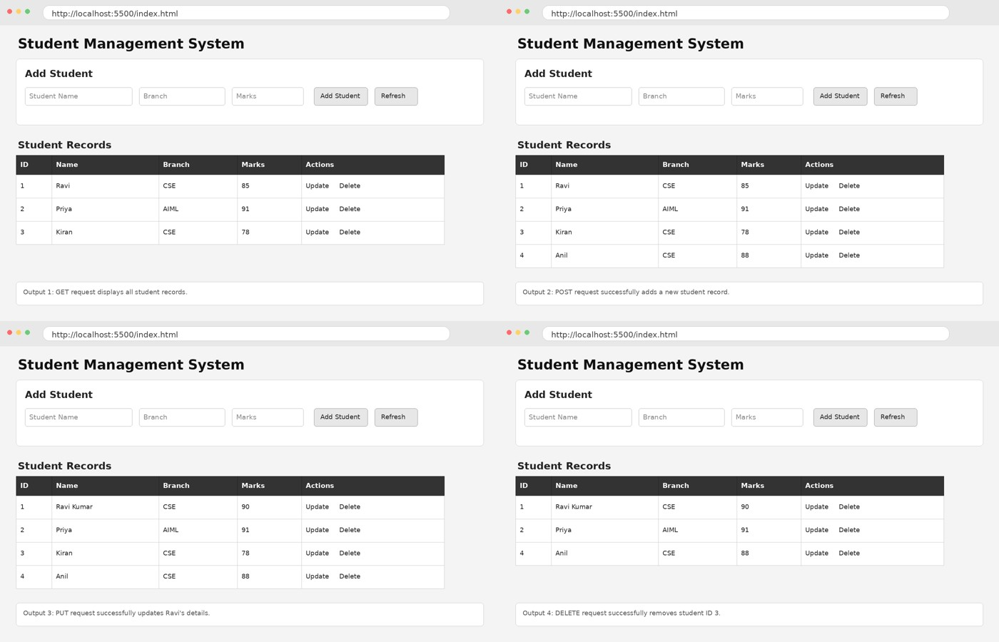

Algorithm / Procedure
Step 1
Install Node.js and npm on the system.

Step 2
Create a new project folder named:
JSONServerDemo

Step 3
Open the terminal in the project folder and initialize the project:
npm init -y
Step 4
Install JSON Server: npm install json-server
Step 5
Create a file named: db.json
Step 6
Add sample student data to db.json.
Step 7
Start JSON Server using: npx json-server --watch db.json --port 3000
Step 8
Test the GET operation to retrieve all students.
Step 9
Test the POST operation to add a new student.
Step 10
Test the PUT operation to modify an existing student's details.
Step 11
Test the DELETE operation to remove a student.
Step 12
Verify the changes in db.json and record the outputs.

Program / Code
1. db.json
Create the following file:
{
"students": [
{

"id": "1", "name": "Ravi", "branch": "CSE", "marks": 85
},
{

"id": "2",
"name": "Priya",

"branch": "AIML", "marks": 91
},
{

"id": "3",
"name": "Kiran",

"branch": "CSE", "marks": 78
}
]
}
2. Start JSON Server npx json-server --watch db.json --port 3000
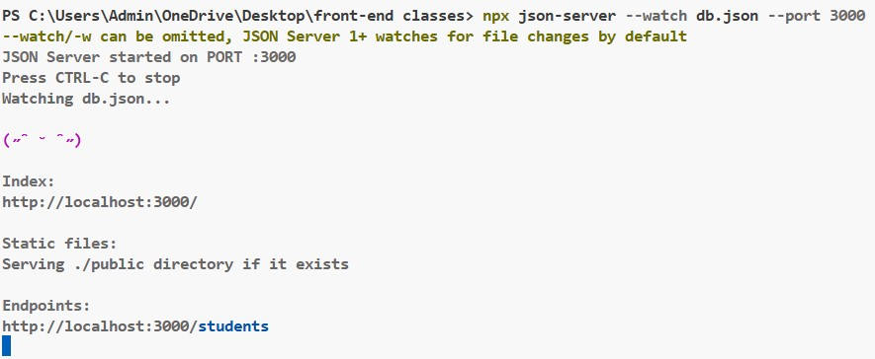

HTTP Operations

A. GET Method

Retrieve all students
Method: GET
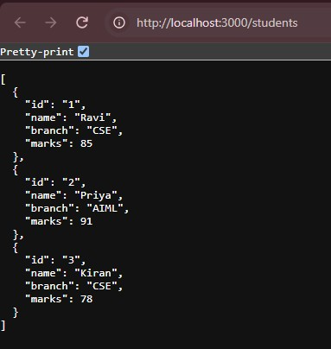

B. POST Method

Add a new student
Method: POST
{
"name": "Anil",
"branch": "CSE",
"marks": 88
}

C. PUT Method

Update student details
Method: PUT
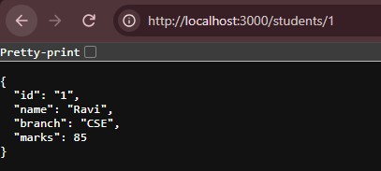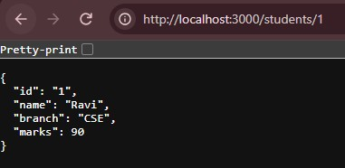

The details of student with ID 1 will be updated.

D. DELETE Method

Delete a student
Method: DELETE
http://localhost:3000/students/3 - The student with ID 3 will be removed.

Test Cases and Execution Data
Students should record at least the following test cases:

Test Case | HTTP Method | URL | Input / Operation | Expected Result
TC01 | GET | /students | Retrieve all students | All student records are displayed
TC02 | GET | /students/1 | Retrieve student ID 1 | Student ID 1 details are displayed
TC03 | POST | /students | Add Anil, CSE, 88 | New student record is created
TC04 | PUT | /students/1 | Change Ravi's marks to 90 | Student ID 1 is updated
TC05 | DELETE | /students/3 | Delete student ID 3 | Student ID 3 is deleted

Execution Data
Operation | Input | Actual Output | Status
GET all students | /students | 3 student records displayed | Pass
GET student | /students/1 | Ravi's details displayed | Pass
POST student | Anil, CSE, 88 | New record added | Pass
PUT student | ID 1, marks = 90 | Record updated | Pass
DELETE student | ID 3 | Record deleted | Pass

Result
Thus, the GET, POST, PUT and DELETE HTTP methods were successfully implemented and tested using JSON Server for managing student records.

