THESIS PROPOSAL

COMPARATIVE ANALYSIS OF FUNDUS IMAGE PREPROCESSING TECHNIQUES AND DEEP LEARNING ARCHITECTURES FOR DIABETIC RETINOPATHY SEVERITY CLASSIFICATION WITH CROSS-DATASET EVALUATION

By:
Gede Tanok Arta Wijaya
Student ID Number: 2315101018

STUDY PROGRAM OF COMPUTER SCIENCE
DEPARTMENT OF INFORMATICS ENGINEERING
FACULTY OF ENGINEERING AND VOCATIONAL STUDIES
UNIVERSITAS PENDIDIKAN GANESHA
2026

THESIS PROPOSAL APPROVAL SHEET

The thesis proposal entitled:
Comparative Analysis of Fundus Image Preprocessing Techniques and Deep Learning Architectures for Diabetic Retinopathy Severity Classification with Cross-Dataset Evaluation

prepared by:
Name : Gede Tanok Arta Wijaya
Student ID Number : 2315101018
Study Program : Computer Science
Department : Informatics Engineering
Faculty : Engineering and Vocational Studies

has been approved by the supervisors to be presented in the thesis proposal seminar.

Singaraja, 2026

Supervisor I

I Made Putrama, S.T., M.Tech., Ph.D.
NIP. ....................................

Supervisor II

....................................
NIP. ....................................

ABSTRACT
Gede Tanok Arta Wijaya. 2315101018. 2026. Comparative Analysis of Fundus Image Preprocessing Techniques and Deep Learning Architectures for Diabetic Retinopathy Severity Classification with Cross-Dataset Evaluation. Thesis Proposal. Computer Science, Informatics Engineering, Engineering and Vocational Studies, Universitas Pendidikan Ganesha.

Supervisor I: I Made Putrama, S.T., M.Tech., Ph.D.; Supervisor II: ....................................

Diabetic retinopathy (DR) is a leading cause of preventable blindness among working-age adults, with rapidly increasing prevalence in Indonesia, while the ophthalmologist-to-population ratio remains far from sufficient to sustain annual fundus screening. Deep learning models have achieved high accuracy in classifying DR severity on fundus images, yet the existing literature tends to select preprocessing techniques and backbone architectures ad-hoc without apple-to-apple comparisons, and rarely evaluates model robustness under cross-dataset conditions. This study conducts a 5x2 factorial comparative analysis of five fundus-image preprocessing techniques (CLAHE, Ben Graham preprocessing, Adaptive Sigmoid Enhancement, LAB-ACE, and Multi-channel Image Enhancement) paired with two backbone architectures (ResNet-50 and Vision Transformer ViT-B/16), using the IDRiD dataset for in-distribution training and evaluation and the DDR dataset for cross-dataset zero-shot evaluation to probe robustness under inter-institutional domain shift. Evaluation is performed using accuracy, quadratic-weighted kappa, and macro-F1, with bootstrap-based confidence intervals and paired significance testing across configurations. The Grad-CAM interpretability technique is applied to the best-performing configuration to visualise lesion regions driving model predictions. The study is expected to deliver reproducible empirical guidance on the preprocessing-and-backbone combinations most suitable for deploying automated DR screening in Indonesian primary-care settings.

Keywords: diabetic retinopathy, fundus image preprocessing, deep learning, Vision Transformer, ResNet-50, cross-dataset evaluation, IDRiD, DDR

TABLE OF CONTENTS

Right-click this table of contents and choose Update Field to display chapter titles and page numbers.

CHAPTER I INTRODUCTION

1.1 Background of the Study
Diabetes mellitus has become one of the most pressing non-communicable disease burdens of the twenty-first century, and diabetic retinopathy (DR), a progressive microvascular complication of the disease, remains the leading cause of preventable blindness among working-age adults in most middle- and high-income countries (American Diabetes Association, 2024). Teo et al. (2021) project that the number of adults affected by DR will rise from 103 million in 2020 to approximately 161 million by 2045, with vision-threatening DR affecting nearly 29 million people globally. The situation in Indonesia is particularly urgent: Sasongko et al. (2025), in a five-year cohort study of 695 patients with type 2 diabetes in a Yogyakarta community, recorded a DR incidence of 34.6 per 1,000 person-years and DR-related blindness of 8.3 per 1,000 person-years, while Saputra et al. (2024) reported a DR prevalence of 55% among diabetic patients at a referral hospital in Padang. The ophthalmologist ratio in Indonesia, however, is fewer than two specialists per 100,000 population and is concentrated in the urban areas of Java, which structurally makes it impossible to deliver the annual fundus examination recommended by the Standards of Care in Diabetes (American Diabetes Association, 2024). An operationally feasible screening strategy for Indonesia must therefore rely on automated interpretation of fundus images at the primary-care level.
The task that needs to be automated is not merely detecting the presence or absence of disease, but determining its severity. Clinically, DR is stratified using the International Clinical Diabetic Retinopathy (ICDR) severity scale proposed by Wilkinson et al. (2003) into five ordinal grades, ranging from no retinopathy (no DR), mild NPDR, moderate NPDR, and severe NPDR, to proliferative DR (PDR), and it is this grade that determines referral decisions: patients with moderate NPDR or worse are referred for specialist evaluation, while PDR demands immediate intervention to prevent permanent vision loss. Because each grade maps to a different clinical action, misclassification is not neutral: under-grading a patient means a delayed referral, whereas over-grading burdens the already scarce capacity of specialists. An automated screening system is therefore required to be accurate precisely at the decision boundaries of these five classes, not merely high on average accuracy.
Deep learning has transformed the landscape of automated DR grading over the past decade. Gulshan et al. (2016), in a landmark study published in JAMA, showed that a convolutional neural network (CNN) trained on 128,175 fundus images could detect referable DR with sensitivity and specificity above 90%, matching board-certified ophthalmologists on curated data. Abramoff et al. (2018) translated a similar approach into IDx-DR, the first artificial intelligence device to obtain U.S. Food and Drug Administration clearance for autonomous clinical use, while large-scale foundation models such as RETFound (Zhou et al., 2023) have further narrowed the gap between research systems and clinical systems. A recent comprehensive survey synthesising more than fifty studies and twenty DR datasets between 2016 and 2025 confirms this technical maturity, but at the same time underscores that the principal gap has shifted toward multi-center validation and clinical trust (Chopra et al., 2025). From the standpoint of technical capability, then, automated DR screening is no longer an open problem. The problem is that almost all of these achievements were obtained and validated on neatly curated data, so they may not hold once the system is moved into the far more heterogeneous conditions of the field.
It is precisely at this point that the gap between research achievement and routine clinical deployment opens up, on aspects that are often overlooked in academic evaluation. The first issue is fundus image quality. Uneven illumination, low contrast, and acquisition noise systematically degrade the accuracy of automated grading systems (Anupama et al., 2025), and this problem is most severe on the low-cost fundus devices realistically used in Indonesian primary care. When early lesions such as microaneurysms cannot be read because of poor images, the model tends to grade patients lower than their actual condition, exactly the type of error that leads to a delayed referral. Various preprocessing techniques have been proposed to improve lesion visibility, ranging from Contrast Limited Adaptive Histogram Equalization (CLAHE), Ben Graham preprocessing, and green-channel extraction, to newer enhancement techniques such as Adaptive Sigmoid Enhancement, LAB-ACE, and Multi-channel Image Enhancement. Their application in the literature, however, tends to be ad-hoc: each study selects a single technique without comparing it on an equal footing with the other alternatives under the same architecture and training protocol. Anupama et al. (2025), in their publication in Scientific Reports, assess that current preprocessing methods for DR grading remain limited to a single focus, such as applying noise filters or contrast enhancement, and therefore do not comprehensively address the diversity and complexity of fundus images; they recommend a systematic exploration of technique combinations. As long as an apple-to-apple comparison between preprocessing techniques under the same architecture is unavailable, the choice of preprocessing for a screening system still rests on guesswork rather than evidence.
The second issue is cross-dataset generalisation. Chokuwa and Khan (2025) show that a DR grading model trained on one dataset source degrades significantly when faced with out-of-distribution data from a different acquisition setting, even when the grading ontology used is identical. Such a drop is not merely a statistical difference: a model that appears adequate on development data can become unreliable for referral decisions when applied to a new population. Differences in camera devices, patient populations, and illumination protocols across institutions are the principal causes, and these are precisely the conditions that will be encountered in Indonesia, where a model is operated on fundus camera devices and patient populations that differ from the public dataset on which it was trained. A model that misclassifies Indonesian patients not only risks missing cases that should be referred, but also wastes the scarce capacity of specialists on mistaken referrals. Anupama et al. (2025) underline the same limitation in their future-work section, recommending that future research involve multi-center datasets spanning different acquisition devices, ethnic backgrounds, and demographic distributions in order to improve robustness and real-world applicability. Without empirical evidence on the magnitude of cross-dataset performance degradation, claims of clinical feasibility for a screening system become difficult to justify.
This study addresses both gaps, grounded in the future-work recommendations of Anupama et al. (2025). It compares the five preprocessing techniques paired with two backbone architectures (ResNet-50 and ViT-B/16), yielding ten configurations. All are trained on IDRiD (Porwal et al., 2020) as in-distribution data, then tested on the IDRiD test set and on DDR (Li et al., 2019) as cross-dataset evaluation without adaptation, using accuracy, quadratic-weighted kappa, and macro-F1; Grad-CAM verifies the basis of the best model’s predictions. This study makes three contributions: (i) a reproducible empirical comparison between preprocessing techniques and backbones for DR grading, which is not yet available in the literature; (ii) quantification of cross-dataset performance degradation as evidence relevant to deployment on Indonesian clinical populations; and (iii) evidence-based guidance for building automated DR screening systems for primary care with limited resources.

1.2 Problem Identification
Based on the background described in Section 1.1, the research problems can be identified as follows.
- The burden of diabetic retinopathy in Indonesia is high and continues to rise (an incidence of 34.6 per 1,000 person-years; Sasongko et al., 2025), while the ophthalmologist ratio is fewer than two specialists per 100,000 population and is concentrated in urban Java, so that manual annual fundus screening is structurally infeasible and demands an automated fundus-image interpretation system at the primary-care level.
- The quality of fundus images produced by low-cost devices in primary care varies widely (uneven illumination, low contrast, and acquisition noise), and this degradation in quality reduces the accuracy of automated grading and tends to cause the model to grade patients lower than their actual condition, which is the type of error that leads to a delayed referral.
- The selection of fundus-image preprocessing techniques in the DR grading literature is still ad-hoc: each study generally selects a single technique without comparing it on an equal footing with other techniques under the same architecture and training protocol, so that apple-to-apple comparative evidence to guide the selection is not yet available (Anupama et al., 2025).
- The performance of DR grading models declines when they are applied across datasets because of domain shift (differences in camera devices, populations, and illumination protocols across institutions), yet the magnitude of this decline has not been systematically quantified on dataset pairs with an identical label ontology, even though these are precisely the conditions that will be encountered when the system is operated on the Indonesian population (Chokuwa and Khan, 2025).
- There is as yet no evidence-based guidance on the combination of preprocessing technique and backbone architecture that is most robust to domain shift for developing automated DR screening systems for primary care with limited resources in Indonesia.

1.3 Scope of the Study
So that the research stays focused and feasible to complete within the thesis timeframe, and to isolate the influence of preprocessing and backbone from other factors, the problems identified in Section 1.2 are limited as follows.
- The classification task is limited to five-class grading of diabetic retinopathy severity on the ICDR scale at the image level, without lesion segmentation or detection.
- The datasets used are only the IDRiD Disease Grading subset (Porwal et al., 2020) for training and in-distribution evaluation, and DDR (Li et al., 2019) for cross-dataset evaluation.
- The preprocessing techniques compared are limited to five methods, namely CLAHE, Ben Graham preprocessing, Adaptive Sigmoid Enhancement, LAB-ACE, and Multi-channel Image Enhancement.
- The backbone architectures compared are limited to ResNet-50 (CNN) and ViT-B/16 (Vision Transformer), both trained via transfer learning from ImageNet weights without domain-specific pretraining.
- Evaluation is quantitative (accuracy, quadratic-weighted kappa, macro-F1) with Grad-CAM visualisation on the best configuration. Cross-dataset evaluation is zero-shot transfer without adaptation on DDR. A reader study and prospective deployment are outside the scope.

1.4 Statement of the Problem
Based on the problem identification and scope in Sections 1.2 and 1.3, this study is formulated through the following three research questions.
- On the IDRiD dataset, how do the five preprocessing techniques (CLAHE, Ben Graham preprocessing, Adaptive Sigmoid Enhancement, LAB-ACE, and Multi-channel Image Enhancement) and the two backbone architectures (ResNet-50 and Vision Transformer) affect diabetic retinopathy severity classification performance as measured by accuracy, quadratic-weighted kappa (QWK), and macro-F1?
- How much does the performance of each preprocessing and backbone configuration decline when a model trained on IDRiD is evaluated across datasets on DDR without adaptation, and which configuration shows the best robustness to inter-institutional domain shift?
- What is the trade-off between predictive accuracy, cross-dataset robustness, and computational cost (number of parameters and inference time) for each combination of preprocessing and backbone, and which configuration is most suitable for deploying a DR screening system in primary care in Indonesia?

1.5 Objectives of the Study
In line with the statement of the problem in Section 1.4, this study has the following three objectives.
- To analyse the influence of the five preprocessing techniques (CLAHE, Ben Graham preprocessing, Adaptive Sigmoid Enhancement, LAB-ACE, and Multi-channel Image Enhancement) and the two backbone architectures (ResNet-50 and Vision Transformer) on diabetic retinopathy severity classification performance on the IDRiD dataset, measured through accuracy, quadratic-weighted kappa (QWK), and macro-F1.
- To quantify the performance decline of each preprocessing and backbone configuration when a model trained on IDRiD is evaluated across datasets on DDR without adaptation, and to identify the configuration that shows the best robustness to inter-institutional domain shift.
- To analyse the trade-off between predictive accuracy, cross-dataset robustness, and computational cost (number of parameters and inference time) in order to recommend the configuration most suitable for deploying a diabetic retinopathy screening system in primary care in Indonesia.

1.6 Significance of the Study
Theoretically, this study produces a reproducible empirical comparison between preprocessing techniques and backbone architectures for DR grading under a unified protocol, while also extending the literature with a cross-dataset evaluation on the IDRiD and DDR pair, which share an identical label ontology but differ in device, population, and illumination. The results provide evidence of the extent to which performance on one DR grading dataset can be maintained on another, while directly addressing the future-work recommendations of Anupama et al. (2025).
Practically, this study provides evidence-based guidance for developing automated DR screening systems for primary care in Indonesia, which must operate on devices and populations different from the public training dataset. The preprocessing and backbone configuration most robust to domain shift can be adopted as a starting point for development. This study also produces a documented experimental pipeline that can be reused to test other preprocessing techniques, backbones, or datasets without reimplementation.

CHAPTER II LITERATURE REVIEW

2.1 Diabetic Retinopathy

2.1.1 Brief Pathophysiology
Diabetic retinopathy (DR) is a chronic microvascular complication of diabetes mellitus. Long-term hyperglycaemia damages the retinal capillaries through the loss of pericytes, thickening of the basement membrane, and breakdown of the blood-retinal barrier, leading to two parallel processes, namely increased capillary permeability (triggering oedema and lipid accumulation) and capillary occlusion (triggering ischaemia); the ischaemic areas then trigger the production of vascular endothelial growth factor (VEGF), which drives the formation of new blood vessels (Wong and Sabanayagam, 2023). Clinically, DR is divided into two stages. Non-proliferative DR (NPDR) is characterised by lesions such as microaneurysms, intraretinal haemorrhages, hard exudates, cotton-wool spots, venous beading, and intraretinal microvascular abnormalities (IRMA), without new blood vessels. Proliferative DR (PDR) is characterised by neovascularisation that risks causing vitreous haemorrhage and tractional retinal detachment. The type and distribution of these lesions form the basis of the severity assessment on the ICDR scale (Section 2.1.3) and are at the same time the target of Grad-CAM visual verification (Section 2.5.3).

2.1.2 Global and Indonesian Disease Burden
DR is a leading cause of preventable blindness in the working-age population. Teo et al. (2021) project that the number of people with DR will rise from 103 million (2020) to approximately 161 million by 2045, a trend that Wong and Sabanayagam (2023) call the “DR pandemic”. In Indonesia, this burden is out of proportion to the availability of ophthalmology personnel: DR incidence reaches 34.6 per 1,000 person-years (Sasongko et al., 2025) and DR prevalence among patients at a referral hospital reaches 55% (Saputra et al., 2024), while the density of ophthalmologists is fewer than two per 100,000 population and is concentrated in urban Java. It is this gap that underlies the need for automated DR screening systems in primary care (American Diabetes Association, 2024).

2.1.3 The International Clinical Diabetic Retinopathy (ICDR) Scale
The clinical target variable in this study is the International Clinical Diabetic Retinopathy (ICDR) scale proposed by Wilkinson et al. (2003) as a simplification of the ETDRS scale. ICDR divides retinopathy into five ordered grades: grade 0 (no retinopathy), grade 1 (mild NPDR, microaneurysms only), grade 2 (moderate NPDR, a condition between the two), grade 3 (severe NPDR, following the “4-2-1” rule, namely intraretinal haemorrhages in four quadrants, or venous beading in two or more quadrants, or prominent IRMA, without neovascularisation), and grade 4 (PDR, characterised by neovascularisation or vitreous/pre-retinal haemorrhage).
This scale is ordinal: the five classes are arranged on a monotonic severity continuum, so that a misclassification two grades apart is more detrimental than one grade apart. This property demands a metric sensitive to class ordering such as quadratic-weighted kappa (Section 2.5.2), not merely accuracy. The clinical cost of errors is also asymmetric: a grade-3 patient predicted as grade 1 loses the referral they should have received, whereas a grade-0 patient predicted as grade 1 wastes specialist capacity.

2.2 Fundus Images and Benchmark Datasets

2.2.1 Colour Fundus Photography
Colour fundus photography is the primary DR screening modality because it is non-invasive, low-cost, and widely available; non-mydriatic acquisition (without pupil dilation) is preferred for patient comfort and ease of use. Image quality depends on cataract, pupil size, and illumination uniformity, so some images are ungradable, which is why modern screening datasets carry a quality label to filter them out.

2.2.2 Indian Diabetic Retinopathy Image Dataset (IDRiD)
The Indian Diabetic Retinopathy Image Dataset (IDRiD; Porwal et al., 2020), the official benchmark of the IEEE ISBI 2018 challenge, serves as the in-distribution data in this study. IDRiD contains 516 fundus images from a single clinic in Nanded, India, with one camera type (Kowa VX-10α). This study uses only the Disease Grading subset, in which each image is labelled with an ICDR grade from 0 to 4. The official train and test partitions are adopted without modification so that the results are comparable with other benchmarks; details of the split are presented in Section 3.2.

2.2.3 Dataset for Diabetic Retinopathy (DDR)
The Dataset for Diabetic Retinopathy (DDR; Li et al., 2019) is used as the cross-dataset evaluation target. DDR contains 13,673 images from 147 hospitals across 23 provinces in China with various camera types, so that its heterogeneity in device, quality, and demographics far exceeds that of IDRiD. Its labels use the ICDR scale from 0 to 4, identical to IDRiD, plus a quality label to separate gradable and ungradable images. This study uses only the DDR test partition after filtering out ungradable images; details are presented in Section 3.2.

2.2.4 Rationale for Pairing IDRiD and DDR
The choice of the IDRiD and DDR pair rests on three considerations. First, both share an identical label ontology (the five-class ICDR scale; Wilkinson et al., 2003), so that any change in cross-dataset performance can be attributed to domain shift rather than annotation inconsistency. Second, they differ along dimensions relevant to deployment, namely country, population, acquisition device (one camera at one location versus many cameras at 147 locations), and image-quality profile, so that a model trained on IDRiD and tested on DDR faces a realistic estimate of the distribution shift between health systems. Third, both are accompanied by peer-reviewed descriptor papers (Porwal et al., 2020; Li et al., 2019) documenting acquisition, annotation, and official partitions, thereby satisfying reproducibility requirements.

2.3 Preprocessing Techniques for Fundus Images
The quality of raw fundus images varies because of differences in illumination, sensor colouration, and the optical condition of the eye. Preprocessing aims to standardise image characteristics so that clinical lesions (microaneurysms, haemorrhages, hard exudates) are more consistently recognised by the model. This study evaluates the following five techniques, which represent a spectrum of approaches in the DR grading literature. Figure 2.1 shows their visual effect on a fundus image.
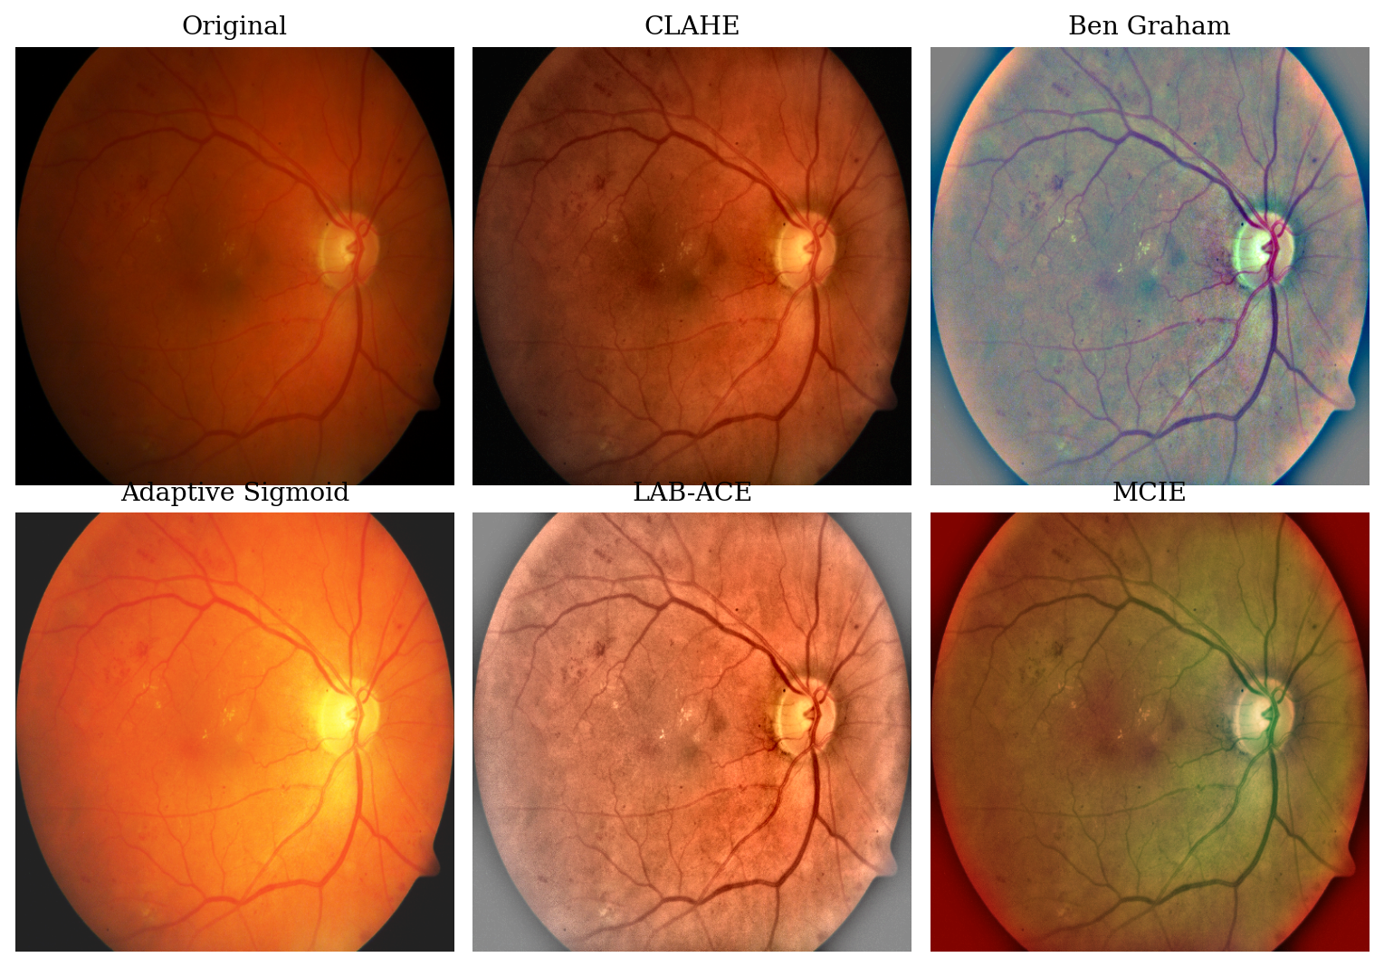
Figure 2.1. The five preprocessing techniques applied to a representative colour fundus image. CLAHE and LAB-ACE amplify local contrast, Ben Graham Normalization stabilises global illumination, Adaptive Sigmoid Enhancement stretches the intensity range, and MCIE composites the green channel, CLAHE, and Ben Graham results into one three-channel input. Source: prepared by the author.

2.3.1 Contrast Limited Adaptive Histogram Equalization (CLAHE)
Contrast Limited Adaptive Histogram Equalization (CLAHE; Zuiderveld, 1994) equalizes the histogram locally per tile. Within each tile a pixel value $r$ is remapped by the contrast-limited cumulative distribution $T(r)=(L−1)\sum_{j=0}^{r}{\hat{p}}(j)$, where $L$ is the number of intensity levels and $\hat{p}$ is the tile histogram after clipping at a clip limit and redistributing the excess; the clip limit caps noise amplification. On fundus images, CLAHE is applied to the luminance channel (LAB) to reveal low-contrast lesions such as microaneurysms hidden under uneven illumination.

2.3.2 Ben Graham Normalization
Ben Graham Normalization (Graham, 2015), the preprocessing used by the winner of the Kaggle Diabetic Retinopathy Detection competition and now a standard step in DR grading, suppresses large-scale illumination by subtracting a Gaussian-blurred copy of the image: $I_{norm}=αI+βG_{σ}(I)+γ$, where $G_{σ}$ is a Gaussian filter of radius $σ$. Small-scale structures such as lesions and vessels become more prominent while inter-camera illumination variation is reduced.

2.3.3 Adaptive Sigmoid Enhancement
Adaptive Sigmoid Enhancement (Anupama et al., 2025) remaps intensities with a sigmoid $f(x)=1/(1+exp(−α(x−β)))$, where the slope $α$ and midpoint $β$ are set adaptively from the local intensity mean and standard deviation. Contrast is amplified in dark regions without boosting noise in bright ones, so pale lesions separate more clearly from the retinal background.

2.3.4 LAB Adaptive Contrast Enhancement (LAB-ACE)
LAB Adaptive Contrast Enhancement (LAB-ACE; Anupama et al., 2025) converts to LAB and enhances only the luminance channel L (CLAHE plus local normalisation), leaving the colour channels A and B untouched, then reconstructs to RGB. Enhancing L alone raises lesion contrast without the colour distortion that could confound grading.

2.3.5 Multi-channel Image Enhancement
Multi-channel Image Enhancement (MCIE; Anupama et al., 2025) stacks several complementary representations into one three-channel input, for example the green channel (sensitive to haemoglobin), CLAHE on the L channel, and the Ben Graham Normalization result. The feature extractor then exploits several enhancements at once rather than a single type; Anupama et al. (2025) recommend such combinations as a future direction.

2.4 Deep Learning Architectures for Image Classification
This study evaluates two deep learning backbones representing two different paradigms, namely the convolutional neural network (CNN) represented by ResNet-50 and the Vision Transformer (ViT) represented by ViT-B/16. Each architecture is described in Sections 2.4.1 and 2.4.2.

2.4.1 Convolutional Neural Network and ResNet-50
A convolutional neural network (CNN) stacks convolutions, non-linear activations ($ReLU(z)=max(0,z)$), and pooling. Weight sharing keeps the parameter count independent of image size and makes the model translation-equivariant, while depth builds a hierarchy of receptive fields from edges and textures to whole structures. The final features map to logits $z∈R^{K}$, converted to class probabilities by the softmax $p_{k}=exp(z_{k})/\sum_{j=1}^{K}{exp}(z_{j})$ and trained with categorical cross-entropy $L_{CE}=−\sum_{k=1}^{K}{y_{k}}logp_{k}$.
ResNet-50 (He et al., 2016) is one of the most widely used CNNs in medical imaging. Its main contribution is the residual connection $y=F(x)+x$, namely a shortcut path that addresses vanishing gradients and enables the training of deep networks. ResNet-50 arranges 50 convolutional layers (its building unit being a three-layer bottleneck block with a residual connection) in four stages of decreasing spatial resolution, as presented in Figure 2.2. This architecture is chosen as the CNN backbone because it is well established, has a moderate parameter size (~25.5 million), and is commonly used as a baseline in the DR grading literature.
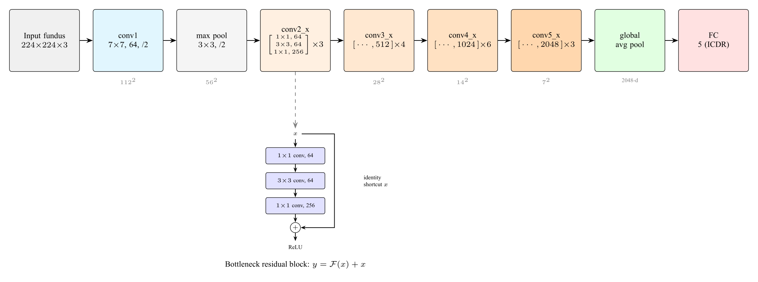
Figure 2.2. The ResNet-50 architecture: a $7×7$ convolution and max pooling followed by four residual stages (conv2_x to conv5_x) built from bottleneck blocks, then global average pooling and a fully connected layer. The inset shows the bottleneck residual block with its identity shortcut, $y=F(x)+x$. In this study the classification head outputs five ICDR classes. Source: adapted from He et al. (2016).

2.4.2 Vision Transformer (ViT)
The Vision Transformer (ViT; Dosovitskiy et al., 2021) adapts the Transformer architecture (Vaswani et al., 2017) to image recognition. ViT divides the image into fixed-size patches ($16×16$ pixels in ViT-B/16), linearises each patch into a token, adds positional embeddings, and then processes them with several Transformer encoder blocks. Its core component is self-attention, which makes each token weigh the relevance of all other tokens through query $Q$, key $K$, and value $V$ projections: $Attention(Q,K,V)=softmax(QK^{⊤}/\sqrt{d_{k}})V$. This ability to model long-range dependencies is relevant for DR grading because lesions can be scattered across various retinal quadrants. The ViT-B/16 architecture, together with the structure of the Transformer encoder block and its multi-head self-attention mechanism, is presented in Figure 2.3. Anupama et al. (2025) explicitly propose ViT as a development direction for DR grading.
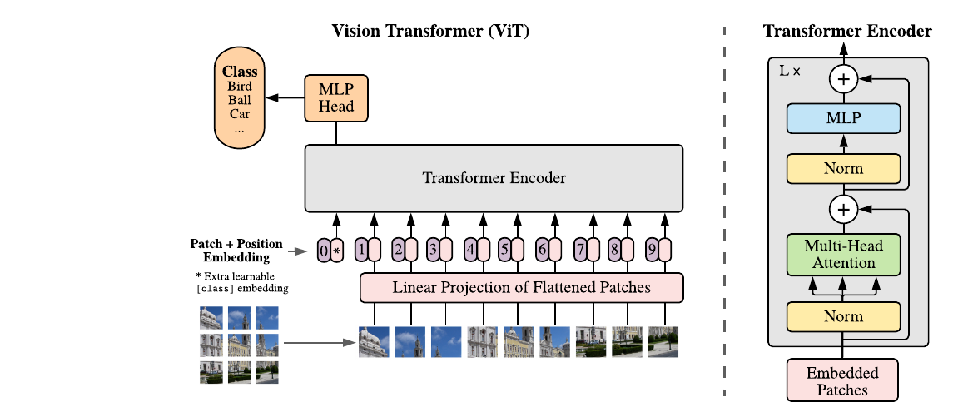
Figure 2.3. The Vision Transformer architecture. An image is split into fixed-size patches that, together with position embeddings and a learnable [class] token, are processed by a Transformer encoder; the right panel shows the encoder block with multi-head self-attention. In this study the input is a fundus image and the classification head outputs five ICDR classes. Source: Dosovitskiy et al. (2021); encoder block after Vaswani et al. (2017).

2.4.3 Transfer Learning
Public DR datasets are small (IDRiD has only a few hundred training images), so training either backbone from random initialisation would overfit. Transfer learning instead initialises from ImageNet-pretrained weights, which already encode general visual features, and fine-tunes on the target data with the classifier head replaced for five classes, cutting the data requirement and speeding convergence enough to make training on IDRiD feasible.

2.5 Evaluation Metrics for DR Grading Classification

2.5.1 Accuracy, Precision, Recall, and Macro-F1
Accuracy is the proportion of correct predictions, $Accuracy=(1/N)\sum_{i=1}^{N}{1}[{\hat{y}}_{i}=y_{i}]$, but it is biased on imbalanced data dominated by grade 0, as in IDRiD and DDR. For this reason, per-class precision and recall are also reported, together with macro-F1, namely the arithmetic mean of $F1=2 (precision⋅recall)/(precision+recall)$ over all classes. Macro-F1 gives equal weight to each class, so that it is sensitive to performance on the minority classes.

2.5.2 Quadratic-weighted Kappa (QWK)
Because ICDR is ordinal, an error two grades apart is more severe than one grade apart, yet accuracy and F1 do not distinguish them. Quadratic-weighted kappa (Cohen, 1968) imposes a penalty proportional to the square of the distance between classes,
$$κ_{w} = 1−\frac{\sum_{i=1}^{K}{\sum_{j=1}^{K}{w_{ij}}}O_{ij}}{\sum_{i=1}^{K}{\sum_{j=1}^{K}{w_{ij}}}E_{ij}}, w_{ij}=\frac{(i−j)^{2}}{(K−1)^{2}},$$
where $O$ is the observed confusion matrix and $E$ is the expected confusion matrix if predictions and labels were independent. A value of $κ_{w}=1$ means perfect prediction and $κ_{w}=0$ is equivalent to random guessing. QWK is the standard metric in DR grading challenges (Kaggle Diabetic Retinopathy Detection, APTOS 2019) and is the primary metric of this study.

2.5.3 Gradient-weighted Class Activation Mapping (Grad-CAM)
Gradient-weighted Class Activation Mapping (Grad-CAM; Selvaraju et al., 2017) produces a heatmap that marks the image regions most influential on the classification decision, by weighting the feature maps of the last convolutional layer using the gradient of the target class score. In DR grading, Grad-CAM is used to verify whether the model bases its prediction on clinically relevant lesions (for example microaneurysms or haemorrhages) or on artefacts such as the lens edge. In this study, Grad-CAM serves as a complementary interpretation tool on the best configuration, not the main quantitative focus, in line with the recommendation of Anupama et al. (2025).

2.6 Related Work
The modern era of deep-learning-based DR classification began with Gulshan et al. (2016), who trained a CNN on 128,175 retinal images and reported a sensitivity of 90.3% and a specificity of 98.1% for referable DR, on par with experts. Abramoff et al. (2018) brought it into the regulatory domain through IDx-DR, the first AI system approved by the FDA for diagnostic decisions in primary care without specialist supervision. Both demonstrated that automated DR grading is technically feasible, clinically beneficial, and approvable by regulators.
The release of public datasets such as IDRiD (Porwal et al., 2020) and DDR (Li et al., 2019) shifted the focus toward open benchmarks, on which various backbones (ResNet, DenseNet, Inception, EfficientNet) are evaluated. Zhou et al. (2023) developed RETFound, a ViT-based foundation model trained in a self-supervised manner on 1.6 million retinal images that consistently outperforms ImageNet weights on retinal tasks, especially when data are limited.
Chokuwa and Khan (2025) showed that DR grading models suffer a marked performance decline when evaluated on datasets with different acquisition settings, because of domain shift (camera, illumination, demographics) rather than annotation inconsistency. This finding underlies this study’s choice to make cross-dataset evaluation a more realistic measure of performance.
The anchor paper of this study is Anupama et al. (2025) in Scientific Reports, which evaluates several backbones for DR grading on a single dataset and, in its future-work section, identifies three directions: (i) systematic exploration of preprocessing combinations; (ii) validation on multi-center datasets with diverse devices and demographics; and (iii) integration of interpretation tools such as Grad-CAM. This study takes all three as its foundation, namely comparing five preprocessing techniques (Section 2.3) on two backbones of different paradigms (Section 2.4), evaluating across the IDRiD and DDR datasets (Section 2.2), and using Grad-CAM on the best configuration (Section 2.5.3).

2.7 Conceptual Framework
Raw fundus images vary in illumination, contrast, and colour (Section 2.2.1), while early DR lesions are small and low-contrast (Section 2.1.1). The five preprocessing techniques act through different mechanisms (local contrast: CLAHE and LAB-ACE; global illumination: Ben Graham Normalization; adaptive stretching: Adaptive Sigmoid Enhancement; representation fusion: MCIE), so each is expected to affect lesion visibility and final performance differently. The two backbones carry different inductive biases (Section 2.4): ResNet-50 captures small, localised lesions through convolutional receptive fields, whereas ViT-B/16 models long-range relations between scattered lesions through self-attention. Performance is therefore treated as a function of the preprocessing $×$ backbone interaction, which the $5×2$ factorial design (Section 3.1) is built to isolate. Under cross-dataset transfer (IDRiD to DDR), domain shift in camera, population, and illumination degrades performance even at an identical label ontology (Chokuwa and Khan, 2025); the size of this drop is expected to depend on how well preprocessing standardises appearance and how robust the backbone is. The ordinal ICDR scale and class imbalance further require QWK and macro-F1 rather than accuracy alone (Section 2.5). This framework motivates the hypotheses in Section 2.8.

2.8 Research Hypotheses
Three directional hypotheses follow the three research questions and are tested empirically through bootstrap confidence intervals (Section 3.7).
H1. Classification performance (accuracy, QWK, macro-F1) on IDRiD differs meaningfully across the five preprocessing techniques and between the two backbones. Techniques that stabilise global illumination or fuse representations (Ben Graham Normalization, MCIE) are expected to lead, and ViT-B/16 to at least match ResNet-50.
H2. All configurations decline under cross-dataset transfer to DDR, but by different margins. Preprocessing that standardises illumination and colour (Ben Graham Normalization, LAB-ACE, MCIE) paired with ViT-B/16 is expected to be the most robust to inter-institutional domain shift.
H3. A trade-off exists among IDRiD accuracy, cross-dataset robustness, and computational cost: the best in-distribution configuration is not necessarily the most robust or the most efficient. The configuration that balances all three is expected to be the most suitable for primary-care deployment in Indonesia.

CHAPTER III RESEARCH METHODOLOGY

3.1 Research Design
This study uses a quantitative factorial experimental design. The independent variables are two factors: the fundus-image preprocessing technique at five levels (CLAHE, Ben Graham Normalization, Adaptive Sigmoid Enhancement, LAB-ACE, and MCIE) and the backbone architecture at two levels (ResNet-50 and ViT-B/16), yielding ten configurations ($5×2$); operational definitions are given in Section 3.3. Every configuration is trained on IDRiD under an identical protocol, then evaluated on the IDRiD test partition (in-distribution) and the DDR test partition (cross-dataset), and compared through accuracy, quadratic-weighted kappa (QWK), macro-F1, and per-class confusion matrices.
All hyperparameters, the augmentation pipeline, the data split, and the random seed are held identical across configurations, so observed differences are attributable to the preprocessing technique and the backbone choice alone. Model weights, seeds, scripts, and metric logs are stored in a public Git repository for reproducibility. Figure 3.1 presents the six-stage flow, from dataset splitting through preprocessing, training, and evaluation to Grad-CAM on the best configuration.
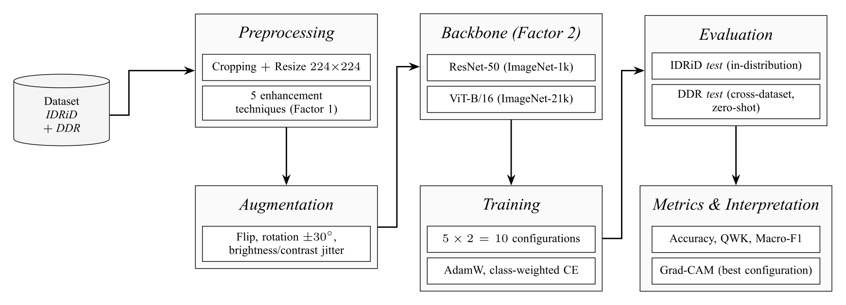
Figure 3.1. Research flow: the combination of five preprocessing techniques (Factor 1) and two backbones (Factor 2) forms ten configurations ($5×2$) that are evaluated on IDRiD test (in-distribution) and DDR test (cross-dataset). Source: prepared by the author.

3.2 Dataset

3.2.1 IDRiD Disease Grading Subset
From the official IDRiD partition (413 training images, 103 test images; Porwal et al., 2020), this study sets aside 15% of the training images (62 images) as a validation partition through stratified random sampling under a fixed seed, leaving 351 training images. The validation partition is used for early stopping and checkpoint selection, while the 103-image test partition is accessed only once, at the end of the experiment, to produce the in-distribution metrics.

3.2.2 DDR for Cross-Dataset Evaluation
DDR (Li et al., 2019) is treated as a zero-shot transfer evaluation set: only the official test partition is used, after ungradable images are filtered out so that the label space remains five classes, yielding approximately 3,759 images. The DDR training and validation partitions are not used at all.

3.2.3 Class Distribution and Handling of Imbalance
Both datasets are imbalanced (long-tailed): grades 0 and 2 dominate, while grades 1, 3, and 4 are minorities. The imbalance is handled at two levels, namely (i) a weighted random sampler with weights $∝1/\sqrt{n_{k}}$ ($n_{k}$ is the number of training images of class $k$) in each mini-batch, and (ii) class-weighted categorical cross-entropy with weights $∝1/\sqrt{n_{k}}$ normalised to sum to $K$. QWK is chosen as the checkpoint-selection metric because it is sensitive to ordinal distance and relatively robust to the marginal distribution.

3.3 Variables and Operational Definitions
This study involves two independent variables, three dependent variables, and a set of controlled variables, defined operationally in Table 3.1.
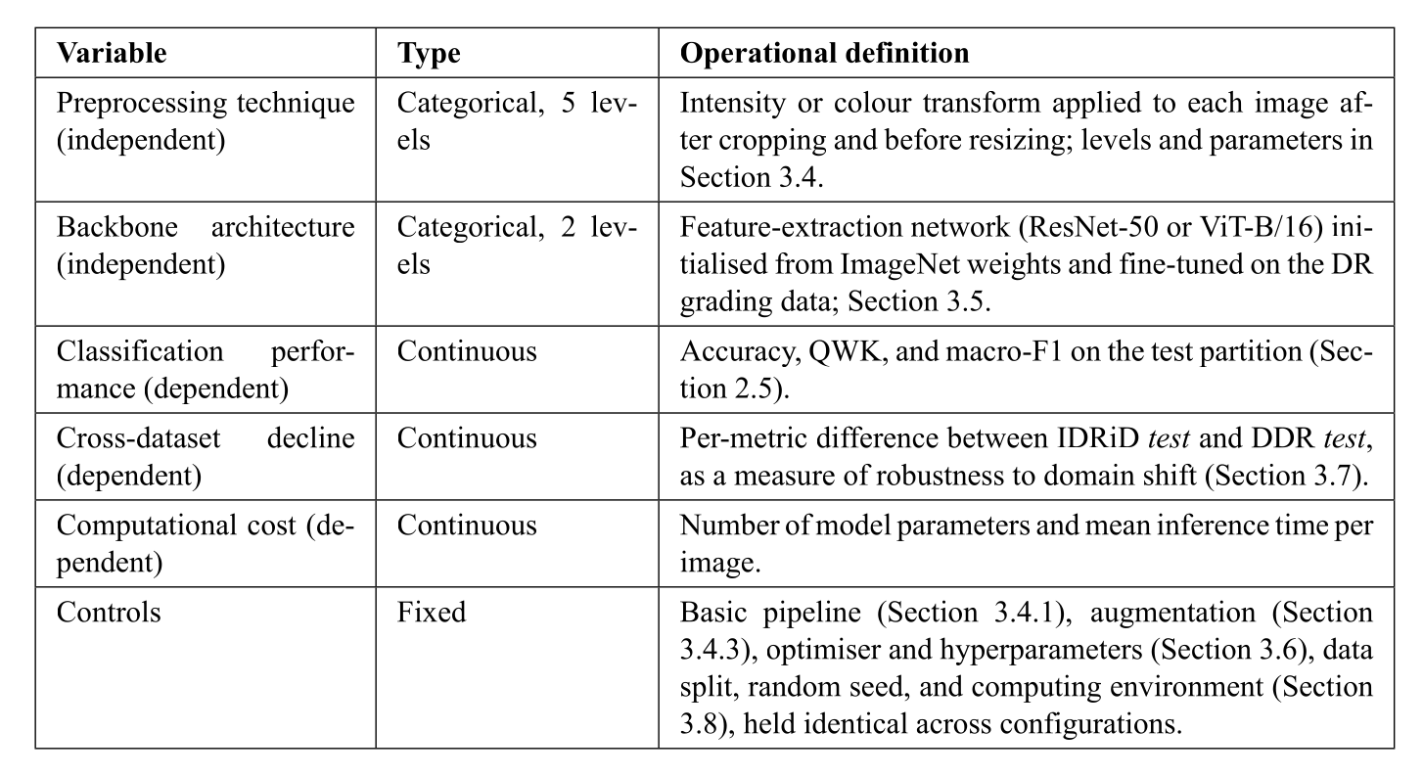
Table 3.1. Research variables and their operational definitions.

3.4 Data Preprocessing

3.4.1 Basic Pipeline
Before the specific technique is applied, each IDRiD and DDR image passes through an identical basic pipeline, namely (i) estimation of the retinal mask via adaptive thresholding on the green channel, followed by cropping to the minimum bounding box to remove the black frame; (ii) resizing to $224×224$ pixels (bilinear interpolation) in accordance with the standard input of ImageNet weights; and (iii) normalisation to $[0,1]$ followed by per-channel normalisation with the ImageNet mean and standard deviation ($μ=(0.485,0.456,0.406)$, $σ=(0.229,0.224,0.225)$). This pipeline is identical for training, validation, testing, and across datasets, so that the domain shift between IDRiD and DDR is not masked by differences in preprocessing.

3.4.2 Application of the Five Preprocessing Techniques
The preprocessing technique is applied between cropping and resizing; the parameters of each technique (concepts in Section 2.3) are as follows. CLAHE: clip limit 2.0 and tile $8×8$ on the L channel (LAB). Ben Graham Normalization: $α=4$, a Gaussian radius $σ$ equal to 10% of the retinal diameter, and $γ=128$, following the original Kaggle 2015 recipe. Adaptive Sigmoid Enhancement: $α$ and $β$ computed adaptively from the mean and standard deviation of the local patch intensity. LAB-ACE: CLAHE on the L channel followed by reconstruction to RGB. MCIE: a combination of the original green channel, the CLAHE result on the L channel, and the Ben Graham Normalization result into a three-channel image.

3.4.3 Data Augmentation
Online augmentation is applied only to the IDRiD training partition, after preprocessing. Geometric augmentation consists of horizontal and vertical flips (probability 0.5) and random rotation $[−{30}^{∘},+{30}^{∘}]$, which preserve the label because the ICDR grade does not depend on spatial orientation. Photometric augmentation consists of random brightness and contrast jitter $[−0.2,+0.2]$ to simulate the illumination variation across locations. The validation and test partitions (both IDRiD and DDR) are not augmented.

3.5 Model Architecture
The concepts of both backbones and their architecture diagrams have been described in Section 2.4 (Figures 2.2 and 2.3); this section details only their experimental configuration. ResNet-50 is loaded with ImageNet-1k pretrained weights via torchvision 0.18, while ViT-B/16 is loaded with ImageNet-21k pretrained weights via timm 1.0. In both backbones, the original classification head is replaced with a new linear layer to the five ICDR logits (ResNet-50: $2048→5$ from the global average pooling vector; ViT-B/16: $768→5$ from the CLS token). All parameters are trained jointly (full fine-tuning) without freezing any layer, with a softmax output optimised using class-weighted categorical cross-entropy (Sections 3.2.3 and 3.6).

3.6 Training Protocol
All models are trained with the AdamW optimiser (Loshchilov and Hutter, 2019), an initial learning rate $η_{0}=1×{10}^{−4}$, weight decay $1×{10}^{−4}$, $β_{1}=0.9$, and $β_{2}=0.999$. The learning rate follows a cosine schedule down to $η_{min}=1×{10}^{−6}$, preceded by a three-epoch linear warm-up. The batch size is 16 images, matching the memory of a single NVIDIA T4 GPU on Google Colab Pro. Training proceeds for up to 50 epochs with early stopping based on validation QWK (patience of 10 epochs); the checkpoint with the highest validation QWK is used for test evaluation.
The loss function is class-weighted categorical cross-entropy (weights as in Section 3.2.3). Mixup, label smoothing, and focal loss are deliberately not used, so that performance differences between configurations arise purely from the preprocessing technique and the backbone choice. All random number generators are initialised with the same seed so that the results can be reproduced. Training a single configuration takes about 2 hours on a T4 GPU, so that ten configurations require about 20 hours.

3.7 Evaluation Protocol
The IDRiD test partition (103 images) is evaluated once per configuration with accuracy, QWK, macro-F1, and a per-class confusion matrix. The DDR test partition (after filtering out ungradable images) is evaluated with an identical metric suite in a zero-shot transfer setting, namely without fine-tuning, batch-normalisation recalibration, or threshold adaptation. The decline in each metric on DDR relative to IDRiD reflects the domain robustness of the configuration.
Each metric is reported with a 95% confidence interval via bootstrap ($B=1,000$ resamples); comparisons between configurations use a paired bootstrap with the same resample indices so that sample-level variability is controlled. Two configurations are considered meaningfully different if their confidence intervals do not overlap. In addition, Grad-CAM (Selvaraju et al., 2017) is generated on the best configuration of each backbone for visual verification of the basis of the predictions.

3.8 Implementation Tools and Environment
The experimental pipeline is implemented in Python 3.11 using the following libraries: PyTorch 2.3 as the tensor and autodiff backend; torchvision 0.18 for ResNet-50 and the ImageNet-1k pretrained weights; timm 1.0 (Wightman, 2019) for ViT-B/16 and the ImageNet-21k pretrained weights; OpenCV 4.9 and scikit-image 0.22 for implementing the five preprocessing techniques; Albumentations 1.4 for the augmentation pipeline; scikit-learn 1.4 for computing the evaluation metrics; and Matplotlib 3.8 and seaborn 0.13 for visualising the confusion matrices and Grad-CAM heatmaps. The experiments are run on Google Colab Pro with an NVIDIA T4 or A100 GPU depending on availability. All code, training scripts, evaluation scripts, configuration files, and metric logs are stored in a public Git repository accompanied by a reproduction README with explicit library versions, seeds, and execution commands.

3.9 Research Schedule
The research activities are planned to run for twelve months, from March 2026 to February 2027, covering literature study and proposal writing, the proposal seminar and its revision, environment preparation and data collection, implementation of the preprocessing pipeline, training of the ten model configurations, in-distribution and cross-dataset evaluation, statistical analysis and Grad-CAM visualisation, the writing of Chapter IV and Chapter V, the results seminar, and the thesis defense and final submission. The monthly schedule is detailed in Table 3.2; the columns from March to December are months in 2026, while January and February are months in 2027. The schedule is indicative and may be adjusted according to the results of consultations with the supervisors and the availability of computational resources on Google Colab Pro.
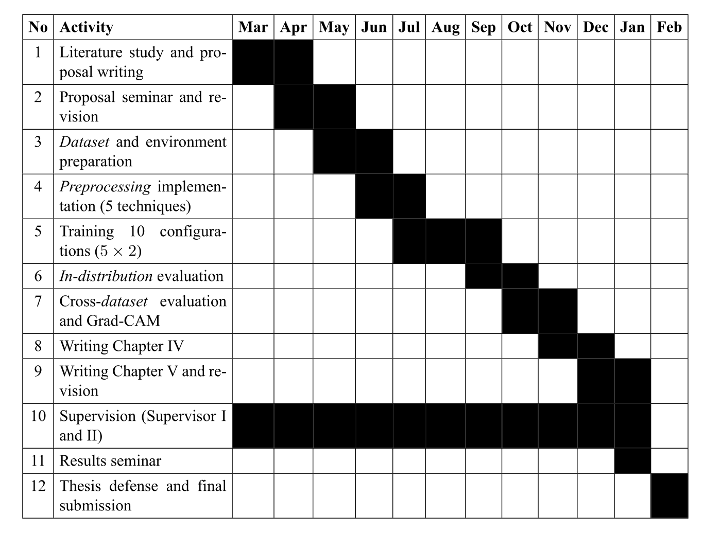
Table 3.2. Research schedule for the period March 2026 to February 2027.

REFERENCES
Abramoff, M. D., Lavin, P. T., Birch, M., Shah, N., & Folk, J. C. (2018). Pivotal Trial of an Autonomous AI-Based Diagnostic System for Detection of Diabetic Retinopathy in Primary Care Offices. NPJ Digital Medicine, 1(1), 39.
American Diabetes Association. (2024). Standards of Care in Diabetes: 2024. Diabetes Care, 47(Suppl. 1), S1–S322.
Anupama, B. C., Rao, S. N., Malini, M. B., & Athreya, V. V. (2025). Comparative Analysis of Novel Preprocessing Techniques and Deep Learning Based Multi-Modal Feature Fusion for Diabetic Retinopathy Grading. Scientific Reports, 15, 31339.
Chokuwa, S., & Khan, M. H. (2025). Divergent Domains, Convergent Grading: Enhancing Generalization in Diabetic Retinopathy Grading. IEEE/CVF Winter Conference on Applications of Computer Vision (WACV).
Chopra, M., Sparrenberg, L., Berger, A., Khanna, S., Terheyden, J. H., & Sifa, R. (2025). From Retinal Pixels to Patients: Evolution of Deep Learning Research in Diabetic Retinopathy Screening. 2025 IEEE International Conference on Big Data (IEEE BigData). arXiv:2511.11065
Cohen, J. (1968). Weighted Kappa: Nominal Scale Agreement Provision for Scaled Disagreement or Partial Credit. Psychological Bulletin, 70(4), 213–220.
Dosovitskiy, A., Beyer, L., Kolesnikov, A., Weissenborn, D., Zhai, X., Unterthiner, T., Dehghani, M., Minderer, M., Heigold, G., Gelly, S., Uszkoreit, J., & Houlsby, N. (2021). An Image Is Worth 16$$16 Words: Transformers for Image Recognition at Scale. International Conference on Learning Representations (ICLR).
Graham, B. (2015). Kaggle Diabetic Retinopathy Detection Competition Report. University of Warwick.
Gulshan, V., Peng, L., Coram, M., Stumpe, M. C., Wu, D., Narayanaswamy, A., … & Webster, D. R. (2016). Development and Validation of a Deep Learning Algorithm for Detection of Diabetic Retinopathy in Retinal Fundus Photographs. JAMA, 316(22), 2402–2410.
He, K., Zhang, X., Ren, S., & Sun, J. (2016). Deep Residual Learning for Image Recognition. Proceedings of the IEEE Conference on Computer Vision and Pattern Recognition (CVPR), 770–778.
Li, T., Gao, Y., Wang, K., Guo, S., Liu, H., & Kang, H. (2019). Diagnostic Assessment of Deep Learning Algorithms for Diabetic Retinopathy Screening. Information Sciences, 501, 511–522.
Loshchilov, I., & Hutter, F. (2019). Decoupled Weight Decay Regularization. International Conference on Learning Representations (ICLR).
Porwal, P., Pachade, S., Kokare, M., Deshmukh, G., Son, J., Bae, W., … & Meriaudeau, F. (2020). IDRiD: Diabetic Retinopathy Segmentation and Grading Challenge. Medical Image Analysis, 59, 101561.
Saputra, N. A., Helvinda, W., & Rahman, K. (2024). Prevalence and Risk Factors of Diabetic Retinopathy in a Tertiary Hospital in Padang, Indonesia. Bioscientia Medicina: Journal of Biomedicine and Translational Research, 9(1), 219–231.
Sasongko, M. B., Widyaputri, F., Agni, A. N., Wardhana, F. S., Kotha, S., Gupta, P., Widayanti, T. W., Haryanto, S., Widyaningrum, R., Wong, T. Y., Kawasaki, R., & Wang, J. J. (2025). Incidence and Progression of Diabetic Retinopathy and Blindness in Indonesian Adults with Type 2 Diabetes. PLoS ONE, 20, e0322093.
Selvaraju, R. R., Cogswell, M., Das, A., Vedantam, R., Parikh, D., & Batra, D. (2017). Grad-CAM: Visual Explanations from Deep Networks via Gradient-Based Localization. Proceedings of the IEEE International Conference on Computer Vision (ICCV), 618–626.
Teo, Z. L., Tham, Y. C., Yu, M., Chee, M. L., Rim, T. H., Cheung, N., … & Cheng, C. Y. (2021). Global Prevalence of Diabetic Retinopathy and Projection of Burden through 2045: Systematic Review and Meta-Analysis. Ophthalmology, 128(11), 1580–1591.
Vaswani, A., Shazeer, N., Parmar, N., Uszkoreit, J., Jones, L., Gomez, A. N., Kaiser, L., & Polosukhin, I. (2017). Attention Is All You Need. Advances in Neural Information Processing Systems (NeurIPS), 5998–6008.
Wightman, R. (2019). PyTorch Image Models (timm) [Computer software]. GitHub. https://github.com/huggingface/pytorch-image-models
Wilkinson, C. P., Ferris III, F. L., Klein, R. E., Lee, P. P., Agardh, C. D., Davis, M., … & Verdaguer, J. T. (2003). Proposed International Clinical Diabetic Retinopathy and Diabetic Macular Edema Disease Severity Scales. Ophthalmology, 110(9), 1677–1682.
Wong, T. Y., & Sabanayagam, C. (2023). The War on Diabetic Retinopathy: Where Are We Now? Asia-Pacific Journal of Ophthalmology, 12(3), 213–221.
Zhou, Y., Chia, M. A., Wagner, S. K., Ayhan, M. S., Williamson, D. J., Struyven, R. R., … & Keane, P. A. (2023). A Foundation Model for Generalizable Disease Detection from Retinal Images. Nature, 622(7981), 156–163.

