THESIS PROPOSAL

COMPARATIVE ANALYSIS OF FUNDUS IMAGE PREPROCESSING TECHNIQUES AND DEEP LEARNING ARCHITECTURES FOR DIABETIC RETINOPATHY SEVERITY CLASSIFICATION ACROSS MULTIPLE PUBLIC DATASETS

By:
Gede Tanok Arta Wijaya
Student ID Number: 2315101018

STUDY PROGRAM OF COMPUTER SCIENCE
DEPARTMENT OF INFORMATICS ENGINEERING
FACULTY OF ENGINEERING AND VOCATIONAL STUDIES
UNIVERSITAS PENDIDIKAN GANESHA
2026

THESIS PROPOSAL APPROVAL SHEET

The thesis proposal entitled:
Comparative Analysis of Fundus Image Preprocessing Techniques and Deep Learning Architectures for Diabetic Retinopathy Severity Classification across Multiple Public Datasets

prepared by:
Name : Gede Tanok Arta Wijaya
Student ID Number : 2315101018
Study Program : Computer Science
Department : Informatics Engineering
Faculty : Engineering and Vocational Studies

has been approved by the supervisors to be presented in the thesis proposal seminar.

Singaraja, 2026

Supervisor I

I Made Putrama, S.T., M.Tech., Ph.D.
NIP. ....................................

Supervisor II

....................................
NIP. ....................................

ABSTRACT
Gede Tanok Arta Wijaya. 2315101018. 2026. Comparative Analysis of Fundus Image Preprocessing Techniques and Deep Learning Architectures for Diabetic Retinopathy Severity Classification across Multiple Public Datasets. Thesis Proposal. Computer Science, Informatics Engineering, Engineering and Vocational Studies, Universitas Pendidikan Ganesha.

Supervisor I: I Made Putrama, S.T., M.Tech., Ph.D.; Supervisor II: ....................................

Diabetic retinopathy (DR) is a leading cause of preventable blindness among working-age adults, with rapidly increasing prevalence in Indonesia, while the ophthalmologist-to-population ratio remains far from sufficient to sustain annual fundus screening. Deep learning models have achieved high accuracy in classifying DR severity on fundus images, yet the existing literature tends to select preprocessing techniques and backbone architectures ad-hoc without apple-to-apple comparisons, and validates these comparisons on only a single dataset, leaving their external validity unproven. This study conducts a 5x2 factorial comparative analysis of five fundus-image preprocessing techniques (CLAHE, Ben Graham preprocessing, Adaptive Sigmoid Enhancement, LAB-ACE, and Multi-channel Image Enhancement) paired with two backbone architectures (ResNet-50 and Vision Transformer ViT-B/16), forming ten configurations that are trained and tested independently on six public datasets sharing the five-grade ICDR ontology (IDRiD, DDR, APTOS 2019, Messidor-2, EyePACS, and DeepDRiD). Evaluation uses accuracy, quadratic-weighted kappa, and macro-F1, and the per-dataset results are aggregated across the six datasets with the Friedman test and Nemenyi post-hoc (critical difference diagram) to identify the configuration that performs best consistently across datasets. The Grad-CAM interpretability technique is applied to the best-performing configuration to visualise lesion regions driving model predictions. The study is expected to deliver reproducible empirical guidance on the preprocessing-and-backbone combinations most suitable for deploying automated DR screening in Indonesian primary-care settings.

Keywords: diabetic retinopathy, fundus image preprocessing, deep learning, Vision Transformer, ResNet-50, multi-dataset comparison, Friedman test, IDRiD, DDR, APTOS, Messidor-2, EyePACS, DeepDRiD

TABLE OF CONTENTS

Right-click this table of contents and choose Update Field to display chapter titles and page numbers.

CHAPTER I INTRODUCTION

1.1 Background of the Study
Diabetic retinopathy (DR), a progressive microvascular complication of diabetes mellitus, is the leading cause of preventable blindness among working-age adults (American Diabetes Association, 2024), and its burden is rising sharply, with Teo et al. (2021) projecting a growth from 103 million adults affected in 2020 to about 161 million by 2045. The situation in Indonesia is acute: a DR incidence of 34.6 per 1,000 person-years (Sasongko et al., 2025) and a prevalence of 55% among diabetic patients at a referral hospital (Saputra et al., 2024) coincide with fewer than two ophthalmologists per 100,000 population, concentrated in urban Java, which makes the annual fundus examination recommended by clinical standards structurally infeasible to deliver manually. An operationally feasible screening strategy must therefore rely on automated interpretation of fundus images at the primary-care level, and the task to be automated is not merely detecting disease but grading its severity on the five-grade International Clinical DR (ICDR) scale (Wilkinson et al., 2003), since the grade drives the referral decision. Misclassification is thus costly in both directions, because under-grading delays a needed referral while over-grading wastes scarce specialist capacity, so the system must be accurate precisely at the boundaries between grades.
Over the past decade, deep learning has made automated DR grading technically feasible. Gulshan et al. (2016) showed that a convolutional neural network trained on 128,175 fundus images could detect referable DR with sensitivity and specificity above 90%, Abramoff et al. (2018) brought the first autonomous DR system (IDx-DR) to FDA clearance, and foundation models such as RETFound (Zhou et al., 2023) have narrowed the gap further. A recent survey of more than fifty studies and twenty datasets confirms this maturity but notes that the principal gap has shifted from raw capability toward multi-center validation and clinical trust (Chopra et al., 2025). The open problem, in other words, is no longer whether a model can grade DR, but whether results obtained on neatly curated data still hold under the far more heterogeneous conditions of the field.
The first overlooked gap concerns fundus image quality and how it is handled. Uneven illumination, low contrast, and acquisition noise systematically degrade grading accuracy (Anupama et al., 2025), most severely on the low-cost devices used in Indonesian primary care, and they cause early lesions such as microaneurysms to be missed, which biases the model toward under-grading. Many preprocessing techniques have been proposed to improve lesion visibility, from CLAHE, Ben Graham preprocessing, and green-channel extraction to newer methods such as Adaptive Sigmoid Enhancement, LAB-ACE, and Multi-channel Image Enhancement, but their use in the literature is ad-hoc: each study adopts a single technique without comparing it on an equal footing with alternatives under the same architecture and protocol. Anupama et al. (2025) make the same observation and call for a systematic exploration of preprocessing techniques, because as long as no apple-to-apple comparison exists, the choice of preprocessing rests on guesswork rather than evidence.
The second gap is the limited generalisability of the comparisons themselves. Almost every preprocessing comparison for DR grading, including the anchor study of Anupama et al. (2025), is validated on a single dataset, so the technique or backbone found best there may be an artefact of that dataset’s cameras, population, and quality rather than a property that holds broadly. Because fundus images vary substantially in illumination, colour, and acquisition protocol across institutions, a technique that wins on one dataset need not win on another, and guidance drawn from one dataset is a weak basis for a screening system meant for the heterogeneous conditions of the field. Anupama et al. (2025) accordingly recommend validating findings on multiple datasets spanning different devices and demographics; until that is done, the external validity of any such comparison remains unproven.
This study addresses both gaps, grounded in the future-work recommendations of Anupama et al. (2025). It compares five preprocessing techniques paired with two backbones (ResNet-50 and ViT-B/16), forming ten configurations, and evaluates them independently on six public DR grading datasets that share the five-grade ICDR ontology (IDRiD, DDR, APTOS 2019, Messidor-2, EyePACS, and DeepDRiD); on each dataset every configuration is trained and tested on that dataset’s own partition under an identical protocol and scored by accuracy, quadratic-weighted kappa (QWK), and macro-F1. To find the configuration that is best not on one dataset but consistently across all six, the per-dataset QWK scores are aggregated with the Friedman test and Nemenyi post-hoc (Demsar, 2006) and shown as a critical difference diagram, and Grad-CAM verifies the basis of the best configuration’s predictions. The study contributes (i) a reproducible, apple-to-apple comparison of preprocessing and backbones for DR grading under a unified protocol, (ii) validation of that comparison across six diverse datasets to establish whether the best configuration is consistent rather than dataset-specific, and (iii) evidence-based guidance for building automated DR screening for primary care with limited resources.

1.2 Problem Identification
Based on the background described in Section 1.1, the research problems can be identified as follows.
- The burden of diabetic retinopathy in Indonesia is high and continues to rise (an incidence of 34.6 per 1,000 person-years; Sasongko et al., 2025), while the ophthalmologist ratio is fewer than two specialists per 100,000 population and is concentrated in urban Java, so that manual annual fundus screening is structurally infeasible and demands an automated fundus-image interpretation system at the primary-care level.
- The quality of fundus images produced by low-cost devices in primary care varies widely (uneven illumination, low contrast, and acquisition noise), and this degradation in quality reduces the accuracy of automated grading and tends to cause the model to grade patients lower than their actual condition, which is the type of error that leads to a delayed referral.
- The selection of fundus-image preprocessing techniques in the DR grading literature is still ad-hoc: each study generally selects a single technique without comparing it on an equal footing with other techniques under the same architecture and training protocol, so that apple-to-apple comparative evidence to guide the selection is not yet available (Anupama et al., 2025).
- Existing preprocessing comparisons for DR grading, including the anchor study of Anupama et al. (2025), are validated on a single dataset, so it is not known whether the preprocessing and backbone identified as best on one dataset remains best on other datasets with different cameras, populations, and quality profiles, and therefore whether such a conclusion has external validity rather than being an artefact of one dataset.
- There is as yet no evidence-based guidance on the combination of preprocessing technique and backbone architecture that performs consistently best across diverse datasets for developing automated DR screening systems for primary care with limited resources in Indonesia.

1.3 Scope of the Study
So that the research stays focused and feasible to complete within the thesis timeframe, and to isolate the influence of preprocessing and backbone from other factors, the problems identified in Section 1.2 are limited as follows.
- The classification task is limited to five-class grading of diabetic retinopathy severity on the ICDR scale at the image level, without lesion segmentation or detection.
- The datasets used are six public DR grading datasets that share the five-class ICDR label ontology, namely IDRiD (Porwal et al., 2020), DDR (Li et al., 2019), APTOS 2019 (APTOS, 2019), Messidor-2 (Decenciere et al., 2014), EyePACS (Kaggle and EyePACS, 2015), and DeepDRiD (Liu et al., 2022). Each dataset is treated as an independent benchmark on which all configurations are trained and tested using that dataset’s own partition; the study does not perform cross-dataset transfer or domain adaptation.
- The preprocessing techniques compared are limited to five methods, namely CLAHE, Ben Graham preprocessing, Adaptive Sigmoid Enhancement, LAB-ACE, and Multi-channel Image Enhancement.
- The backbone architectures compared are limited to ResNet-50 (CNN) and ViT-B/16 (Vision Transformer), both trained via transfer learning from ImageNet weights without domain-specific pretraining.
- Evaluation is quantitative (accuracy, quadratic-weighted kappa, macro-F1) per dataset, aggregated across the six datasets with the Friedman test and Nemenyi post-hoc (critical difference diagram), and complemented by Grad-CAM visualisation on the best configuration. A reader study and prospective deployment are outside the scope.

1.4 Statement of the Problem
Based on the problem identification and scope in Sections 1.2 and 1.3, this study is formulated through the following three research questions.
- On each of the six datasets, how do the five preprocessing techniques (CLAHE, Ben Graham preprocessing, Adaptive Sigmoid Enhancement, LAB-ACE, and Multi-channel Image Enhancement) and the two backbone architectures (ResNet-50 and Vision Transformer) affect diabetic retinopathy severity classification performance as measured by accuracy, quadratic-weighted kappa (QWK), and macro-F1?
- When the per-dataset results are aggregated across the six datasets using the Friedman test and the Nemenyi post-hoc procedure, which preprocessing and backbone configuration ranks significantly and consistently highest, and how stable is that ranking across datasets?
- What is the trade-off between predictive performance and computational cost (number of parameters and inference time) for each combination of preprocessing and backbone, and which configuration is most suitable for deploying a DR screening system in primary care in Indonesia?

1.5 Objectives of the Study
In line with the statement of the problem in Section 1.4, this study has the following three objectives.
- To analyse the influence of the five preprocessing techniques (CLAHE, Ben Graham preprocessing, Adaptive Sigmoid Enhancement, LAB-ACE, and Multi-channel Image Enhancement) and the two backbone architectures (ResNet-50 and Vision Transformer) on diabetic retinopathy severity classification performance on each of the six datasets, measured through accuracy, quadratic-weighted kappa (QWK), and macro-F1.
- To aggregate the per-dataset results across the six datasets using the Friedman test and the Nemenyi post-hoc procedure in order to identify the preprocessing and backbone configuration that ranks significantly and consistently highest across datasets.
- To analyse the trade-off between predictive performance and computational cost (number of parameters and inference time) in order to recommend the configuration most suitable for deploying a diabetic retinopathy screening system in primary care in Indonesia.

1.6 Significance of the Study
Theoretically, this study produces a reproducible empirical comparison between preprocessing techniques and backbone architectures for DR grading under a unified protocol, and strengthens it by validating the comparison across six public datasets that share an identical label ontology but differ in device, population, and illumination. By aggregating the per-dataset results with the Friedman test and Nemenyi post-hoc, the study establishes whether the best configuration is consistent across datasets rather than an artefact of one dataset, directly addressing the future-work recommendations of Anupama et al. (2025).
Practically, this study provides evidence-based guidance for developing automated DR screening systems for primary care in Indonesia, which must operate on devices and populations that vary widely across the field. The preprocessing and backbone configuration that performs consistently best across diverse datasets can be adopted as a starting point for development. This study also produces a documented experimental pipeline that can be reused to test other preprocessing techniques, backbones, or datasets without reimplementation.

CHAPTER II LITERATURE REVIEW

2.1 Diabetic Retinopathy

2.1.1 Brief Pathophysiology
Diabetic retinopathy is a chronic microvascular complication of diabetes mellitus: long-term hyperglycaemia damages the retinal capillaries, causing increased permeability (oedema and lipid exudation) and capillary occlusion (ischaemia), and the resulting ischaemia drives vascular endothelial growth factor (VEGF) production and neovascularisation (Wong and Sabanayagam, 2023). Clinically it has two stages: non-proliferative DR (NPDR), marked by microaneurysms, intraretinal haemorrhages, hard exudates, cotton-wool spots, venous beading, and intraretinal microvascular abnormalities (IRMA) without new vessels; and proliferative DR (PDR), marked by neovascularisation that risks vitreous haemorrhage and tractional retinal detachment. The type and distribution of these lesions form the basis of the ICDR severity scale (Section 2.1.3) and are the target of Grad-CAM verification (Section 2.5.3).

2.1.2 Global and Indonesian Disease Burden
As detailed in Section 1.1, DR is a leading cause of preventable blindness whose global burden is projected to grow from 103 million people in 2020 to about 161 million by 2045 (Teo et al., 2021), a trajectory that Wong and Sabanayagam (2023) call the “DR pandemic”. In Indonesia this burden is compounded by a severe shortage of ophthalmologists, fewer than two per 100,000 population and concentrated in urban Java, which is the structural reason automated DR screening at the primary-care level is needed (Sasongko et al., 2025; Saputra et al., 2024; American Diabetes Association, 2024).

2.1.3 The International Clinical Diabetic Retinopathy (ICDR) Scale
The clinical target variable in this study is the International Clinical Diabetic Retinopathy (ICDR) scale proposed by Wilkinson et al. (2003) as a simplification of the ETDRS scale. ICDR divides retinopathy into five ordered grades: grade 0 (no retinopathy), grade 1 (mild NPDR, microaneurysms only), grade 2 (moderate NPDR, a condition between the two), grade 3 (severe NPDR, following the “4-2-1” rule, namely intraretinal haemorrhages in four quadrants, or venous beading in two or more quadrants, or prominent IRMA, without neovascularisation), and grade 4 (PDR, characterised by neovascularisation or vitreous/pre-retinal haemorrhage).
This scale is ordinal: the five classes are arranged on a monotonic severity continuum, so that a misclassification two grades apart is more detrimental than one grade apart. This property demands a metric sensitive to class ordering such as quadratic-weighted kappa (Section 2.5.2), not merely accuracy. The clinical cost of errors is also asymmetric: a grade-3 patient predicted as grade 1 loses the referral they should have received, whereas a grade-0 patient predicted as grade 1 wastes specialist capacity.

2.2 Fundus Images and Benchmark Datasets

2.2.1 Colour Fundus Photography
Colour fundus photography is the primary DR screening modality because it is non-invasive, low-cost, and widely available; non-mydriatic acquisition (without pupil dilation) is preferred for patient comfort and ease of use. Image quality depends on cataract, pupil size, and illumination uniformity, so some images are ungradable, which is why modern screening datasets carry a quality label to filter them out.
This study uses six public DR grading datasets, each treated as an independent benchmark and described in Sections 2.2.2 to 2.2.7. They are chosen because they share the same five-class ICDR label ontology yet differ in country, acquisition device, population, and image quality; the rationale for the selection is given in Section 2.2.8, and the partition details in Section 3.2.

2.2.2 Indian Diabetic Retinopathy Image Dataset (IDRiD)
The Indian Diabetic Retinopathy Image Dataset (IDRiD; Porwal et al., 2020) is the official benchmark of the IEEE ISBI 2018 challenge. IDRiD contains 516 fundus images from a single clinic in Nanded, India, with one camera type (Kowa VX-10α). This study uses only the Disease Grading subset, in which each image is labelled with an ICDR grade from 0 to 4, and adopts the official train and test partitions without modification so that the results are comparable with other benchmarks.

2.2.3 Dataset for Diabetic Retinopathy (DDR)
The Dataset for Diabetic Retinopathy (DDR; Li et al., 2019) contains 13,673 images from 147 hospitals across 23 provinces in China with various camera types, so that its heterogeneity in device, quality, and demographics far exceeds that of IDRiD. Its labels use the ICDR scale from 0 to 4, plus a quality label to separate gradable and ungradable images. This study uses the official DDR train and test partitions after filtering out ungradable images.

2.2.4 APTOS 2019 Blindness Detection Dataset
The APTOS 2019 dataset (APTOS, 2019), released by the Asia Pacific Tele-Ophthalmology Society in collaboration with Aravind Eye Hospital, India, contains 3,662 labelled fundus images collected in rural India with several camera types under varied conditions. The images are graded on the five-class ICDR scale; only the publicly labelled training set is used, because the competition test labels are not released.

2.2.5 Messidor-2
Messidor-2 (Decenciere et al., 2014) consists of 1,748 macula-centred fundus images (874 examinations) acquired in France. This study uses the publicly available adjudicated third-party ICDR grades (1,744 gradable images), which were established by a panel of retina specialists. Messidor-2 adds a European population and acquisition device different from the Asian datasets.

2.2.6 EyePACS (Kaggle Diabetic Retinopathy Detection)
The EyePACS dataset (Kaggle and EyePACS, 2015) is the largest public DR resource, with 88,702 fundus images acquired in the United States using many camera types under highly variable imaging conditions, graded on the five-class ICDR scale. Because roughly a quarter of the images are ungradable and the dataset is very large, this study uses a quality-filtered, class-stratified subset of its official partitions, as detailed in Section 3.2.

2.2.7 DeepDRiD
DeepDRiD (Liu et al., 2022), the dataset of the ISBI 2020 challenge, provides 2,000 regular fundus images from 500 patients in China, each graded on the five-class ICDR scale through adjudication by multiple ophthalmologists. Only the regular (non ultra-widefield) images are used; for the dual-view cases a single field per eye is retained so that each input maps to one image-level grade.

2.2.8 Rationale for the Six-Dataset Selection
The selection of these six datasets rests on three considerations. First, all share an identical label ontology (the five-class ICDR scale; Wilkinson et al., 2003), so that performance is comparable across datasets and any difference in the ranking of configurations can be attributed to the data rather than to annotation inconsistency. Second, they span dimensions relevant to deployment, namely country (India, China, France, United States), acquisition device (a single camera at one location through to many cameras at 147 locations), population, and image-quality profile, so that a configuration that performs consistently well across all six is supported by strong external validity rather than by the idiosyncrasies of one dataset. Third, each is publicly available and documented (Porwal et al., 2020; Li et al., 2019; APTOS, 2019; Decenciere et al., 2014; Kaggle and EyePACS, 2015; Liu et al., 2022), satisfying reproducibility requirements. Crucially, each dataset is used as a self-contained benchmark on which every configuration is both trained and tested, so the comparison is never confounded by the distribution shift that would arise from transferring a model trained on one dataset to another.

2.3 Preprocessing Techniques for Fundus Images
The quality of raw fundus images varies because of differences in illumination, sensor colouration, and the optical condition of the eye. Preprocessing aims to standardise image characteristics so that clinical lesions (microaneurysms, haemorrhages, hard exudates) are more consistently recognised by the model. This study evaluates the following five techniques, which represent a spectrum of approaches in the DR grading literature. Figure 2.1 shows their visual effect on a fundus image.
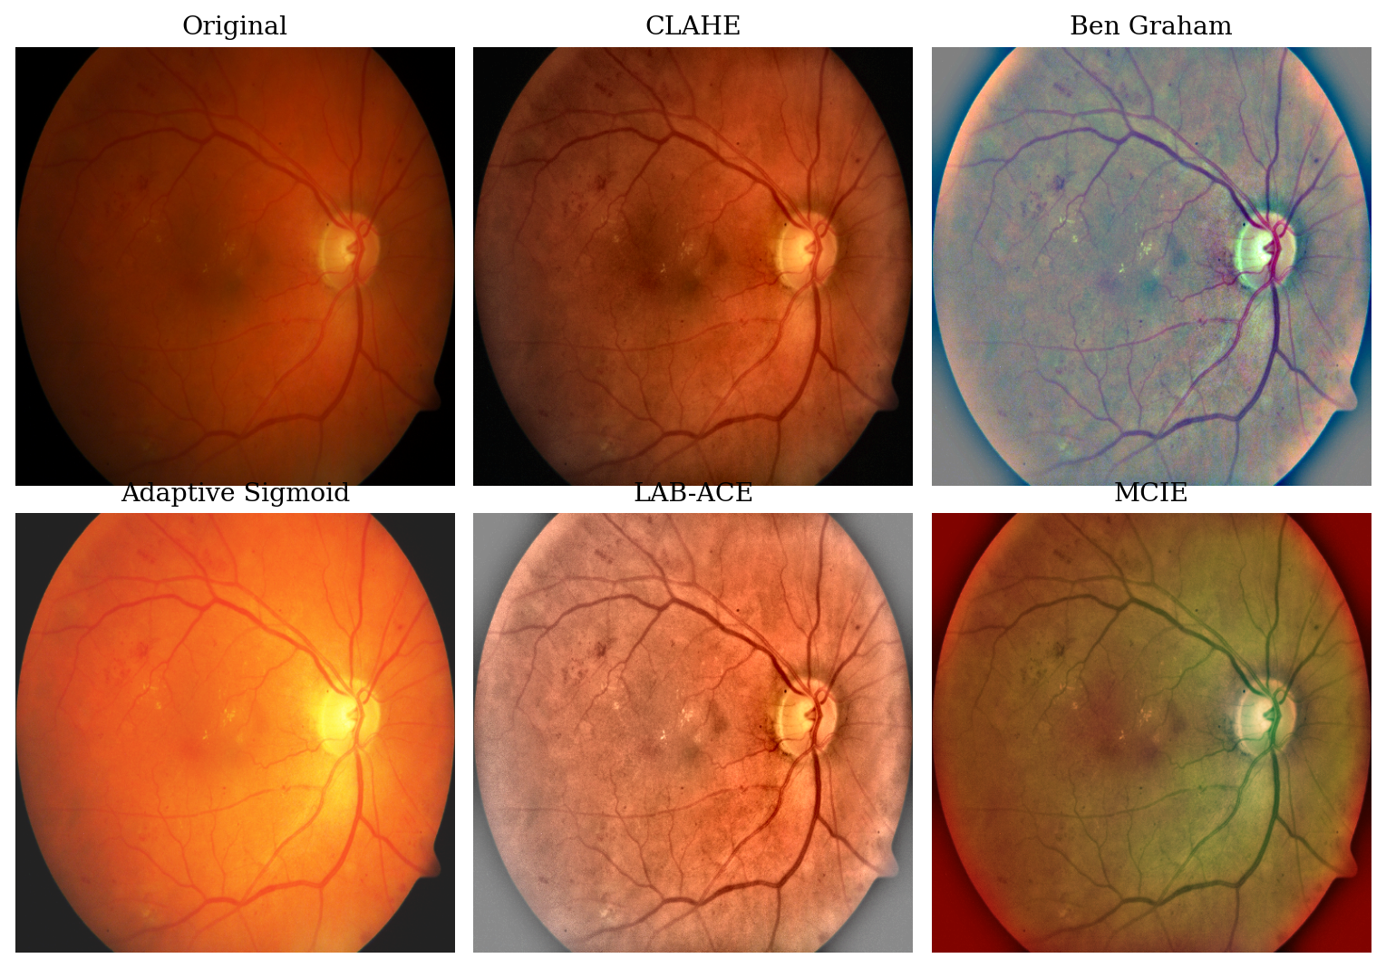
Figure 2.1. The five preprocessing techniques applied to a representative colour fundus image. CLAHE and LAB-ACE amplify local contrast, Ben Graham Normalization stabilises global illumination, Adaptive Sigmoid Enhancement stretches the intensity range, and MCIE composites the green channel, CLAHE, and Ben Graham results into one three-channel input. Source: prepared by the author.

2.3.1 Contrast Limited Adaptive Histogram Equalization (CLAHE)
Contrast Limited Adaptive Histogram Equalization (CLAHE; Zuiderveld, 1994) equalizes the histogram locally per tile. Within each tile a pixel value $r$ is remapped by the contrast-limited cumulative distribution $T(r)=(L−1)\sum_{j=0}^{r}{\hat{p}}(j)$, where $L$ is the number of intensity levels and $\hat{p}$ is the tile histogram after clipping at a clip limit and redistributing the excess; the clip limit caps noise amplification. On fundus images, CLAHE is applied to the luminance channel (LAB) to reveal low-contrast lesions such as microaneurysms hidden under uneven illumination.

2.3.2 Ben Graham Normalization
Ben Graham Normalization (Graham, 2015), the preprocessing used by the winner of the Kaggle Diabetic Retinopathy Detection competition and now a standard step in DR grading, suppresses large-scale illumination by subtracting a Gaussian-blurred copy of the image: $I_{norm}=αI+βG_{σ}(I)+γ$, where $G_{σ}$ is a Gaussian filter of radius $σ$. Small-scale structures such as lesions and vessels become more prominent while inter-camera illumination variation is reduced.

2.3.3 Adaptive Sigmoid Enhancement
Adaptive Sigmoid Enhancement (Anupama et al., 2025) remaps intensities with a sigmoid $f(x)=1/(1+exp(−α(x−β)))$, where the slope $α$ and midpoint $β$ are set adaptively from the local intensity mean and standard deviation. Contrast is amplified in dark regions without boosting noise in bright ones, so pale lesions separate more clearly from the retinal background.

2.3.4 LAB Adaptive Contrast Enhancement (LAB-ACE)
LAB Adaptive Contrast Enhancement (LAB-ACE; Anupama et al., 2025) converts to LAB and enhances only the luminance channel L (CLAHE plus local normalisation), leaving the colour channels A and B untouched, then reconstructs to RGB. Enhancing L alone raises lesion contrast without the colour distortion that could confound grading.

2.3.5 Multi-channel Image Enhancement
Multi-channel Image Enhancement (MCIE; Anupama et al., 2025) stacks several complementary representations into one three-channel input, for example the green channel (sensitive to haemoglobin), CLAHE on the L channel, and the Ben Graham Normalization result. The feature extractor then exploits several enhancements at once rather than a single type; Anupama et al. (2025) recommend such combinations as a future direction.

2.4 Deep Learning Architectures for Image Classification
This study evaluates two deep learning backbones representing two different paradigms, namely the convolutional neural network (CNN) represented by ResNet-50 and the Vision Transformer (ViT) represented by ViT-B/16. Each architecture is described in Sections 2.4.1 and 2.4.2.

2.4.1 Convolutional Neural Network and ResNet-50
A convolutional neural network (CNN) stacks convolutions, non-linear activations ($ReLU(z)=max(0,z)$), and pooling. Weight sharing keeps the parameter count independent of image size and makes the model translation-equivariant, while depth builds a hierarchy of receptive fields from edges and textures to whole structures. The final features map to logits $z∈R^{K}$, converted to class probabilities by the softmax $p_{k}=exp(z_{k})/\sum_{j=1}^{K}{exp}(z_{j})$ and trained with categorical cross-entropy $L_{CE}=−\sum_{k=1}^{K}{y_{k}}logp_{k}$.
ResNet-50 (He et al., 2016) is one of the most widely used CNNs in medical imaging. Its main contribution is the residual connection $y=F(x)+x$, namely a shortcut path that addresses vanishing gradients and enables the training of deep networks. ResNet-50 arranges 50 convolutional layers (its building unit being a three-layer bottleneck block with a residual connection) in four stages of decreasing spatial resolution, as presented in Figure 2.2. This architecture is chosen as the CNN backbone because it is well established, has a moderate parameter size (~25.5 million), and is commonly used as a baseline in the DR grading literature.
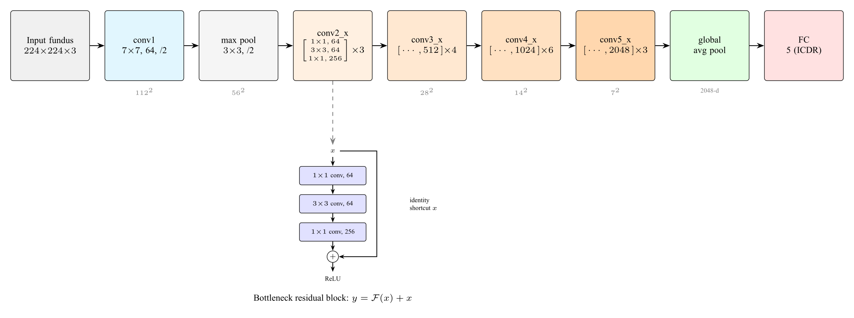
Figure 2.2. The ResNet-50 architecture: a $7×7$ convolution and max pooling followed by four residual stages (conv2_x to conv5_x) built from bottleneck blocks, then global average pooling and a fully connected layer. The inset shows the bottleneck residual block with its identity shortcut, $y=F(x)+x$. In this study the classification head outputs five ICDR classes. Source: adapted from He et al. (2016).

2.4.2 Vision Transformer (ViT)
The Vision Transformer (ViT; Dosovitskiy et al., 2021) adapts the Transformer architecture (Vaswani et al., 2017) to image recognition. ViT divides the image into fixed-size patches ($16×16$ pixels in ViT-B/16), linearises each patch into a token, adds positional embeddings, and then processes them with several Transformer encoder blocks. Its core component is self-attention, which makes each token weigh the relevance of all other tokens through query $Q$, key $K$, and value $V$ projections: $Attention(Q,K,V)=softmax(QK^{⊤}/\sqrt{d_{k}})V$. This ability to model long-range dependencies is relevant for DR grading because lesions can be scattered across various retinal quadrants. The ViT-B/16 architecture, together with the structure of the Transformer encoder block and its multi-head self-attention mechanism, is presented in Figure 2.3. Anupama et al. (2025) explicitly propose ViT as a development direction for DR grading.
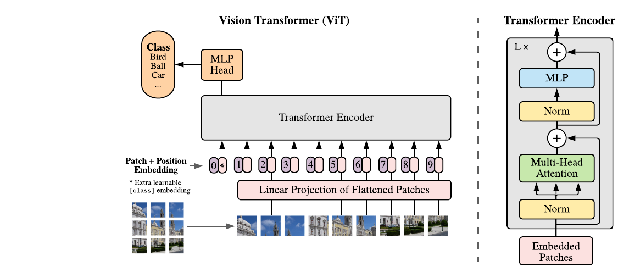
Figure 2.3. The Vision Transformer architecture. An image is split into fixed-size patches that, together with position embeddings and a learnable [class] token, are processed by a Transformer encoder; the right panel shows the encoder block with multi-head self-attention. In this study the input is a fundus image and the classification head outputs five ICDR classes. Source: Dosovitskiy et al. (2021); encoder block after Vaswani et al. (2017).

2.4.3 Transfer Learning
Public DR datasets are small (IDRiD has only a few hundred training images), so training either backbone from random initialisation would overfit. Transfer learning instead initialises from ImageNet-pretrained weights, which already encode general visual features, and fine-tunes on the target data with the classifier head replaced for five classes, cutting the data requirement and speeding convergence enough to make training on IDRiD feasible.

2.5 Evaluation Metrics for DR Grading Classification

2.5.1 Accuracy, Precision, Recall, and Macro-F1
Accuracy is the proportion of correct predictions, $Accuracy=(1/N)\sum_{i=1}^{N}{1}[{\hat{y}}_{i}=y_{i}]$, but it is biased on imbalanced data dominated by grade 0, as in IDRiD and DDR. For this reason, per-class precision and recall are also reported, together with macro-F1, namely the arithmetic mean of $F1=2 (precision⋅recall)/(precision+recall)$ over all classes. Macro-F1 gives equal weight to each class, so that it is sensitive to performance on the minority classes.

2.5.2 Quadratic-weighted Kappa (QWK)
Because ICDR is ordinal, an error two grades apart is more severe than one grade apart, yet accuracy and F1 do not distinguish them. Quadratic-weighted kappa (Cohen, 1968) imposes a penalty proportional to the square of the distance between classes,
$$κ_{w} = 1−\frac{\sum_{i=1}^{K}{\sum_{j=1}^{K}{w_{ij}}}O_{ij}}{\sum_{i=1}^{K}{\sum_{j=1}^{K}{w_{ij}}}E_{ij}}, w_{ij}=\frac{(i−j)^{2}}{(K−1)^{2}},$$
where $O$ is the observed confusion matrix and $E$ is the expected confusion matrix if predictions and labels were independent. A value of $κ_{w}=1$ means perfect prediction and $κ_{w}=0$ is equivalent to random guessing. QWK is the standard metric in DR grading challenges (Kaggle Diabetic Retinopathy Detection, APTOS 2019) and is the primary metric of this study.

2.5.3 Gradient-weighted Class Activation Mapping (Grad-CAM)
Gradient-weighted Class Activation Mapping (Grad-CAM; Selvaraju et al., 2017) produces a heatmap that marks the image regions most influential on the classification decision, by weighting the feature maps of the last convolutional layer using the gradient of the target class score. In DR grading, Grad-CAM is used to verify whether the model bases its prediction on clinically relevant lesions (for example microaneurysms or haemorrhages) or on artefacts such as the lens edge. In this study, Grad-CAM serves as a complementary interpretation tool on the best configuration, not the main quantitative focus, in line with the recommendation of Anupama et al. (2025).

2.6 Related Work
As noted in Section 1.1, deep-learning DR grading reached clinical and regulatory maturity through landmark systems (Gulshan et al., 2016; Abramoff et al., 2018), after which the release of public benchmarks such as IDRiD (Porwal et al., 2020) and DDR (Li et al., 2019) shifted attention to the open comparison of backbones (ResNet, DenseNet, Inception, EfficientNet) and, more recently, foundation models such as RETFound (Zhou et al., 2023). This study sits within that open-benchmark line of work but focuses on two underexplored questions: how preprocessing interacts with the backbone, and whether the resulting comparison holds across datasets.
Chokuwa and Khan (2025) showed that DR grading models suffer a marked performance decline when a model trained on one dataset is evaluated on another with different acquisition settings, because of domain shift (camera, illumination, demographics) rather than annotation inconsistency. This finding motivates this study’s decision not to transfer a single model across datasets, but instead to treat each dataset as a self-contained benchmark and to test whether the comparative conclusion, namely which preprocessing and backbone is best, is consistent across datasets.
The anchor paper of this study is Anupama et al. (2025) in Scientific Reports, which evaluates several backbones for DR grading on a single dataset and, in its future-work section, identifies three directions: (i) systematic exploration of preprocessing combinations; (ii) validation on multi-center datasets with diverse devices and demographics; and (iii) integration of interpretation tools such as Grad-CAM. This study takes all three as its foundation, namely comparing five preprocessing techniques (Section 2.3) on two backbones of different paradigms (Section 2.4), evaluating independently across six public datasets (Section 2.2), and using Grad-CAM on the best configuration (Section 2.5.3).

2.7 Conceptual Framework
Raw fundus images vary in illumination, contrast, and colour, while early DR lesions are small and low-contrast (Sections 2.1 and 2.2). The five preprocessing techniques (Section 2.3) and the two backbones (Section 2.4) act through different mechanisms and inductive biases, so performance is treated as a function of the preprocessing $×$ backbone interaction, which the $5×2$ factorial design (Section 3.1) is built to isolate. To test whether this interaction holds beyond a single dataset, the ten configurations are trained and evaluated independently on six datasets that differ in camera, population, and illumination but share the ICDR ontology, so that a configuration ranking highest consistently across all six has external validity. Because the ICDR scale is ordinal and the classes are imbalanced, the comparison relies on QWK and macro-F1 rather than accuracy alone (Section 2.5) and aggregates the per-dataset QWK with the Friedman test and Nemenyi post-hoc (Section 3.7). This framework motivates the hypotheses in Section 2.8.

2.8 Research Hypotheses
Following the three research questions, this study proposes three hypotheses, which are tested with the Friedman test and Nemenyi post-hoc (Section 3.7).
H1. The choice of preprocessing technique and backbone affects grading performance, so the ten configurations do not all perform equally.
H2. One configuration performs best consistently across the six datasets, rather than the best configuration changing from one dataset to another.
H3. The configuration that performs best is not necessarily the most efficient, so choosing a configuration for primary-care deployment involves a trade-off between performance and computational cost.

CHAPTER III RESEARCH METHODOLOGY

3.1 Research Design
This study uses a quantitative factorial experimental design. The independent variables are two factors: the fundus-image preprocessing technique at five levels (CLAHE, Ben Graham Normalization, Adaptive Sigmoid Enhancement, LAB-ACE, and MCIE) and the backbone architecture at two levels (ResNet-50 and ViT-B/16), yielding ten configurations ($5×2$); operational definitions are given in Section 3.3. Each of the six datasets (IDRiD, DDR, APTOS 2019, Messidor-2, EyePACS, and DeepDRiD) is treated as an independent benchmark: on every dataset, all ten configurations are trained and tested on that dataset’s own partition under an identical protocol, and scored through accuracy, quadratic-weighted kappa (QWK), macro-F1, and per-class confusion matrices. This yields a $10×6$ matrix of per-dataset QWK scores.
To determine which configuration is best not on a single dataset but consistently across all six, the per-dataset QWK scores are aggregated with the Friedman test and the Nemenyi post-hoc procedure (Demsar, 2006), visualised as a critical difference diagram (Section 3.7). All hyperparameters, the augmentation pipeline, the data split per dataset, and the random seed are held identical across configurations, so observed differences within a dataset are attributable to the preprocessing technique and the backbone choice alone. Model weights, seeds, scripts, and metric logs are stored in a public Git repository for reproducibility. Figure 3.1 presents the six-stage flow, from per-dataset splitting through preprocessing, training, and evaluation to the Friedman aggregation and Grad-CAM on the best configuration.
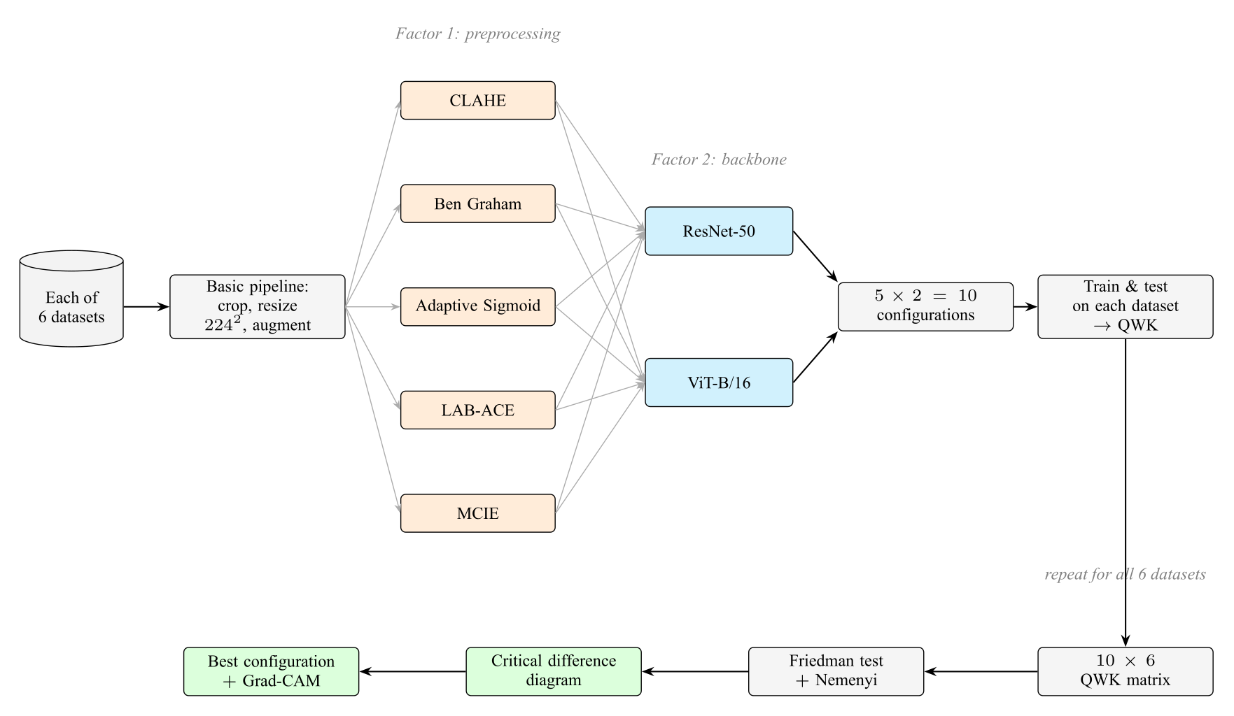
Figure 3.1. Research design. For each of the six datasets, an image passes through the basic pipeline and then branches into the five preprocessing techniques (Factor 1); each branch is paired with both backbones (Factor 2), forming ten configurations that are trained and tested on that dataset to produce its QWK. Repeating this for all six datasets yields a $10×6$ QWK matrix, which is aggregated with the Friedman test and Nemenyi post-hoc into a critical difference diagram that identifies the best configuration, finally verified with Grad-CAM. Source: prepared by the author.

3.2 Dataset

3.2.1 Per-Dataset Train, Validation, and Test Partitions
Each of the six datasets is split into train, validation, and test partitions independently, and all ten configurations are trained and evaluated within each dataset using these partitions. The validation partition is used for early stopping and checkpoint selection; the test partition is accessed only once per configuration, at the end of training, to produce the reported metrics. For datasets that provide official partitions, those are adopted unchanged; for the others, a stratified split under a fixed seed is used.
For IDRiD, the official partition (413 training, 103 test; Porwal et al., 2020) is used, with 15% of the training images (62 images) set aside as a stratified validation partition under a fixed seed, leaving 351 training images. For DDR (Li et al., 2019), the official train, validation, and test partitions are used after ungradable images are filtered out. For DeepDRiD (Liu et al., 2022) and EyePACS (Kaggle and EyePACS, 2015), the official partitions are likewise adopted; for EyePACS, ungradable images are removed and a class-stratified subset is drawn to keep the training cost manageable while preserving the class distribution. For APTOS 2019 (APTOS, 2019) and Messidor-2 (Decenciere et al., 2014), which do not provide official train and test partitions, a stratified 70/15/15 train/validation/test split under a fixed seed is used. All splits are released in the public repository so that they can be reproduced exactly.

3.2.2 Class Distribution and Handling of Imbalance
All six datasets are imbalanced (long-tailed): grade 0 dominates while the higher grades, especially grades 3 and 4, are minorities. Within each dataset the imbalance is handled identically at two levels, namely (i) a weighted random sampler with weights $∝1/\sqrt{n_{k}}$ ($n_{k}$ is the number of training images of class $k$ in that dataset) in each mini-batch, and (ii) class-weighted categorical cross-entropy with weights $∝1/\sqrt{n_{k}}$ normalised to sum to $K$. QWK is chosen as the checkpoint-selection metric because it is sensitive to ordinal distance and relatively robust to the marginal distribution.

3.3 Variables and Operational Definitions
This study involves two independent variables, three dependent variables, and a set of controlled variables, defined operationally in Table 3.1.
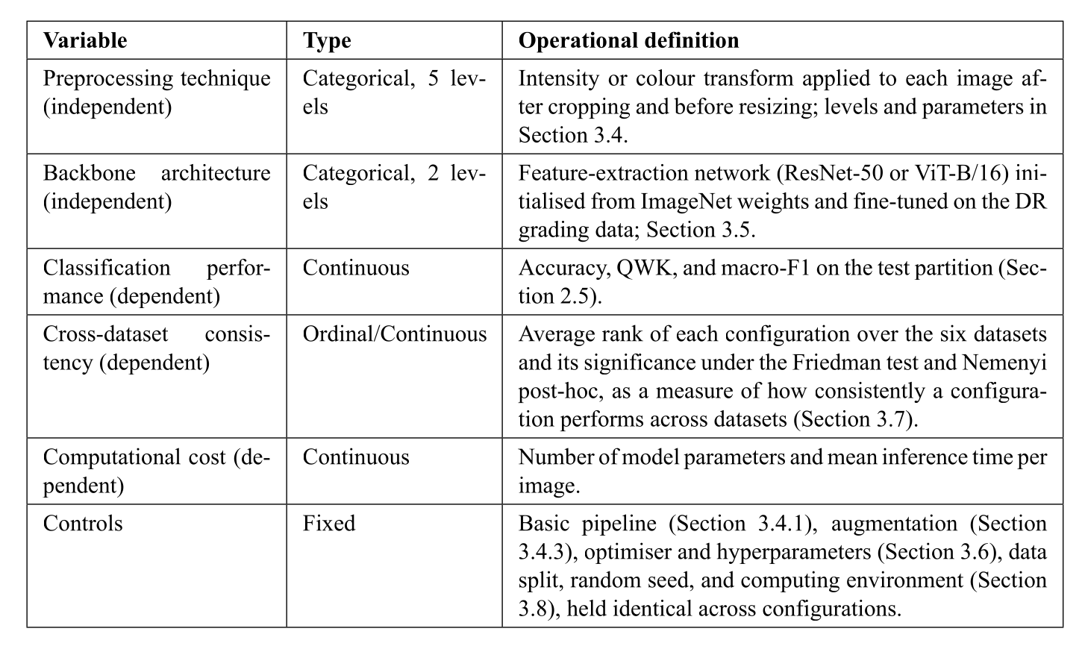
Table 3.1. Research variables and their operational definitions.

3.4 Data Preprocessing

3.4.1 Basic Pipeline
Before the specific technique is applied, every image from all six datasets passes through an identical basic pipeline, namely (i) estimation of the retinal mask via adaptive thresholding on the green channel, followed by cropping to the minimum bounding box to remove the black frame; (ii) resizing to $224×224$ pixels (bilinear interpolation) in accordance with the standard input of ImageNet weights; and (iii) normalisation to $[0,1]$ followed by per-channel normalisation with the ImageNet mean and standard deviation ($μ=(0.485,0.456,0.406)$, $σ=(0.229,0.224,0.225)$). This pipeline is identical for training, validation, and testing across all datasets, so that differences between configurations are not masked by differences in the basic pipeline.

3.4.2 Application of the Five Preprocessing Techniques
The preprocessing technique is applied between cropping and resizing; the parameters of each technique (concepts in Section 2.3) are as follows. CLAHE: clip limit 2.0 and tile $8×8$ on the L channel (LAB). Ben Graham Normalization: $α=4$, a Gaussian radius $σ$ equal to 10% of the retinal diameter, and $γ=128$, following the original Kaggle 2015 recipe. Adaptive Sigmoid Enhancement: $α$ and $β$ computed adaptively from the mean and standard deviation of the local patch intensity. LAB-ACE: CLAHE on the L channel followed by reconstruction to RGB. MCIE: a combination of the original green channel, the CLAHE result on the L channel, and the Ben Graham Normalization result into a three-channel image.

3.4.3 Data Augmentation
Online augmentation is applied only to the training partition of each dataset, after preprocessing. Geometric augmentation consists of horizontal and vertical flips (probability 0.5) and random rotation $[−{30}^{∘},+{30}^{∘}]$, which preserve the label because the ICDR grade does not depend on spatial orientation. Photometric augmentation consists of random brightness and contrast jitter $[−0.2,+0.2]$ to simulate the illumination variation across locations. The validation and test partitions of every dataset are not augmented.

3.5 Model Architecture
The concepts of both backbones and their architecture diagrams have been described in Section 2.4 (Figures 2.2 and 2.3); this section details only their experimental configuration. ResNet-50 is loaded with ImageNet-1k pretrained weights via torchvision 0.18, while ViT-B/16 is loaded with ImageNet-21k pretrained weights via timm 1.0. In both backbones, the original classification head is replaced with a new linear layer to the five ICDR logits (ResNet-50: $2048→5$ from the global average pooling vector; ViT-B/16: $768→5$ from the CLS token). All parameters are trained jointly (full fine-tuning) without freezing any layer, with a softmax output optimised using class-weighted categorical cross-entropy (Sections 3.2.2 and 3.6).

3.6 Training Protocol
All models are trained with the AdamW optimiser (Loshchilov and Hutter, 2019), an initial learning rate $η_{0}=1×{10}^{−4}$, weight decay $1×{10}^{−4}$, $β_{1}=0.9$, and $β_{2}=0.999$. The learning rate follows a cosine schedule down to $η_{min}=1×{10}^{−6}$, preceded by a three-epoch linear warm-up. The batch size is 16 images, matching the memory of a single NVIDIA T4 GPU on Google Colab Pro. Training proceeds for up to 50 epochs with early stopping based on validation QWK (patience of 10 epochs); the checkpoint with the highest validation QWK is used for test evaluation.
The loss function is class-weighted categorical cross-entropy (weights as in Section 3.2.2). Mixup, label smoothing, and focal loss are deliberately not used, so that performance differences between configurations arise purely from the preprocessing technique and the backbone choice. All random number generators are initialised with the same seed so that the results can be reproduced. Because the design trains every configuration on every dataset, there are ten configurations across six datasets, giving sixty training runs in total. To keep this tractable, the very large EyePACS dataset is trained on a class-stratified subset (Section 3.2.1), and the smaller datasets contribute most of the runs at low cost; the indicative total training budget is therefore on the order of a hundred GPU-hours on Google Colab Pro, scheduled across the training months in the work plan (Section 3.9).

3.7 Evaluation Protocol
On each of the six datasets, the test partition is evaluated once per configuration with accuracy, QWK, macro-F1, and a per-class confusion matrix, all reported in a per-dataset results table. This produces a $10×6$ matrix of QWK scores, one per configuration per dataset, which is the basis of the statistical analysis.
The configurations are compared across datasets with the Friedman test (Demsar, 2006), the standard non-parametric procedure for comparing several methods over multiple datasets. Within each dataset the ten configurations are ranked by QWK, and the Friedman test, using the Iman-Davenport $F$ correction appropriate for a small number of datasets, examines whether the average ranks differ significantly. When the Friedman test is significant, the Nemenyi post-hoc procedure identifies which pairs of configurations differ by more than the critical difference, and the result is presented as a critical difference (CD) diagram in which configurations not significantly different are connected. QWK is the metric on which the test is run because it is the primary, ordinal-aware metric for DR grading; accuracy and macro-F1 are reported descriptively alongside it. Because the test rests on six datasets, the Nemenyi procedure is conservative, so a non-significant pair is interpreted as insufficient evidence of a difference rather than as evidence of equivalence. The analysis is implemented with the and libraries. In addition, Grad-CAM (Selvaraju et al., 2017) is generated on the best configuration for visual verification of the basis of the predictions.

3.8 Implementation Tools and Environment
The experimental pipeline is implemented in Python 3.11 using the following libraries: PyTorch 2.3 as the tensor and autodiff backend; torchvision 0.18 for ResNet-50 and the ImageNet-1k pretrained weights; timm 1.0 (Wightman, 2019) for ViT-B/16 and the ImageNet-21k pretrained weights; OpenCV 4.9 and scikit-image 0.22 for implementing the five preprocessing techniques; Albumentations 1.4 for the augmentation pipeline; scikit-learn 1.4 for computing the evaluation metrics; and Matplotlib 3.8 and seaborn 0.13 for visualising the confusion matrices and Grad-CAM heatmaps. The experiments are run on Google Colab Pro with an NVIDIA T4 or A100 GPU depending on availability. All code, training scripts, evaluation scripts, configuration files, and metric logs are stored in a public Git repository accompanied by a reproduction README with explicit library versions, seeds, and execution commands.

3.9 Research Schedule
The research activities are planned to run for twelve months, from March 2026 to February 2027, covering literature study and proposal writing, the proposal seminar and its revision, environment preparation and collection of the six datasets, implementation of the preprocessing pipeline, training of the ten configurations on each of the six datasets, per-dataset evaluation, Friedman statistical analysis and Grad-CAM visualisation, the writing of Chapter IV and Chapter V, the results seminar, and the thesis defense and final submission. The monthly schedule is detailed in Table 3.2; the columns from March to December are months in 2026, while January and February are months in 2027. The schedule is indicative and may be adjusted according to the results of consultations with the supervisors and the availability of computational resources on Google Colab Pro.
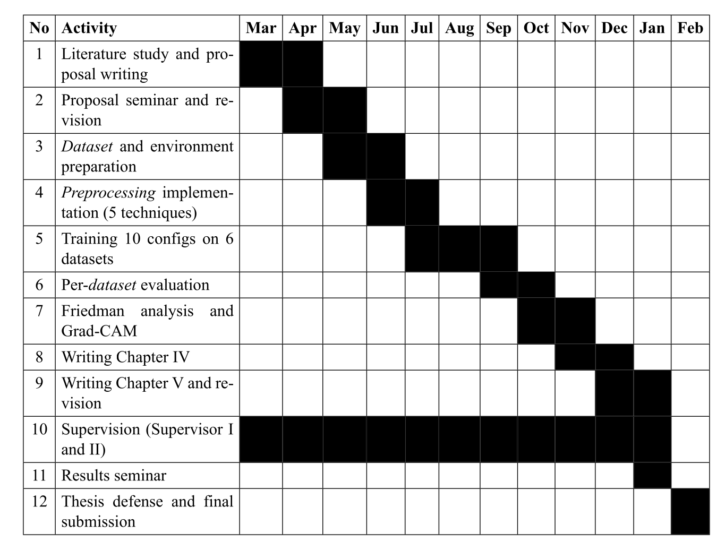
Table 3.2. Research schedule for the period March 2026 to February 2027.

REFERENCES
Abramoff, M. D., Lavin, P. T., Birch, M., Shah, N., & Folk, J. C. (2018). Pivotal Trial of an Autonomous AI-Based Diagnostic System for Detection of Diabetic Retinopathy in Primary Care Offices. NPJ Digital Medicine, 1(1), 39.
American Diabetes Association. (2024). Standards of Care in Diabetes: 2024. Diabetes Care, 47(Suppl. 1), S1–S322.
Anupama, B. C., Rao, S. N., Malini, M. B., & Athreya, V. V. (2025). Comparative Analysis of Novel Preprocessing Techniques and Deep Learning Based Multi-Modal Feature Fusion for Diabetic Retinopathy Grading. Scientific Reports, 15, 31339.
Asia Pacific Tele-Ophthalmology Society (APTOS). (2019). APTOS 2019 Blindness Detection [Data set]. Kaggle. https://www.kaggle.com/c/aptos2019-blindness-detection
Chokuwa, S., & Khan, M. H. (2025). Divergent Domains, Convergent Grading: Enhancing Generalization in Diabetic Retinopathy Grading. IEEE/CVF Winter Conference on Applications of Computer Vision (WACV).
Chopra, M., Sparrenberg, L., Berger, A., Khanna, S., Terheyden, J. H., & Sifa, R. (2025). From Retinal Pixels to Patients: Evolution of Deep Learning Research in Diabetic Retinopathy Screening. 2025 IEEE International Conference on Big Data (IEEE BigData). arXiv:2511.11065
Cohen, J. (1968). Weighted Kappa: Nominal Scale Agreement Provision for Scaled Disagreement or Partial Credit. Psychological Bulletin, 70(4), 213–220.
Decenciere, E., Zhang, X., Cazuguel, G., Lay, B., Cochener, B., Trone, C., et al. (2014). Feedback on a Publicly Distributed Image Database: The Messidor Database. Image Analysis & Stereology, 33(3), 231–234.
Demsar, J. (2006). Statistical Comparisons of Classifiers over Multiple Data Sets. Journal of Machine Learning Research, 7, 1–30.
Dosovitskiy, A., Beyer, L., Kolesnikov, A., Weissenborn, D., Zhai, X., Unterthiner, T., Dehghani, M., Minderer, M., Heigold, G., Gelly, S., Uszkoreit, J., & Houlsby, N. (2021). An Image Is Worth 16$$16 Words: Transformers for Image Recognition at Scale. International Conference on Learning Representations (ICLR).
Graham, B. (2015). Kaggle Diabetic Retinopathy Detection Competition Report. University of Warwick.
Gulshan, V., Peng, L., Coram, M., Stumpe, M. C., Wu, D., Narayanaswamy, A., … & Webster, D. R. (2016). Development and Validation of a Deep Learning Algorithm for Detection of Diabetic Retinopathy in Retinal Fundus Photographs. JAMA, 316(22), 2402–2410.
He, K., Zhang, X., Ren, S., & Sun, J. (2016). Deep Residual Learning for Image Recognition. Proceedings of the IEEE Conference on Computer Vision and Pattern Recognition (CVPR), 770–778.
Kaggle, & EyePACS. (2015). Diabetic Retinopathy Detection [Data set]. Kaggle. https://www.kaggle.com/c/diabetic-retinopathy-detection
Li, T., Gao, Y., Wang, K., Guo, S., Liu, H., & Kang, H. (2019). Diagnostic Assessment of Deep Learning Algorithms for Diabetic Retinopathy Screening. Information Sciences, 501, 511–522.
Liu, R., Wang, X., Wu, Q., Dai, L., Fang, X., Yan, T., et al. (2022). DeepDRiD: Diabetic Retinopathy-Grading and Image Quality Estimation Challenge. Patterns, 3(6), 100512.
Loshchilov, I., & Hutter, F. (2019). Decoupled Weight Decay Regularization. International Conference on Learning Representations (ICLR).
Porwal, P., Pachade, S., Kokare, M., Deshmukh, G., Son, J., Bae, W., … & Meriaudeau, F. (2020). IDRiD: Diabetic Retinopathy Segmentation and Grading Challenge. Medical Image Analysis, 59, 101561.
Saputra, N. A., Helvinda, W., & Rahman, K. (2024). Prevalence and Risk Factors of Diabetic Retinopathy in a Tertiary Hospital in Padang, Indonesia. Bioscientia Medicina: Journal of Biomedicine and Translational Research, 9(1), 219–231.
Sasongko, M. B., Widyaputri, F., Agni, A. N., Wardhana, F. S., Kotha, S., Gupta, P., Widayanti, T. W., Haryanto, S., Widyaningrum, R., Wong, T. Y., Kawasaki, R., & Wang, J. J. (2025). Incidence and Progression of Diabetic Retinopathy and Blindness in Indonesian Adults with Type 2 Diabetes. PLoS ONE, 20, e0322093.
Selvaraju, R. R., Cogswell, M., Das, A., Vedantam, R., Parikh, D., & Batra, D. (2017). Grad-CAM: Visual Explanations from Deep Networks via Gradient-Based Localization. Proceedings of the IEEE International Conference on Computer Vision (ICCV), 618–626.
Teo, Z. L., Tham, Y. C., Yu, M., Chee, M. L., Rim, T. H., Cheung, N., … & Cheng, C. Y. (2021). Global Prevalence of Diabetic Retinopathy and Projection of Burden through 2045: Systematic Review and Meta-Analysis. Ophthalmology, 128(11), 1580–1591.
Vaswani, A., Shazeer, N., Parmar, N., Uszkoreit, J., Jones, L., Gomez, A. N., Kaiser, L., & Polosukhin, I. (2017). Attention Is All You Need. Advances in Neural Information Processing Systems (NeurIPS), 5998–6008.
Wightman, R. (2019). PyTorch Image Models (timm) [Computer software]. GitHub. https://github.com/huggingface/pytorch-image-models
Wilkinson, C. P., Ferris III, F. L., Klein, R. E., Lee, P. P., Agardh, C. D., Davis, M., … & Verdaguer, J. T. (2003). Proposed International Clinical Diabetic Retinopathy and Diabetic Macular Edema Disease Severity Scales. Ophthalmology, 110(9), 1677–1682.
Wong, T. Y., & Sabanayagam, C. (2023). The War on Diabetic Retinopathy: Where Are We Now? Asia-Pacific Journal of Ophthalmology, 12(3), 213–221.
Zhou, Y., Chia, M. A., Wagner, S. K., Ayhan, M. S., Williamson, D. J., Struyven, R. R., … & Keane, P. A. (2023). A Foundation Model for Generalizable Disease Detection from Retinal Images. Nature, 622(7981), 156–163.

