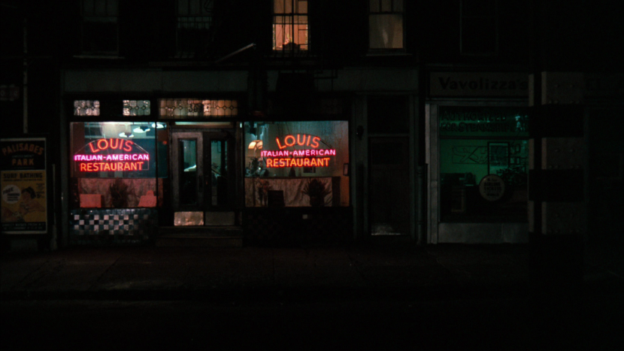

Where in Raleigh, NC Should I Open an Italian Restaurant?

Scott Josephson | Applied Data Science Capstone | 1/2/19

# Data

The data that will be using are from Italian Restaurant venues, Cafes, Shopping, and the Nightlife located near the Italian Restaurants in the city of Raleigh. We will look at features such as name, categories, address, cross street, latitude, longitude.