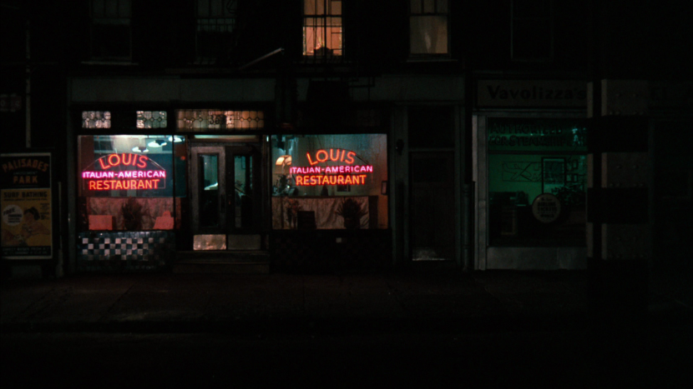

Where in Raleigh, NC Should I Open an Italian Restaurant?

Scott Josephson | Applied Data Science Capstone | 1/2/19

# Introduction

My friend is looking to move out from New York City as he gets closer to retirement. . He has been in the restaurant business for 20 years and has owned several Italian Restaurants in New York. He wants to move to a quieter town, but he still needs income. He has asked me to research other cities to see which towns are need of a good Italian restaurant. I am currently looking at Raleigh North Carolina. I decided to research Italian restaurant competitors, Cafes, Shopping, and Nightlife. I am most interested in finding places from the different categories and seeing where in Raleigh are the greatest concentration of other Italian Restaurants located.