Financial manager

Software Requirement Specification (SRS)
v0.1

Gábor Harsányi

October 31, 2012
Revision History

Revision | Date | Author | Comment
v0.1 | October 31, 2012 | Gábor Harsányi | First draft
v0.2 | November 4, 2012 | Gábor Harsányi | Changed Scope of the Project
v0.3 | November 4, 2012 | Gábor Harsányi | Added system environment and functional requirement specifications

Table of Contents

Table of Contents 3
List of Figures 4
1. Introduction 5
1.1. Purpose 5
1.2. Scope of Project 5
1.3. Glossary 5
1.4. References 6
1.5. Overview of Document 6
2. Overall Description 7
2.1. System Environment 7
2.2. Functional Requirements Specification 8
2.2.1. Use Cases of Receipt OCR 8
2.2.2. Use Cases of My Data Administrator 8
2.2.3. Use Cases of Web Application 8
2.3. User Characteristics 8
2.4. Non-Functional Requirements 8
3. Requirements Specification 9
Index 10

List of Figures

Figure 1 - System Environment 7
Figure 2 - Use Cases of Receipt OCR 8
Figure 3 - Use Cases of Receipt OCR - Authenticated 8

1. Introduction

1.1. Purpose
The purpose of this document is to present a detailed description of the Financial Manager System. It will explain the purpose and features of the system, the interfaces of the system, what the system will do.
This document is intended for both the teachers of my courses at JAMK University and the developers of the system and will be proposed for its approval to final projects of the following courses: Qt, Android and HTML5.

1.2. Scope of Project
This software system will consist of three parts, an Android, a Qt and a Web Application with HTML5 front-end and aim to provide tools to assist in automating of tracking our financial affairs.
With Android part of the system can take a photo from your receipts and it will recognize what you bought, where and when. Then your phone, or other gadgets what can run android os, will organize your financial data and it will be traceable on your phone. With wireless or bluetooth this data can be shared between the other parts of the system. This function is only available when you have created a user account on the web site and you are authenticated on your machine by the site.
With Qt part of the system your data is manageable and can be organized. This system can create reports and can classify the bought items. Reports can be about grouped items or it can be seen in timetable format.
The web application part of the system could be the same as the QT part but web site can authorize, authenticate the user and should have more sophisticated functionalities. More data and bigger time slot can be seen and not only in list layout rather then charts or more fancy ways to render the collected information.
Each of these parts also contain a relational database containing a list of receipts, shops and the bought items.

1.3. Glossary
Term | Definition
OCR | Optical character recognition, the electronic conversion of scanned images of handwritten, typewritten or printed text into machine-encoded text.

1.4. References
IEEE. IEEE Std 830-1998 IEEE Recommended Practice for Software Requirements Specifications. IEEE Computer Society, 1998.
Harald Störrle - UML (Unified Modeling Language) 2
Panem, Bp, 2007

1.5. Overview of Document
The next chapter, the Overall Description section, of this document gives an overview of the functionality of the product. It describes the informal requirements and is used to establish a context for the technical requirements specification in the next chapter.
The third chapter, Requirements Specification section, of this document is written primarily for the developers and describes in technical terms the details of the functionality of the product.

2. Overall Description

2.1. System Environment
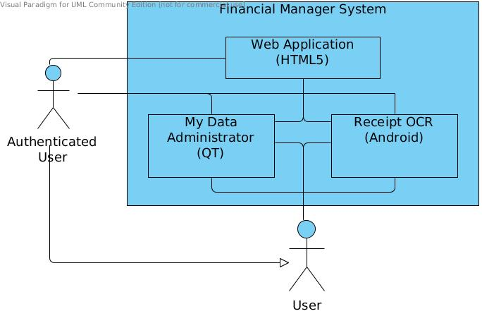Figure 1 - System Environment

The Financial Manager System has two actors. These actors are very similar, one is a user who want to collect and manage his financial data and the other one is also a kind of user, but this is an authenticated one. The web site could be used only if have a user account. With this account your data can be shared between devices and between subsystems.

2.2. Functional Requirements Specification

2.2.1. Use Cases of Receipt OCR
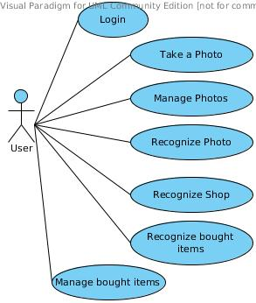Figure 2 - Use Cases of Receipt OCR
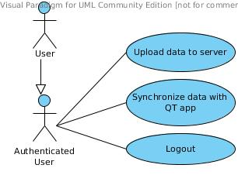Figure 3 - Use Cases of Receipt OCR - Authenticated

2.2.1.1. Use Case: Login
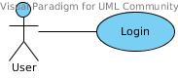

The user log into the system via the web site.

Initial Step-By-Step Description
- the User hit the menu button
- select the accounts menu
- select the new account menu
- write in his/her credentials
- click on the login button
- if it was success then click the finish button
- if it wasn't then click on retry button

- the User hit the menu button
- select the accounts menu
- select existing account

2.2.1.2. Use Case: Take a photo

The user take a photo using the first screen of the application.

Initial Step-By-Step Description
- the User

2.2.2. Use Cases of My Data Administrator

2.2.3. Use Cases of Web Application

2.3. User Characteristics

2.4. Non-Functional Requirements

3. Requirements Specification

Index

