Science Manuscript Template

General Instructions on using this template and submitting a manuscript to Science: Thank you for preparing a manuscript for submission to Science. Using this template, or following the guidelines below, will help us in processing your paper. Our goal is to be able to identify each section of your manuscript so that we can accurately record the title, authors, abstract, etc. and also be able to enrich it by including reference links and an accurate layout.

Please use the actual template, which starts on page 2. When you are ready to submit, please delete the text on this cover page.

You can submit your paper at www.submit2science.org
Additional instructions are available at http://www.sciencemag.org/site/feature/contribinfo/index.xhtml

If you are using LaTeX , please convert your paper into a Word or RTF file if possible. If this is not possible, please use our LaTeX template and upload a PDF version of your paper. Some conversion approaches are available here: http://www.tug.org/utilities/texconv/textopc.html

So that we can identify the parts of your paper, and even if you do not use our template, please begin each section with the specific key words listed below, some of which are followed by a colon. Please do not use paragraph breaks in the title, author list, or abstract.

Title:
Authors:
Affiliations:
One Sentence Summary:
Abstract:
Main Text:
References and Notes (followed by a numbered list)
Acknowledgements:
Fig. #: (Begin each figure caption with a label, “Fig. 1.” for example, as a new paragraph.).
Table #: (Begin each table caption with a label “Table 1.”, etc.) as a new paragraph.
Supplementary Materials: a list of the supplementary materials, followed by the actual text of the Supplementary Materials.

Several of these headings are optional, for example, not all papers will include a one-sentence summary, figures or tables, or supplementary material.

Please use the .docx format if possible (all version after Word 2007).

More specific formatting instructions are provided in the actual template, which follows.

Selection and Genetic Drift Drive Emergent Diversity in a Simulated Prochlorococcus Metacommunity
Authors: Ben A. Ward¹*, Sinéad Collins², Boris Sauterey³
Affiliations:
¹Ocean and Earth Science, University of Southampton, Waterfront Campus, Southampton, UK.
²Institute of Evolutionary Biology, School of Biological Sciences, University of Edinburgh, Edinburgh, UK.
³Ecole Normale Supérieure, PSL Research University, Institut de Biologie de l’Ecole Normale Supérieure (IBENS), 46 rue d’Ulm, F-75005 Paris, France.
*Correspondence to: b.a.ward@soton.ac.uk
Abstract: The abstract should be about 100-150 words, and organized in this structure: An opening sentence that sets the question that you address and is comprehensible to the general reader, background content specific to this study, results, and a concluding sentence. It should be one paragraph only.
One Sentence Summary: A brief summary of the main result of your paper, without excessive jargon and less than 150 characters.
Main Text: In general, this should include a brief (1-2 paragraph) introduction, followed by a statement of the specific scope of the study, followed by results and then interpretations. Please avoid statements of future work or claims of priority, and avoid repeating the conclusions at the end. All of the Figures and Tables should be cited in order, including those in the supporting online material (which should be cited as, for example, figure S1, and table S1). You can include page breaks if you would like to place the figures within the text.

Figure 1:

Subheads. These can be included in Research Articles or Reviews and should be brief.
References should be cited in parentheses with an italic number (1). Multiple reference citations are separated by commas (2, 3) or if a series, dashes (4-6). References are cited in order by where they first are called out, through the text, then the notes, captions, then through the supplementary material.
Equations can be included. We do not recommend using the native Word 2007, 2008, 2010 or 2011 equation editor. This can in some cases produce less reliable MathML, the online markup language we use, which may result in display errors. Instead, use the legacy equation editor in word (Insert menu; select insert object; select word equation) or use Mathtype (recommended). If you enter equations in simple LaTeX, check that they will convert accurately (Word 2007 and higher can convert simple LaTeX equations).

References and Notes:
- There is only one reference list spanning the text, figure captions and supplementary materials. Do not include a second reference list in the supplementary materials section. Reference only cited in the supplementary materials section are not counted toward length guidelines.
- Each reference should be on a separate line ending in a period. For a style guide, see www.sciencemag.org/about/authors/prep/res/refs.xhtml .
- You can include titles in references and full page ranges. Titles are not counted toward length guidelines
- Please include the above heading “References and Notes:”
- You can use a numbered list in Word.
- Each references should have a separate number.
- Please do not mix in references with explanatory notes.
Acknowledgments: The acknowledgments should include a statement about where the data reported in the paper are presented, archived, or available (for example, in the Supplementary Materials or in a community archive). If in an archive, include the accession number or a placeholder for it. Please also include relevant funding information such as grant numbers and funding agencies. You can also include a statement of author contributions here or in the Supplementary Materials.
The acknowledgements can be multiple paragraphs. Acknowledgments follow the references and notes but are not numbered.

Fig. 1. The figure caption should begin with an overall descriptive statement of the figure followed by additional text. They should be immediately after each figure. Figure parts are indicated with capital letters (A). If you prefer, you can place both the actual figures and captions logically through the text near where they are cited rather than at the end of the file (but not both). If a paragraph in the main text begins with the name of a figure, write out “Figure” in full (e.g., <para>“Figure 1 shows….”)

Fig. 2. You can place graphics above each equation as part of this file.

Table 1. Start this caption with a short description of your table. Format tables using the Word Table commands and structures. Do not create tables using spaces or tabs characters.

Supplementary Materials:
Materials and Methods
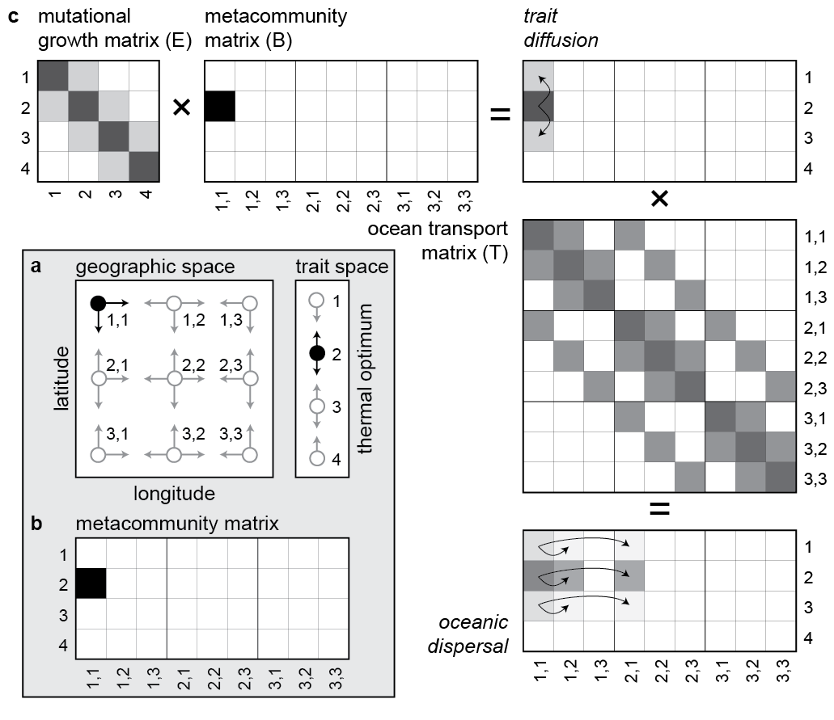
Figure S1:

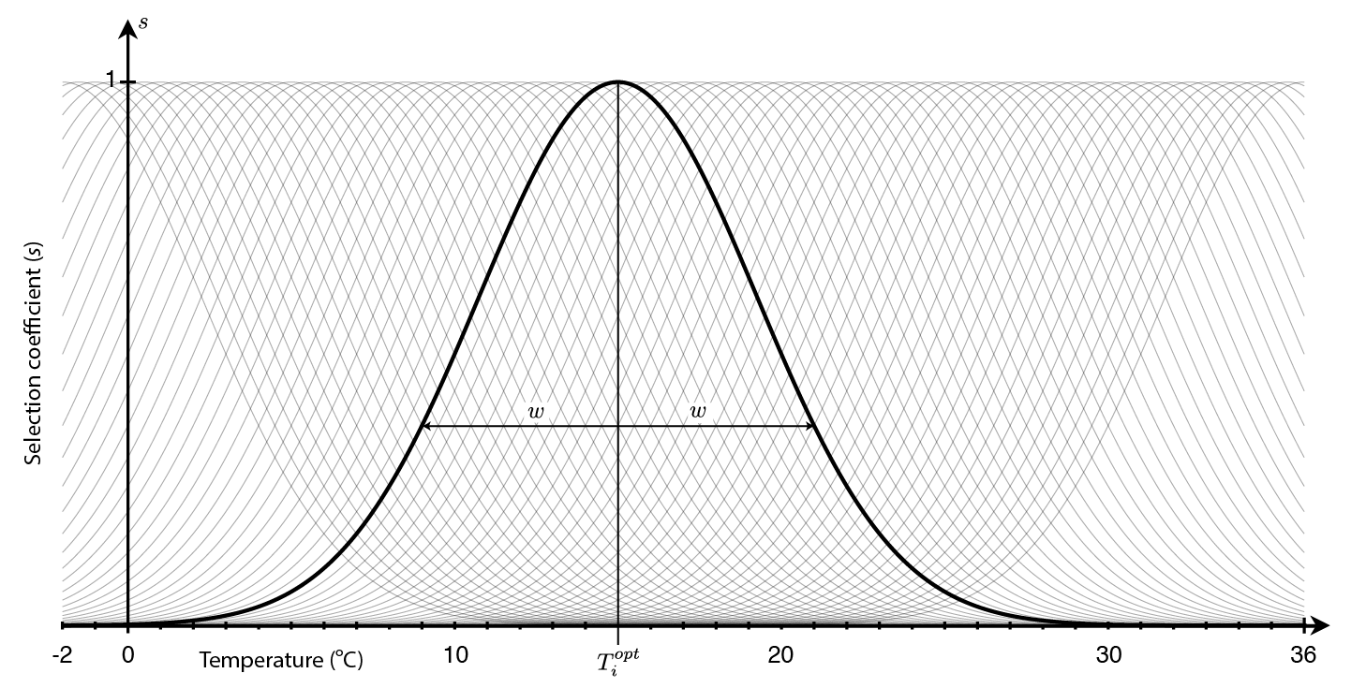
Figure S2:

Figures S1-S#
Tables S1-S#
Movies S1-S#
Audio Files S1-S#
External Databases S1-S#
References (##-##)

Supplementary Materials:
This section includes the actual text of the Supplementary Materials, which can include any or all of the preceding items, and figure captions and tables that can easily be incorporated into one supplementary material file. Please edit the list above as appropriate and include it at the end of your main paper. If there are additional files that cannot be easily accommodates (e.g., movies or large tables), please include captions here.
Materials and Methods: Can include the Materials and Methods here. Additional references should be cited here and included in the main reference list.
Any Additional Author notes: For example, author contributions or a list of group authors.

