# Introduction about UNO R4 Wi-Fi

## Difficult Level: C:\Users\52pidev1\Documents\Tencent Files\49719976\FileRecv\星星1.jpg

## UNO R4 Wi-Fi

The Arduino UNO R4 Wi-Fi is designed around the 32-bit microcontroller RA4M1 from Renesas while also featuring a ESP32 module for Wi-Fi® and Bluetooth® connectivity. Its distinctive 12x8 LED matrix makes it possible to prototype visuals directly on the board, and with a Qwiic connector, you can create projects plug-and-play style.

## Features

The MCU on the board is the high performance Renesas RA4M1 (Arm® Cortex®-M4) with a 48 MHz clock speed, 32 kB SRAM and 256 kB flash memory. This MCU features an RTC, a DAC and a CAN bus and has support for HID via USB.

The UNO R4 Wi-Fi also features an ESP32-S3 for Wi-Fi®/Bluetooth® connectivity, which can also be separately programmed via a specific header.

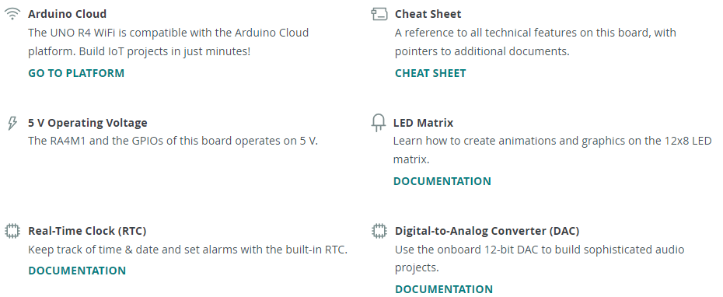



## Tech Specs

Here you will find the technical specifications for the Arduino® UNO R4 Wi-Fi.

Note on ESP header: the ESP32-S3 module on this board operates on 3.3 V. The ESP header located close to the USB-C® connector is 3.3V only and should not be connected to 5 V. This may damage your board.

Note on Qwiic connector: The Qwiic connector on this board is connected to a secondary I2C bus on this board, IIC0. This connector is 3.3 V only, connecting higher voltages may damage your board. To initialize this bus, use Wire1.begin() instead.

Maximum current draws per pin: the UNO R4 series' maximum current draw per GPIO is 8 mA, which is significantly lower than previous versions. Exceeding this limit may damage your pin / board.

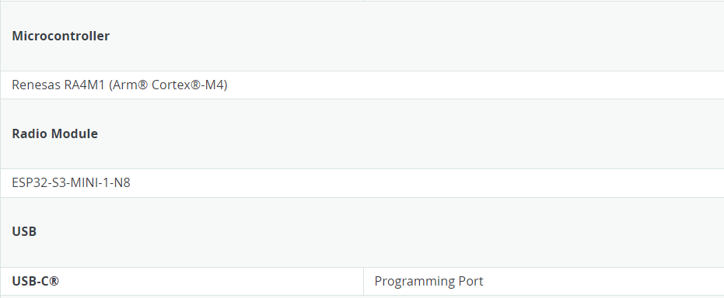

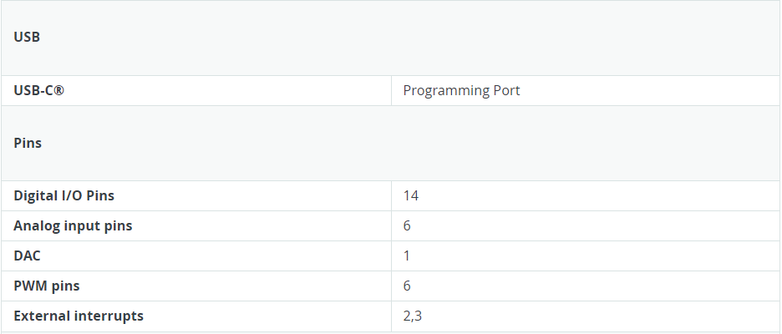

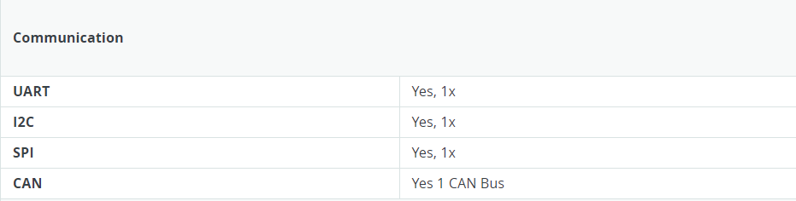

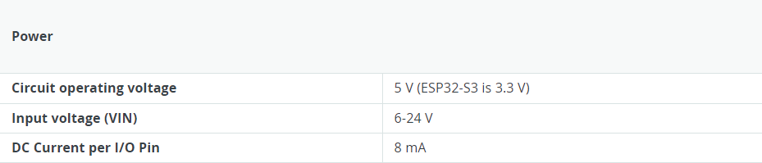

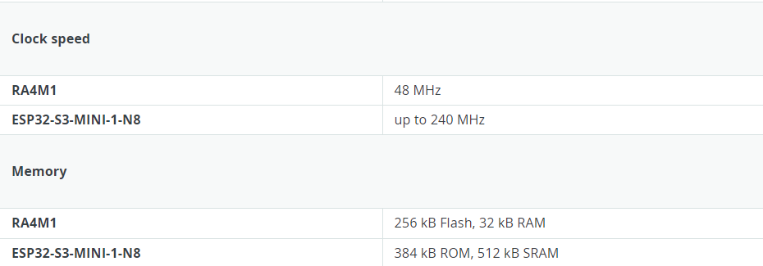

## Compatibility



You can find the Arduino IDE software in the TF card coming with the Kit.

## Suggested Libraries

* Wire

This library allows you to communicate with I2C devices, a feature that is present on all Arduino boards. I2C is a very common protocol, primarily used for reading/sending data to/from external I2C components.

URL: <https://www.arduino.cc/reference/en/language/functions/communication/wire/>

* SPI

This library allows you to communicate with SPI devices, with the Arduino as the controller device. This library is bundled with every Arduino platform (avr, megaavr, mbed, samd, sam, arc32), so **you do not need to install** the library separately.

* Servo

Allows Arduino boards to control a variety of servo motors.

This library can control a great number of servos. It makes careful use of timers: the library can control 12 servos using only 1 timer. On the Arduino Due you can control up to 60 servos.

## Learn about Arduino Uno R4 Wi-Fi kit

## Description

This is an Arduino UNO R4 Wi-Fi kit. Based on the characteristics of the UNO R4 Wi-Fi board, we carefully selected a variety of sensors and used these sensors to gradually lead you to learn and explore in depth in the form of projects. Throughout the writing of the tutorial We also followed the principle of step-by-step and tried our best to guide everyone to complete the project step by step. After each project is completed, you will encounter higher challenges.

## Package Includes

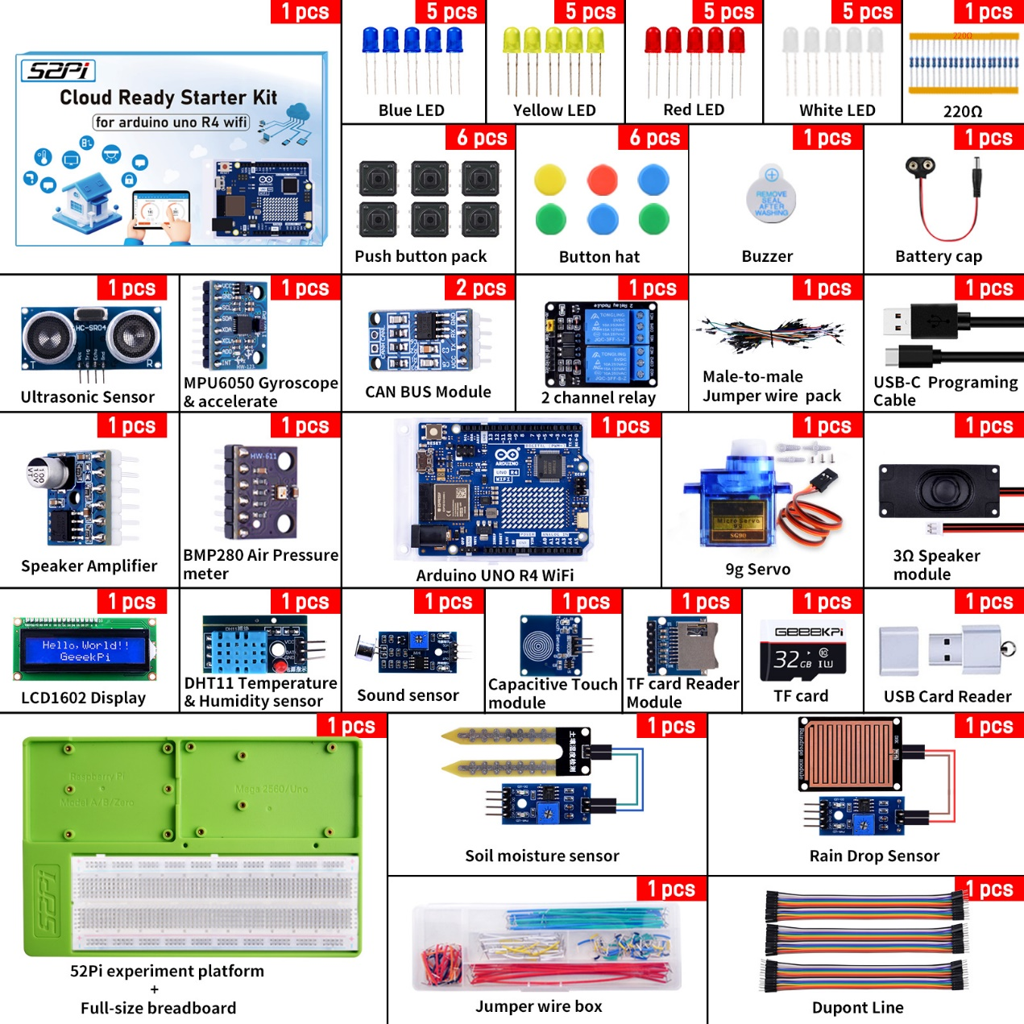

## HOWTO

The sensors and related experimental documents, data manuals, circuit pin diagrams and other information included in this kit can be found in the TF card provided with the kit. Please read the documentation carefully before use and refer to the electronic manual in the kit. Build your own circuit environment and programming.

The experimental document includes how to use Internet of Things applications, such as how to interact with your Arduino UNO R4 WIFI on the Adafruit IO platform, and also explains in detail how to build a Raspberry Pi-based home assistant system environment in your own home. It includes how to install the HACS service plug-in, configuration and other operations, and fully explains the cooperation between the sensor and the Internet of Things platform.

We have already downloaded some necessary software in advance, which can be found directly in the Resources directory.

Note:

**Please back up the data when using the TF card that comes with the package. It contains the necessary software, official data manuals, CAD files, sample codes and documentation we provide you.**

## File structure in TF card

### Software

Windows/Linux/MacOS

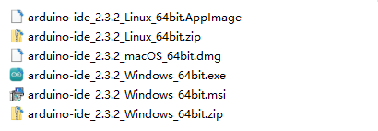

### Resources

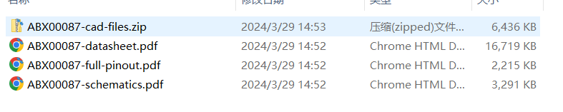

### Documentations

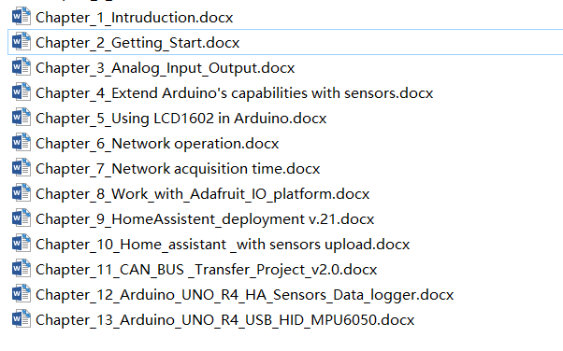

### Demo Code

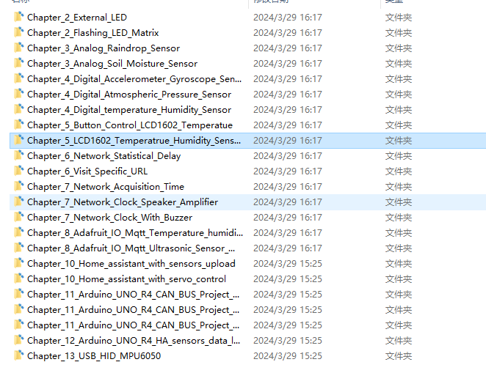

### GitHub Repo

In addition, we have put the code and documents on the GitHub site, and will continue to update them based on user feedback to add more and more interesting content. You can pay attention to our warehouse.

**GitHub URL:** [**https://github.com/geeekpi/Arduino_uno_r4_wifi_kit**](https://github.com/geeekpi/Arduino_uno_r4_wifi_kit)

## Application Scenario

### Sensors

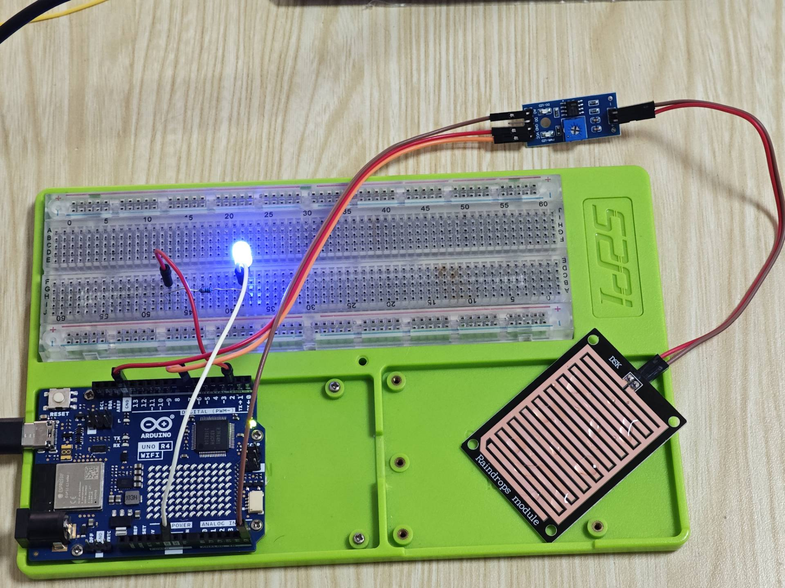

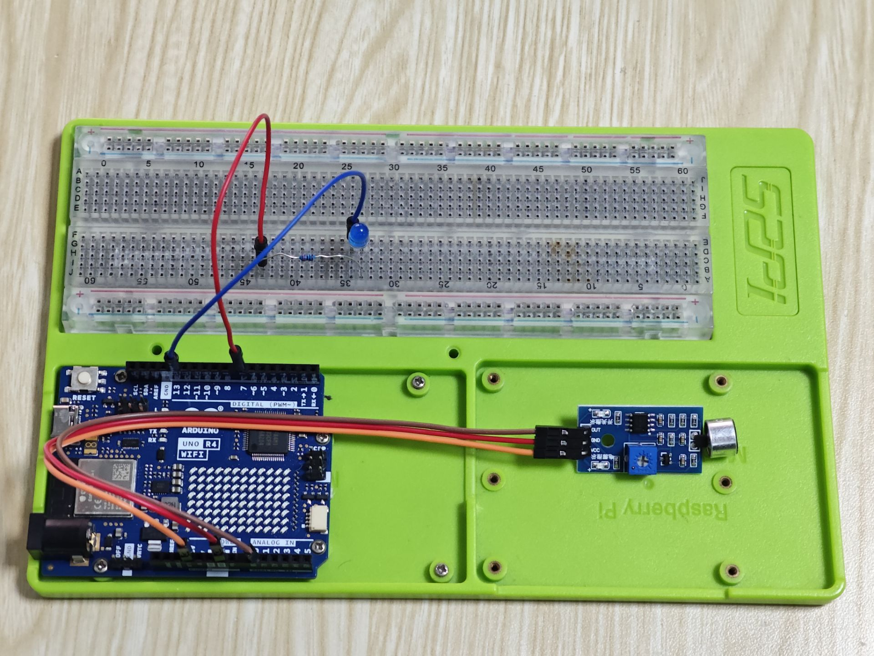

### Home assistant

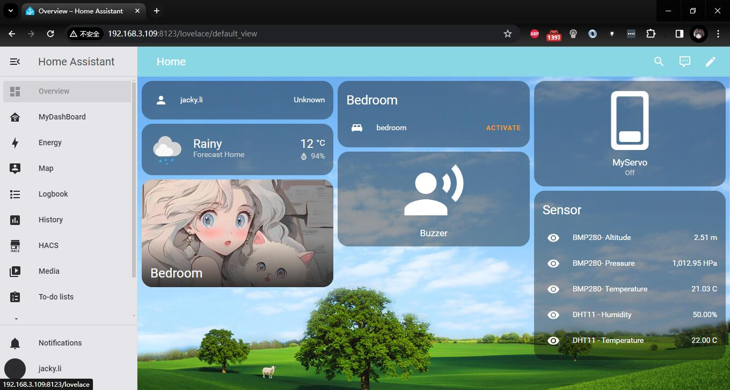

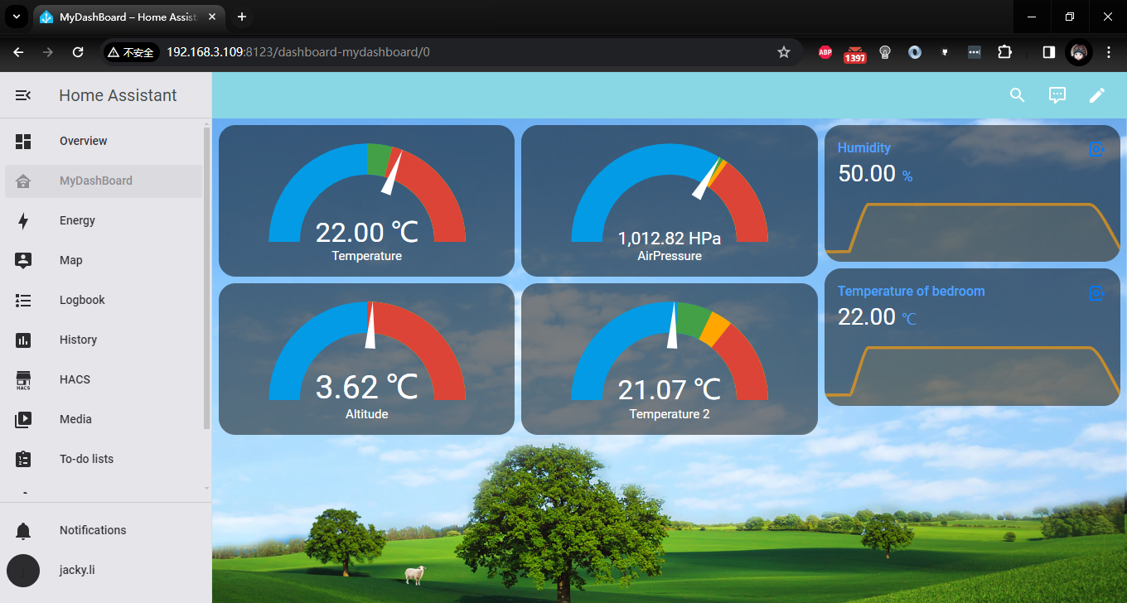

### Adafruit IO Platform

